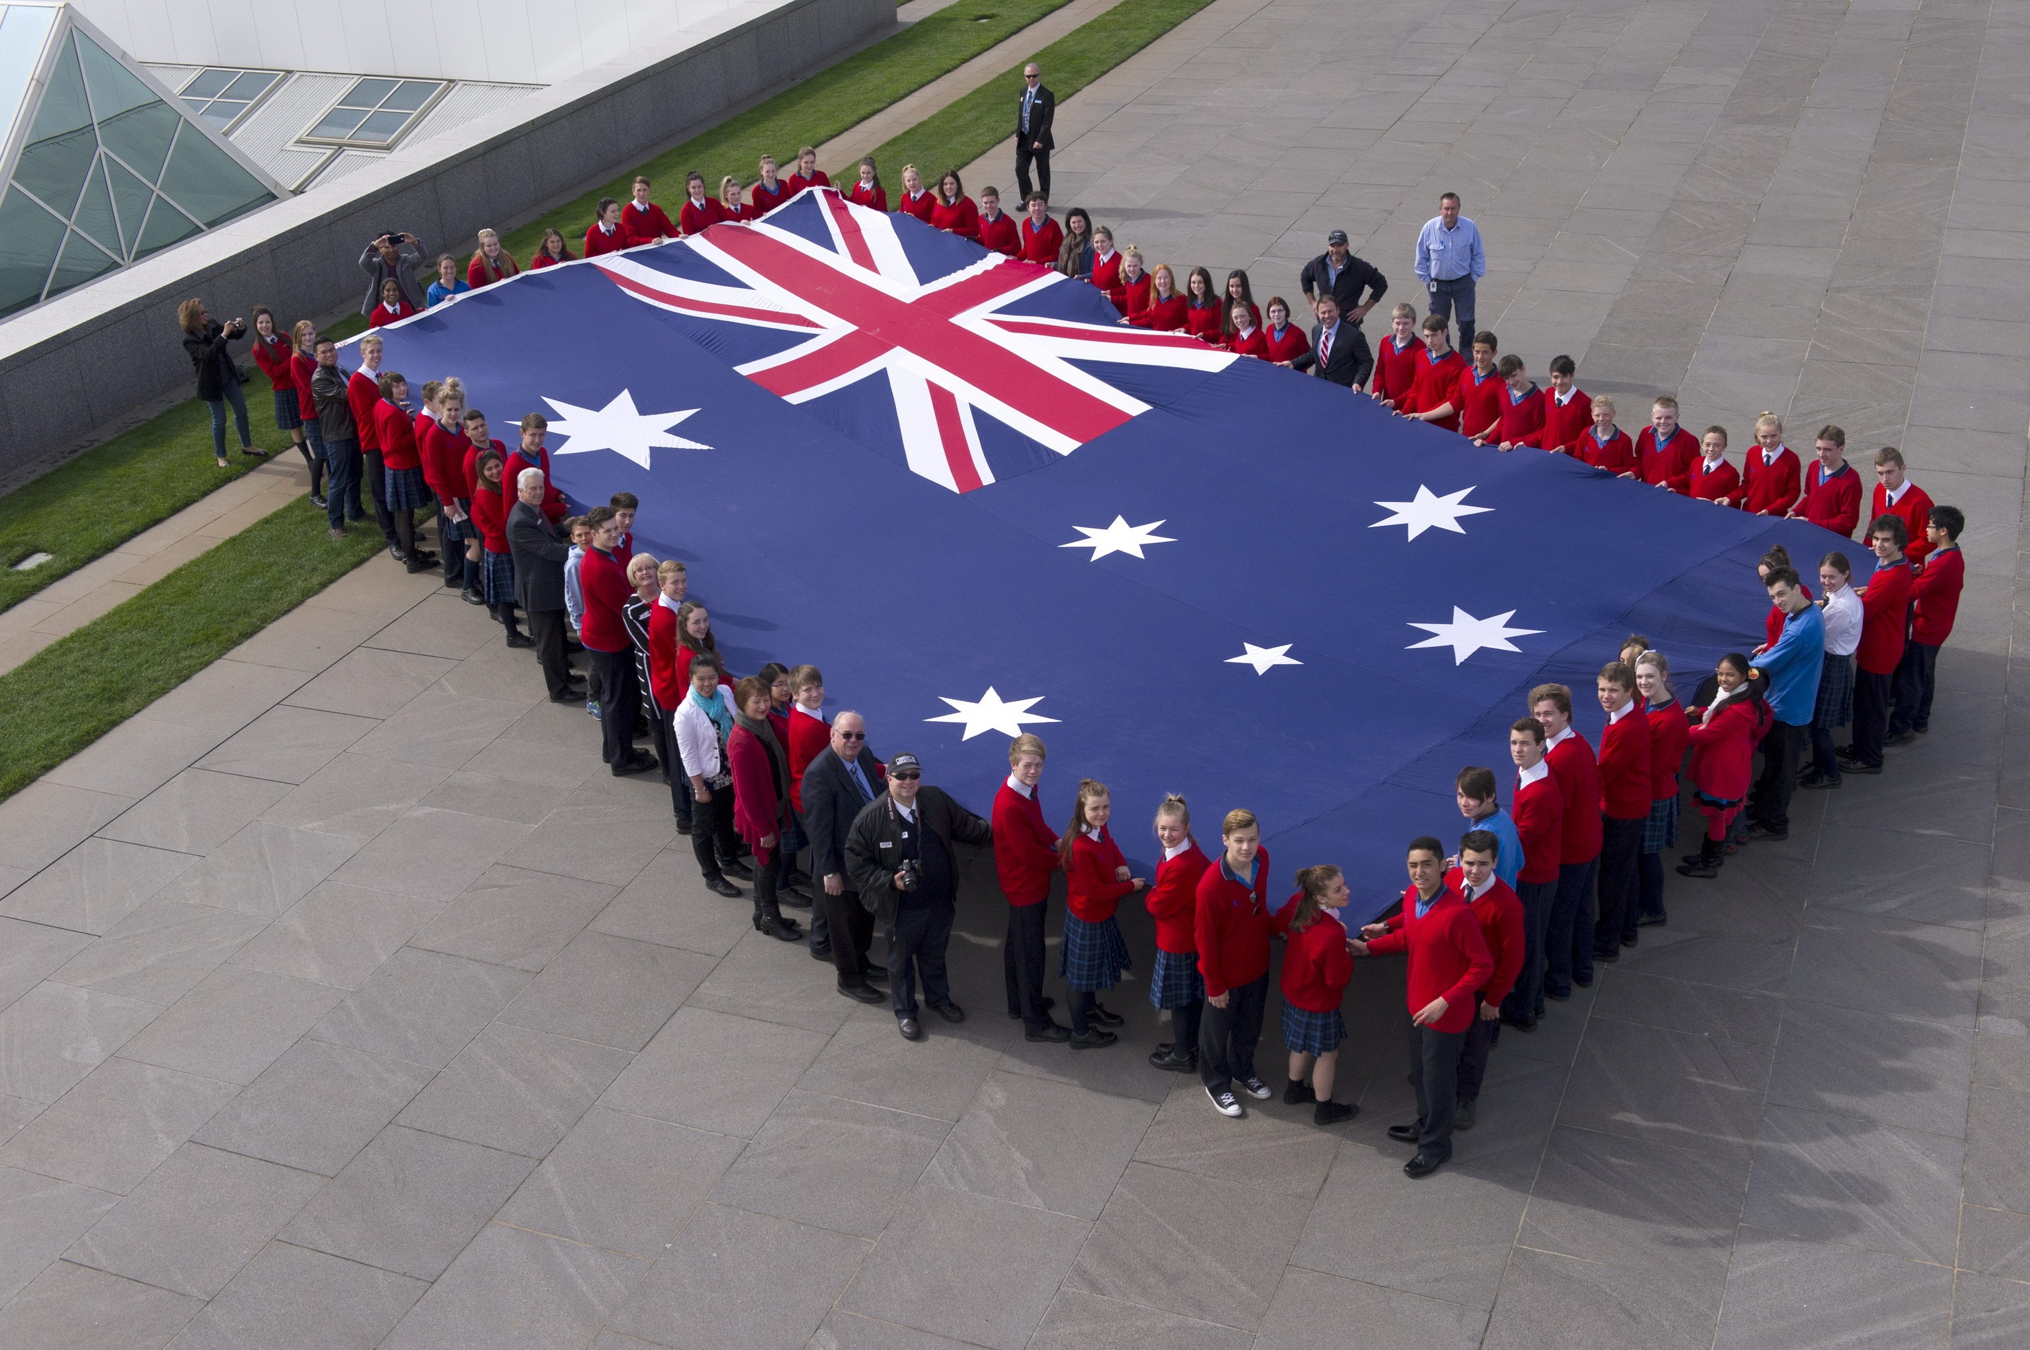
Australian National Flag – Fun Facts

- Following federation in 1901, the new Commonwealth Government held an open competition calling for public input into the design of a flag. It was the first time in history that a national flag had been chosen in this way.
Where was the first place that the Australian National Flag was flown?
  - Parliament House, Canberra
  - The Sydney Opera House
  - The Exhibition Building, Melbourne
  - The Lodge (Residence of the Prime Minister)

- Australian National Flag Day was proclaimed by the then Governor-General in 1996 to ‘commemorate the day in 1901 on which the Australian National Flag was first flown’. On what date do we celebrate each year?

- Which colour features on the Australian National Flag?
  - Red
  - White
  - Blue
  - All of the above

- The crosses of which countries may be seen on the Australian National Flag?
  - England
  - Scotland
  - Ireland
  - All of the above

- How many points are there on the Commonwealth Star, the largest star on the Australian National Flag?
  - 5
  - 6
  - 7
  - 8

- Which other Australian symbol features the Commonwealth Star?

School children holding a large flag that is flown over Parliament House in Canberra.

- Five people tied for the honour of designing our flag, sharing the £200 prize money. Match the name of the winning flag designer to their correct occupation:

Name of winning flag designer | Occupation
- Ivor Evans | - First Officer with Union Steamship Company of New Zealand
- Annie Dorrington | - Teenage optician’s apprentice from Leichhardt, New South Wales
- Leslie Hawkins | - 14 year old schoolboy from Melbourne, Victoria
- Egbert Nuttal | - Well-known artist from Perth, Western Australia
- William Stevens | - Architect with the Melbourne & Metropolitan Board of Works

- Approximately how many entries were submitted in the competition to find the first Australian National Flag?
  - 152
  - 3,500
  - 30,000
  - 130,000

- The Southern Cross is a constellation that is significant to First Nations peoples because it features in Dreaming Stories. In which hemisphere is the Southern Cross visible?

- Which of the following statements about the Australian National Flag is true?
  - The Australian National Flag is the only official flag of Australia
  - The design for the Flag was chosen by an international competition
  - The Flag can only be flown at certain times of the year
  - The flag has not changed since 1901

- Name one other official flag of Australia.

- How big is the Australian National Flag flying over Parliament House?

Answers
- C
- 3 September
- D
- D
- C
- The Commonwealth Coat of Arms
- (a)-(iii). (b)-(iv). (c)-(ii). (d)-(v). (e)-(i)
- C
- The Southern Hemisphere
- B
- Australia recognises other official flags including the Australian Aboriginal Flag, the Torres Strait Islander Flag, the Australian red ensign and the ensigns of the Australian Defence Force.
- 12.8 by 6.4 metres, or slightly larger than the side of a double decker bus

