Australian National Flag Day – 3 September each year

History of Australian National Flag Day
Australian National Flag Day celebrates the first time the flag was flown on 3 September 1901.
On that day the then Prime Minister the Rt Hon Edmund Barton announced the winners of a competition to find a flag for Australia. It was a large flag, 5.5 metres by 11 metres, and was flown over the dome of the Exhibition Building in Melbourne, where the first Commonwealth Parliament had opened.
At that time, the flag was known as the Commonwealth blue ensign. Later, that same flag became known as the Australian National Flag.
Australian National Flag Day was proclaimed by the then Governor-General on 28 August 1996 and has been celebrated each year since 3 September 1996.

Celebrating Australian National Flag Day
All Australians are encouraged to fly or display the Australian National Flag to celebrate Australian National Flag Day on 3 September each year.
Australian National Flag Day is an opportunity for individuals, community organisations, local authorities, businesses and schools to celebrate with pride the anniversary of the Australian National Flag.
Some ideas to celebrate Australian National Flag Day include:
- Conduct a flag-raising ceremony.
- Businesses and organisations which don’t have a flagpole may wish to display the Australian National Flag in the public areas of their buildings, such as foyers.
- Read about the history of the Australian National Flag and the protocols for flying the flag at www.pmc.gov.au/flag.
- Join the Commonwealth Flag Network.
- Celebrate the day and the flag’s history on social media.
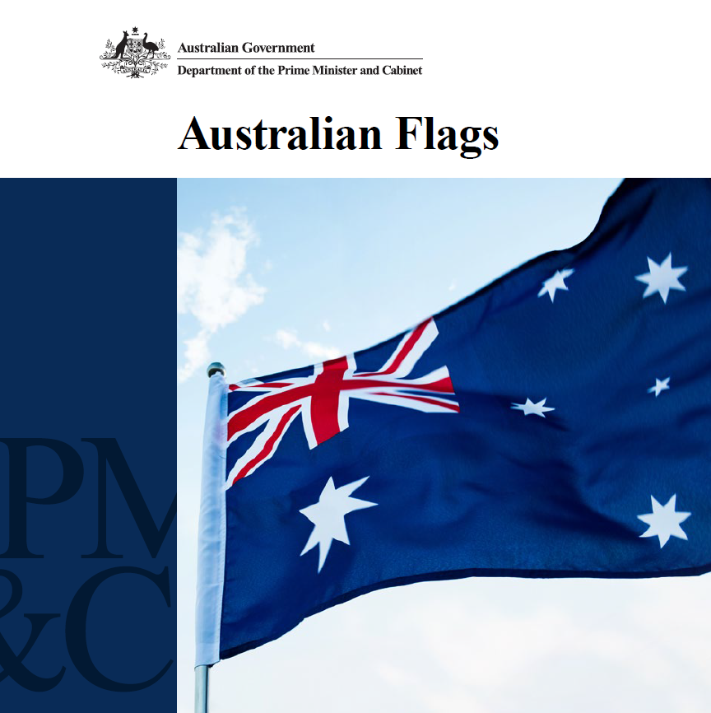

Australian Flags booklet
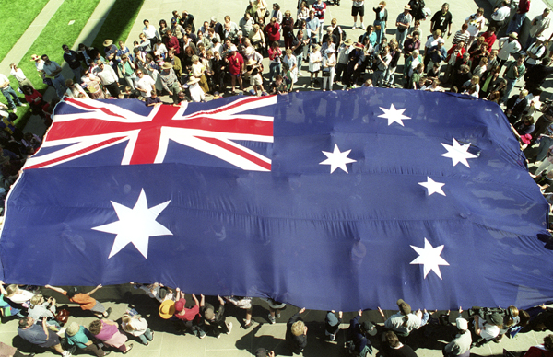

School children holding the Australian National Flag at a flag-raising ceremony at Parliament House, Canberra.
Photo: Auspic.

Protocols for raising the flag
While there are no official guidelines in relation to conducting flag raising ceremonies, basic flag protocol should be observed:
- the flag should be treated with respect and dignity
- the flag should be raised no earlier than dawn and lowered no later than dusk, but may be flown at night when illuminated
- the flag should be raised briskly and lowered ceremoniously
- the Australian National Flag should be raised first and lowered last
- two flags should not be flown from the same flagpole
- the flag should not be allowed to fall or lie on the ground.

Commonwealth Flag Network
Join the Commonwealth Flag Network to be notified of half-masting messages and other nationally significant events for flying the Australian National Flag.
Subscribe to the network by visiting www.pmc.gov.au/flag.

More information
Department website: http://www.pmc.gov.au/flag

