Official Gifts – Guidelines for the Importation of Official Gifts

Guidelines for the importation of official gifts

Gifts presented to officials are subject to customs clearance. Gifts are treated according to whether they are intended for the personal use of the recipient, or are intended for use by the Australian Government.
When returning to Australia the officials must:
- declare “Yes” to question three (3) on their Incoming Passenger Card (IPC) if they are carrying any goods, including gifts obtained overseas or purchased duty and/or tax free in Australia have a combined value more than AUD$900.00;
- declare “Yes” to question four (4) on their IPC if they have any goods of any value that are gifts to the Australian Government and not to them personally.

An English sample of the IPC is available at: https://www.border.gov.au/EnteringorleavingAustralia/Documents/english-ipc-sample.pdf#search=ipc

Where the Gift obtained is either given as a gift to the Australian Government or personally to the individual but not intended to be retained (ie surrendered to the Australian Government on return to Australia):

Value of Gift is AUD$1000.00 or less
Gifts valued at AUD$1000.00 or less may be subject to Duty and/or GST. Passenger concessions are only available on goods for personal use and this does not include items gifted to the Australian Government. If payment of the appropriate duty/GST cannot be made on arrival, a Form B787 (see section on Form B787) may be completed to grant the movement of the goods.

Value of Gift exceeds AUD$1000.00
Gifts over the value of $1000.00 must be formally entered into the country for home consumption and the correct duty and GST paid prior to their release. An Import Declaration must be completed and appropriate duty and GST paid. If such payments or an Import Declaration cannot be made or submitted upon arrival, a Form B787 may be completed to grant the movement of the goods.

Gifts obtained that are intended for personal use:

Value of AUD$900.00 or less
If the gift and any other goods obtained overseas or purchased duty and/or tax free in Australia have a combined value of less than AUD$900.00 then there is no requirement to declare the goods to an Australian Border Force officer and no intervention is required.

Value exceeding AUD$900.00
A passenger arriving into Australia is entitled to a concession of AUD$900.00 worth of goods purchased overseas, received as gifts or purchased duty and/or tax free in Australia. Where the gift and any other goods obtained overseas and/or purchased on a duty/tax free basis in Australia have a combined value more than AUD$900.00 the individual will be charged duty and/or GST on the value of those items. If payment cannot be made upon arrival a Form B787(see section on Form B787) may be completed to grant the movement of the goods.

Where a person is travelling with a family member they may pool their concessions. For example if the official and spouse are travelling together they can combine their AUD$900.00 concessions to have a combined concession of AUD$1800.00. They would then not have to pay duty and/or GST for goods where their total value is under AUD$1800.00.

Form B787 - MOVEMENT APPLICATION FOR CUSTOMABLE GOODS – SINGLE TRANSACTION

Form B787 is shown at attachment A and is available at: https://www.border.gov.au/Forms/Documents/b787___movement_application_for_customable_goods___single_transaction.pdf#search=B787

This form is used to grant the movement of the goods to a designated place and allows a 14 day period for the goods to be entered accordingly. This application must include details of the goods being entered into the country, their quantity, and their value in Australian dollars.

If further inspection of the goods is necessary after their movement to a designated place, the goods must be made available to the relevant authorities within 7 days of the request.

When all regulatory requirements have been met the goods will then be deemed not to be subject to Australian Border Force control and released into the possession of the government or individual.

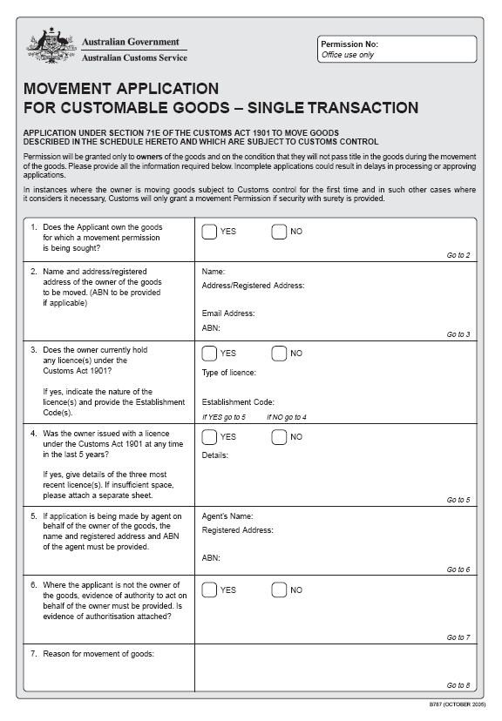
Attachment A
