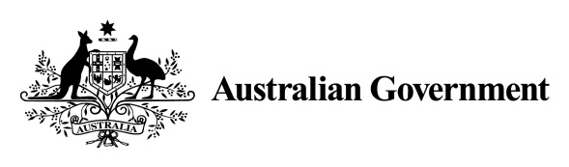

Addendum to the Australian National Action Plan on Women, Peace and Security 2012–2018
The Australian National Action Plan on Women, Peace and Security 2012–2018 (National Action Plan) is due to expire at the end of 2018. This addendum to the National Action Plan extends the National Action Plan to 30 June 2019.
Australia is a strong supporter of the United Nations Women, Peace and Security agenda and we are considered a global leader in its implementation. Having a National Action Plan is a key contributing factor to Australia’s achievements in advancing this agenda, and developing our next National Action Plan is an opportunity to further contribute to international efforts to implement the Women, Peace and Security agenda.
The National Action Plan has been extended to allow for the development of our next National Action Plan, one that reflects global best practice, and is flexible enough to take us in to the next decade. This will allow time to consider the recommendations from the forthcoming independent final review of the National Action Plan and engage with our stakeholders on the development of the next Plan.
The Independent Interim Review of the National Action Plan found the strategies and actions remain highly relevant. The current National Action Plan provides a flexible and strategic framework that supports responsible departments to implement the Women, Peace and Security agenda. Responsible departments are shaping their activities to respond to changes in the Women, Peace and Security landscape.
The monitoring and evaluation framework and reporting timeframes remain unchanged under the extended National Action Plan. The next report of progress under the current National Action Plan will cover the period 1 January 2016 to 31 December 2017 as mandated in the current National Action Plan.
An independent final review of the National Action Plan will be conducted in 2018, intended to inform the development of the Australian Government’s next National Action Plan. Ensuring the monitoring and evaluation framework remains provides for a comparable data set that supports the evaluation undertaken as part of the Independent Final Review. It also ensures reporting requirements are predictable for departments with continued responsibilities under the current National Action Plan. The findings of the independent final review will inform the development of the next National Action Plan.
Progress under the extended National Action Plan will be reported with the first report on progress of Australia’s second National Action Plan.
As the Australian Government commences the development of the next National Action Plan, the governance arrangements will continue to operate as the primary mechanism responsible for its implementation. The current National Action Plan references the Inter-Departmental Working Group as the primary mechanism responsible for its implementation. As the Australian Government commences the development of the next National Action Plan, the governance arrangements will evolve to reflect the importance of this work. The Inter-Departmental Working Group will be renamed, as the Inter-Departmental Committee and will be supported by a Sub-Committee. Representation in these groups includes departments with implementation responsibilities under the current National Action Plan.
Civil society will continue to contribute to the implementation of the current NAP and the development of the next NAP. Representation of the non-government sector will continue on both the Inter-Departmental Committee and the Sub-Committee.
The Minister for Women, Senator the Hon Michaelia Cash is the lead Minister responsible for the National Action Plan, and works closely with her ministerial colleagues across government on its implementation.

Independent Interim Review of the Australian National Action Plan on Women, Peace and Security 2012–2018 available at: https://www.dpmc.gov.au/resource-centre/office-women/independent-interim-review-australian-national-action-plan-women-peace-and-security-2012-2018
The Department of the Prime Minister and Cabinet chairs both committees. Representation in these groups is extended to the Department of Foreign Affairs and Trade, the Department of Defence, the Australian Federal Police, the Attorney-General’s Department, the Australian Civil Military Centre. The Australian Coalition on Women, Peace and Security also participates in these groups.

