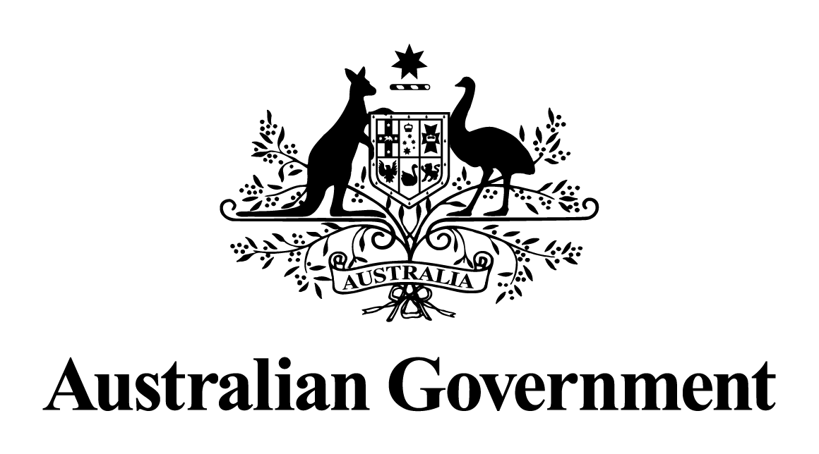

Australian Government response to the   
Joint Committee on Publications report:

Inquiry into the printing standards for documents presented to Parliament

2017 Report

October 2018

The Joint Committee on Publications report makes five recommendations: the Departments of the Prime Minister and Cabinet, and Finance, and the Digital Transformation Agency are responsible for responding to recommendations 1 and 4; and the Parliamentary Departments recommendations 2, 3 and 5.

Recommendation 1:

*That the Digital Transformation Agency in consultation with the Department of Finance develop a minimum set of publication standards for digital documents with suitability for possible future electronic tabling.*

Agreed. Through its work in improving digital access to government, the Digital Transformation Agency’s (DTA) Design System product provides a framework and a set of tools to help designers and developers build useable and accessible government products and services. The Design System’s roadmap includes the development of generic templates that could be used for preparation of simpler government documents and from which specific templates could be developed for more complex material. DTA and the Department of Finance are collaborating to pilot this system in line with the development of the digital annual report project. This, combined with the application of DTA’s Digital Service Standard and minimum mandatory requirements for Australian Government websites, will provide a sound basis for facilitating future electronic tabling.

Recommendation 4:

*That the parliamentary departments and the Department of the Prime Minister and Cabinet develop a system for the embargoed delivery of digital documents to Parliament; and that once in place, the system be accompanied by a requirement for government departments to deliver digital documents prior to tabling.*

Agreed. The parliamentary departments are progressing a project to receive and publish tabled documents online in consultation with the Department of the Prime Minister and Cabinet (PM&C). As this project progresses it is intended that functionality will be extended, subject to resourcing constraints, to enable the embargoed delivery of government documents in digital format to Parliament.

At the appropriate time, the Government will issue a Tabling Circular to all agencies advising of the requirements for the delivery of digital documents prior to tabling.