Australian Government Branding
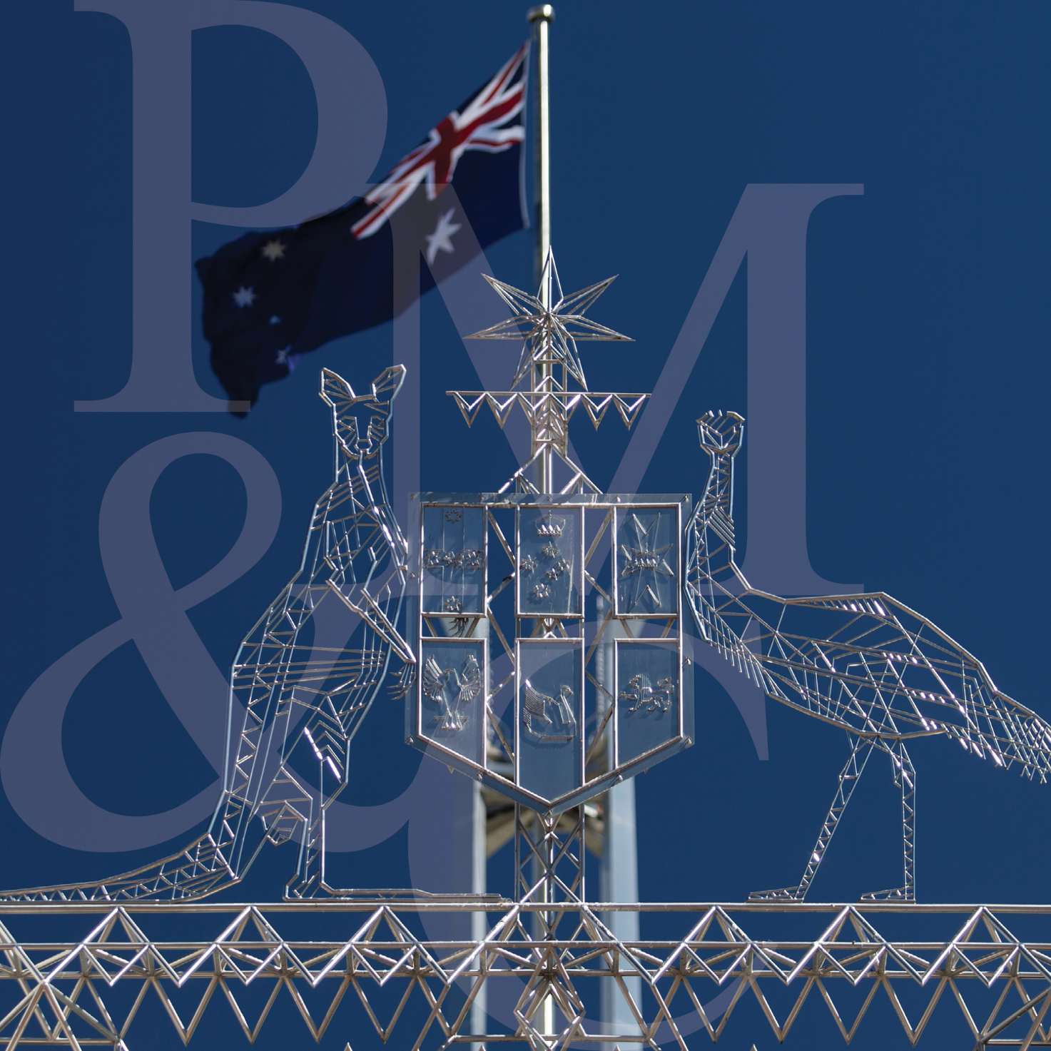
  - Guidelines on use of the Australian Government logo by Australian Government departments and agencies
Contents
1. Introduction 1
1.1 Policy basis 1
1.2 Further information 1
2. Elements of the logo 2
2.1 The design 2
2.2 Colour use 3
3. Applying the logo 4
3.1 Positioning the logo 4
3.2 Identifying a hierarchy 5
3.3 Identifying multiple bodies 6
3.4 Program branding 7
3.5 International branding – Nation Brand 8
3.6 Incorrect application 9
3.7 Basic stationery - inline version 10
3.8 Basic stationery - stacked version 11
4. Website logo application 12
5. Other issues 14

1. Introduction

1.1 Policy basis
The Australian Government decided in June 2003 that common branding would apply to all Australian Government departments and agencies (this covers PGPA Act entities and companies) and this branding policy continues to apply under the current government.
A common, easily recognisable brand ensures clear and consistent branding across Australian Government departments and agencies. These guidelines have been developed to help departments and agencies ensure the Australian Government logo is consistently applied to products such as official Australian Government documents and publications.
Departments and agencies are required to comply with the branding policy unless an exemption, or permission to use a co-branded logo, has been granted by the minister responsible for the branding policy. This is currently the Assistant Minister to the Prime Minister, the Hon Patrick Gorman MP. Requests for an exemption or a co branded logo are considered on a case by case basis.
Agencies that have been granted an exemption from the branding policy may use the Commonwealth Coat of Arms without the words ‘Australian Government’ and with the name of the agency and/or a unique logo.
Agencies that have been granted permission to co-brand can apply a logo that consists of the Commonwealth Coat of Arms with the words ‘Australian Government’ and a unique logo.

1.2 Further information
Any questions about the application of the Australian Government logo as advised in these guidelines, including about possible exemptions or co-branding, should be directed to:
Honours and Symbols Section
Department of the Prime Minister and Cabinet
PO Box 6500
CANBERRA ACT 2600
Ph 02 6271 5601
Email governmentbranding@pmc.gov.au
For guidance on branding for government campaigns and advertising please refer to guidelines issued by the Department of Finance and Deregulation at https://www.finance.gov.au/government/advertising.
For guidance on government website design please refer to guidelines issued by the Digital Transformation Agency at https://www.dta.gov.au/help-and-advice/guides-and-tools/requirements-australian-government-websites.

2. Elements of the logo

2.1 The design
When applied to departments and agencies, the Australian Government logo consists of four elements:
- the Commonwealth Coat of Arms (Conventional Version 3A Solid)
- the words ‘Australian Government’ (Times New Roman Bold)
- an underline, and
- the department’s or agency name (also Times New Roman Bold).
Consistency of construction of the logo is critical to the intention of establishing and maintaining a single recognition device for the Australian Government.
There are several forms of the logo which may be used for different situations. Examples as applied to departments and agencies are below.
It is left to the discretion of the department or agency as to which should be used on any given occasion.

Inline  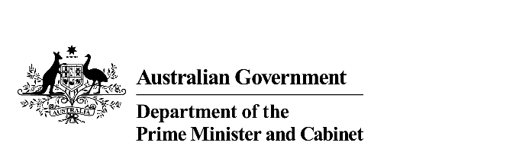 | Inline strip  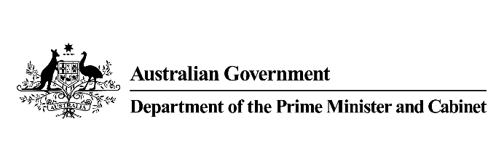
Stacked  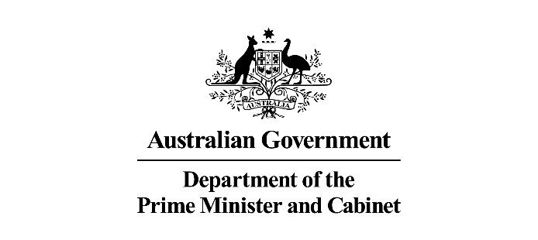 | Stacked Strip  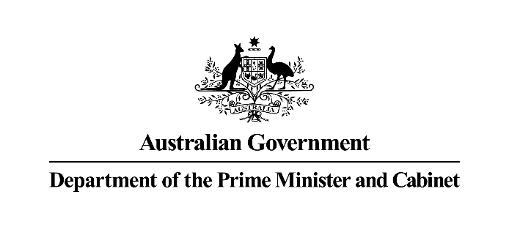

The minimum width of the Commonwealth Coat of Arms on stationery and larger items must be 20mm. However, on items such as name badges and identity cards where it may not be possible to adhere to this, the Coat of Arms may be altered in width, but must remain recognisable

2.2 Colour use
NOTE: This page is best viewed in colour
It is intended that the Australian Government logo be reproduced in one colour only, preferably black. However, to add flexibility to this reproduction, guidelines for limited colour use have been developed.
The logo can be reversed – white on black – or can appear as a light colour on a dark colour (e.g. charcoal, navy, maroon, dark green, etc) or as a dark colour on a light colour. The choice of these colours is up to individual Australian Government bodies, but it is essential to ensure that any use of colour does not compromise the integrity of the logo. Attention to contrast must always be considered carefully. The logo must not appear in a pastel or light colour on a light background colour, or as a tint or stipple of any colour. The logo must not appear as a dark colour on a dark background.
The various elements of the logo must not be represented in more than one colour, and the full colour version of the Commonwealth Coat of Arms must not be used in place of the Conventional Version 3A Solid Commonwealth Coat of Arms in single colour.
Use of a black and white logo on a particular product does not preclude the use of the logo in a different colour palette on other products.
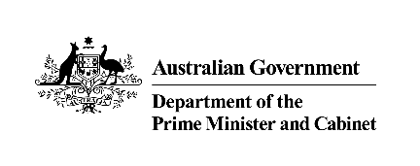
 |  | 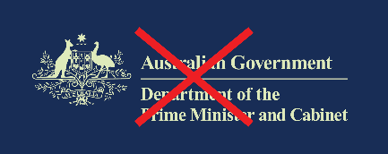
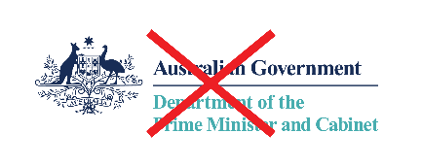 | 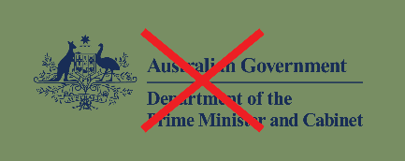 | This cell has been left deliberately blank

3. Applying the logo

3.1 Positioning the logo
In most circumstances, the logo must have prominence over and above other images and graphic elements. Where possible, the logo must be placed at the top of the item it appears on and other logos, text or images must not be placed above or to the left of the logo.
An individual logo must appear only once in a document.
The logo must not be used as decorative or artistic element or as a watermark, and must not be overprinted with text or images.
An isolation zone has been established to ensure that the dignity of the logo is not jeopardised through crowding. The location of this zone is indicated by the grey Xs in the illustrations below. The width of ‘X’ is the distance between the top of the capital ‘A’ in ‘Australian Government’ and the bottom of the horizontal line beneath these words (as indicated by the red Zs in the illustrations below). That measurement will vary depending on the size of the font used in the particular case. Please note that the isolation zone shown here must be seen as a minimum and can be greater; and that it applies to every form of the logo and in every application of the logo.

Inline logo isolation zone  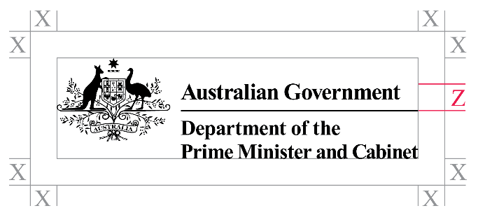 | Stacked logo isolation zone  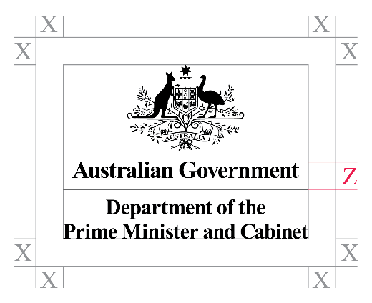

3.2 Identifying a hierarchy
Divisions, Branches, Offices and Units within departments may identify themselves in the common branding in either of the ways shown below, depending on the preference of the relevant Portfolio Secretary. Where the title of an organisational unit is not unique within the Australian Government, contextualising information such as the department or agency name must be included.

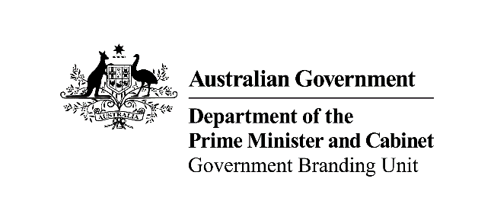 | 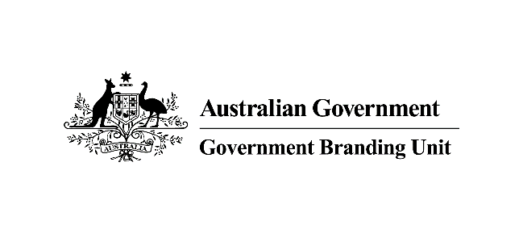
NB: The Government Branding Unit is a hypothetical example and does not actually exist.

3.3 Identifying multiple bodies
In circumstances where a number of departments and/or agencies are to be identified, for example on a sponsorship acknowledgment, the following options may be used at the discretion of the bodies (examples of each are shown below):
- include the logos of each of the individual departments and agencies involved
- a single Australian Government logo with the department or agency names listed below the line (this protocol can apply to all versions of the logo); or
- the Australian Government logo, which is the Commonwealth Coat of Arms (Conventional Version 3A Solid) and the words ‘Australian Government’ (Times New Roman Bold), to acknowledge the government as a whole.

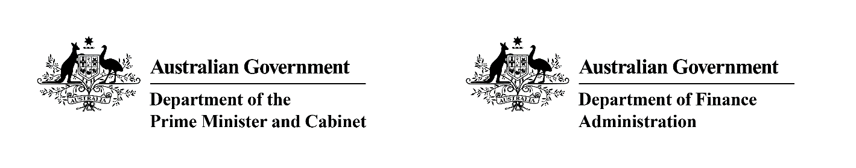
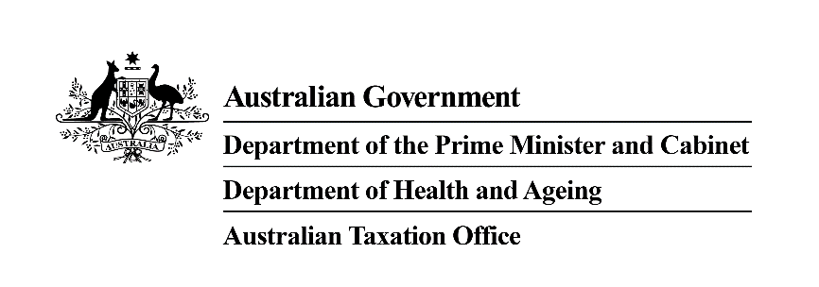
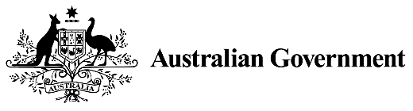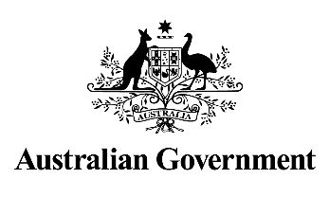

3.4 Program branding
Where the branding for an Australian Government program includes its own logo (e.g. ‘My Health Record’, or ‘National Relay Service’), that program logo can be used in conjunction with one of the following forms of the official logo:
- the departmental or agency logo, comprising the Commonwealth Coat of Arms (Conventional Version 3A Solid), the words ‘Australian Government’ (Times New Roman Bold), an underline, and the department or agency name (also Times New Roman Bold);
- the Australian Government logo, comprising the Commonwealth Coat of Arms (Conventional Version 3A Solid) and the words ‘Australian Government’ (Times New Roman Bold); or
- the Australian Government Initiative logo, comprising the Commonwealth Coat of Arms (Conventional Version 3A Solid) and the words ‘An Australian Government Initiative’ (Times New Roman Bold).
The official logo must take the position of prominence either above or to the left of the program logo. The program logo must be no larger than the official logo.

Example with an agency logo

Example with the Australian Government logo

Example with the Australian Government initiative logo

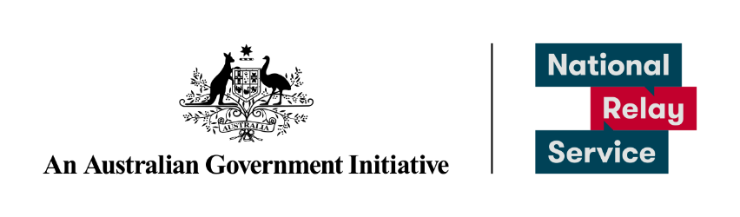

3.5 International branding – Nation Brand
The Government has approved a Nation Brand to present a unifying image of Australia. This is a special logo that is for use when promoting or marketing Australia in international communications and events. This logo can be used in conjunction with the official logo in one of the previous listed forms in section 3.4.
To find out more about Australia’s Nation Brand and the story behind it, visit https://www.brandaustralia.com/
To download free assets including guidelines, logos, fonts and templates for social media, events, presentations and retail marketing activities, visit https://assets.australiabrand.com.au

The Nation brand
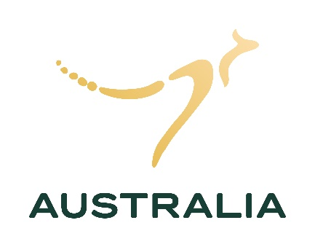  Vertical  This is the primary logo and should be used in most cases | Horizontal  Should only be used for wide formats
Example of the Nation Brand with an agency logo
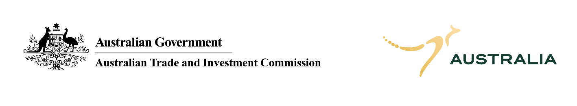

3.6 Incorrect application
Consistency of application of the logo is critical to the intention of establishing and maintaining a single recognition device for the Australian Government. For this reason, the integrity of the logo and its use must be maintained at all times. The examples below show how the logo is NOT to be used. Please note: the examples below apply to every form of the logo, and in every application of the logo.

Do not tilt the design  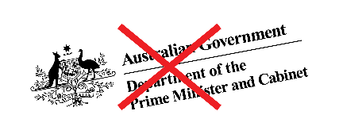 | Do not enlarge or alter in proportion any part of the design  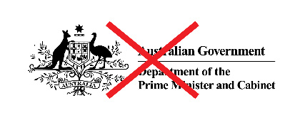 | Do not rearrange the design  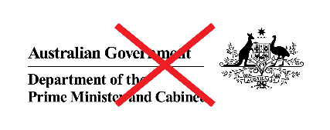
Do not reduce the design below the minimum size (Coat of Arms must be at least 20mm in width)  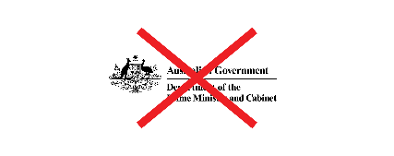 | Do not use any part of the design as a graphic element | Do not use the design in a low contrast manner  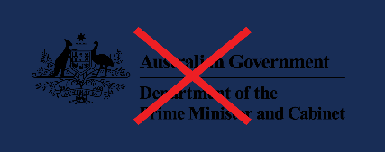

3.7 Basic stationery - inline version
Please note: these examples have been reduced to fit on this page. In practice the minimum width of the Coat of Arms is 20mm.
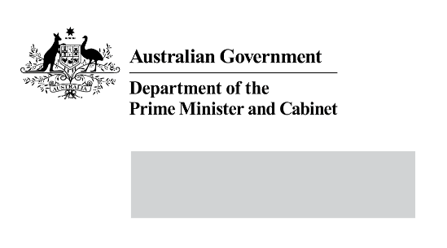

3.8 Basic stationery - stacked version
Please note: these examples have been reduced to fit on this page. In practice the minimum width of the Coat of Arms is 20mm.

4. Website logo application
All Australian Government departments and agencies are required to use government branding on their websites consistent with their print publications.

Creating logo files
Australian Government logos and program logos should be created by each agency in accordance with the advice outlined in Section 3.
Do not modify the size, leading, tracking/kerning of the typeface or the dimensions between the primary elements of the logo. Use only Times New Roman Bold for all versions of the logo.

Adding alternative (alt) text
Where you use the logo for navigation (for example, as a link to the home page) include alternative text (alt text) to describe the image. The alt text should also describe the destination of the link:
- if the logo represents government and agency branding (most situations), alt text should be the agency name
- if the logo is a only link to the agency’s home page, then the alt text should be ‘[agency name] home’.

Using Australian Government logos on websites
When creating websites department and agencies have the option of using:
- their department/agency logo
- the Australian Government logo
- the Australian Government Initiative logo.
Agencies should ensure consistency between digital and print products.
The chosen logo should appear at the top left of every page. The logo can be used to link to the homepage.
For example: Department of the Prime Minister and Cabinet

Program logo and/or title
The size and placement of the program/product/policy logo or title of the site should not compromise the hierarchy of the design.
For example:
- Family Relationships Online
- myGov

Ministerial websites
There must be a clear distinction between agency websites and ministerial websites.
Ministerial sites should not include the Australian Government logo or the Agency logo. However the Commonwealth Coat of Arms may be used.
For example: Prime Minister

Mobile websites
The same principles of applying government branding should be followed wherever possible. That is, the appropriate logo should be applied to every page in a size and placement that does not compromise the integrity of the logo.
Where it is not practical to apply the branding according to the instruction already outlined, include the text alternative that is applied to the logo.

Mobile applications
The same principles of applying government branding should be followed wherever possible. That is, the appropriate logo should be applied to the landing or splash page in a size and placement that does not compromise the integrity of the logo.

Intranets
The agency logo should be applied to intranet sites. Placement is at the discretion of the agency. We recommend top-left corner.

eNewsletters, digital versions of forms and digital brochures
Use the appropriate logo in a size that does not compromise the integrity of its design. Where a plain text version of the email newsletter/alert is provided, incorporate the words ‘Australian Government’ in a prominent position.
On all forms, use the logo in a size and placement that does not compromise the integrity of its design.

Non-government websites
Agencies may find they have a need to be involved with cross-jurisdictional initiatives or websites outside the gov.au domain either through a sponsorship agreement or entering into a collaborative arrangement.
Consider branding. Negotiate to use a logo in the most appropriate place on the site that recognises the Australian Government’s involvement, without compromising the intention of the initiative. Ensure recognition for the Australian Government and its partners.
For example:
- Cross-jurisdictional: Indigenous Justice Clearinghouse
- Non-government: The Numbering System

Amending old content
Only update content to reflect this guidance if the content describes current activities.
Do not change the following content for previous years:
- annual reports
- media releases
- publications that have been tabled in Parliament
- previous policy or program documents
- financial statements
- documents describing agencies’ legal entity or legislation
- anything that alters the official record.

5. Other issues

Reference to ‘Australian Government’ for branding purposes
All references to the ‘Commonwealth Government’ or ‘Federal Government’ must now be to the ‘Australian Government’ in all cases and on all products.

Departmental names
Where previously a reference would be made to ‘the Commonwealth Department of XYZ’, it must now be to ‘the Australian Government Department of XYZ’.

Use of the term ‘Commonwealth’
The ‘Commonwealth of Australia’ is the legal entity established by the Constitution. It is sometimes referred to simply as ‘the Commonwealth’. Where the term ‘Commonwealth Government’ has been used previously to refer to the national government, whether in relation to the elected government or the bureaucracy that serves it, replace it with ‘Australian Government’. References to the ‘Commonwealth of Australia’ as the entity established by the Constitution should remain unchanged.

Use of the Australian Government logo by third parties
Departments and agencies are able to authorise third parties to use the Australian Government logo (in various forms) where appropriate, for example to acknowledge Australian Government funding and support. This is at the discretion of the department or agency.

Use of the Commonwealth Coat of Arms by third parties
The Commonwealth Coat of Arms may be used by third parties in limited circumstances – such as use in educational publications and media and use by Australian representative national sporting teams participating in international competitions – but only where authorised in advance. Applications for such use should be directed to the Honours and Symbols Section of the Department of the Prime Minister and Cabinet.

Government advertising
The Department of Finance and Deregulation provides advice on appropriate branding for campaign and non-campaign advertising. https://www.finance.gov.au/government/advertising

Internet
The Digital Transformation Agency issues guidelines on the appearance and construction of departmental and agency web pages. https://www.dta.gov.au/help-and-advice/guides-and-tools/requirements-australian-government-websites/

Other Guidelines
Commonwealth Coat of Arms – Information and Guidelines. https://www.pmc.gov.au/resource-centre/government/commonwealth-coat-arms-information-and-guidelines
Austrade advice on the Australia’s National Brand program. https://assets.australiabrand.com.au

