Australian Red Ensign

The Australian Red Ensign is the official flag to be flown at sea by Australian registered merchant ships.

About the Australian Red Ensign
The Australian Red Ensign has three elements, similar to the Australian National Flag, on a red background. The Union Jack in the upper left corner (or canton), the white Commonwealth Star underneath it and the Southern Cross on the fly (or right hand side) of the flag in white.

History of the Australian Red Ensign
When the Commonwealth Government announced a competition to design a flag for Australia in 1901, entrants were asked to send a design for two flags – one for official and naval purposes and the other for merchant ships. This resulted in a Blue Ensign and a Red Ensign.
There was considerable confusion in the first half of the 20th century over the appropriate use of the Red Ensign as opposed to the Blue Ensign.
This was clarified with the passage of the Flags Act 1953 which proclaimed the Blue Ensign as the Australian National Flag. The Australian Red Ensign became the official flag to be flown at sea by Australian registered merchant ships.

Merchant Navy Day
September 3 each year, as well as being Australia National Flag Day, is also Merchant Navy Day. Organisations and individuals commemorating Merchant Navy Day can choose to fly the Australian Red Ensign.

Proclamation
The Australian Red Ensign is an official flag of Australia and is proclaimed under the
Flags Act 1953.

Use of the Australian Red Ensign
The Australian Red Ensign is generally only flown at sea by Australian registered merchant ships or on land by organisations and individuals for ceremonial purposes such as Merchant Navy Day.
When the Australian Red Ensign is flown along with the Australian National Flag, the Australian National Flag should be flown in the position of honour.

More information
Department WEBSITE: https://www.pmc.gov.au/government/australian-national-symbols/australian-flags

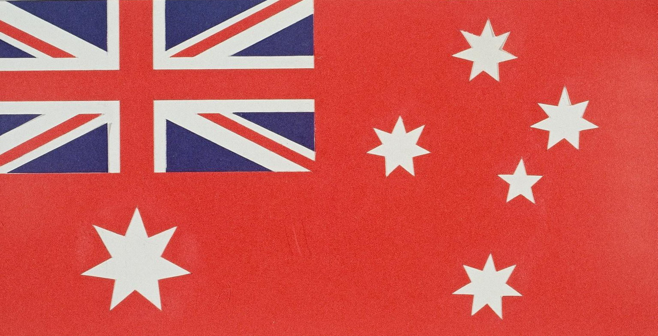
The Australian Red Ensign has three elements on a red background. The Union Jack, the Commonwealth Star and the Southern Cross.

