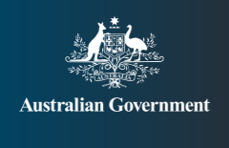

# AUSTRALIA’S CANDIDATE

## COMMITTEE ON THE ELIMINATION OF DISCRIMINATION AGAINST WOMEN 2021–24

## Natasha Stott Despoja

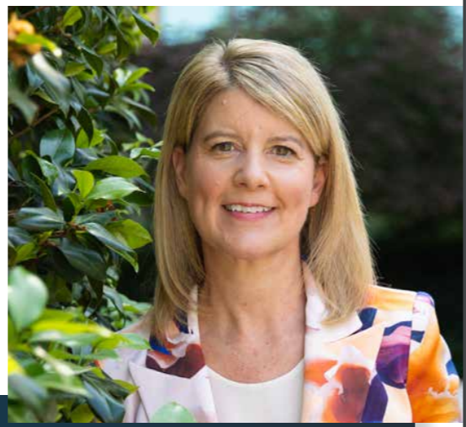

AUSTRALIA SEEKS YOUR GOVERNMENT’S SUPPORT FOR THE ELECTION OF NATASHA STOTT DESPOJA TO THE COMMITTEE ON THE ELIMINATION OF DISCRIMINATION AGAINST WOMEN

Australia is committed to ending all types of discrimination against women and girls to create an inclusive society. We have a proud record of advocacy on ending violence against women and girls, promoting women’s economic empowerment and enhancing women’s leadership choices. Our nomination of Natasha Stott Despoja to CEDAW demonstrates our commitment to gender equality and eliminating discrimination against women and girls in Australia, the Indo-Pacific and globally.

### CURRENT ROLES

* Inaugural Chair of Our Watch, Australia’s national foundation to prevent violence against women and their children
* Non-Executive Director of Global Citizen, a movement of engaged citizens using their collective voice to end extreme poverty by 2030
* Member of the Global Women’s Institute Leadership Council
* Member, Advisory Council of the 50/50 by 2030 Foundation an Australian foundation focused on increasing, women’s representation in leadership positions

### RECOGNITION

* Officer of the Order of Australia
* TIAW Lifetime Achievement Award
* Zonta Lifetime Achievement Award
* Apolitical’s ‘Gender Equality Top 100’
* Global Leader for Tomorrow, World Economic Forum

“WITH MY INTERNATIONAL ADVOCACY AND DIPLOMATIC EXPERIENCE, COMBINED WITH MY PASSION FOR WOMEN’S RIGHTS, I BELIEVE I CAN MAKE A VALUABLE CONTRIBUTION TO THE COMMITTEE ON THE ELIMINATION OF DISCRIMINATION AGAINST WOMEN”

Twitter: @NStottDespoja

Website: pmc.gov.au/cedaw-candidate

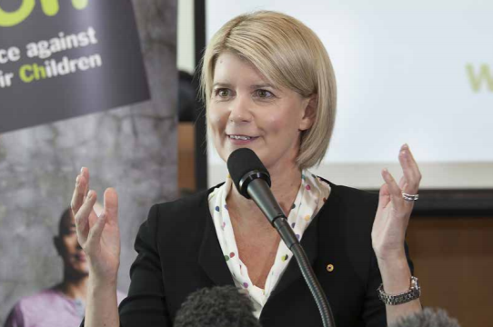

### EXPERTISE

Natasha Stott Despoja has been a lifelong advocate for women’s rights and gender equality. Natasha is a former Australian Senator and Party leader with a thorough understanding of international and Australian domestic law, and a champion for women’s rights. As a former Australian Senator – the youngest woman ever elected to parliament in Australia – she tabled Australia’s first paid maternity leave bill in the Australian Parliament and advocated for Australia’s ratification of the CEDAW Optional Protocol.

Natasha is the inaugural Chair of Our Watch, Australia’s national foundation dedicated to ending violence against women and children. As Chair she has overseen the development of the first-ever national framework for the prevention of violence against women.

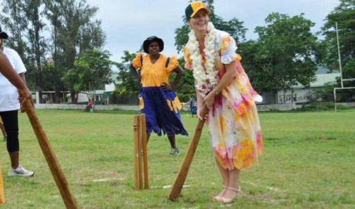

Natasha was previously the Australian Ambassador for Women and Girls. In this role, she worked tirelessly to deliver Australia’s international gender equality policies and programs, and represented Australia at crucial gender-focused fora. She is a former member of the UN High Level Working Group on the Health and Human Rights of Women, Children and Adolescents, a former member of the World Bank Advisory Council, and an experienced company director.

In 2018, Natasha was selected as one of the top 100 most influential people in the world on gender equality. Natasha is a prolific and sought-after speaker on gender equality and women’s rights.

### MAIN PROFESSIONAL ACTIVITIES

2013-2016 Australian Ambassador for Women and Girls. Represented Australia at gender-focussed multilateral and regional meetings including several sessions of the UN Commission on the Status of Women, the Human Rights Council, APEC Women and the Economy Forum, Pacific Women Business Leaders Dialogue

2017 Member of the United Nations High Level Working Group on the Health and Human Rights of Women, Children and Adolescents

2015-2017 Member of the World Bank Gender Advisory Council

2001-2002 Leader of the Australian Democrats party, Australian Parliament

1995-2008 Senator for South Australia

“THE CONVENTION ON THE ELIMINATION OF ALL FORMS OF DISCRIMINATION AGAINST WOMEN IS A CRUCIAL PART OF THE GLOBAL WOMEN’S RIGHTS ARCHITECTURE. I WOULD BE HONOURED TO SERVE ON THE COMMITTEE THAT HELPS UPHOLD IT.”

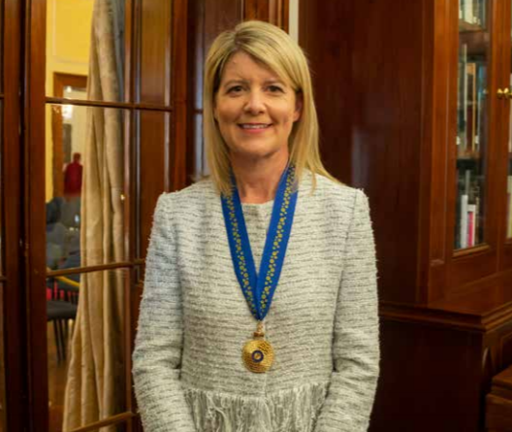

Twitter: @NStottDespoja

Website: pmc.gov.au/cedaw-candidate