Commonwealth Coat of Arms
  - 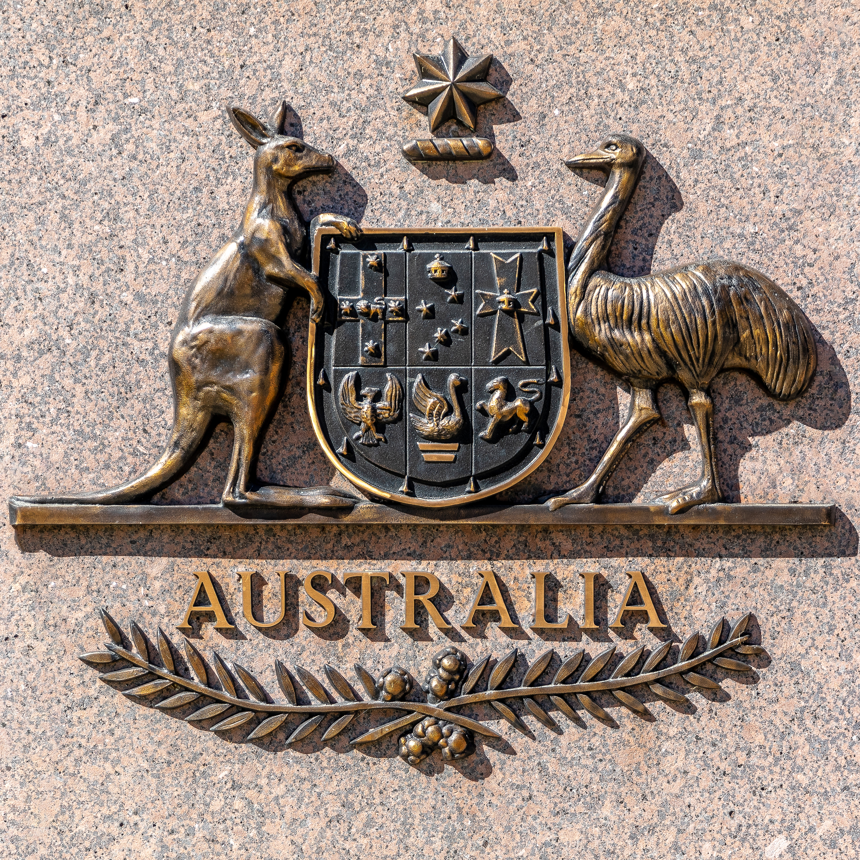Information and Guidelines
Parliamentary and Government Branch
Contents
1 Introduction 1
1.1 General information 1
1.2 Contact information 1
2 Forms of the Arms 2
3 Official Uses 2
3.1 General usage 2
3.2 Size and colour 3
3.3 Placement on official documents and publications 4
3.4 Use in electronic media 4
3.5 Use on or in buildings 5
3.6 Use on uniforms 5
3.7 Use with the Australian National Flag 5
4 Unauthorised use 5
5 Use by Sporting Bodies 6
6 Use in Educational Publications 6

Introduction

General information
The Commonwealth Coat of Arms (the Arms) is the formal symbol of the Commonwealth of Australia that signifies Commonwealth authority and ownership.
The ‘Commonwealth of Australia’ is the legal entity established by the Constitution. Where the term ‘Commonwealth Government’ has been used previously to refer to the national government, whether in relation to the elected government or the bureaucracy that serves it, it will normally be appropriate to replace it with ‘Australian Government’.
Requests for permission to use the Arms outside the authorised uses detailed in these guidelines – such as in educational publications and media and use by Australian representative national sporting teams participating in international competitions should be directed to the Honours and Symbols Section, Parliamentary and Government Branch at governmentbranding@pmc.gov.au

Contact information
Any questions about the use of the Commonwealth Coat of Arms as advised in these guidelines, including its use by third parties, should be directed to:
Honours and Symbols Section
Parliamentary and Government Branch
Department of the Prime Minister and Cabinet
PO Box 6500
CANBERRA ACT 2600
Ph 02 6271 5601
Fax 02 6271 5662
Email governmentbranding@pmc.gov.au
For guidance on Australian Government branding please refer to Australian Government Branding – Guidelines on use of the Australian Government Logo for Departments and Agencies available at https://www.pmc.gov.au/publications/australian-government-branding-guidelines
For guidance on branding for government campaigns and advertising please refer to guidelines issued by the Department of Finance at https://www.finance.gov.au/government/advertising
For guidance on government website design please refer to guidelines issued by the Digital Transformation Agency at https://www.dta.gov.au/help-and-advice/guides-and-tools/requirements-australian-government-websites

Forms of the Arms
There are 3 versions of the Arms which may be used for various purposes – the colour version, the conventional Arms and the stylised Arms.
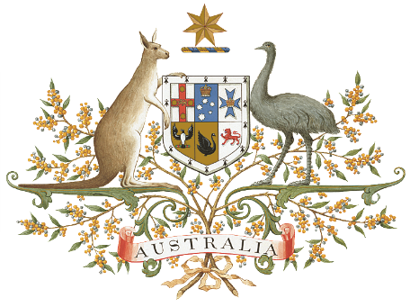
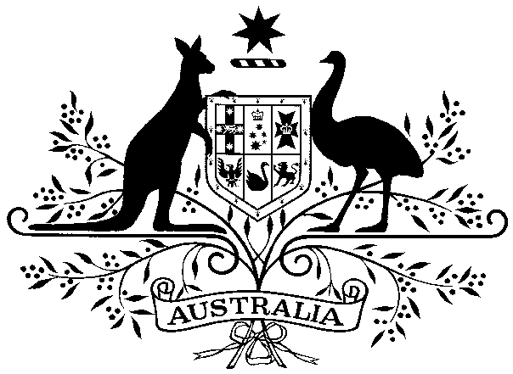
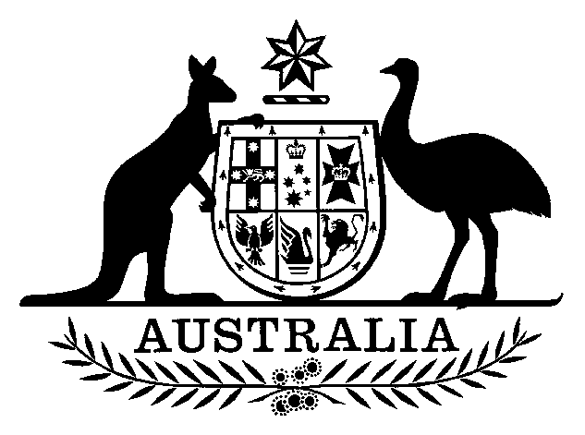

The Australian Government logo uses a variation of the conventional version. Graphic quality images of these versions of the Arms (and variations) can be obtained from the Honours and Symbols Section (see Section 1.2 for contact information).

Official Uses

General usage
The Commonwealth Coat of Arms is used by Australian Government departments and agencies, statutory and non-statutory authorities, the Parliament and Commonwealth courts and tribunals.
Senators and Federal Members of Parliament may use the Arms in the course of their duties as Parliamentarians.
The Arms may be used on Australian currency and coinage and as an element on the insignia of Australian honours.
The Commonwealth Coat of Arms is incorporated into the logos of Australian Government departments and agencies subject to the Australian Government’s branding policy, unless an exemption has been granted by the minister responsible for the branding policy.
The Arms may be used on products including: stationery; documents and publication; websites; signage; and staff ID cards.
As an important and unique symbol, the Arms should be used with dignity and respect, in particular:
- The Arms must not be used with political logos
- The dignity of the Arms should not be compromised by any adjacent signs or features
- The Arms should not be used as decorative or artistic element
- The Arms should not be overprinted with words or images
For further information please refer to the Australian Government Branding – Guidelines on use of the Australian Government Logo for Departments and Agencies available at https://www.pmc.gov.au/publications/australian-government-branding-guidelines

Size and colour
The minimum width of the Arms on stationery and larger items should be 20mm.
On items such as name badges and identity cards where it may not be possible to adhere to this, the Arms may be altered in width, but must remain recognisable.
The conventional and stylised versions of the Arms should be reproduced in single colour only, not full colour, but may be reproduced in colours other than black on white. The use of colour should not compromise the dignity of the Arms.
The Arms should not appear in a pastel or light colour on a light background colour, as a dark colour on a dark background or as a tint or stipple of any colour.
Use of a black on white Arms on a particular product does not preclude the use of the Arms in a different colour palette on other products.
The stylised version lends itself to reproduction in metal coloured inks used on formal stationery.

Placement on official documents and publications
The Arms should appear only once in a document.
The Arms should always have prominence over and above other images and graphic elements. Where possible, the Arms should be placed at the top of the item it appears on and other logos, text or images should not be placed above or to the left of the logo.
The Arms should not be overprinted with words or images.
The Arms should not be used as decorative or artistic element or as a watermark, for example, in a publication, display or presentation.
For brochures and transitory communications such as television and print advertisements, the Arms may be placed elsewhere as appropriate.
Certain documents need not require the Arms.
- Stationery, forms and printed matter for use within departments or agencies.
- Documents or promotional material co-authored jointly by the Commonwealth with another state or territory government. However with agreement of all governments in the joint project, the Arms of all participants may be displayed in the documents.
- Documents intended for a foreign audience presenting a whole of Australia view.
- Documents and stationery of Commonwealth trading enterprises must not use the Arms on material used when functioning in the marketplace.
Private persons acting as the agents of the Commonwealth may use the Arms only if authorised.
The Arms must not be used on material with political logos.

Use in electronic media
Electronic media published by or on behalf of the Commonwealth should carry an image of the Arms to indicate the authority and source of the information. The Arms should be prominently located and reproduced accurately and in a size that enables it to be clearly identifiable. The guidelines for positioning the Arms in the place of prominence apply to electronic documents such as web pages.
For further information regarding Australian Government website branding please refer to the Australian Government Branding – Guidelines on use of the Australian Government Logo for Departments and Agencies available at
https://www.pmc.gov.au/publications/australian-government-branding-guidelines

Use on or in buildings
The Arms may be placed in a prominent position on the facades of buildings occupied by departments or agencies provided the dignity of the Arms is not compromised by any adjacent signs or features.
The Arms may be displayed on the external facades of buildings occupied by Commonwealth departments and agencies whether owned or leased. The Arms may also be displayed indoors. Where a building incorporates the Arms on its facade, forming an integral part of the building, the Arms can be retained on vacating the building. Similarly, pre-existing Arms forming part of the fabric of a building can be retained on occupancy.

Use on uniforms
The Arms may be used on the uniforms of members of the Australian Defence Force and other Commonwealth agencies. The name of the agency should appear under the Arms.
The Arms may be embroidered directly onto the uniform, on patches sewn to the cloth or in the form of metal badges or nameplates.

Use with the Australian National Flag
The Australian National Flag and the Arms may be used together, with the position of prominence taken by the Arms.

Unauthorised use
Use of the Commonwealth Coat of Arms without permission may breach the Competition and Consumer Act 2010, the Trade Marks Act 1995 or the Criminal Code Act 1995. Applications for permission to use the Arms outside the authorised uses detailed in these guidelines should be directed to the Honours and Symbols Section.
Importation of goods bearing the Commonwealth Coat of Arms is prohibited under the Customs (Prohibited Imports) Regulations 1956. The Honours and Symbols Section considers requests to import such goods and permission is generally only granted to those authorised to use the Arms, for example, Australian Government departments and agencies.

Use by Sporting Bodies
Australian representative national sporting teams participating in international competitions may seek the Australian Government’s permission to display the Arms on their uniforms. Requests should be directed to the Honours and Symbols Section in writing by an authorised officer of the team and include:
- the name of the team, and
- the location, dates and the name of the competition.
Only teams recognised by the Australian Sports Commission may be permitted to use the Arms or where, after consultation with the Commission, the Minister or their delegate is satisfied that it is appropriate for a team to receive permission.
Permission, where granted, will allow the Arms to be displayed by representative sports persons on their playing and dress uniforms and by accompanying officials on their dress uniforms. Permission will not extend to use on merchandise and sponsors material.
Each approval is for one competition only. However, approval may be given for more than one competition where competitions of a like kind occur within a short period of time or sequentially within a given overseas tour.
Each request will be dealt with on a case by case basis and requests will usually only be considered within four months of the commencement date of the competition.
Should approval be granted, the name and the dates of the competition must be shown immediately under the Arms on the dress and playing uniforms. No advertising material or sponsorship is to be positioned near the Arms and no words or images are to be positioned above the Arms.

Use in Educational Publications
Publishers may seek permission to reproduce the 1908 and 1912 Arms in educational publications and media. Requests are considered on a case by case basis. Requests should be directed to the Honours and Symbols Section and include the text and illustrations accompanying the depiction of the Arms. These must be sighted before permission can be granted.
The publisher is required to place the following words at the end of the text: “Permission to reproduce the Commonwealth Coat of Arms granted by the Department of the Prime Minister and Cabinet”.
No material should be placed above or near the Arms in a way which diminishes its dignity.
The Arms must not be produced on the cover or dust jacket of a book or shown in a way which might lead a reader to believe that the material is of Australian Government origin or has Australian Government endorsement.

