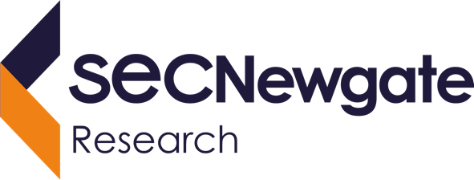

23 August 2024

Prepared for the Department of the   
Prime Minister and Cabinet

COVID-19 Response Inquiry Community Input Survey:  
FINAL REPORT



|  |  |  |  |  |  |
| --- | --- | --- | --- | --- | --- |
| **Prepared for:**    **Michael Carter** **E** COVID-19InquiryTaskforce@pmc.gov.au | **Prepared by:**   |  | | --- | | **Dr. Benjamin Wegener** Partner **E** benjamin.wegener@secnewgate.com.au  **T** 0432 722 893 | | **Dr. David Stolper** Partner  **E** david.stolper@secnewgate.com.au  **T** 0422 472 596 | | **Jasmine Hoye** Partner  **E** jasmine.hoye@secnewgate.com.au  **T** 0419 886 998 | | **Yoko Di Benedetto** Senior Research Executive  **E** yoko.dibenedetto@secnewgate.com.au  **T** 0458 097 955 | |

|  |
| --- |
| **DISCLAIMER** In preparing this report we have presented and interpreted information that we believe to be relevant for completing the agreed task in a professional manner. It is important to understand that we have sought to ensure the accuracy of all the information incorporated into this report. Where we have made assumptions as a part of interpreting the data in this report, we have sought to make those assumptions clear. Similarly, we have sought to make clear where we are expressing our professional opinion rather than reporting findings. Please ensure that you take these assumptions into account when using this report as the basis for any decision-making. This project was conducted in accordance with AS: ISO20252:2019 guidelines, to which SEC Newgate Research is accredited. This document is commercial-in-confidence; the recipient agrees to hold all information presented within as confidential and agrees not to use or disclose, or allow the use or disclosure of the said information to unauthorised parties, directly or indirectly, without prior written consent. Our methodology is copyright to SEC Newgate Research, 2024.  Logo  Description automatically generatedText  Description automatically generated with medium confidenceGraphical user interface, text, application, chat or text message  Description automatically generatedText  Description automatically generated with medium confidenceA black and white sign  Description automatically generated with low confidence |

Contents

Executive Summary 1

Introduction 6

Research Methodology 8

Pandemic experiences and perceived government performance 9

Information needs 26

Future preparedness, compliance and trust 35

Looking deeper: understanding the key attitudinal segments of the community 43

Appendix 67

Executive Summary

Introduction

The Department of the Prime Minister and Cabinet commissioned SEC Newgate Research to conduct this Community Input Survey for its COVID-19 Response Inquiry (the Inquiry). The 18-minute survey was conducted in June 2024 via online panel with a nationally representative sample of n=2,126 members of the Australian population aged 18+. The Inquiry’s independent panel will use the findings in its deliberations and preparation of its final report due to the Prime Minister by the end of September.

Personal experiences of the pandemic

On balance, the pandemic had a negative impact on the majority of Australians (61% very or somewhat negative), while 13% said it positively affected their lives overall. The most negative specific impacts related to the impact on people’s social interactions with friends (68% negative), their children's education (67%), and social interactions with family (57%).

Results from statistical modelling showed that the strongest drivers of how people assessed their overall pandemic experience were:

1. How it affected their mental health – this accounted for 35% of the total relative impact on people’s overall experience and more than half (54%) reporting negative effects on their mental health.
2. How it affected people’s financial situation, with an impact score of 22%, and 43% reporting a negative effect on their finances.
3. How the pandemic affected social interactions with friends, with an impact score of 17%.

These top three factors combined accounted for most (74%) of what influenced people’s overall pandemic experience, with the other aspects measured being much less influential by comparison.

At the overall pandemic experience level (i.e. whether the pandemic had a positive or negative effect on people’s lives) there were very few significant differences by gender, age or by location.

However, some demographic differences are evident when considering specific aspects of people’s experience. In this regard, we found that the groups that experienced more negative effects included those who: are living with disability, have dependent children, live regionally and/or in Victoria, and younger people.

Views on the Australian Federal Government’s response

Although there was noticeable confusion around what particular actions were taken by Federal vs State or Territory Governments at the time, when asked to specifically rate the Federal Government’s performance in responding to the pandemic, public sentiment is mixed – while nearly half (47%) felt it did at least a good job, 53% rated it as either ‘fair’ (29%) or ‘poor/’very poor’ (24%).

This retrospective view of Government performance is significantly weaker than that recorded in a similar question during the height of the pandemic (February 2021); SEC Newgate’s *‘Community Attitudes to Coronavirus’* study found that 56% rated government performance as ‘good’ or better at the time and 18% gave a ‘poor’ rating. This suggests that, with the benefit of hindsight, people can identify more things that could have been done better.

In total, just over half of all those surveyed felt the Federal Government’s response during the pandemic was appropriate (54%), while a reasonably large proportion thought that it overreacted (29%) and only a small minority thought it underreacted (16%).

People now have fairly low levels of trust in the Federal Government to have done the right thing during the height of the pandemic. Only three in ten (30%) said they had complete or high trust in it, and a similar proportion (32%) felt they had low or no trust at all. Amongst other key institutions:

* Trust in State or Territory government fared little better with 37% having complete/high trust.
* Nearly half (48%) said they had low or no trust in mainstream media during the height of the pandemic – an important finding given the majority used it as a key information source at the time.

In terms of specific information sources, people placed their highest trust at the time in the information from the Chief Medical Officer (69% considered it ‘very’ or ‘somewhat’ trustworthy) and State Government press conferences (64%).

### What do Australians think the Government did well?

When asked an *unprompted* question on what they thought the Australian Federal Government did particularly well in responding to COVID-19 and managing its impacts, the top, coded response theme was about keeping people informed (17% mentioned this), though the next most common response was ‘nothing’ (16%). This was followed by views that the lockdowns were run well and ‘not too long’ (12%) – perhaps highlighting a degree of confusion about what the Federal Government was responsible for versus the states and territories.

When asked to rate specific aspects of Government performance, the top five highest rated aspects were:

1. Communicating what people needed to do to keep “COVID-safe” (65% net good/very good/excellent, with a positive ‘net performance score’ of +31% - which is the net proportion who rated this good or better minus those who gave lower ratings of fair, poor or very poor);
2. Its COVID safety measures such as mask wearing, QR check-ins, contact tracing etc (+19% net performance score);
3. Its approach to international border closures (+13% performance score);
4. The delivery of the COVID vaccination program (+9%); and
5. The overall response of the health system (+8%).

In relation to the information provided by Government during the height of the pandemic, the majority agreed it was ‘easy to access’ (77% net agree), ‘clear and easy to understand’ (73%), ‘up to date’ (73%), ‘provided useful health advice’ (72%) and ‘was helpful’ (71%). However, most were more likely to ‘somewhat’ rather than ‘strongly’ agree on these dimensions, suggesting room for improving information provided.

The quality of specific communication topics rated highest in relation to: where people could get vaccinated (+46% net performance score), health restrictions and social distancing (+42%), the COVID-19 health risks (+39%) and lockdown requirements (+39%); positively, these were the very topics that were also most importance to people.

### What was the Government judged most harshly on?

The number one *unprompted* theme in what the Federal Government was seen to have done poorly related to the lockdowns being unnecessary, too harsh or too long (15% mentioned this), followed by information being seen as unclear or even false (11%).

Although reasonably high numbers of survey participants were unsure of the Government’s support for people in vulnerable situations, those who *were* able to provide ratings were the most scathing of how the Federal Government supported:

* People experiencing homelessness or housing insecurity (a net performance score of -44%);
* Those experiencing family or domestic violence (-44%);
* People with disabilities (-25%);
* Regional, rural and remote Australia (-25%);
* Australia’s First Nations peoples (-15%); and
* People from culturally diverse or non-English speaking backgrounds (-15%).

While the majority (58%) agreed the Government’s coronavirus restrictions were generally ‘fair and reasonable’, only 16% agreed *strongly* with this, and this overall agreement is significantly lower than what was measured in SEC Newgate’s tracker during the pandemic (e.g. 76% agreement in February 2021). Further, in this year’s survey 52% agreed the coronavirus restrictions made their day-to-day life very difficult. The hotel quarantine program was also a prominent sore point for many, which only 32% agreed the Government did a good job of managing, while 43% disagreed.

Even though 44% thought the Government did well (net good or better) in coordinating efforts with State and Territory Governments (e.g. via the National Cabinet), it was also among the lowest rated aspects, with a net performance score of -12%.

In terms of providing specific types of information, ratings were the weakest in communicating:

* The reasons for different rules and restrictions across different regions (a net performance score of +11%);
* Educational arrangements for children (+12%);
* The safety and efficacy of the vaccine (+12%);
* The support services that were available (+15%); and
* Exemptions to public health rules and travel restrictions (+16%).

### Community Segmentation of the Australian public

To better understand pandemic experiences across the community we undertook a statistical segmentation analysis to identify distinct groups of people who are the most like one another in relation to their pandemic experience. This analysis revealed four distinct groups in the Australian population that were defined by: their pandemic experiences, their views on how the government responded, and their perspectives on a future pandemic situation.

Interestingly, and unusually for a segmentation analyses, we found that these groups are not strongly defined by their demographic circumstances and instead appear to be defined by their world views, values and ideologies. As such, it seems that values-based factors (rather than simple demographics) are most important in forming attitudes to both government performance and pandemic management approaches.

The four groups are shown in the image on the following page, and we have given them names to characterise their perspective on the situation.

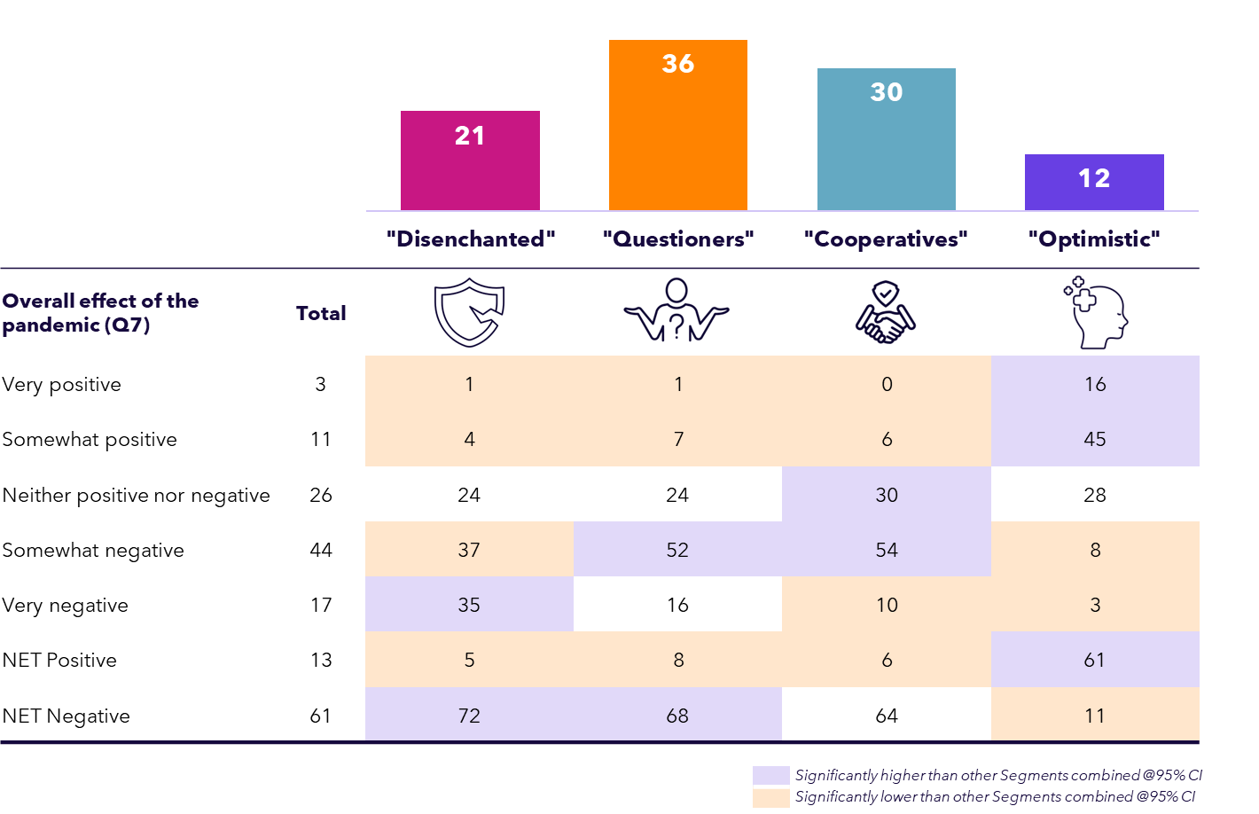

The main section of this report provides detailed results, but amongst interesting findings we found that:

**‘Disenchanted’** (21% of those surveyed) had the worst experience of the pandemic by far and were around three times more likely than others to say it had a *very* negative effect on their lives. Just 11% of the Disenchanted rated Government performance as ‘good’ or better.

**‘Questioners’** (36% of people) Their assessment of the pandemic was most strongly based on the health system’s response and the Government’s role in communicating border closures. The largest of the segments, their overall experience was most strongly driven by concerns over their mental health, financial situation and social interactions with friends.

**‘Cooperatives’** (30%). The use of COVID safety measures (e.g. masks, QR check-ins) had the biggest impact on their ratings of Government performance (29% impact). Although most had a negative pandemic experience overall, they gave relatively high ratings of the Australian Government’s response and were the most trusting of it among all segments by far (67% having complete or high trust in the Federal Government during the pandemic).

**‘Optimistic’** (12%) had a very different experience – 61% of whom reported a net *positive* impact from the pandemic on their lives, compared with just 7% of all others surveyed. Government performance rose to 81% among this segment.

Looking to the future

If there was another public health emergency like COVID-19 in the future, the majority of those surveyed agreed the Government will: ‘*have learnt the lessons from COVID-19*’ (65%), say they would ‘*trust the Government to respond appropriately’* (58%), and that it will *‘be well prepared’* (54%).

However, they weren’t so convinced the Australian public will follow Government advice and directions, (only 47% agreed while 30% disagreed). When it comes to how likely people thought they would be to follow Government directions in a similar future scenario we found that:

* Most (86%) thought they would stay home if unwell, but only 62% said they ‘*definitely’* would.
* Similarly, 80% thought they would stay home if directed to lock down but only 56% said ‘*definitely’*.

And importantly, of all the potential directives asked about, only 41% of those surveyed said they would ‘*definitely’* get a vaccine offered by the government in a future health emergency, while one in five (21%) said they *‘probably’* or *‘definitely’* wouldn’t get a vaccine. Combined with relatively low trust levels, potentially suggesting the community’s response to Federal Government directions may be less cooperative the next time around.

Highlighting the importance of good communication, the top three things people thought would make them more likely to comply with restrictions in future were 1) a clear rationale of why, 2) clear and easy to understand information about what they need to do, and 3) a belief that any restrictions are justified. The community’s strongest advice to Government was to provide good information and to learn from what happened, with less use of aggressive lockdowns, and better financial support.

--

*“When society was opening back up post-COVID, many people were left vulnerable and many died, including a relative. Restrictions should be slowly dismantled instead of everything opened up instantly. People should also be protected more during this period, especially vulnerable people.”*

*“The enforceable actions of mandatory vaccinations when there was not enough sufficient testing on the implications was a disaster that now has serious consequences. If in future there is a pandemic, forcing everyday people including pregnant women to have a vaccination that wasn't researched enough and forcing them to lose their babies is insane. Focusing on safety measures is probably a better measure than anything else.”*

*“Don't lock people up like they are lab rats! People lost precious time due to the stupid lock downs and time that we can't ever get back, and we got no compensation at all from it.”*

*“Don't lie to the Australian public, don't deceive us.   
You will have more sheep to follow you if you are truthful.”*

*“Be more proactive to support ALL of Australia not just certain parts/people.   
Don't scare people; that was a huge thing that happened, and it made it worse.”*

Introduction

Background & Objectives

**On 21 September 2023, Prime Minister Anthony Albanese announced the Commonwealth Government’s COVID-19 Response Inquiry (the Inquiry) to identify lessons learned and improve Australia’s preparedness for future pandemics. ​**

## The Inquiry’s Independent Panel is reviewing the Commonwealth Government’s health and non-health responses to the COVID-19 pandemic, and making recommendations to improve response measures in the event of future pandemics.

## Applying a ‘whole-of-government’ approach, the Inquiry’s Terms of Reference detail a broad remit looking not only at the role of governance at Commonwealth, State and Territory levels (and their associated health measures and international policies), but also the supports in place for communities, particular populations within those communities, and business and industry. ​

## Alongside the public submissions process, the Inquiry’s Taskforce sought a complementary evidence base of insights through a robust survey with a demographically representative sample of Australians.

## In March 2020, SEC Newgate launched a nationally representative tracking survey of the lived experiences of Australians throughout the pandemic, titled ‘Community Attitudes to Coronavirus’. This evolved into an in-depth series of 45 waves of weekly or fortnightly reports produced throughout this period, which have been shared with the Inquiry’s Taskforce as a supplementary data set.

## In May 2024 SEC Newgate Research was commissioned to conduct this survey for the Inquiry. Of particular use was SEC Newgate’s extensive work in the area of tracking the effects of the pandemic during its peak years in Australia – relevant findings from that study are also provided throughout this report for context.

Research Objectives

The broad objectives of the National Community Input Survey for the Inquiry were to measure:

* Public sentiment towards pandemic management approaches;​
* The effectiveness of public communications during the pandemic; and
* How public sentiment may inform future public responses.​

The findings on the incidence, direction and intensity of public perception will be used to assist the Commonwealth Government to identify opportunities for systemic change to better anticipate, adapt and respond to future pandemics. ​

Specific lines of enquiry in the survey were to measure and understand:

* People’s overall experience of the pandemic and the effects it had on various aspects of their lives;
* Views on the Australian Federal Government’s performance in responding to the COVID-19 pandemic and managing the impacts;
* Information sources and topics of importance to people during the height of the pandemic in 2020-21, along with perceptions of the information and sources used, and sources people anticipate they would use in a similar future health emergency;
* Awareness and receipt of government payments during the pandemic;
* Perceptions of how different parties might respond in a similar future health emergency, including survey participants themselves;
* The public’s advice to Government should a similar situation occur again; and
* How the findings differed by demographics, with particular interest in the following priority groups: Culturally and Linguistically Diverse (CaLD) participants, people with disability and those from a First Nations background.

SEC Newgate was also commissioned to undertake advanced analyses including formal segmentation to identify and understand different cohorts within the community; driver analyses to understand the relative importance of different factors affecting people’s experiences and views; and comparisons of relevant findings against the *Community Attitudes to Coronavirus* survey.

Research Methodology

The survey results are based on a robust, nationally representative online survey of n=2,126 Australian residents aged 18+. This fieldwork took place between 12th – 25th June 2024. Survey participants were sourced via accredited fieldwork supplier Octopus Group. In addition to the final sample closely reflecting the demographic target quotas, the final data set was weighted to correct for sampling bias – see Appendix 1 for the final sample profile.

The quotas were set based on population characteristics according to the ABS’ 2021 Census to ensure a representative, best-practice national sample involving:

* + - * Separate quotas for each state
      * Separate quotas for metro and regional locations within each state
      * Interlocked aged and gender quotas for each state.

Additionally, a targeted boost sampling method was applied to achieve a robust sample of n=200 First Nations participants, which was weighted to a representative level when reporting on national results.

We also captured in the natural sampling fallout those who self-identified as having a disability (n=184), and those classified as having a culturally and linguistically diverse (CALD) background (n=444 in total, with n=103 from non-English speaking backgrounds and the remainder being English-speaking but born overseas).

The robust sample size of n=2,126 is associated with a margin of error of +/- 2.1 (at an industry standard 95% confidence interval) and it enables an accurate understanding of the attitudes of key segments of the Australian community.

The average survey length of 18 minutes allowed us to cover the topic in detail while also maintaining participant engagement to ensure high-quality data.

The questionnaire included a mix of closed-ended and open-ended questions, with closed-end questions being either 5 or 6 point Likert scale depending on requirements (e.g. Very poor, Poor, Fair, Good & Excellent, or Very negative, Somewhat negative, Neither positive nor negative, Somewhat positive & Very positive).

**Data analysis & weighting**

SEC Newgate’s data management processes ensure the survey data was appropriately processed, weighted and cleaned of redundant variables. Data weighting is a statistical process which adjusts the profile of a sample to align with known characteristics of a particular population (for example, the over-sampled First Nations cohort was subsequently weighted down to population proportions according to the most recent ABS Census). This ensures that the results of the survey are as representative as possible of the population at large. The key characteristics of age, sex, location and highest level of education completed have been used for weighting – all key factors in shaping behaviour and attitudes of the public.

Personal impacts from the COVID pandemic

The majority of Australians felt the pandemic negatively affected their lives in a range of ways – especially in social interactions (68% saying it had a negative impact), their children's education (67%) and wellbeing (53%), and their own mental health (54%), yet close to one in six reported positive effects. Opinions were quite divided on whether the pandemic improved people’s trust in science with 35% feeling it had a positive effect and 32% feeling it was detrimental.

*Q7. Overall, what effect did the COVID pandemic have on your life?*

*Q8. What effect did the COVID-19 pandemic have on the following aspects of your life?*

*Base: All participants (n=2,126)*

*\*Asked only those who had any dependent children aged 18 or under living together in 2020 or 2021 (n=732)*

**Impacts of COVID pandemic on your life (%)**

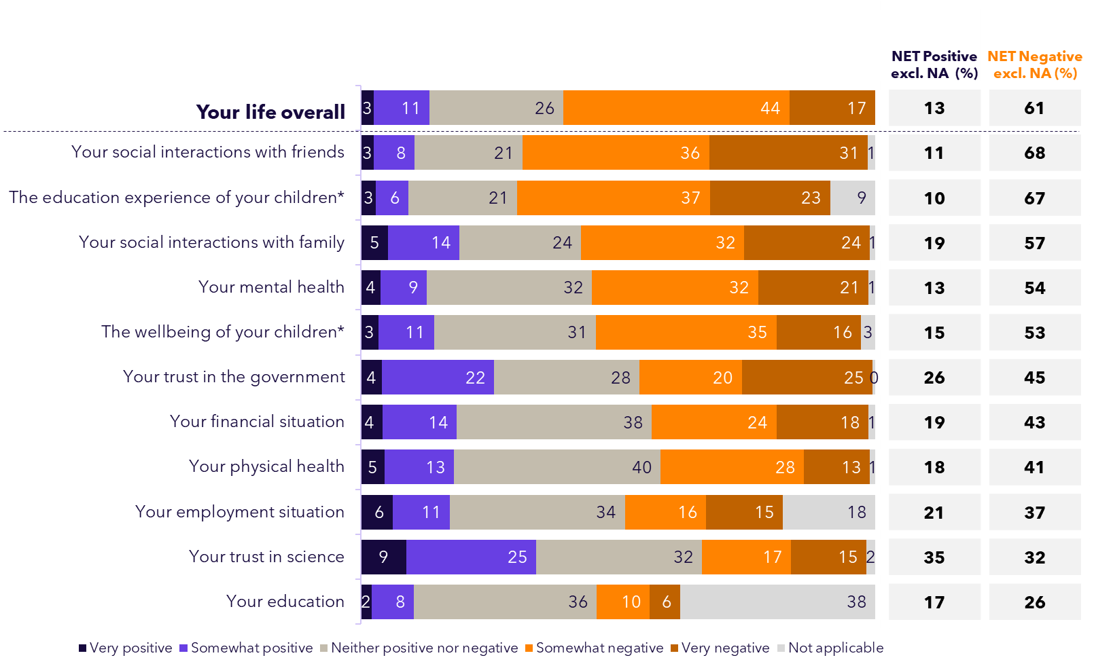

These broad and largely negative impacts of the pandemic were shared across the population, with detailed demographic breakdowns provided on the following page, as well as in the Appendix to this report.

Unpacking who reported more negative effects

The pandemic affected the community in many different ways, with a range of negative impacts more likely to be reported by those with a disability, those with dependent children, regional dwellers and Victorians.

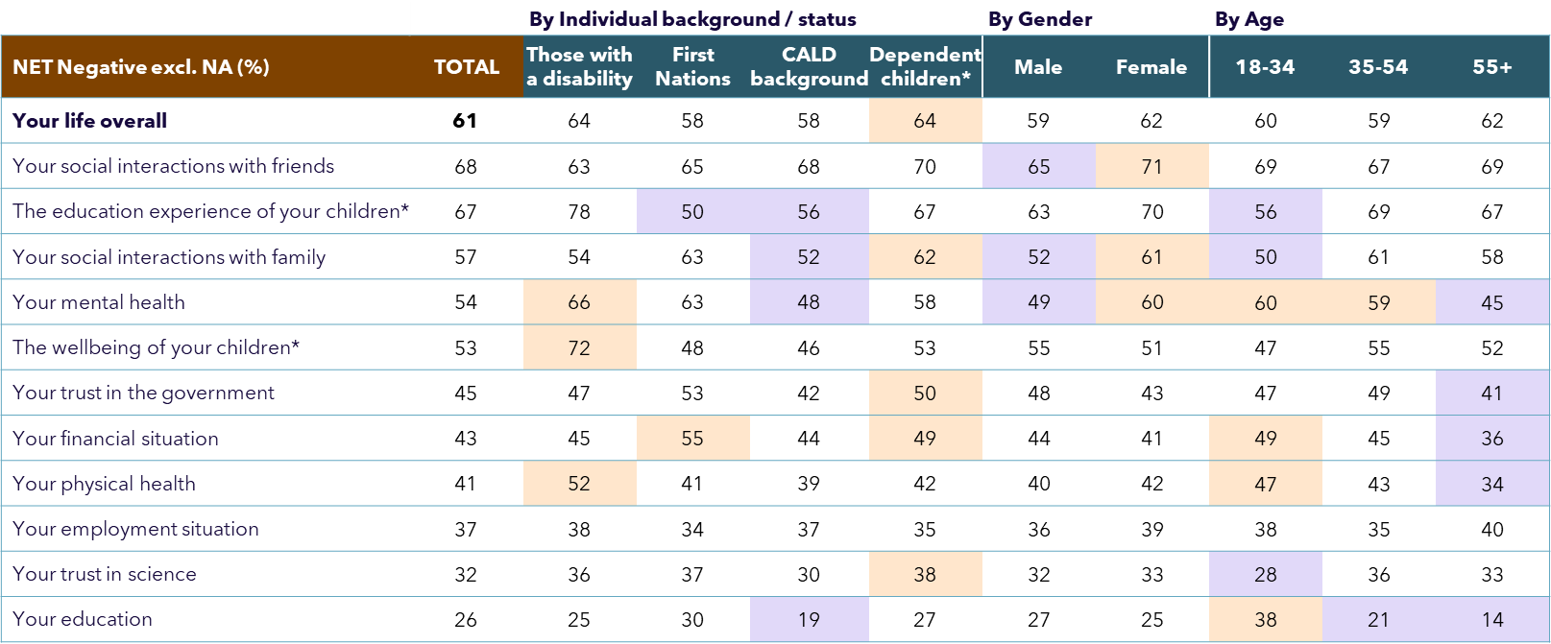

*Q7. Overall, what effect did the COVID pandemic have on your life?*

*Q8. What effect did the COVID-19 pandemic have on the following aspects of your life?*

*Base: All participants (n=2,126)*

*\*Only those who had any dependent children aged 18 or under living together in 2020 or 2021*

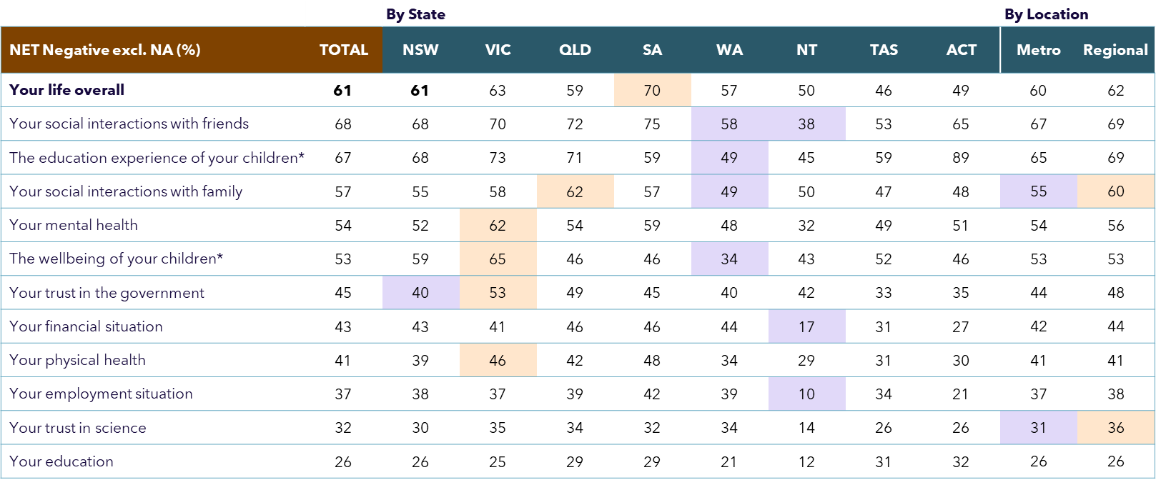

****Those with a disability, who had dependent children living with them at the time, and those living in Victoria had particularly negative experiences on a range of factors.

Drivers of the overall experience of the pandemic

Statistical modelling was undertaken to understand the relative impact of specific attributes in driving people’s overall experience of the pandemic. Results are shown below, alongside the NET positive and negative scores. The higher the Impact Score from the modelling, the stronger the attribute was in driving people’s overall pandemic experience.

Results show that impacts on mental health (35%) and people’s financial situation (22%) had the strongest influences on people’s overall pandemic experience, closely followed by their social interactions with friends (17%).

**Modelled relative impact of different factors on people’s overall experience   
of the COVID pandemic**

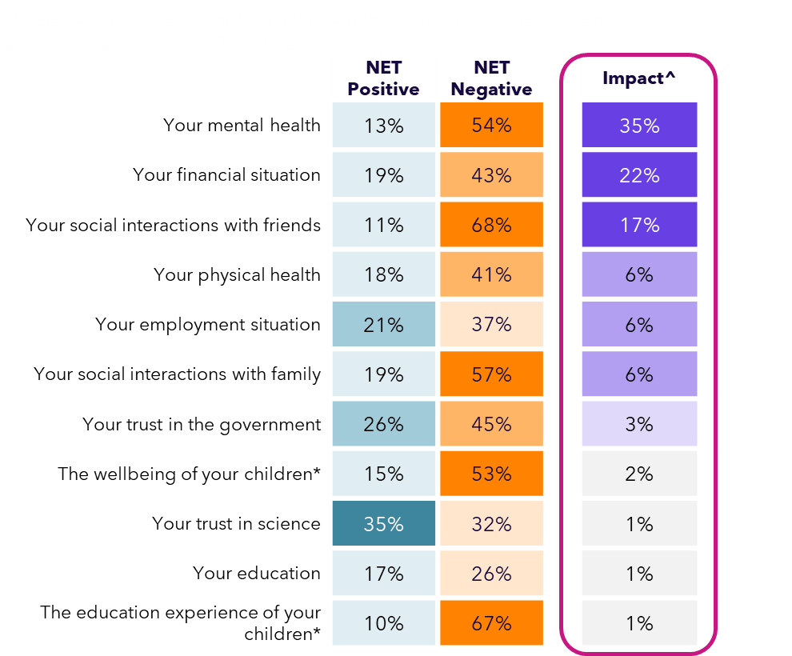

*Q7. Overall, what effect did the COVID pandemic have on your life? vs. Q8. What effect did the COVID-19 pandemic have on the following aspects of your life?*

*Base: All participants (n=2,126)*

*^Impact Score derived from driver modelling represents the weighted impact that each attribute from Q8 had on people’s overall experience at Q7 (all drivers included in the model sum to 100%).*

Overall views on the Federal Government’s response

Just under half (47%) felt the Federal Government did a good or better job in responding to COVID-19 and managing its impacts with experiences differing to some degree across key demographics. This was outweighed slightly by those who rated it as fair (29%) or poor/very poor (24%).

**Question preamble: “During the COVID-19 pandemic, the Australian Federal Government based in Canberra (including the Commonwealth elected leaders as well as the Federal public servants) had to respond to the situation and manage the health, social and economic impacts of COVID-19.**

The following questions will ask your opinion about the Federal Government’s performance at this time. Note that this does not include your opinion of the performance of State or Territory governments and public officials.”

**Rating the Australian Federal Government’s performance in responding to COVID-19 and managing its impacts (%)**

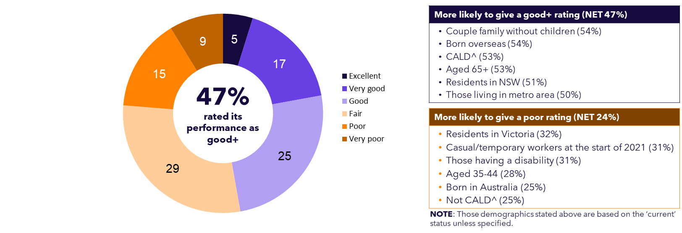

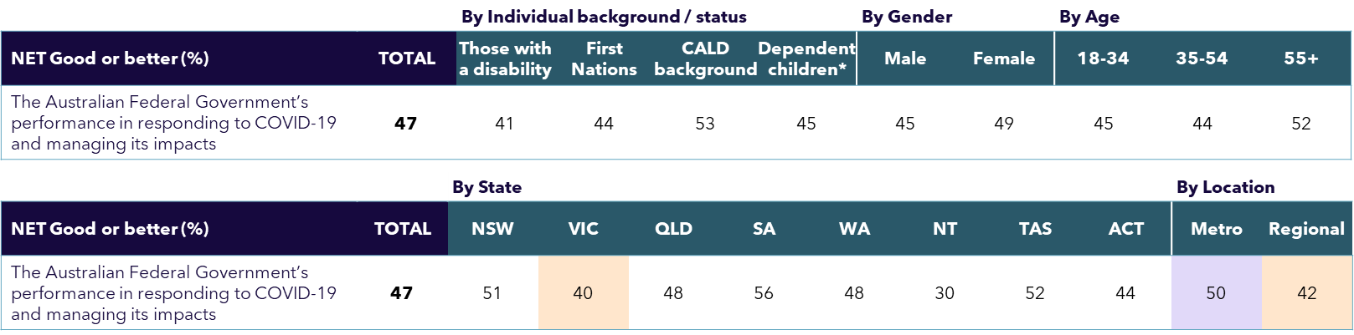

*Q9. Overall, how would you rate the Australian Federal Government’s performance in responding to COVID-19 and managing its impacts?*

*Base: All participants (n=2,126)*

*^Born overseas and/or prefer to speak a language other than English at home*

*\*Only those who had any dependent children aged 18 or under living together in 2020 or 2021*

*2020 – 2022 surveys vs now:   
Federal Government’s performance*

Ratings of the Federal Government’s response during the peak of the pandemic were significantly higher than the public’s current retrospect view (56% rated it as ‘good’ or better in February 2021 vs. 47% in this study).

**Rating of Federal Government performance during the peak of the pandemic (%)**

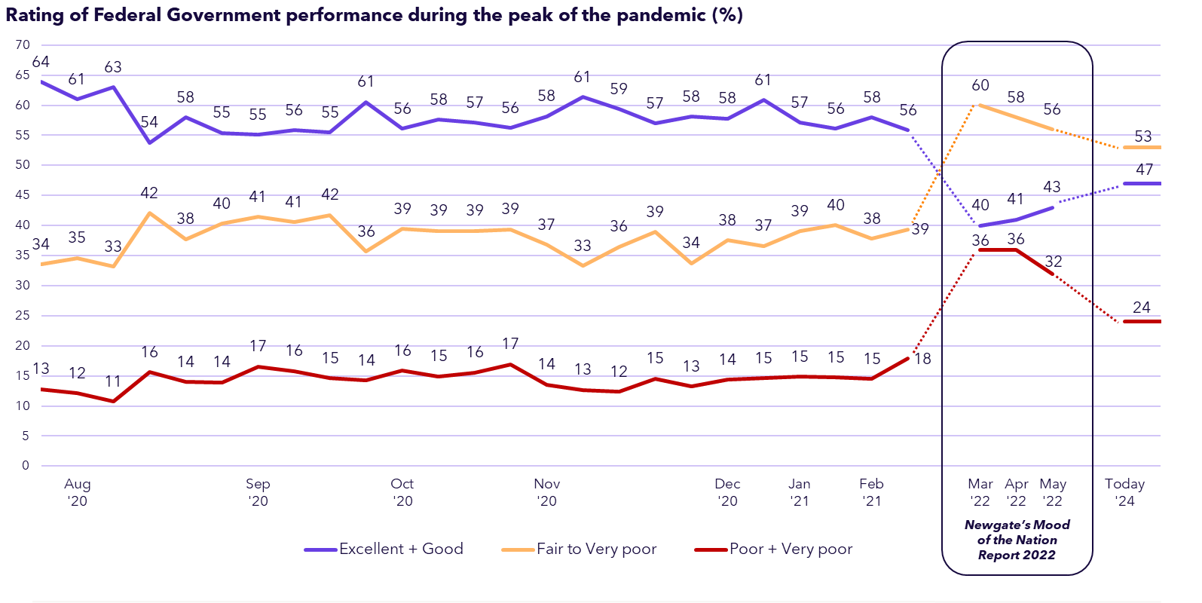

In a revealing comparison, the three broadly similar questions represented in the above figure show a significant negative shift in public perception of Government performance in managing the pandemic, with the final measure of 47% rating ‘good’ or better taken from this study.

At the peak of the pandemic (2020-2021), the clear majority of the public (~60%) was supportive of how Australia was managing the challenges at the time. However, as the crisis dragged on into 2022, this sentiment took a sharp downturn (with just 40% rating ‘good’ or better by May 2022). Now more than two years later and with the benefit of hindsight, we see a slight improvement on public perceptions (47%), although it is still less positive than during the pandemic.

***EXTERNAL DATA SOURCES:***

*Q13. How would you rate the performance of the following individuals and groups in responding to coronavirus and its associated effects? NB: Scale slightly different, did not include ‘very good’ rating point. // F3 (Mood of the Nation). How would you rate the performance of the Federal Government in managing COVID and its associated effects? Base: all participants: Wave 1 to Wave 45 (n=1,001-2,377), Mood of the Nation: Wave 1 (n=1,204), Wave 2 (n=1,401), Wave 3 (n=1,403)*

What the Federal Government did well

The top unprompted response as to what the Federal Government did well related to keeping people informed (17%), followed by 12% saying the lockdowns were well run, and that they did well in relation to containing the virus and closing borders. However, the second most frequent response to this question however was ‘nothing’ (16%).

*Q10. What, if anything, did the Australian Federal Government do particularly well when it came to responding to COVID-19 and managing its impacts?*

*Base: All participants randomly selected for coding (n=1,000) – i.e. all responses NOT coded*

*\*Responses <3% not shown*

**What the Government did well in responding to COVID-19 (Unprompted, Coded %)**

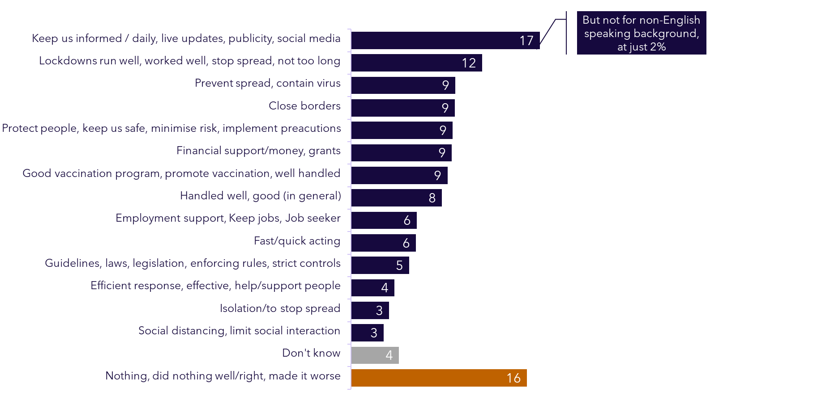

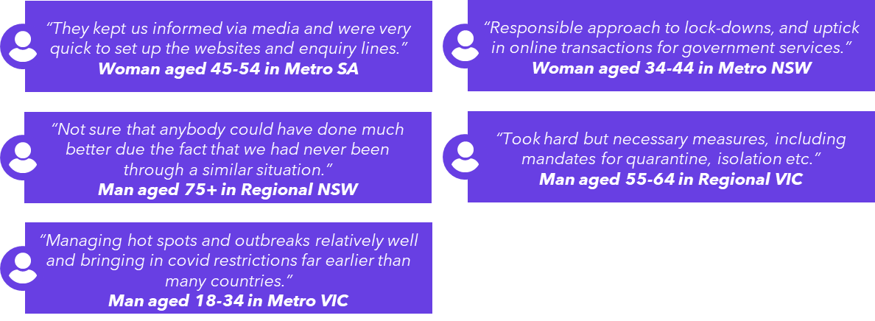

Perceived poor aspects of Government’s response

Unprompted themes in what the Federal Government was thought to have done poorly were more varied, topped by concerns about lockdowns and unclear or false information provision.

*Q11. And what, if anything, did the Australian Federal Government do poorly (or could have done better) when it came to responding to COVID-19 and managing its impacts?*

*Base: All participants randomly selected for coding (n=1,000) – i.e. all responses NOT coded*

*\*Responses <4% not shown*

**What the Government did poorly in responding to COVID-19 (Unprompted, Coded %)**

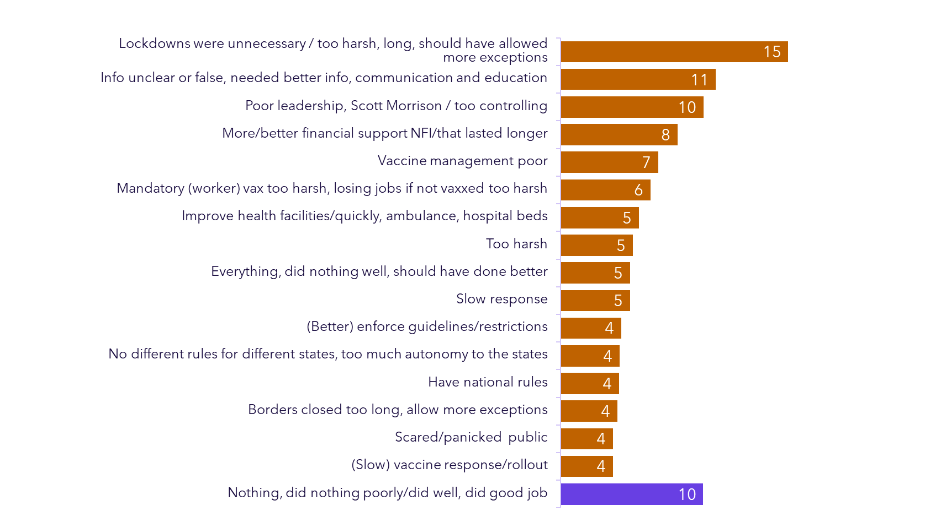

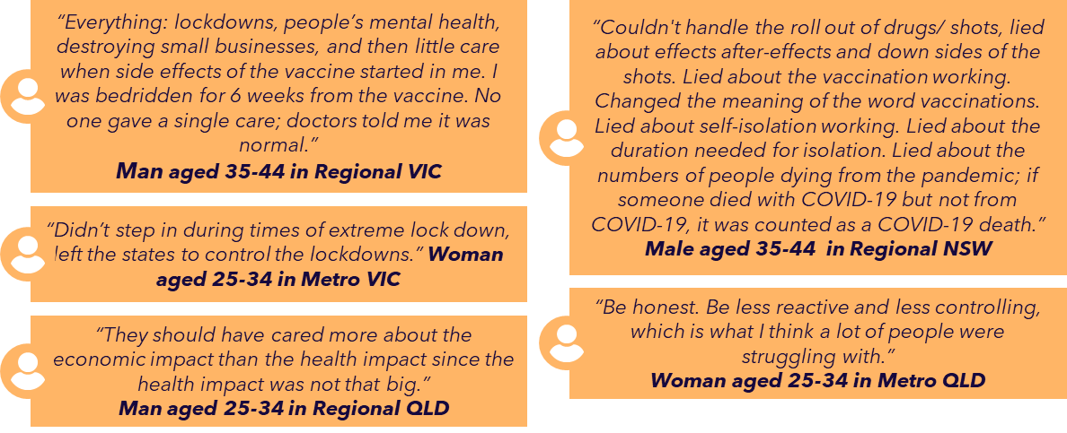

Did the Government overreact or underreact?

The majority felt the overall response from the Government at the time was appropriate (54%), or even an under-reaction (16%), while three in ten (29%) thought it had overreacted.

**View of the Australian Federal Government’s overall response   
in managing the pandemic at the time (%)**

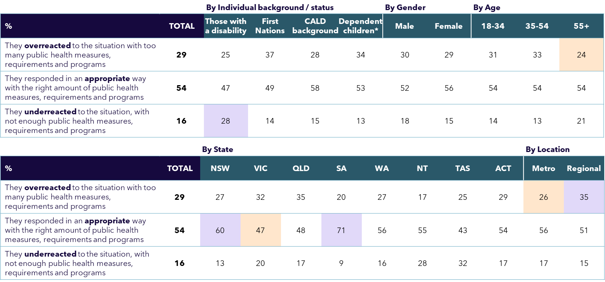

*Q12. Thinking back, what is your view of the Australian Federal Government’s overall response to the COVID-19 pandemic and its management of the situation at the time?*

*Base: All participants (n=2,126)*

*\*Only those who had any dependent children aged 18 or under living together in 2020 or 2021*

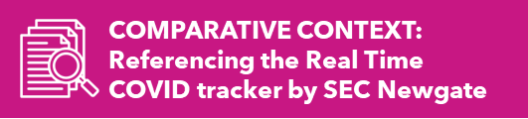

*2020 – 2021 SURVEY:   
Australia’s* overall reaction to coronavirus*

Views on the appropriateness of Australia’s reaction measured during the pandemic are very different to the retrospective view, with most (~70-80%) feeling it was appropriate at the time.

Although not a direct comparison due to slightly different question wording (with the question being “how would you rate the performance of Australia” compared to the current study which asked “what is your view of the Australian Federal Government’s overall response”), these results suggest that in hindsight many people are now much less convinced of the appropriateness of the Government’s response (just 54% feel the same today).

**Australia’s reaction to coronavirus %**

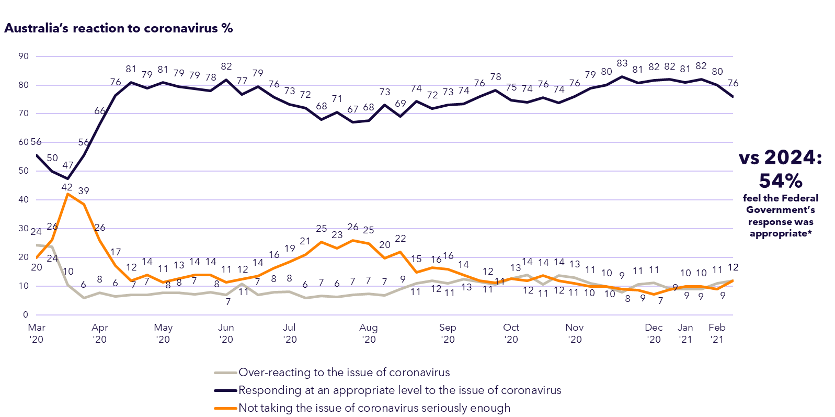

***EXTERNAL DATA SOURCES:***

*Q9. Overall, do you think that Australia is…?*

*\*NB: Was not specific to the Australian Federal Government. Indicative comparison only.*

*Base: all participants, Wave 1 to Wave 45 (n=1,001- 2,377)*

Federal Government’s performance on initiatives

On balance, Australians feel the Federal Government did best at communicating what needed to be done to be “COVID-safe”, its use of COVID safety measures and its approach to international border closures. It was considered to have fallen particularly short in supporting vulnerable Australians, including those experiencing domestic violence, homelessness, those with a disability and First Nations peoples.

*Q13. How well would you rate the performance of the Australian Federal Government on the following aspects of its COVID-19 response and management?*

*Base: All participants (n=2,126)*

**Rated performance of the Federal Government’s response and management (%)**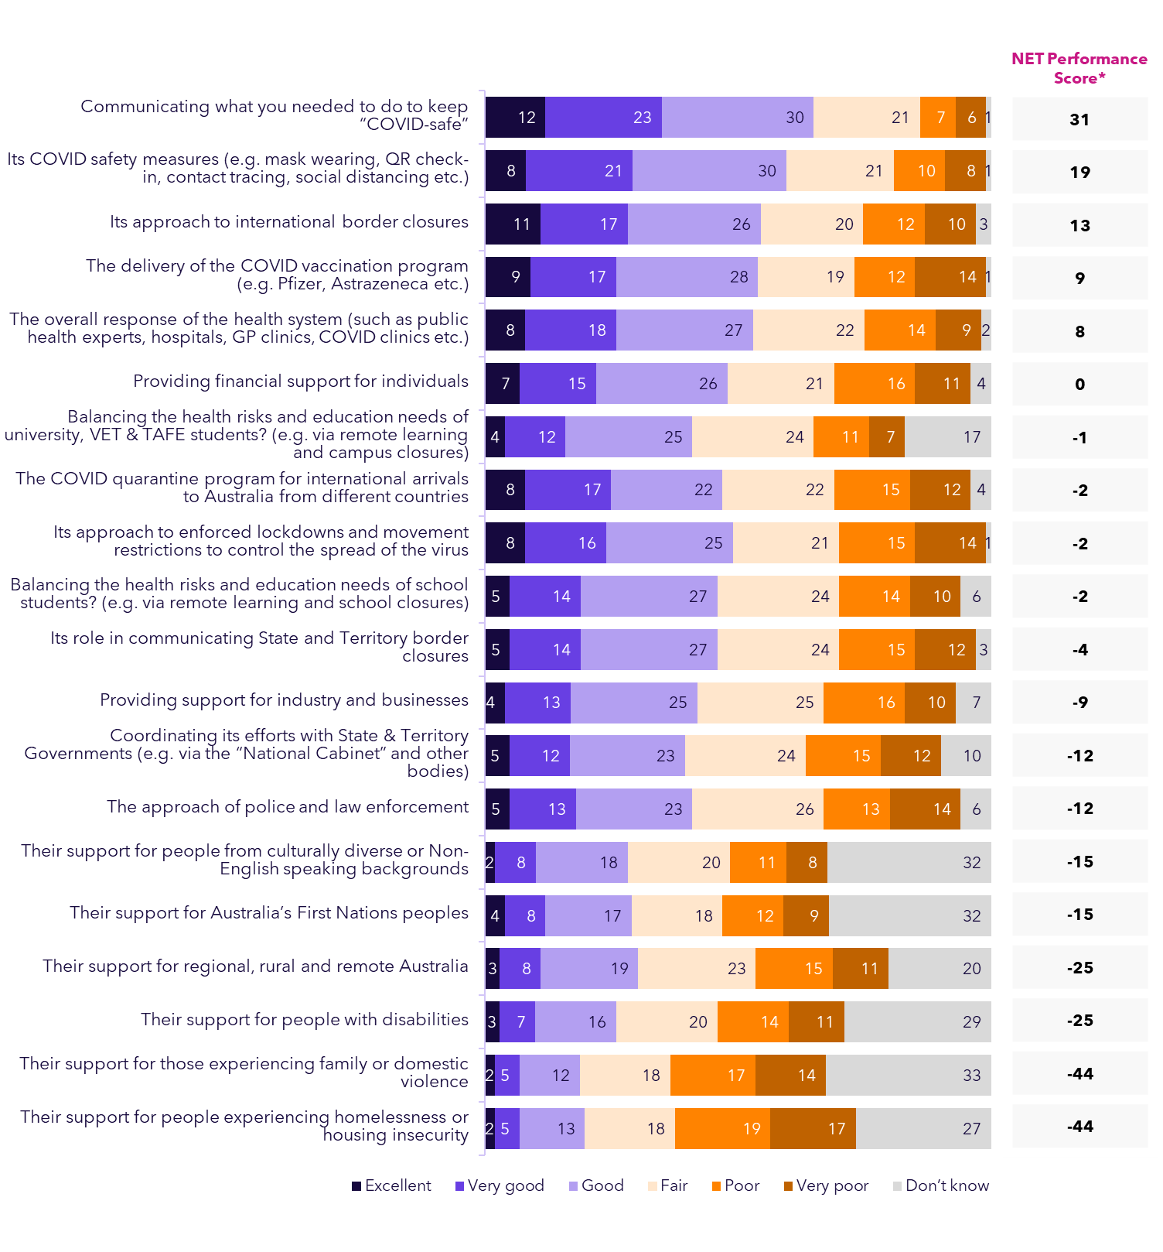



Drivers of views on Government’s performance

Modelling was undertaken to understand the relative impact of various government actions (Question 13) in driving people’s overall perception of Federal Government performance. The figure below shows these results, alongside the NET scores of ‘good’ or better, among those who provided ratings of each attribute. As with the previous driver modelling on overall experience, the higher the Impact Score from the modelling, the stronger the attribute was in driving overall perceptions of the Government’s performance.

Results show that views on the Government’s approach to lockdowns and restrictions to control the spread of the virus had the strongest on people’s overall ratings of Government performance (with an Impact Score of 23%), with the overall response of the health system being the second most influential (15%). How the Government was seen to have coordinated efforts with State and Territory Governments came in as the third strongest driver of overall ratings (9% Impact).

**Modelled relative impact of factors affecting views on   
the Australian Federal Government’s performance**

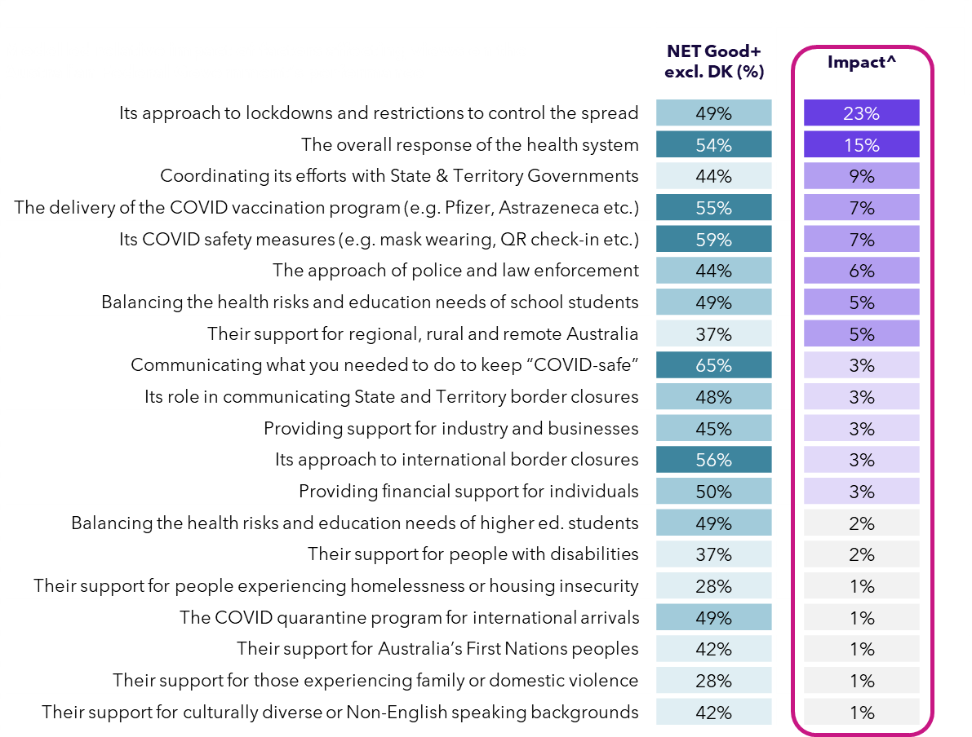

*Q9. Overall, how would you rate the Australian Federal Government’s performance in responding to COVID-19 and managing its impacts? vs. Q13. How well would you rate the performance of the Australian Federal Government on the following aspects of its COVID-19 response and management?*

*Base: All participants (n=2,126)*

*^Impact Score derived from driver modelling represents the weighted impact that each attribute has on overall perceptions of Federal Government performance in managing the pandemic (all drivers sum to 100).*

Opinion of Federal Government actions at the peak of COVID-19

Most felt they understood why they needed to adhere to the health rules, and that the Government made it clear what people needed to do and why, although only 40% agreed *strongly* with this. Similarly, while the majority (70%) agreed the Government clearly communicated what people needed to do, only 24% agreed strongly.

*Q14. Do you agree or disagree with the following statements about the Australian Federal Government’s handling of coronavirus at the peak of the pandemic (2020-2021)?*

*Base: All participants (n=2,126)*

Many were unconvinced about its initiatives to protect businesses (just 45% agreed it took appropriate measures on this front) or to protect those experiencing financial difficulties (49% agreed). Its performance in managing hotel quarantines was particularly poor, with 43% *disagreeing* it did a good job of this.

**Opinion towards Federal Government’s handling of coronavirus at the peak of pandemic (%)**

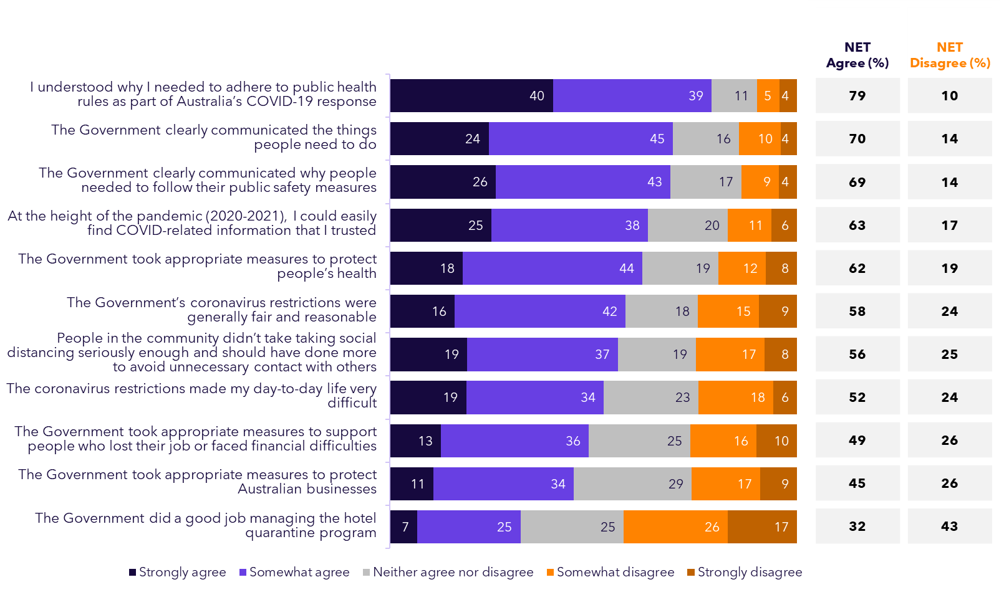

Of note in the above attributes, those with disabilities were significantly less likely to agree that Government provided appropriate support for those in financial difficulties (36%), and First Nations peoples were less likely to say they understood why they needed to adhere to public health rules (67%).

A number of these attributes were also asked during the peak of the pandemic as part of SEC Newgate’s coronavirus tracking study that ran through 2020 and 2021. These are provided for comparison on the following page.

*2020 – 2021 SURVEY:   
Government action & communications*

In hindsight, we can see significant declines in agreement with most of the statements that were also asked of the Australian public in 2020-2021 – especially in terms of the restrictions being fair and reasonable, which 76% agreed with in February 2021, compared with just 58% in this year’s survey. Similar drops were seen for Government taking appropriate measures to protect Australian businesses (an 11% point drop) and support people who lose their job or face financial difficulties (10% point drop).

**Strongly + somewhat agree %**

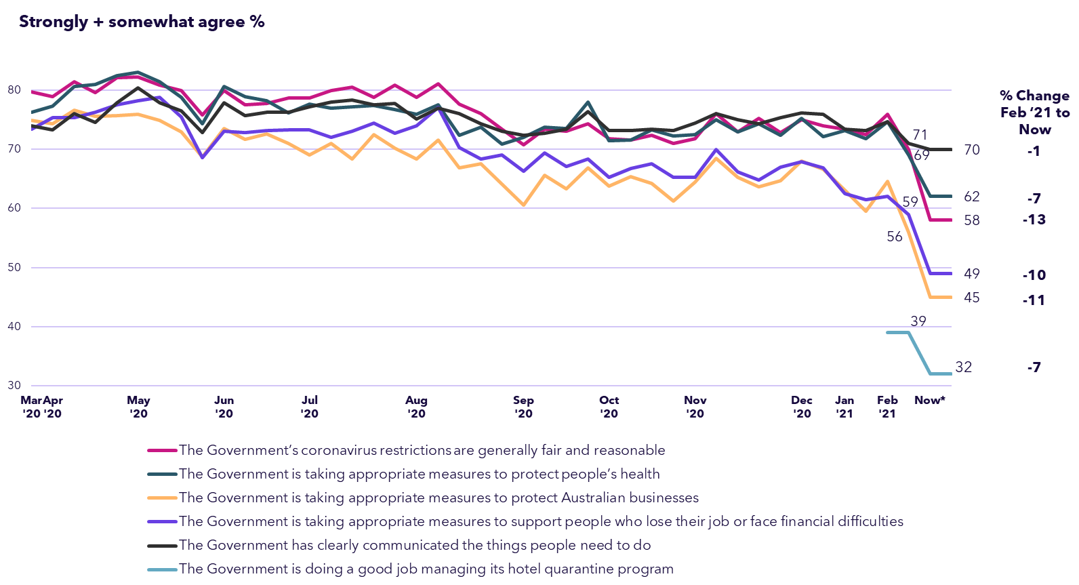

***EXTERNAL DATA SOURCES:***

*Q13a. Do you agree or disagree with the following statements related to coronavirus? // Q14. Do you agree or disagree with the following statements about the Australian Federal Government’s handling of coronavirus at the peak of the pandemic (2020-2021)?*

*Base: All ‘Community Attitudes to Coronavirus’ survey participants: Wave 4 to Wave 45 (n=1,006-2,377) / All participants 2024 (n=2,126). * Framing this wave was past tense.*

Trust levels at the height of the pandemic

We found that trust for a range of groups is quite low, mirroring results seen globally around declining trust levels in both governments and institutions. People trusted their family and friends the most to do the right thing when responding to the challenges of COVID-19, followed by the police, local communities and government. Social media was the least trusted, followed by mainstream media.

*Q15. At the height of the pandemic (2020 to 2021), how much did you trust each of the following to do the right thing in responding to COVID-19?*

*Base: All participants (n=2,126)*

**Trust in doing the right thing at the peak of the pandemic (%)**

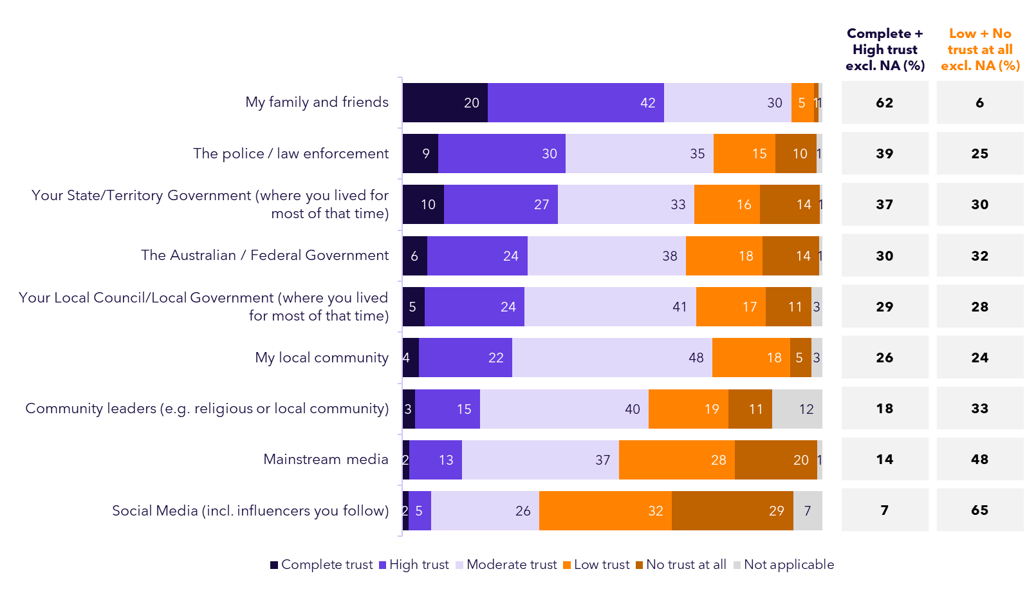

People in a number of key demographics were more likely to say they had low or no trust in certain groups at the peak of the pandemic:

* Mainstream media was more likely be distrusted by those with a disability (60%) and those living in regional Australia (55%);
* Distrust in State or Territory governments was highest in Victoria (40%), First Nations people (41%) and those in the regions (35%); and
* Similarly, distrust in the Federal Government was highest for those in Victoria (38%) and those living in the regions (36%).

Needed government financial support

Around half (52%) felt they needed financial support from the government during the pandemic. This was particularly the case for those with a disability (64%), First Nations peoples (69%) and those aged 18-34 (63%).

**Felt they needed financial support from the Government during the pandemic (%)**

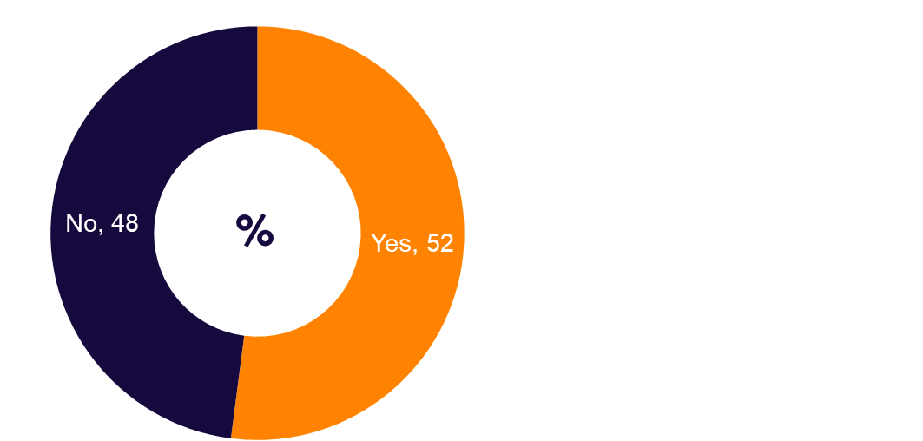

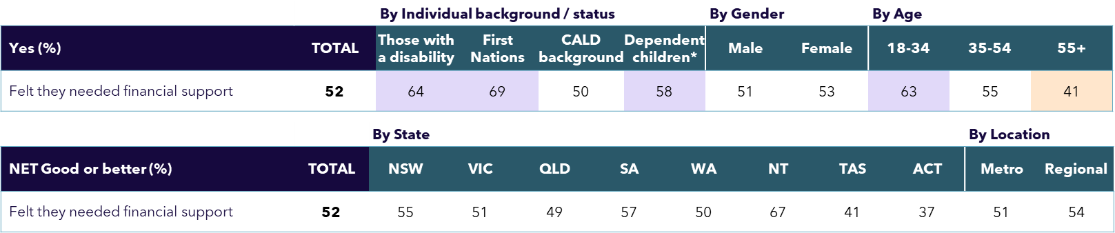

*Q16. Did you feel you needed financial support from the government during the pandemic (whether or not you actually received it)?*

*Base: All participants (n=2,126)*

*^Any of those who did not answer “Don’t Know” for Q13 attributes 15, 16, 18 & 20 (n=1,146)*

*\*Only those who had any dependent children aged 18 or under living together in 2020 or 2021*

Awareness and uptake of government payments

JobSeeker (78%) and JobKeeper (75%) had the highest levels of awareness. In total, 12% of participants received JobSeeker and 14% received JobKeeper.

*Q17. At the height of the pandemic (2020 to 2021), were you aware of the following government payments?*

*Q18. And did you receive any of the following government payments?*

*Base: All participants (n=2,126)*

**Awareness and receipt of Government payments at the height of the pandemic (%)**

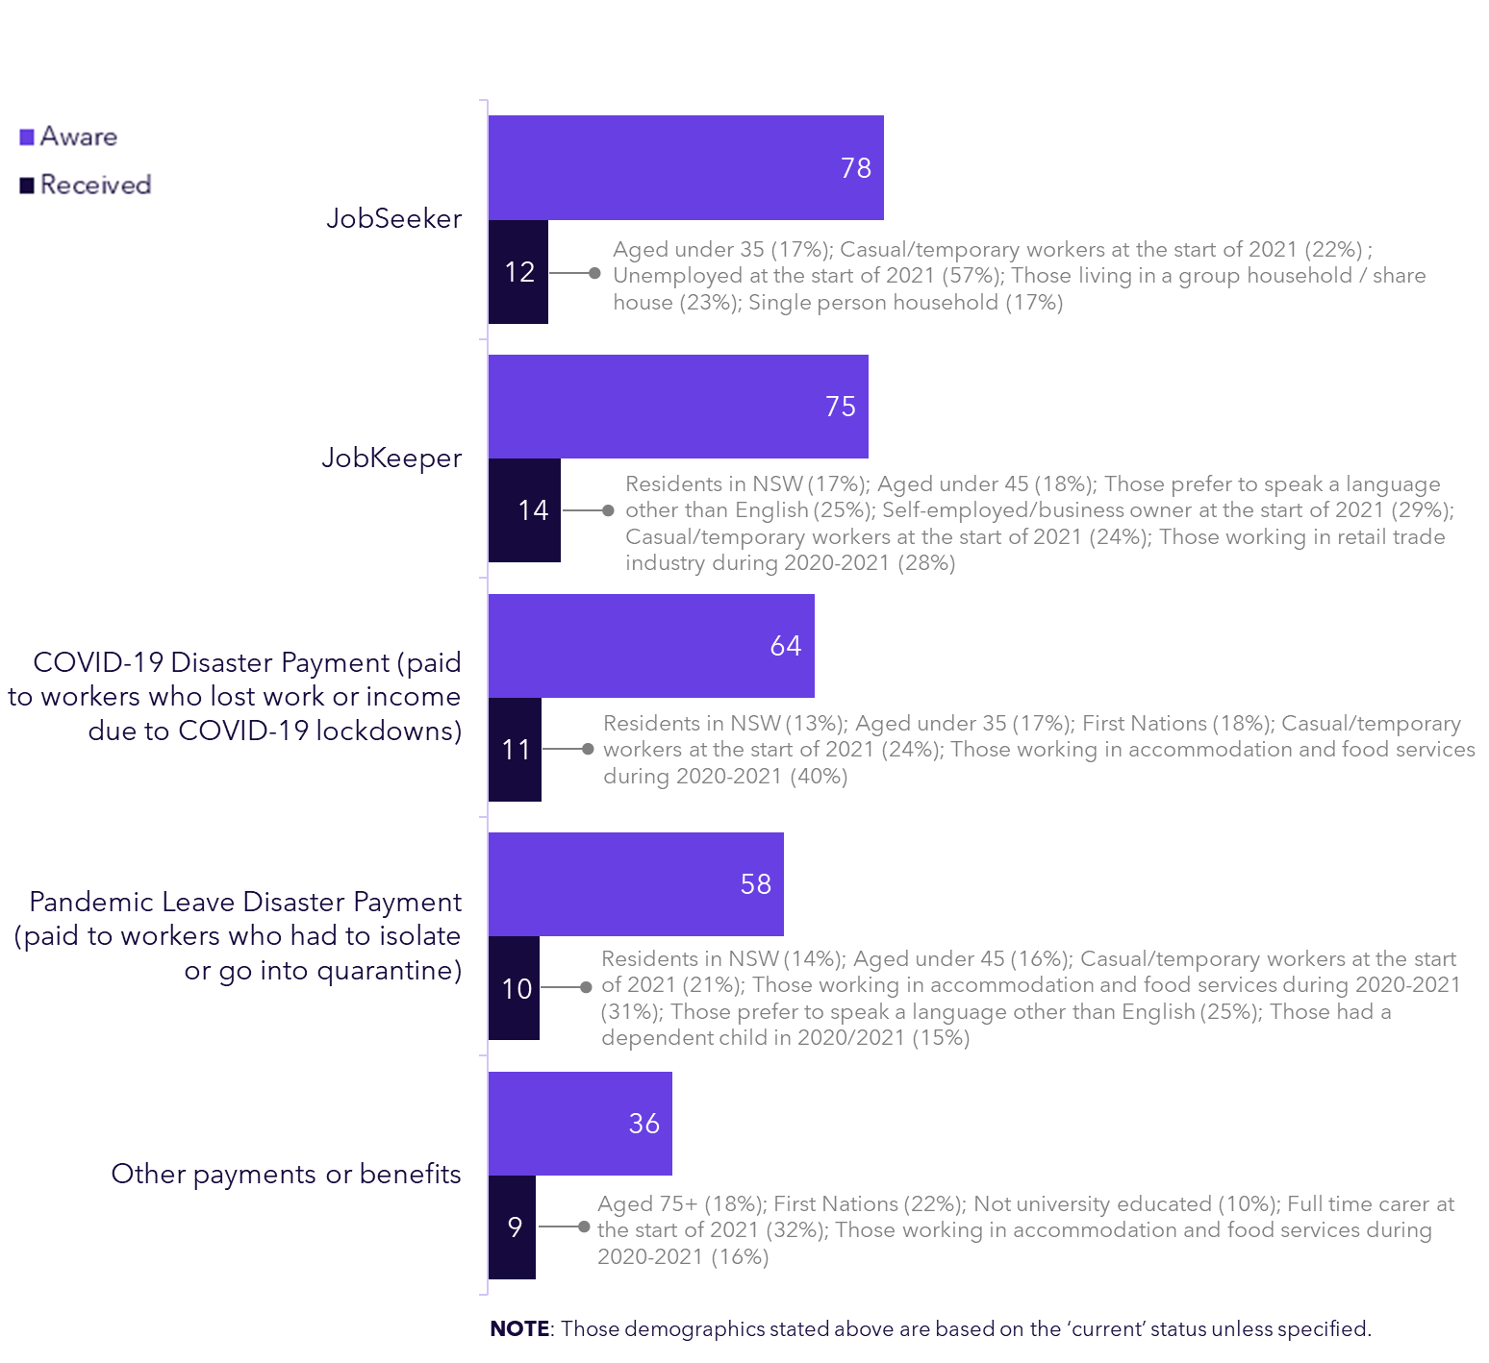

In positive signs, most (78%) who thought they needed financial help did received some form of payment, although around 1 in 5 did not.

Main information sources during the COVID-19 peak

At the peak of the pandemic the Australian public most commonly sourced their information from official news programs and government press conferences.

*Q19. Which of the following were your main sources of COVID-19 information during the height of the pandemic*

*(2020-2021)?*

*Base: All participants (n=2,126)*

*\*Born overseas and/or prefer to speak a language other than English at home*

**Main sources of COVID-19 information during the height of the pandemic (%)**

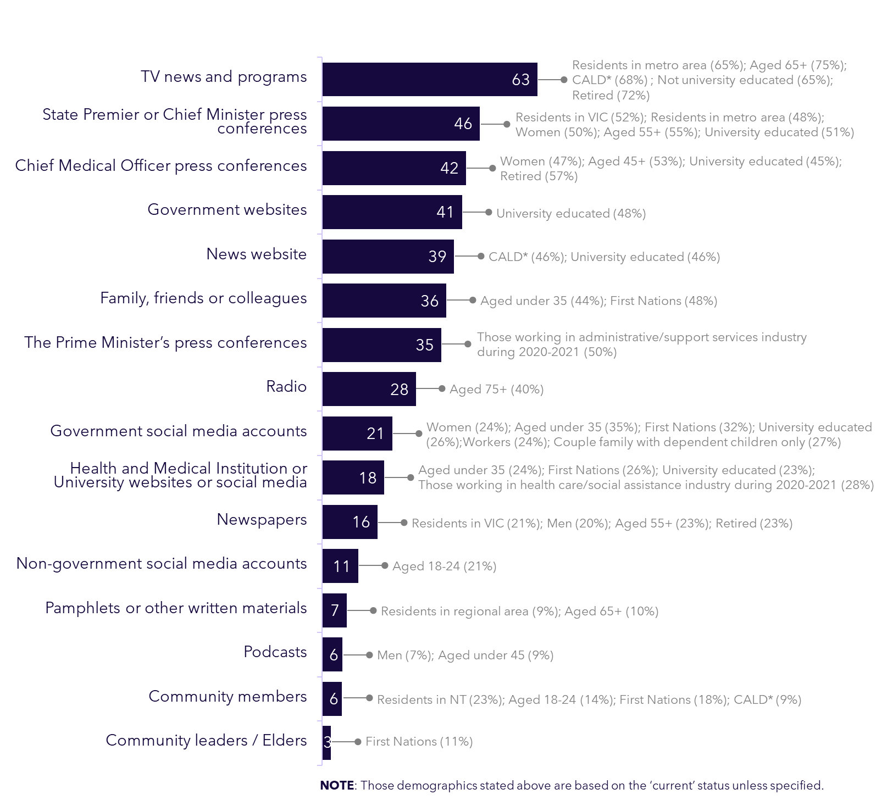

*2020 – 2021 SURVEY:   
Main coronavirus information sources*

Top information sources used during the peak of the pandemic are very similar to what participants stated in the current study.

**Top 10 information sources %**

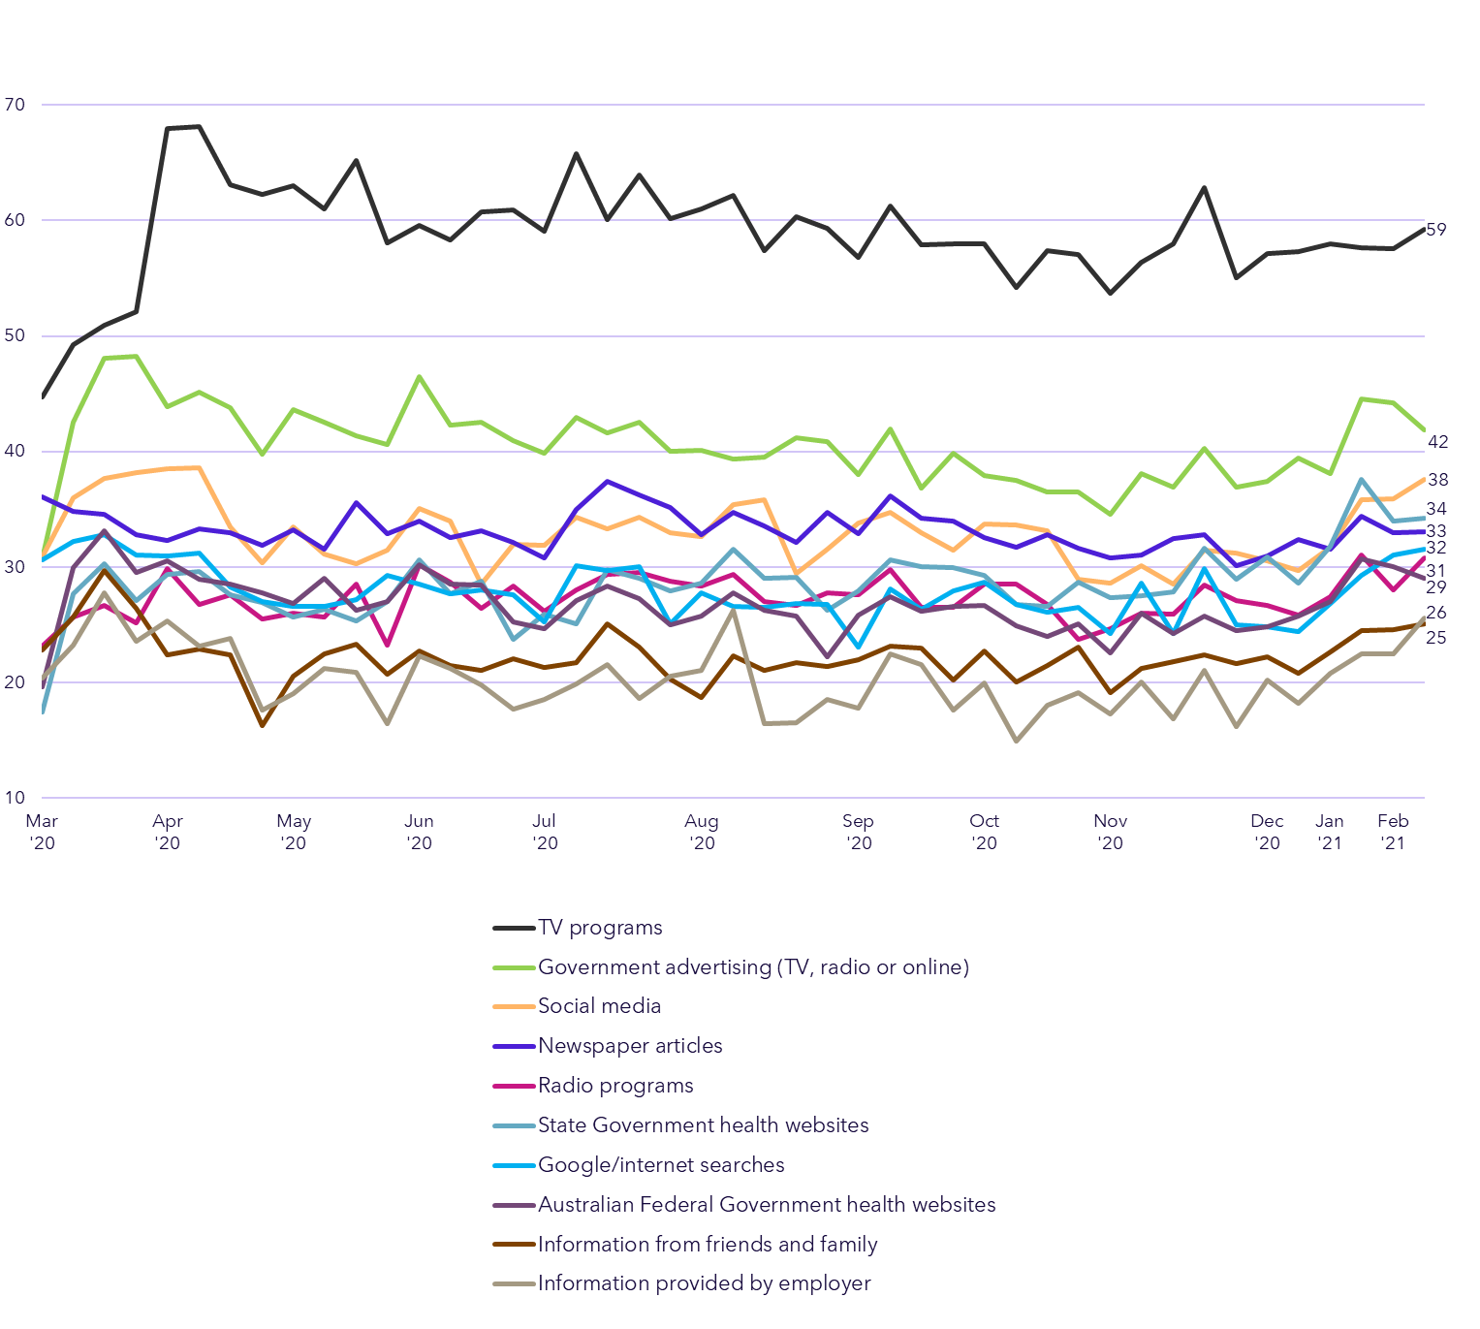

***EXTERNAL DATA SOURCES:***

*Community attitudes to Coronavirus survey: Q14. Where have you been getting your information from on Coronavirus?*

*Base: all participants: Wave 1-45 (n=1,001-2,377)*

Main information sources used vs would use

We see a similar order of priority in information sources people think they would use in a similar future emergency, but with notably less expected reliance on TV (falling from 63% having used it to 48% saying they would in future), and more emphasis on health and medical institutions (rising from 18% to 26%).

**Main sources of COVID-19 information used during the height of the pandemic vs would use  
in a similar future health emergency (%)**

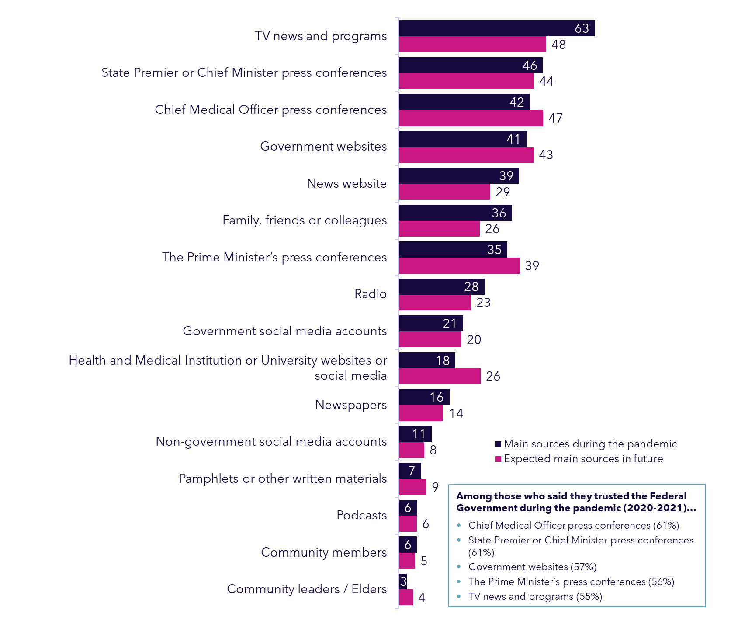

*Q19. Which of the following were your main sources of COVID-19 information during the height of the pandemic (2020-2021)?*

*Q22. In a future public health emergency, what do you think would be the main ways you would find important information?*

*Base: All participants (n=2,126)*

Trustworthiness of COVID-19 information sources

People placed the highest trust in the information provided by CMO and State Government press conferences, while non-government social media and podcasts were the least trusted. Notably, none of the sources had especially high levels saying they were ‘very trustworthy’, perhaps given the unprecedented situation as well as the range of concerns expressed about the information and people’s lived experiences.

*Q20. How trustworthy did you find the following sources when it came to providing accurate COVID-19 information?*

*Base: All participants (n=2,126)*

**Trustworthiness of COVID-19 information sources (%)**

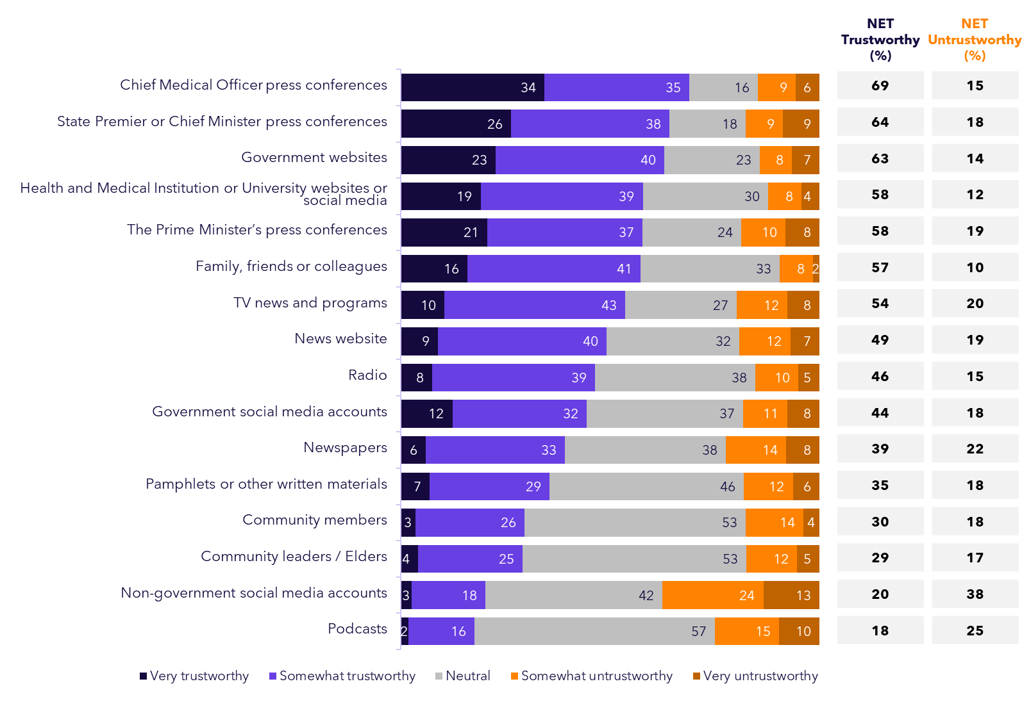

Levels of trust in these information sources varied amongst the population, with those with a disability having the lowest trust in newspapers (26% being at least somewhat trustworthy), Government social media accounts (33%) and Radio (30%). First Nations peoples by comparison had lower levels of trust in TV news and programs (40%), State Premier or Chief Minister press conferences (51%) and Chief Medical officer press conferences (56%).

See Appendix for full demographic analysis of how these results differed for the various cohorts surveyed in this study.

Opinion of COVID-19 Government information

Peak-COVID government information was regarded best in relation to being easy to access, clear and up to date. Its credibility and trustworthiness scored lowest amongst the attributes measured. Again, the level of *strong* agreement across these attributes was not especially high, suggesting there was certainly room for improvement in the information provided.

*Q21. Back at the height of the pandemic (2020 to 2021), do you agree or disagree that the information from government…*

*Base: All participants (n=2,126)*

**Perceptions of information provided by the Government at the peak of pandemic (%)**

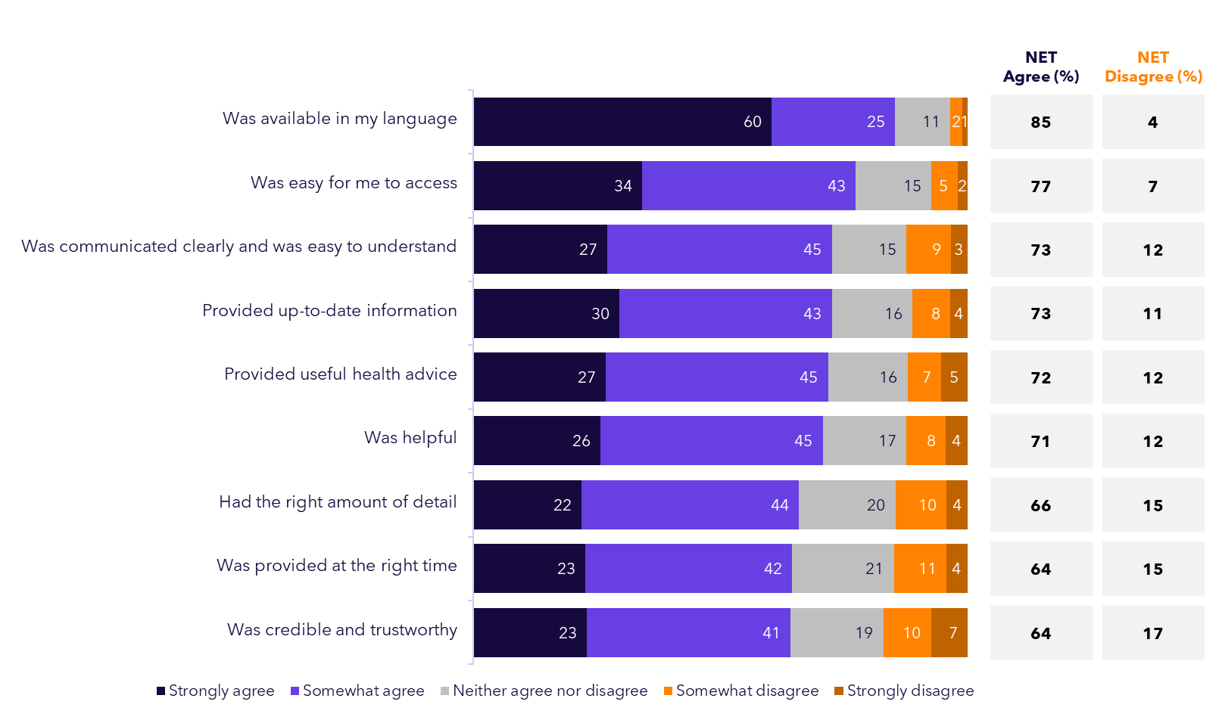

While the information provided by Government was generally rated more positively, both First Nations peoples and Victorians were notably critical on a range of elements.

First Nations peoples had significantly lower levels of agreement on whether the information was provided at the right time (53% agreed), whether it was trustworthy and credible (54%) and had the right amount of detail (56%). Victorians on the other hand were less likely agree that the information was trustworthy and credible (59%), up to date or communicated clearly (both 68% agreement).

Most important COVID-19 information from Government

During the pandemic, people were generally looking for information from the Government on a range of topics, on average selecting 6 out of the 12 topics asked about. The most sought-after topics were information around lockdown requirements (which 70% selected as important to them), health restrictions such as social distancing (66% selected this) and the health risks of COVID-19 (63%).

*Q23. The following are a series of topics that the Australian Federal Government communicated on during the pandemic. Which of the following were most important for you to know about? [Multiple response allowed]*

*Base: All participants (n=2,126)*

*\*Born overseas and/or prefer to speak a language other than English at home*

**Most important topics the Federal Government communicated on during the pandemic   
(% Selected)**

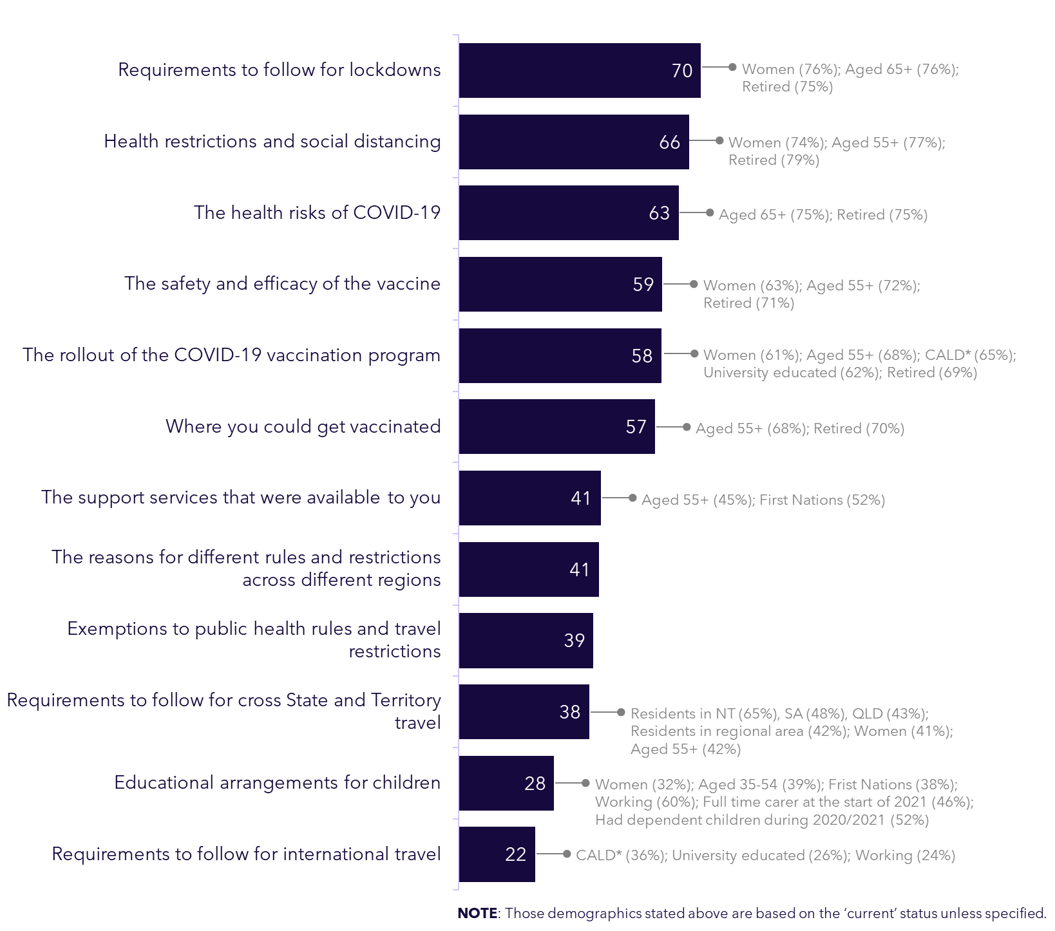

Quality of Federal Government communication

The public thinks the Government did best at providing information on where they could get vaccinated, health restrictions like social distancing, the health risks of the virus and lockdown requirements. The weakest ratings were given for the information about the safety and efficacy of the vaccine, educational arrangements for children and the reasons for different rules and restrictions across different regions.

*Q24. How would you rate the Australian Federal Government’s communication during the pandemic on the following specific topics?*

*Base: All participants (n=2,126)*

**Quality of Federal Government’s communication during the pandemic (%)**

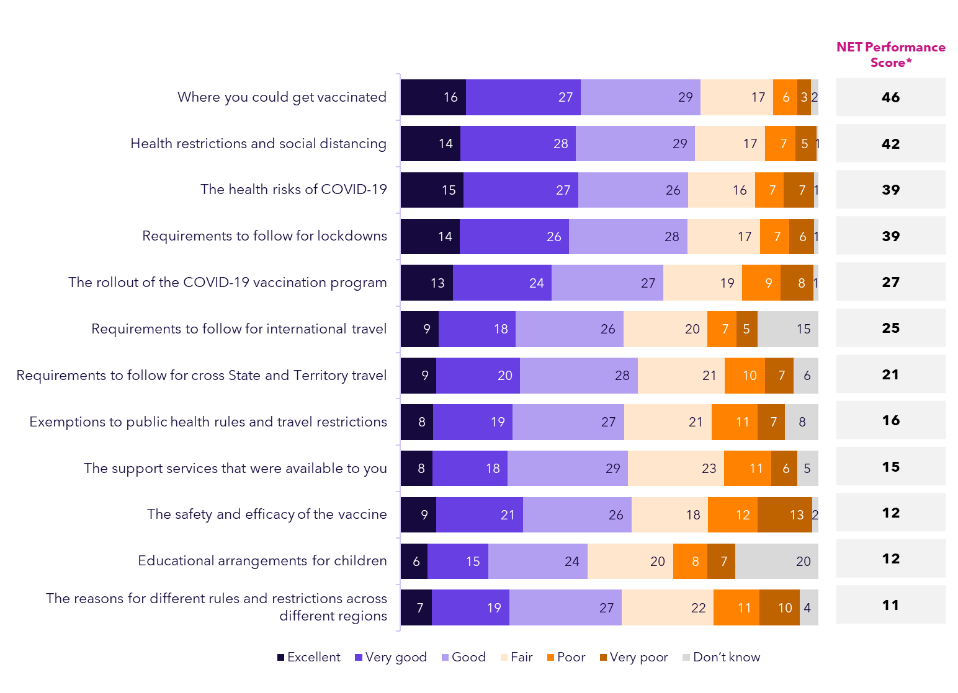

Elements of the Government’s pandemic communications**** that were more heavily criticised included the support services that were available – among those who identified as having a disability (with just 43% rating this ‘good’ or better), and perceptions of the rollout of the vaccination program for both First Nations peoples and those with a disability (50% and 51% respectively).

In contrast, CALD participants were more likely to feel positively about communications regarding requirements for both interstate (64%) and overseas requirements (61%) travel.



Importance vs. perceived performance of Federal Government communications

The public generally felt the Government delivered good quality information on most of the most important topics. The areas most criticised related to the information on educational arrangements for children, and the safety and efficacy of the vaccine.

*Q23. The following are a series of topics that the Australian Federal Government communicated on during the pandemic. Which of the following were most important for you to know about? [Multiple response allowed]*

*Q24. How would you rate the Australian Federal Government’s communication during the pandemic on the following specific topics? (Don’t know responses removed)*

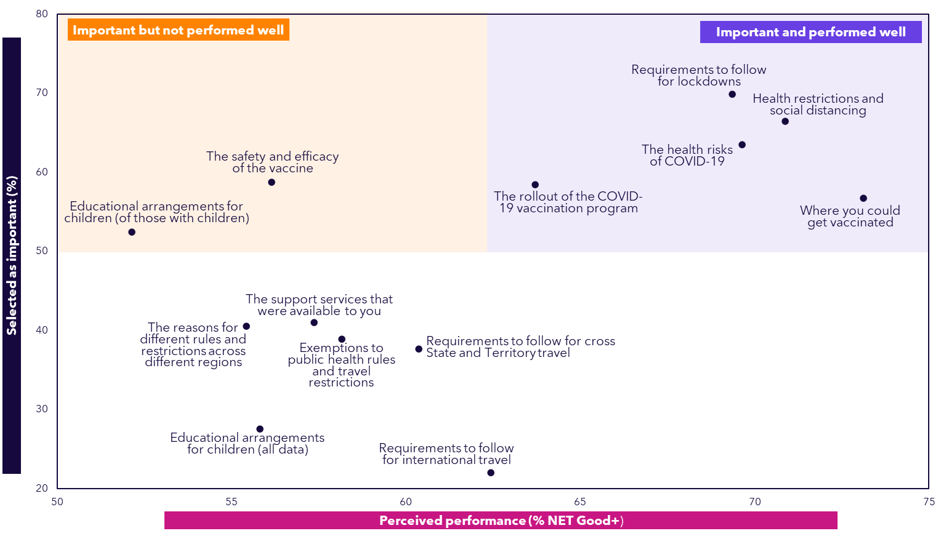

When participants were asked to rate specific topics of Government pandemic communication, the areas they public felt were most important and also communicated well related to requirements to follow for lockdowns, health restrictions and social distancing, where you could get vaccinated and the health risks of the virus.

In saying this, both those with a disability and First Nations people were significantly less likely to rate the Government performance as ‘good’ or better for the rollout of the vaccination program (51% and 50% respectively).

Perceived preparedness for future health emergencies

The majority agreed the Government will have learnt the lessons from the pandemic should a similar emergency occur, but only one in four agreed *strongly* (24%), and there is scepticism that the public will follow government directives if one does.

**Opinion towards potential health emergencies (%)**

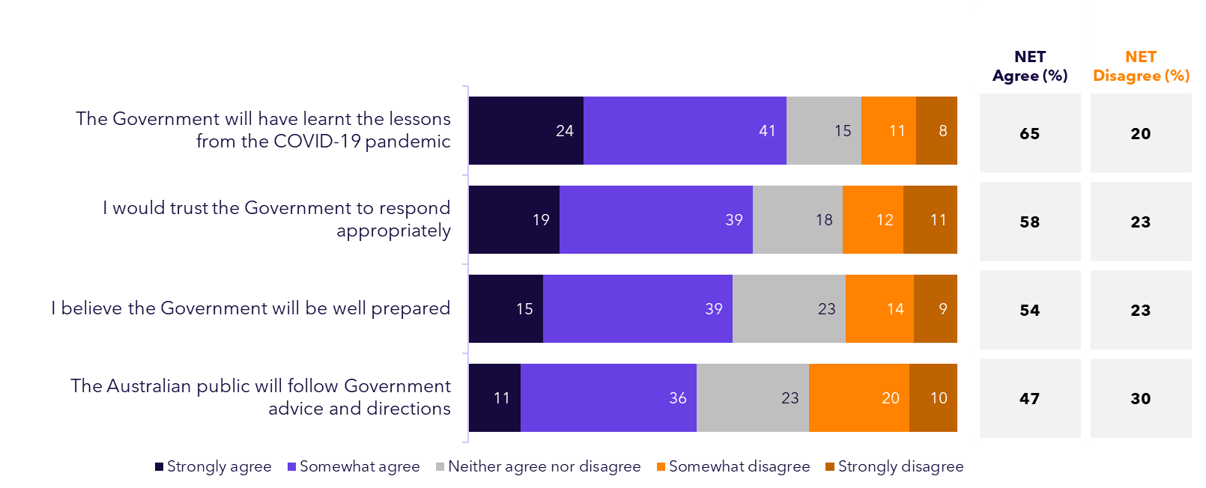

Scepticism is present across a range of cohorts, particularly for Victorians, males and those with a disability:

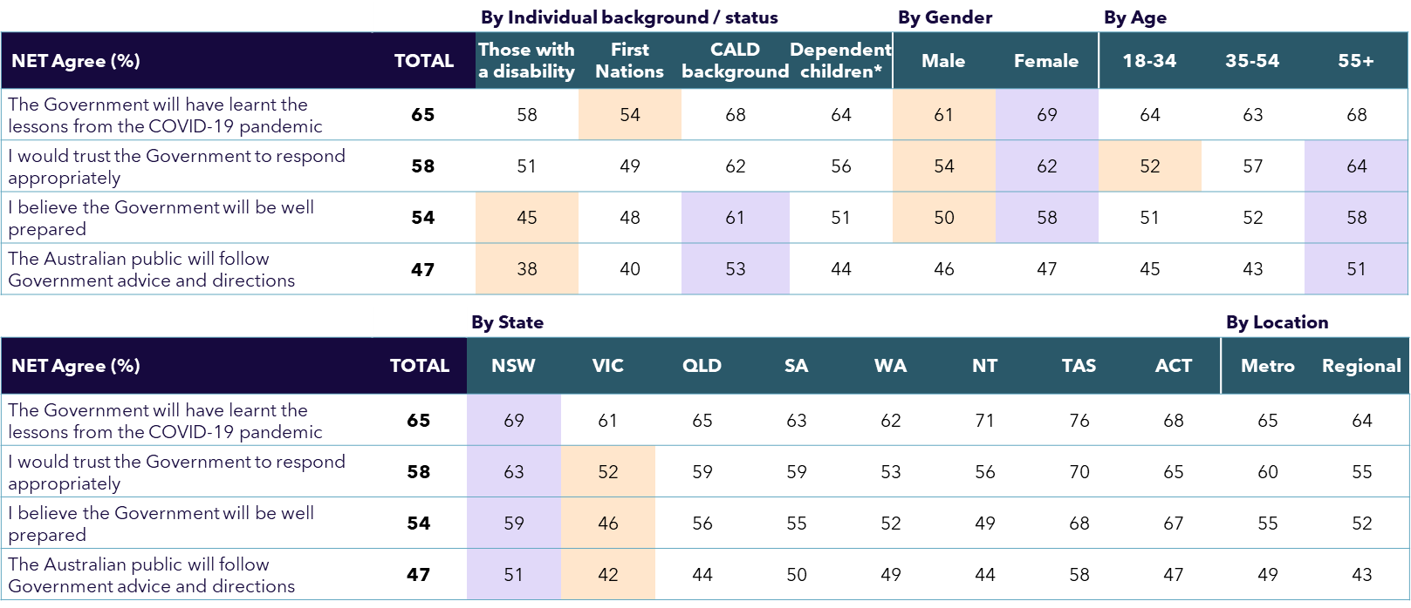

*Q25. Imagine that there was another public health emergency like COVID-19 in the future. To what extent do you agree or disagree with the following statements about this potential scenario?*

*Base: All participants (n=2,126)*

*\*Only those who had any dependent children aged 18 or under living together in 2020 or 2021*

Likelihood to follow future Government directions

Around 4 in 5 thought they would follow most health directions although fewer than two thirds thought they would get a vaccine offered by the Government (similar to levels anticipated before the COVID-19 vaccine was available#). Younger people were also significantly less likely to think they would follow these directions than those over 55. On face value, even though this was not a measure to predict behaviours, it suggests there may be quite a different community response should a similar crisis happen again.

**Likelihood of following Government directions in future (%)**

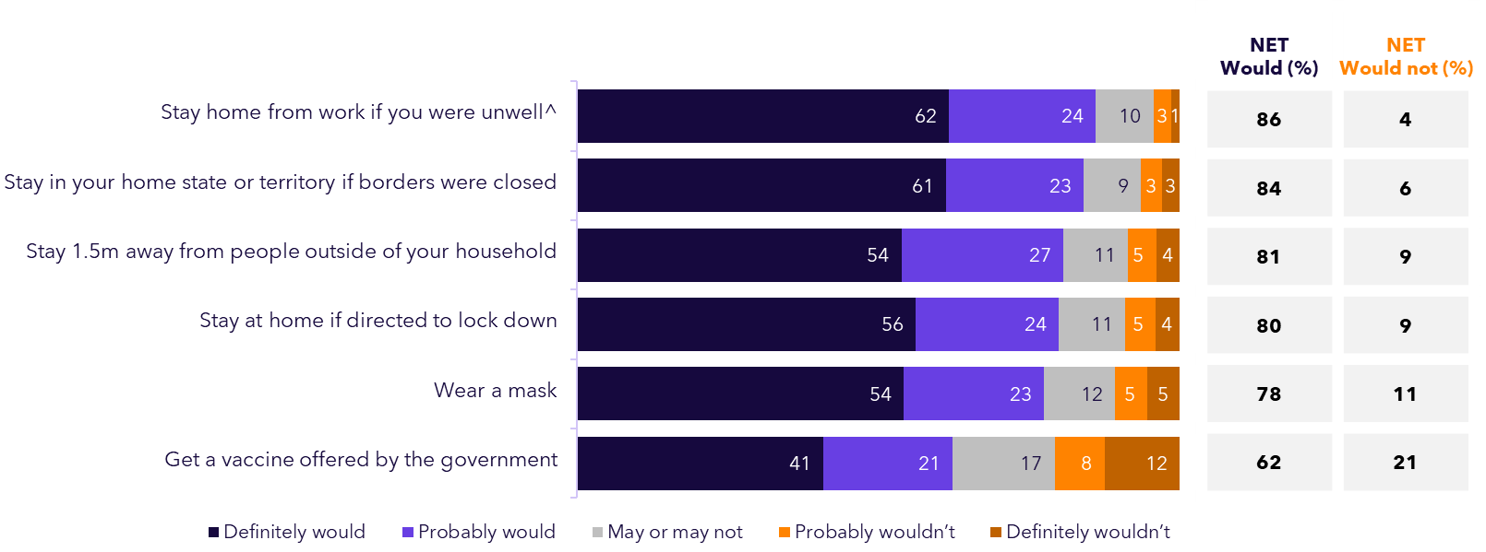

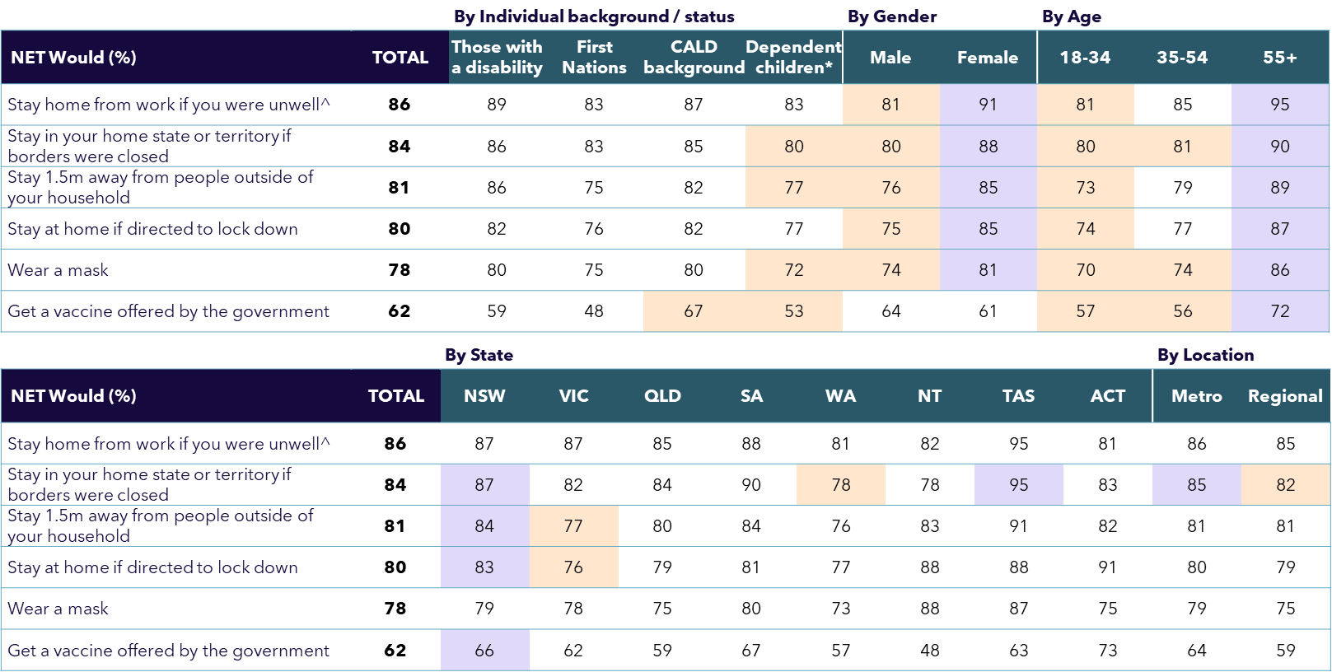

*Q26. Imagine there was a future health emergency with a similar level of risk to health as COVID-19 when it first emerged. How likely would you be to do the following if you were directed to do so by the government?*

*Base: All participants (n=2,126)*

*# From our national ‘Community Attitudes to Coronavirus’ tracker, at 64% definitely/probably in January 2021.*

*^Asked only working people (n=1,560).*

*\*Only those who had any dependent children aged 18 or under living together in 2020 or 2021*

Factors to increase compliance with future restrictions

To strengthen compliance, participants felt it was most important to be provided with a clear reason as to why they are being asked to do things, what is required of them, and justification for any restrictions.

*Q27. What, if anything, would make you more likely to comply with restrictions in a future health emergency?*

*Base: All participants (n=2,126)*

**Factors to help compliance with future restrictions (%)**

Those who self-identify as having a disability were significantly more likely to select ‘If I believe the restrictions are fair’ (63%), ‘Easily accessed information on what is required of me’ (62%) and ‘If the request was coming from an organisation or person I trusted’ (61%). In comparison, those with children at the time of the pandemic were less likely select ‘If the request was coming from an organisation or person I trusted’ (38%), ‘Easily accessed information on what is required of me’ (42%) and ‘Clear and easy to understand information on what is required of me’ (52%).

For a full examination of the demographic and cohort differences, see data tables provided in the Appendices as a complementary output to this report.

Trust in groups to do the right thing in a future emergency

The groups people trust the most to do the right thing are health, medical and science experts (64% net complete or high trust), followed by their own family and friends (61%), yet the wider ‘Australian public’ is the least trusted (at just 16%). Victorians have particularly low levels of trust for Government, and towards family and friends.

*Q28. How much would you trust the following groups to do the right thing in response to a future public health emergency similar to COVID-19?*

*Base: All participants (n=2,126)*

**Trust in doing the right thing in responding to a future public health emergency (%)**

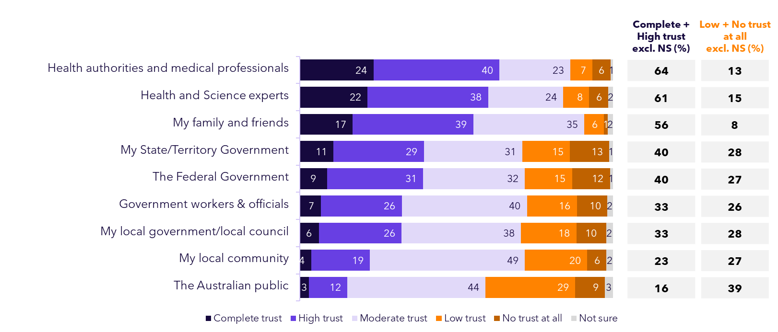

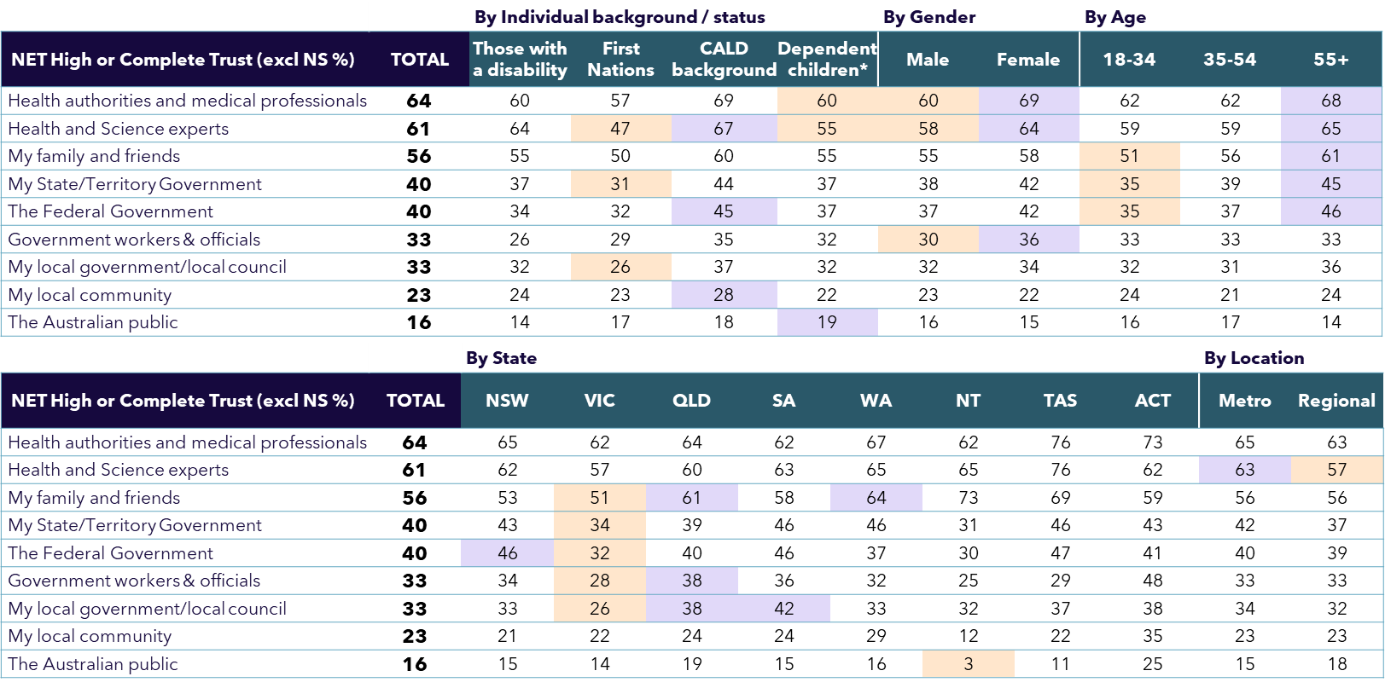

Final advice to the Federal Government

When asked to provide final advice to Government should a similar event occur in the future, we saw many extensive and considered responses. Such high engagement is indicative of the strong sentiment and opinions the public have on this event that had such a profound impact across Australia.

**Advice to Government on best responding to a future health emergency (Unprompted, Coded %)**

*Q29. Finally, what advice would you give the Australian Federal Government on how it should best respond to a future health emergency similar to COVID-19?”*

*Base: All participants randomly selected for coding (n=1,000)*

*Responses <5% not shown*

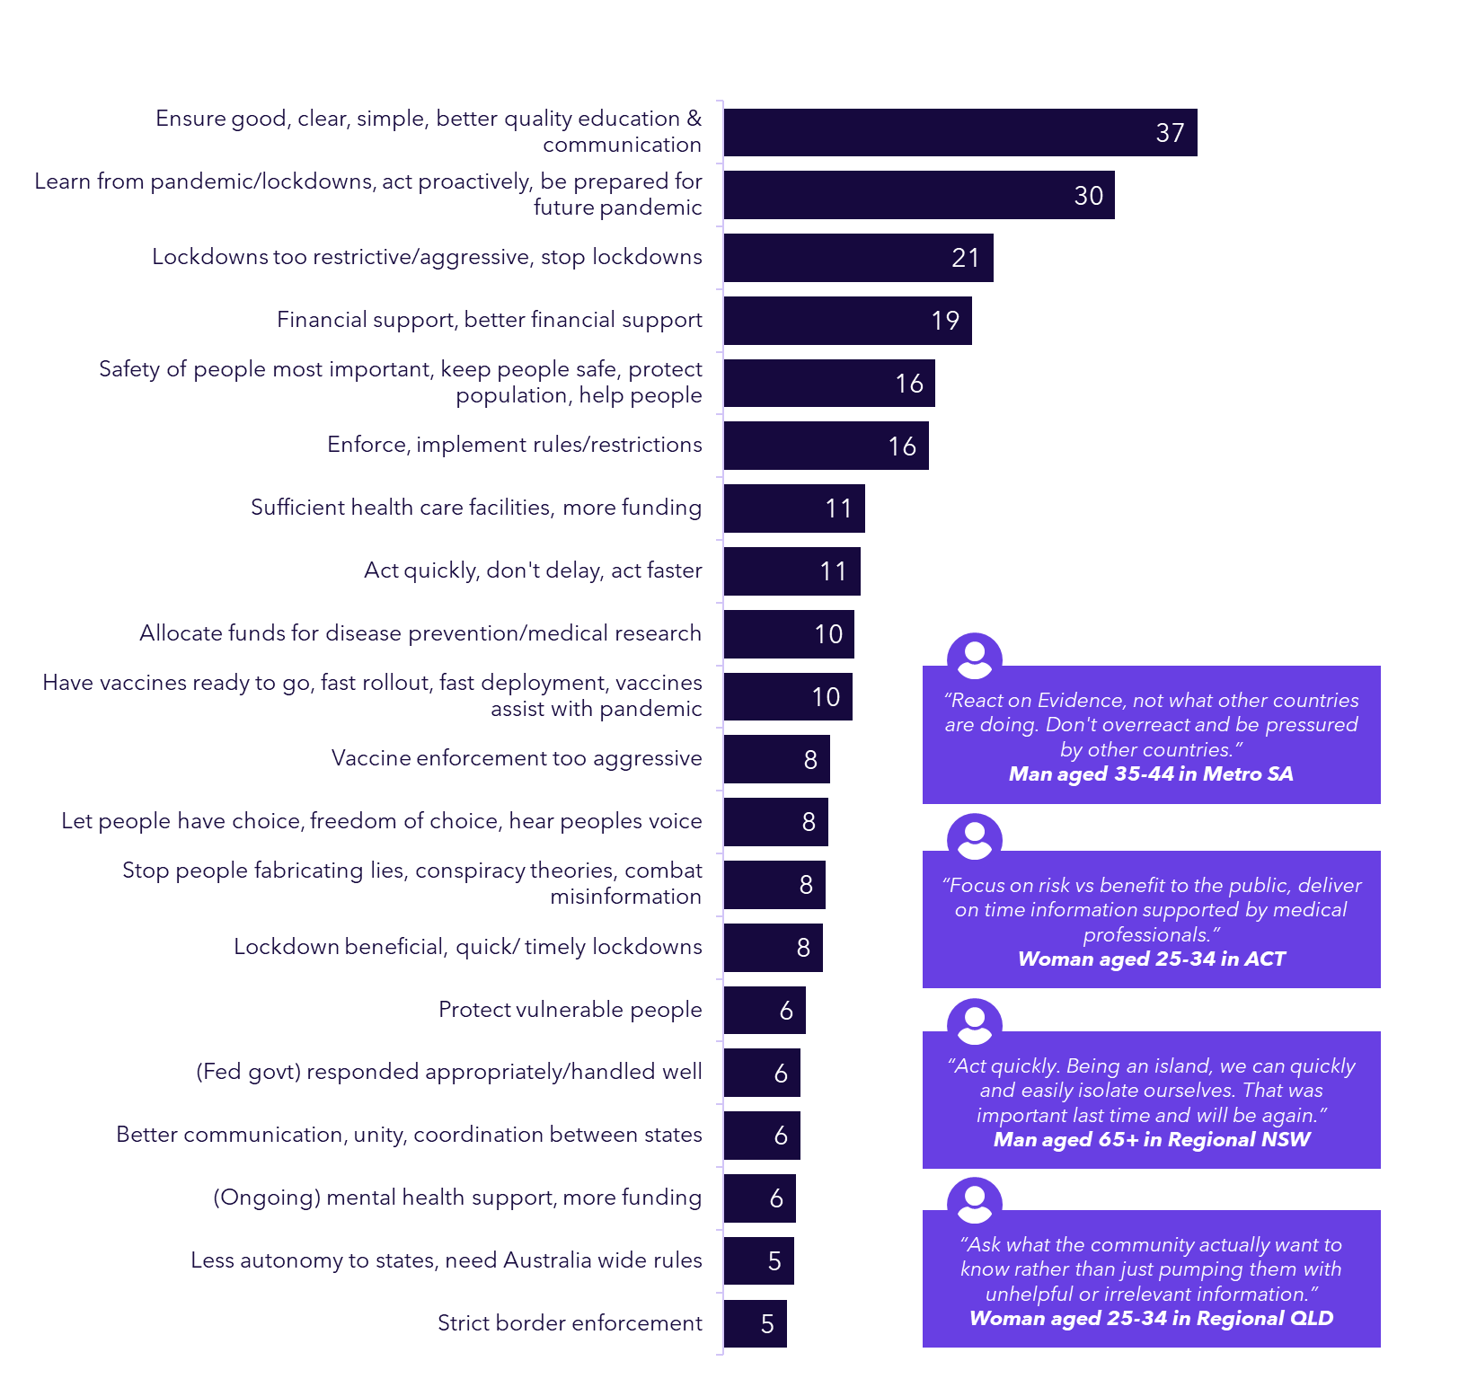

Victorians experienced the harshest restrictions in Australia, earning the unenviable title of most locked down city in the world (six lockdowns, totalling 262 days). Over the next two pages we provide a detailed demographic comparison of the most affected cohorts within Victoria, with significant differences present across a large number of attributes measured in this study.

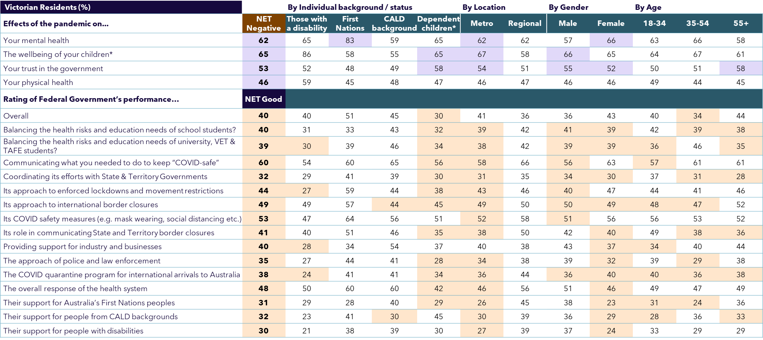

*Base: Victorian participants (n=539)*

*\*Only those who had any dependent children aged 18 or under living together in 2020 or 2021*

Focus: The Victorian pandemic experience 

Victorian analysis continued…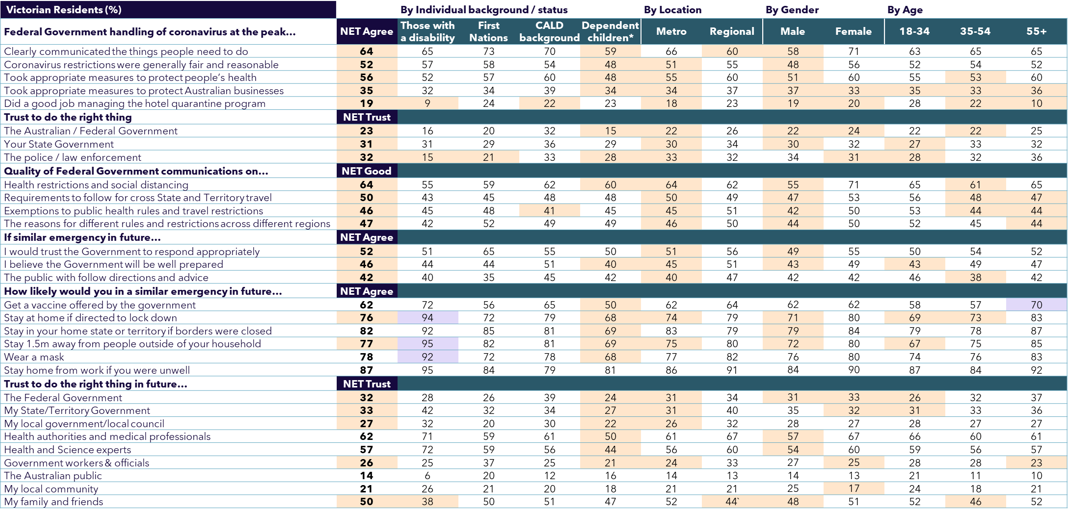

*Base: Victorian participants (n=539)*

*\*Only those who had any dependent children aged 18 or under living together in 2020 or 2021*

**Looking deeper: understanding the key attitudinal segments  
**

Segmentation analysis

**To shed more light on the public’s experiences and views we undertook formal segmentation analysis on the survey data, arriving at a solution that revealed four distinct segments within the Australian public.**

**Purpose:**

* + Identify mutually exclusive sub-groups of survey sample participants who have similar needs, experiences and/or expectations.
  + Create personas or relatable descriptions that can be used to identify key target audiences for future communications and initiatives.

**Approach:**

* + An industry standard and powerful technique called Latent Class Analysis which allows the natural, latent groups to emerge.
  + Carefully consider which variables/questions to include in the modelling.
    - In this instance we focused on: personal effects from the pandemic (Q7, Q8, Q16), the Australian Government’s response and performance during the height of the pandemic (Q9, Q12), trustworthiness of information sources and groups (Q20, Q28), perceived preparedness for similar future health emergencies (Q25), and anticipated individual responses to potential government directions (Q26).
  + Examine the solutions yielded and choose one that is the most fit for purpose (one had as many as 9 segments), then refine the analysis to provide the clearest picture of each segment.

**Outcome:**

A 4-segment solution which is clear, easy to understand and practical

Distinct community segments to consider in future

The proportion of each segment within the sample is shown here, along with an outline of their key characteristics and a descriptive name reflecting their nature.

*Various questions – see previous page.*

*Base: All participants (n=2,126)*

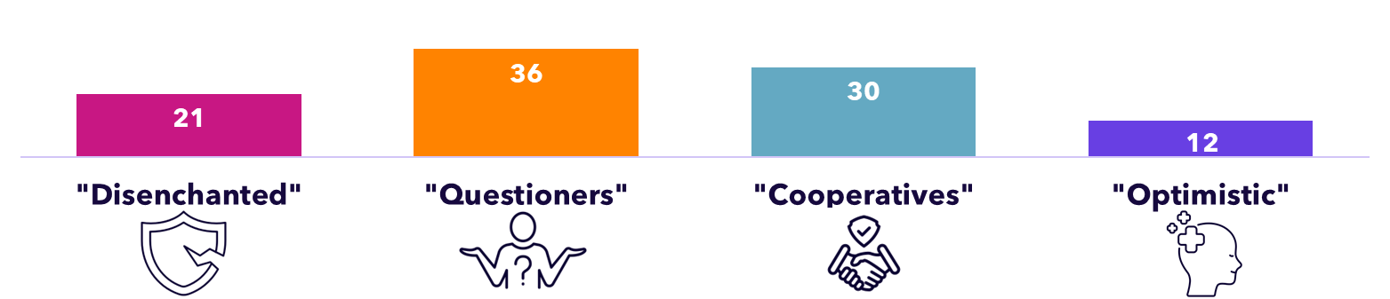

|  |  |  |  |  |
| --- | --- | --- | --- | --- |
| **Key characteristics** | * Felt the most negatively affected on all aspects asked about, especially trust in government and science * Majority rated the Government’s response as poor, 30% ‘very poor’, most felt it overreacted (75%) * Distrusting of most sources * Majority won’t comply with directions in a similar future scenario, and just 7% would get a vaccine | * The second-most negatively affected group, with stand-out impacts on mental health and social interactions * Ratings of Government’s response more mid-range, most likely segment to feel it underreacted (27%) * Trust levels more on the fence * Despite their concerns, most still think they’d comply with future Government directions, except vaccination (66%) | * Generally milder negative impacts from the pandemic than others * Notable gains in trust in science and government * Second highest ratings of Government’s response, and most (83%) felt it was apt * Highest trust in Government * Anticipate near universal compliance with Government directions in a similar situation * Highest retiree contingent (26%) | * Far more likely to report positive experiences of the pandemic than all other segments, overall (61% net positive) and for all aspects asked about * Rated the Government’s response the highest * Very high trust levels * Anticipate very high compliance with Government directions in a similar situation (e.g. get a vaccine = 82%) |
| **Implications** | * Will be *very* difficult to engage * Inherent scepticism, traumas * Limited shorter-term potential to build trust * Open to genuine dialogue, messaging and initiatives re evidence-based decisions and freedom of choice | * Can become more convinced and supportive about Government directions and initiatives if very clear and timely rationales and instructions provided, to address questions, grey areas | * Very easy to engage * Seeking Government direction and will most likely trust and follow the guidance, despite difficulties it may cause them * Can become advocates for Government action | * Important to remember they are a small minority * Explore their capacity to help others in the community who are likely to experience difficulty in future situations |

Key demographic differences across the segments

This table shows a summary of statistically significant demographic differences, which, although present, did not act as the primary descriptors for understanding the segments.

*Base: All participants (n=2,126)*

*^Born overseas and/or prefer to speak a language other than English at home*

*\*Only those who had any dependent children aged 18 or under living together in 2020 or 2021*

**Compared to other segments, significantly more likely to be…**

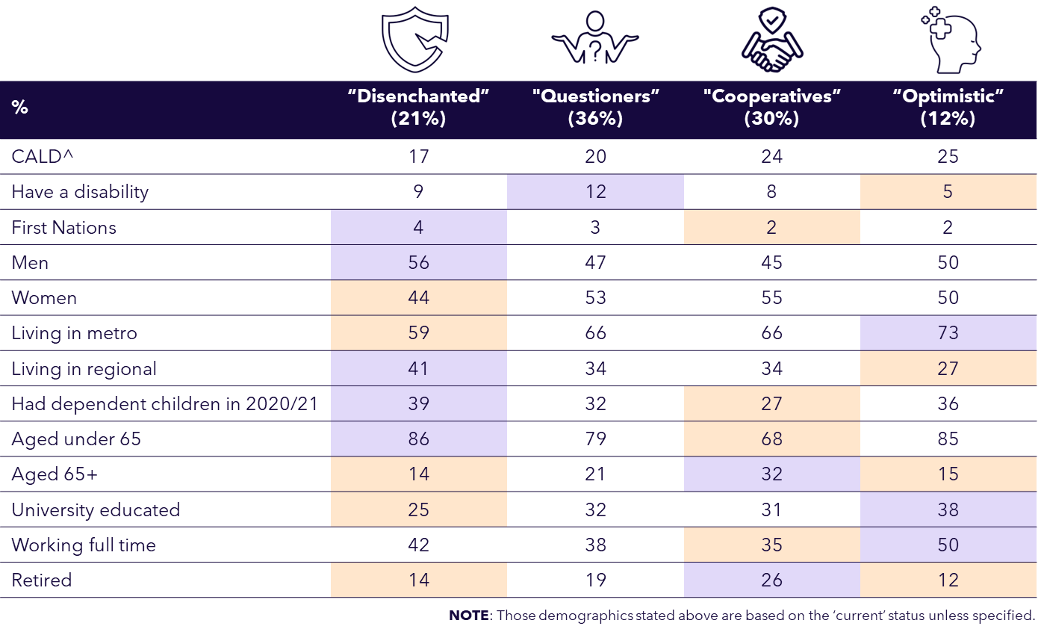

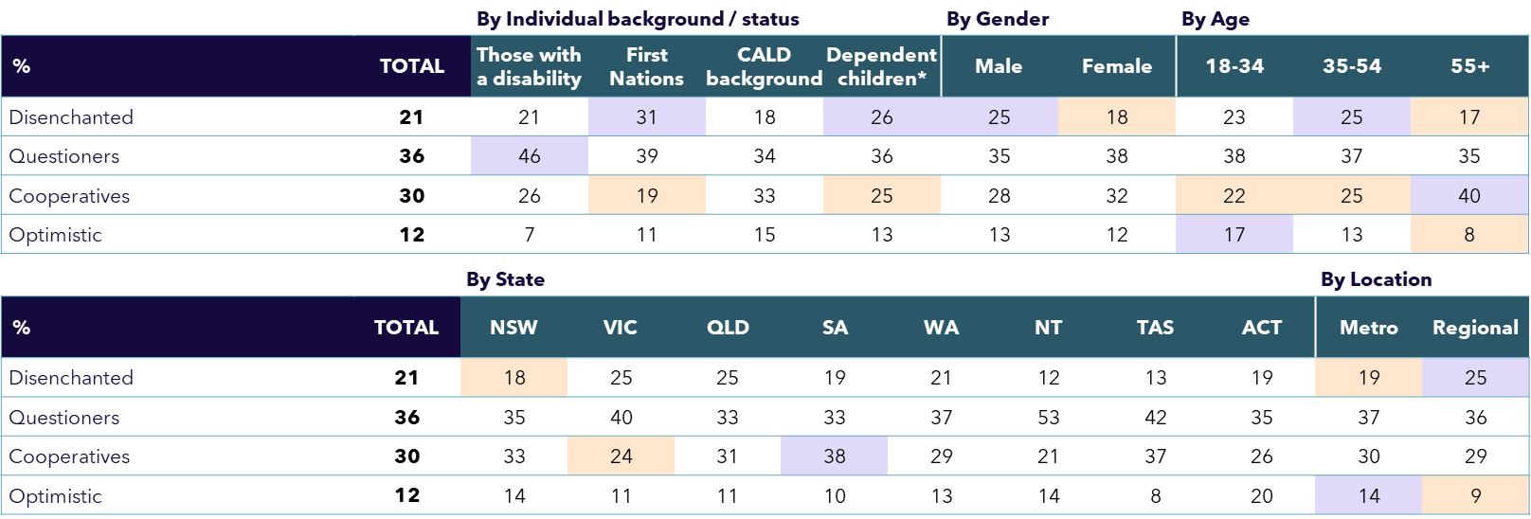

Drivers of overall experience by segment

Driver analyses were conducted for each of the four segments, with distinct differences shown to be driving their experiences and perspectives. While the Questioners and Cooperatives have the most similar driver profiles, the Optimistic are a particular standout, with their employment situation and physical health being their top drivers of their overall experience. For the Disenchanted, the effects of the pandemic on their interactions with their families played a key role in their overall perspective.

**Modelled relative impact of different factors on people’s  
overall experience of the COVID pandemic**

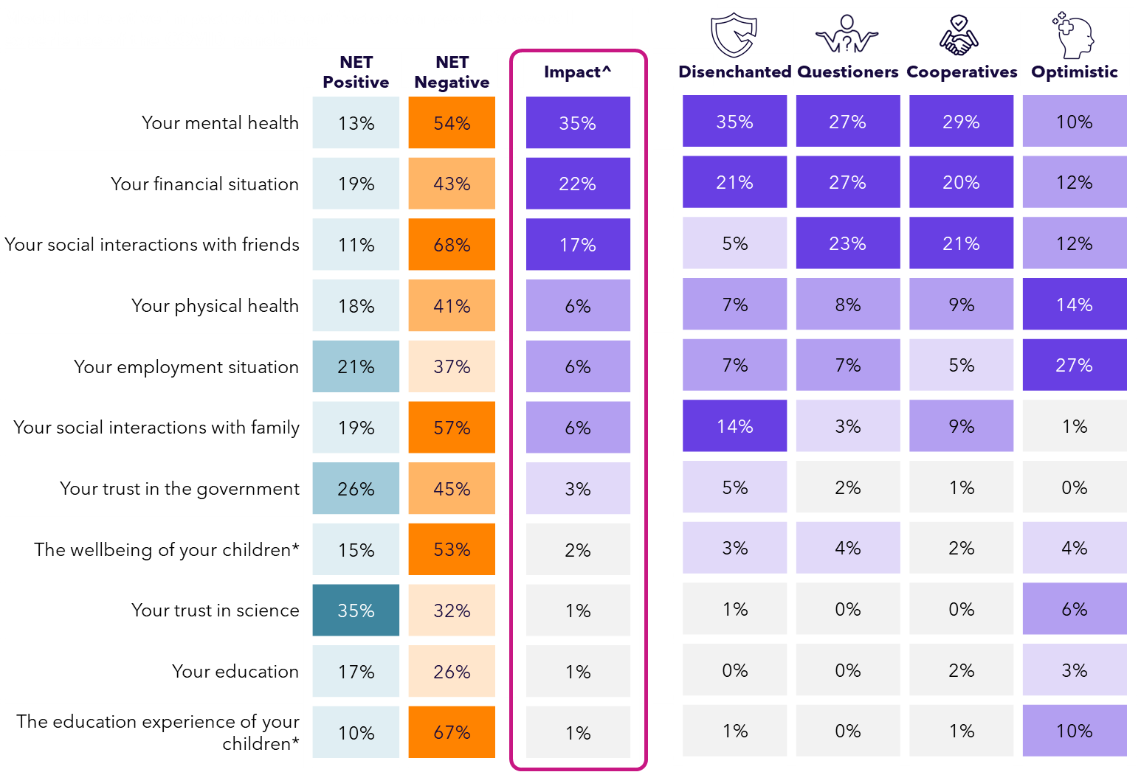

*Q7. Overall, what effect did the COVID pandemic have on your life?*

*Q8. What effect did the COVID-19 pandemic have on the following aspects of your life?*

*Base: All participants (n=2,126)*

*\*Asked only those who had any dependent children aged 18 or under living together in 2020 or 2021 (n=732)*

*^Impact Score derived from driver modelling represents the weighted impact that each attribute has on overall experience (all drivers sum to 100)*

Drivers of segment views on Gov’t. performance

We see even more pronounced differences when we explore the attributes that drive each segment’s perceptions of the Federal Government’s overall performance in managing the pandemic. This analysis reveals very divergent views in what mattered most to each group about how the government responded at the time.

**Modelled relative impact of factors affecting views on   
the Australian Federal Government’s performance**

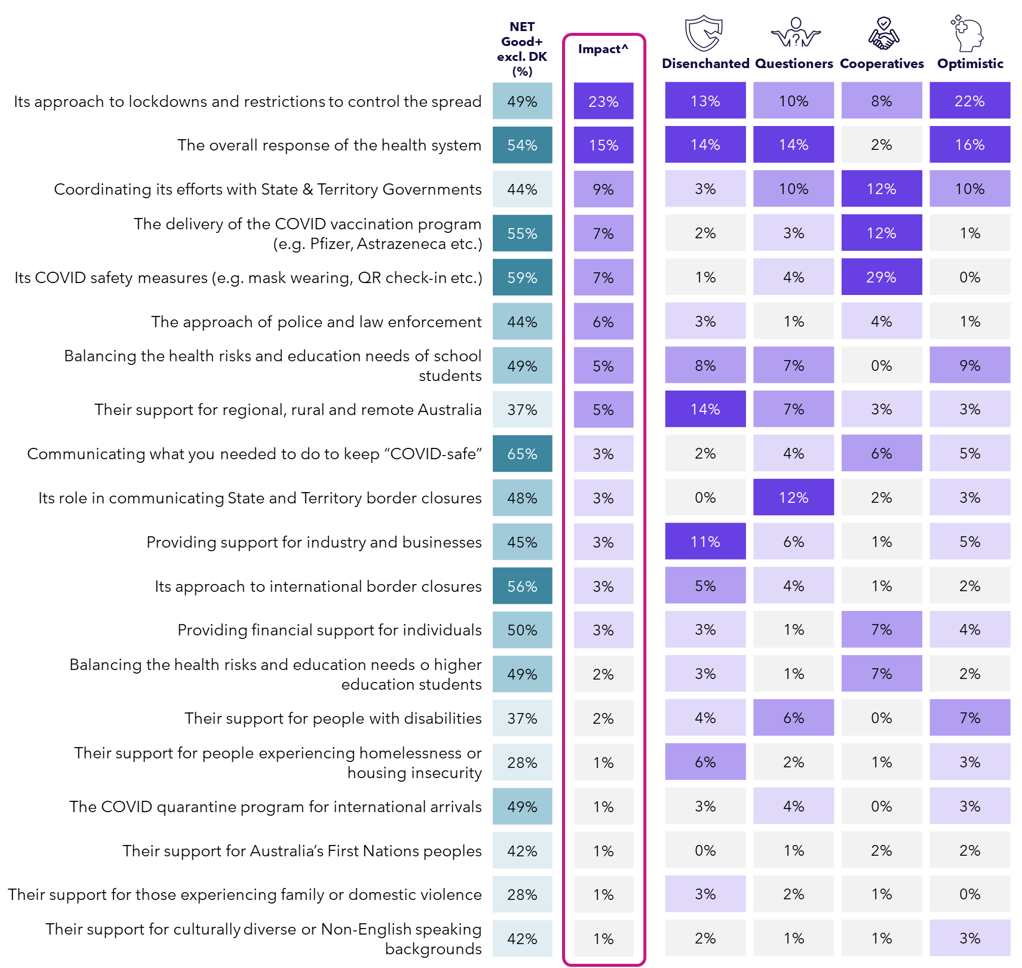

*Q9. Overall, how would you rate the Australian Federal Government’s performance in responding to COVID-19 and managing its impacts? / Q13. How well would you rate the performance of the Australian Federal Government on the following aspects of its COVID-19 response and management?*

*Base: All participants (n=2,126)*

*^Impact Score derived from driver modelling represents the weighted impact that each attribute has on overall perceptions of Federal Government performance in managing the pandemic (all drivers sum to 100)*

*^Impact Score presents the normalised coefficient values from a statistical driver model, with all coefficients summing to 100%.*

Segment summaries

Getting to know the community segments and their advice to Government for the future

**Two-page summaries follow for each segment,** covering:

* + The top drivers of their overall experiences of the pandemic
  + Views on the Australian Federal Government’s pandemic response and the top factors driving this
  + How they would respond to directions from the Australian Federal Government in a similar future health emergency
  + The top three things likely to increase their compliance with government directions in future
  + Their advice to Government in a future similar health emergency

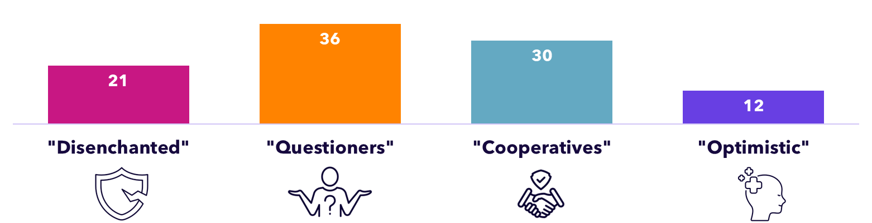

Summary – looking back: Disenchanted (21%)

Negative feelings run very deep in this segment, with effects on their mental health and financial situation having the biggest impact on their overall experiences. Two thirds (66%) rated the Australian Government’s performance as poor / very poor – mostly driven by how it supported regional Australia, the health system’s response, and lockdowns.

|  |  |  |
| --- | --- | --- |
| **Top 5 Drivers of Overall Experience**  **for this segment** | **NET  Negative** | **Impact**  **Score** |
| Overall impact on their lives | **72%** | * |
| Your mental health | **71%** | 35% |
| Your financial situation | **52%** | 21% |
| Social interactions with family | **65%** | 14% |
| Your physical health | **53%** | 7% |
| Your employment situation | **47%** | 7% |

|  |  |  |
| --- | --- | --- |
| **Top 5 Drivers of Government’s**  **Pandemic Performance** | **NET  Good+** | **Impact**  **Score** |
| Overall performance | **11%** | # |
| Their support for regional, rural and remote Australia | **9%** | 14% |
| The overall response of the health system | **15%** | 14% |
| Its approach to enforced lockdowns and movement restrictions to control the spread | **12%** | 13% |
| Providing support for industry and businesses | **20%** | 11% |
| Balancing health risks and education needs of school students | **13%** | 8% |

**1%** NET Complete / high trust in the Australian Government during the pandemic (Q15)

*Various survey questions. Base: All in this segment (n=456)*

*\* Modelled analysis of the relative impact of specific factors (Q8) on overall experience (Q7). Impact scores add to 100%  
 - top five drivers only shown here.*

*# Modelled analysis of the relative impact of specific factors (Q13) on overall performance ratings (Q9). Impact scores add to 100%  
 - top five drivers only shown here.  
NB: Percentages in* ***orange*** *or* ***purple*** *are significantly different from rest of sample.*

In Their Words *looking back*: Disenchanted (21%)

*“Scientific evidence was totally ignored. Putting people in a position where they were forced to be vaccinated or risk losing their jobs and homes was unnecessary and violated human rights. The sense that our rights were removed, that we were dictated to and fear was spread amongst us was terrible. It was reminiscent of Hitler's times. Governments actively fed into the fear in the community and did not seek to reassure everyday people that the risk was minimal for the majority of the population.”*

*“Scott Morrison passed the buck completely to state governments to avoid the federal government taking any responsibility. They could have actually showed leadership and managed the pandemic.”*

*“I witnessed friends and family have to take a medication they didn't want to take and many of them now have massive reactions. And now we know (and Pfizer have admitted) that the vaccination NEVER stopped the spread, it just maybe provided some protection to that individual person so the vaccination should NEVER have been mandatory and people should not have had to lose their jobs if they were not willing to take it. Protecting yourself should have been your own decision. Also people were kept from saying goodbye to dying loved ones, yet rugby games were allowed to continue, yet kids were not allowed to play sport. The hypocrisy from our government was horrific and I hope there is an investigation and heads roll for the damage they did to many. I know people who had family members die riddled with cancer and were forced to put "covid" on the death certificate to make the hospital more money. There are so so so so so many instances of bad decision making, overreach, and more and the government needs to accept that they now have an issue with many many people having ongoing reactions to the vaccine, not the virus. The virus became less virulent as all viruses do but yet that horrible untested vaccine was forced upon everyone. And don't get me started about mental health. I know people who are senior in the hospitals and in the psych association and the mental health outcomes from the pandemic are horrific. We are losing too many young people.”*

*“They lied, and scared everyone into making decisions based on biased information.”*

*“Poor management of children's education. Horrific management with the 5km rule [applied in Melbourne during some of the pandemic]. Bad management of people's mental health and well-being. All the social distancing requirements and mask mandates were utter rubbish."*

*“Should have treated it like any other flu. As that's what it was. The government blew it way out of proportion.”*

Summary – looking *forward*: Disenchanted (21%)

In the future, they were the least likely to say they will comply with future restrictions – especially if they think they’re unfair or unjustified. Their advice to government focused on less aggressive lockdowns and vaccinations – and ensuring vaccines are properly tested, along with giving people more freedom of choice.

*Various survey questions: Q26, Q27, Q29. Base: All in this segment (n=456)*

*\*Asked only working people   
NB: Percentages in* ***orange*** *or* ***purple*** *are significantly different from rest of sample.*

|  |  |  |
| --- | --- | --- |
| **Definitely / probably would do in a similar health emergency if directed to by government (Q26)** | **Segment** | **Total sample** |
| Stay home from work if you were unwell* | **60%** | 86% |
| Stay in your home state or territory if borders were closed | **45%** | 84% |
| Stay 1.5m away from people outside of your household | **38%** | 81% |
| Stay at home if directed to lock down | **28%** | 80% |
| Wear a mask | **28%** | 78% |
| Get a vaccine offered by the government | **7%** | 62% |

|  |  |  |
| --- | --- | --- |
| **Top 3 things likely to increase their compliance in future (Q27)** | **Segment** | **Total sample** |
| If I believe the restrictions are justified | 56% | 56% |
| If I believe the restrictions are fair | 48% | 50% |
| A clear reason for why I am being asked to do these things | **47%** | 63% |

|  |  |  |
| --- | --- | --- |
| **Advice to Government in a future similar emergency - significantly higher themes for this segment (Q29, coded)** | **Segment** | **Total Sample** |
| Lockdowns too restrictive/aggressive, stop lockdowns | **32%** | 21% |
| Vaccination enforcement too aggressive | **21%** | 8% |
| Let people have choice, freedom of choice, hear people's voice | **18%** | 8% |
| Don't use untested vaccinations | **10%** | 4% |

In Their Words *looking forward*: Disenchanted (21%)

*“I’ve had to move back in with my mother with my daughter because getting another job in a small regional town is extremely hard. I lost my job through the pandemic and have not been financially stable since. For regional Queensland places should not have been forced to close or do take away only … Honestly the whole thing was an absolute joke and now people are struggling more than ever. Realistically how many people die from the flu each year, yet the government does not lock down for that.”*

*“They need to do the proper testing for any new vaccines and not rush approvals through. Many people died unnecessarily, and they lied to the public that the vaccinations would stop the spread of Covid which simply was not true. People should not be forced to be vaccinated. I am not an anti-vaxxer, I am fully immunised and am fully vaccinated when I travel to Asia or Africa for Yellow Fever, Typhoid, etc.”*

*“What they should NEVER do again is force and threaten loss of jobs for people to get vaccinated. Our freedom of choice in a democratic country was completely disregarded. There was absolutely NO acknowledgement for so many people who suffered injuries from vaccines; so many of them being life threatening. I will personally never trust this Government again after what they did.”*

*“Don’t lie. Most people have good intuition. Unfortunately, you lied so much during this event.*

*Most will never ever trust you.”*

*“I can only speak from my personal experience, and I felt like the government was in no way concerned for the mental health issues that arose from the lockdowns, and the subsequent ongoing mental health issues that a lot of people including myself have. Put on top of that the impact of losing employment, having to take a majority of my superannuation to supplement day to day expenses means that I now have the added concern of my financial future. The effects of government mandates during the time have had far reaching negative effects that were and continue not to be addressed by the government.”*

*“Fully test vaccines before using the entire nation as guineapigs!”*

*“I don’t think anything should be made mandatory, and having people backed into a corner takes trust away from the government. Where’s the freedom of choice when our only options were get vaxxed or lose your job?! How is that fair?”*

Summary – looking back: Questioners (36%)

The second-most negatively affected segment, their overall experience was most strongly driven by concerns over their mental health, financial situation and social interactions with friends. Their views on the Australian Government’s performance were most driven by the health system’s response and its role in communicating border closures.

|  |  |  |
| --- | --- | --- |
| **Top 6 Drivers of Overall Experience**  **for this segment** | **NET  Negative** | **Impact**  **Score** |
| Overall impact on their lives | **68%** | * |
| Your mental health | **63%** | 27% |
| Your financial situation | **49%** | 27% |
| Social interactions with friends | **74%** | 23% |
| Your physical health | **48%** | 8% |
| Your employment situation | **41%** | 7% |

|  |  |  |
| --- | --- | --- |
| **Top 5 Drivers of Government’s**  **Pandemic Performance** | **Net  Good+** | **Impact**  **Score** |
| Overall performance | **32%** | # |
| The overall response of the health system | **45%** | 14% |
| Its role in communicating State and Territory border closures | **36%** | 12% |
| Coordinating its efforts with State & Territory Governments | **32%** | 10% |
| Its approach to enforced lockdowns and movement restrictions to control the spread | **36%** | 10% |
| Balancing health risks and education needs of school students | **39%** | 7% |

**9%** NET Complete / high trust in the Australian Government during the pandemic (Q15)

*Various survey questions. Base: All in this segment (n=791).*

*\* Modelled analysis of the relative impact of specific factors (Q8) on overall experience (Q7). Impact scores add to 100%  
 - top five drivers only shown here.*

*# Modelled analysis of the relative impact of specific factors (Q13) on overall performance ratings (Q9). Impact scores add to 100%  
 - top five drivers only shown here.  
NB: Percentages in* ***orange*** *or* ***purple*** *are significantly different from rest of sample.*

In Their Words *looking back*: Questioners (36%)

*“We were told that the vaccine would prevent us from getting COVID, when in fact after 4 doses, I still got the virus twice. Did the wearing of face masks actually work? I don't think it did. It just made people angrier. The distancing rules crushed the retail and hospitality industries. I have since learned that the distancing rules were just made up, a fabrication to look like we knew what we were doing.”*

*“They have done everything right, except for making vaccine mandatory. I don't trust the vaccine and didn't want to get vaccinated, but I still got it just to make my life easier. My mental health took a toll as a result.”*

*“My 18-year-old son was stuck in Victoria and the only way to get home to NT meant to go into a quarantine facility when he had already been in strict lockdown for a long time. The flights were so expensive as was the quarantine facility. … The decisions made had serious impact on the mental health of young people. … Young people should not have been treated the same way as adults. They should have been able to fly home and quarantine at their homes.”*

*“Pandemics have been forecast for decades and I was majorly surprised to find government departments were extremely poorly prepared for this event. It was always going to happen; the question was just when. If this is how Australia is prepared for a major international crisis, ouch!”*

*“As a front-line worker… in a nursing home… [we] had to work in atrocious conditions. There was no financial relief for us, yet the unemployed were given extra payments because of COVID. Unfortunately, myself and other carers contracted COVID and were very ill ourselves, yet we didn't qualify for any payment to cover our time off work or doctors' bills.”*

*“The Federal Government let all the States run their own show which divided Australia, families and transport.”*

*“The lockdowns were kind of excessive and probably unnecessary most of the time.”*

Summary – looking *forward*: Questioners (36%)

Despite their concerns, most in this segment think they are likely to comply with restrictions in future – but are less likely to get a government-offered vaccine. To boost their compliance, they are especially interested in clear rationales for any future restrictions, and clear information about what is required. Their advice to government focused on transparent communication, supporting the health system and coordinating more consistently across States, with less aggressive lockdowns and better financial support for those in need.

*Various survey questions: Q26, Q27, Q29. Base: All in this segment (n=791).*

*\*Asked only working people   
NB: Percentages in* ***orange*** *or* ***purple*** *are significantly different from rest of sample.*

|  |  |  |
| --- | --- | --- |
| **Definitely / probably would do in a similar health emergency if directed to by government (Q26)** | **Segment** | **Total sample** |
| Stay home from work if you were unwell* | **94%** | 86% |
| Stay in your home state or territory if borders were closed | **93%** | 84% |
| Stay 1.5m away from people outside of your household | **91%** | 81% |
| Stay at home if directed to lock down | **91%** | 80% |
| Wear a mask | **87%** | 78% |
| Get a vaccine offered by the government | **66%** | 62% |

|  |  |  |
| --- | --- | --- |
| **Top 3 things likely to increase their compliance in future (Q27)** | **Segment** | **Total sample** |
| A clear reason for why I am being asked to do these things | **67%** | 63% |
| Clear and easy to understand information on what is required of me | **63%** | 58% |
| If I believe the restrictions are justified | **57%** | 56% |

In Their Words *looking forward*: Questioners (36%)

*“I think the best thing that the Government could do would be to make our Public Health System the best it can be, plenty of hospitals, medical facilities. Stop the ramping of ambulances, make the Emergency departments big enough to cope for any kind of emergency. Stop closing down hospitals, invest more in mental health; the pandemic has had such a big impact on the mental health of people. It would be a great idea to make vaccines free of charge to all citizens.”*

*“Take full control of national cabinet and do not allow individual state / territories to go their own direction. Allow the defence forces to assist if required. Move quickly to secure international movement and close national borders to minimise the risk of incoming disease from overseas.”*

*“Everything they know they need to share. Everything they do needs to be justified. Everything they spend needs to be justified. Protect the vulnerable, the sick and elderly better, and support for people who are financially disadvantaged. I’m not meaning save a company, I’m meaning help a person who is almost losing everything to feed their families.”*

*“MENTAL HEALTH IS IMPORTANT. If I have to lock myself and my kids up again I will go crazy.*

*Suicide is a much bigger pandemic than COVID was.”*

*“Don’t play politics when there is a pandemic and go with what is best recommended by the health experts.”*

*“Community wellbeing, back up statistics, build trust with people, be forthcoming, ensuring that no one is left out. Don’t make it mandatory to take vaccinations. Don’t take away choice.”*

*“The government should not be too quick to implement vaccines that have not been properly tested to get an idea on potential side-effects. Also, rather than relying on pharmaceutical companies that are driven by profit and are ready to lie about the efficacy of their products, government should focus on herbal and traditional remedies. Most people who stuck to homemade remedies during COVID survived. At least, the government should adopt a balanced approach. Big Pharma cannot be trusted!”*

Summary – looking back: Cooperatives (30%)

Although the large majority in this segment reported a negative pandemic experience, they gave relatively high ratings of the Australian Government’s response and were the most trusting of it among all segments by far – driven most strongly by its safety measures, followed by the vaccination program delivery and the National Cabinet. Their personal experience was most influenced by impacts on their mental health, followed by social interactions with friends and how it affected their financial situation.

|  |  |  |
| --- | --- | --- |
| **Top 5 Drivers of Overall Experience**  **for this segment** | **NET  Negative** | **Impact**  **Score** |
| Overall impact on their lives | **64%** | * |
| Your mental health | **51%** | 29% |
| Your social interactions with friends | **74%** | 21% |
| Your financial situation | **41%** | 20% |
| Your social interactions with family | **62%** | 9% |
| Your physical health | **36%** | 9% |

|  |  |  |
| --- | --- | --- |
| **Top 6 Drivers of Government’s**  **Pandemic Performance** | **NET  Good+** | **Impact**  **Score** |
| Overall performance | **78%** | # |
| Its COVID safety measures | **86%** | 29% |
| The delivery of the vaccination program | **78%** | 12% |
| Coordinating its efforts with State & Territory Governments | **70%** | 12% |
| Its approach to enforced lockdowns and movement restrictions to control the spread | **79%** | 8% |
| Providing financial support for individuals | **70%** | 7% |
| Balancing the health risks and education needs of tertiary students | **75%** | 7% |

**67%** NET Complete / high trust in the Australian Government during the pandemic (Q15)

*Various survey questions. Base: All in this segment (n=622).*

*\* Modelled analysis of the relative impact of specific factors (Q8) on overall experience (Q7). Impact scores add to 100%   
 - top five drivers only shown here.*

*# Modelled analysis of the relative impact of specific factors (Q13) on overall performance ratings (Q9). Impact scores add to 100%*

*- top five drivers only shown here.  
NB: Percentages in* ***orange*** *or* ***purple*** *are significantly different from rest of sample.*

In Their Words *looking back*: Cooperatives (30%)

*“Controlling the spread of the virus, and taking care of people financially.”*

*“They gave us an allowance per week to claim via Centrelink on the very difficult time. Especially for me working in the restaurant, it was a very difficult time back then.”*

*“Payments for businesses, with some large corporations receiving significant money that they didn't require in comparison to small businesses.”*

*“The Government has stepped up its efforts to clean and disinfect public places, with regular disinfection treatments for public transport, shopping malls and schools.”*

*“The Australian government provided adequate information on the pandemic and made sure the population were aware of the impacts, and also … how to respond and manage the symptoms without panic. Moreover, the financial support given to the citizens who were impacted was very helpful.”*

*“JobKeeper payments, early access to super, vaccination roll out.”*

*“The curfew period could have been more flexible so people can go out at certain times of the day.”*

*“I didn’t like how we went from 0 to 100 in terms of opening up and would have preferred a more staggered approach. We were pregnant with our second and were isolating for the health of our bub so we had to take our eldest out of daycare - it was a big ask for us to keep paying fees for this chunk of time given there were frequent cases in ELC.”*

Summary – looking *forward*: Cooperatives (30%)

**Near universal compliance with Government mandates is anticipated among this segment in a similar future situation.** They place much more importance on government information than all other segments, especially regarding health restrictions, social distancing and risks, lockdown requirements, vaccination programs and information about their safety and efficacy. But they are also more likely than others to want clear and easy to access information about what’s required and why.

*Various survey questions: Q26, Q27, Q29. Base: All in this segment (n=622).*

*\*Asked only working people   
NB: Percentages in* ***orange*** *or* ***purple*** *are significantly different from rest of sample.*

|  |  |  |
| --- | --- | --- |
| **Definitely / probably would do in a similar health emergency if directed to by government (Q26)** | **Segment** | **Total sample** |
| Stay home from work if you were unwell* | **99%** | 86% |
| Stay in your home state or territory if borders were closed | **99%** | 84% |
| Stay 1.5m away from people outside of your household | **97%** | 81% |
| Stay at home if directed to lock down | **100%** | 80% |
| Wear a mask | **97%** | 78% |
| Get a vaccine offered by the government | **89%** | 62% |

|  |  |  |
| --- | --- | --- |
| **Top 3 things likely to increase their compliance in future (Q27)** | **Segment** | **Total sample** |
| Clear and easy to understand information on what is required of me | **76%** | 58% |
| A clear reason for why I am being asked to do these things | **73%** | 63% |
| Easily accessed information on what is required of me | **68%** | 50% |

In Their Words *looking forward*: Cooperatives (30%)

*“I was a casual nurse who lost income during COVID, but wasn’t eligible for any financial support, and then wasn’t able to get any work for two or three months. Please consider people like me next time for financial assistance.”*

*“Encourage people to use video health appointments to keep them out of GP offices. Ensure testing sites are well-staffed/not congested. Provide RAT tests when people get tested and advise to test in a few days for those that may not test positive straight away. I had symptoms but didn't test positive until a few days later.”*

*“I think the key is to lock the country down asap and keep it that way. Spend more resources on keeping places clean and sanitised. Basic, strict rules, because the sooner it is stamped out and under control, the sooner life can go back to normal. And more financial support for those who need it. We have a cost of living crisis; if tens of thousands of people were to lose their jobs now due to another pandemic, I hate to think how many would be left on the street with no money or way to look after themselves. Rent increase caps, rent relief, support for business owners as an incentive to keep staff.”*

*“Clear timeframes on restrictions so people know there is an end. Always having reasoning backed by health and medical professionals. Overall, I think the government did a good job at keeping people safe compared to other countries who didn’t take action quick enough or were not as strict. I was always happy to comply with the restrictions as I knew it was for the greater good.”*

*“Maybe not let NRL players prance over the border when people were blocked from family funerals or medical emergencies?”*

*“Listen to people, be more helpful to those in domestic violence situations. Don’t make a vaccine “mandatory”.”*

*“Some have experienced allergies they never had before. The vaccines now seem to have developed symptoms for some that have remained, so health officials are still finding mysteries that aren't beneficial to that person. I am now contemplating no more vaccines due to family with new allergies, so more investigations are needed.”*

Summary – looking back: Optimistic (12%)

**This segment reported a very different pandemic experience compared to others, with 61% saying it had a positive impact on their lives overall** (vs. just 7% among all others surveyed), and far higher levels of positive effects across all of the specific aspects asked about. The strongest driver of their overall experience was their employment situation (65% said the pandemic had a positive effect on this, vs 15% of others), followed by their physical health (63% positive vs 12% among all others).

|  |  |  |
| --- | --- | --- |
| **Top 6 Drivers of Overall Experience**  **for this segment** | **NET  Positive** | **Impact**  **Score** |
| Overall impact on their lives | **61%** | * |
| Your employment situation | **65%** | 27% |
| Your physical health | **63%** | 14% |
| Social interactions with friends | **53%** | 12% |
| Your financial situation | **64%** | 12% |
| Your mental health | **73%** | 10% |
| Children’s education experience* | **42%** | 10% |

|  |  |  |
| --- | --- | --- |
| **Top 5 Drivers of Government’s**  **Pandemic Performance** | **NET  Good+** | **Impact**  **Score** |
| Overall performance | **81%** | # |
| Its approach to enforced lockdowns and movement restrictions to control the spread | **80%** | 22% |
| The overall response of the health system | **80%** | 16% |
| Coordinating its efforts with State & Territory Governments | **69%** | 10% |
| Balancing health risks and education needs of school students | **69%** | 9% |
| Their support for people with disabilities | **61%** | 7% |

**52%** NET Complete / high trust in the Australian Government during the pandemic (Q15)

Their views on the Australian Government’s performance were most driven by its approach to lockdowns and the health system’s response and its role in communicating border closures, with very high ratings across all aspects.

*Various survey questions. Base: All in this segment (n=257).*

*\*Asked only those who had any dependent children aged 18 or under living together in 2020 or 2021*

*\* Modelled analysis of the relative impact of specific factors (Q8) on overall experience (Q7). Impact scores add to 100%*

*- top five drivers only shown here.*

*# Modelled analysis of the relative impact of specific factors (Q13) on overall performance ratings (Q9). Impact scores add to 100%*

*- top five drivers only shown here.  
NB: Percentages in* ***orange*** *or* ***purple*** *are significantly different from rest of sample.*

In Their Words *looking back*: Optimistic (12%)

*“Forced vaccinations were released early so anyone that wanted to go out or contribute to the economy (have a job) had to be vaccinated which was helpful in limiting its spread in WA.”*

*“Closing the borders as fast as they did to stop the spread.”*

*”Restricting borders, JobKeeper for people financially affected, funding developments to create a vaccine and then freely distributing that.”*

*“Isolating the country with the exception of that cruise ship.”*

*”Increased support payments and free childcare for essential workers.”*

*“Regular updates and health messages.”*

*“Ensuring everyone knew the numbers and daily toll.”*

*“The lockdowns, lengthy quarantine periods, and strict mask requirements were an overall positive as I believe they helped slow the spread of COVID-19 and reduce deaths.”*

*“I think it was reasonable to close borders at the time. JobKeeper was appreciated as I was stood down as I worked in healthcare.”*

*“They could have provided more well-rounded information (based on science of course) as well as more support for people and their mental health.”*

Summary – looking *forward*: Optimistic (12%)

Most in this segment say they are likely to comply with all of the mandates asked about in future, including getting a government-offered vaccine. To boost their compliance, they are interested in clear information about what is required of them, clear rationales for any future restrictions, and easy access to information. Their advice to government focused on ensuring good communication, keeping people safe as a priority, and learning from the pandemic.

*Various survey questions: Q26, Q27, Q29. Base: All in this segment (n=257).*

*\*Asked only working people   
NB: Percentages* ***orange*** *or* ***purple*** *are significantly different from rest of sample.*

|  |  |  |
| --- | --- | --- |
| **Definitely / probably would do in a similar health emergency if directed to by government (Q26)** | **Segment** | **Total sample** |
| Stay home from work if you were unwell* | **85%** | 86% |
| Stay in your home state or territory if borders were closed | **90%** | 84% |
| Stay 1.5m away from people outside of your household | **86%** | 81% |
| Stay at home if directed to lock down | **91%** | 80% |
| Wear a mask | **87%** | 78% |
| Get a vaccine offered by the government | **82%** | 62% |

|  |  |  |
| --- | --- | --- |
| **Top 3 things likely to increase their compliance in future (Q27)** | **Segment** | **Total sample** |
| Clear and easy to understand information on what is required of me | **57%** | 58% |
| A clear reason for why I am being asked to do these things | **56%** | 63% |
| Easily accessed information on what is required of me | **54%** | 50% |

In Their Words *looking forward*: Optimistic (12%)

*“Education is the most important thing to focus on, and providing reliable and trustworthy data to support community understanding. Be more transparent when implementing safety measures and how this will impact individuals and for how long.”*

*“Public health. Don't pressure public into doing something they don't fully understand. Educate them on the topic first. Involve experts in decision making processes, and for the love of GOD elect the right people as state heads. MAKE STRAYA GREAT AGAIN!!!”*

*“Take action as soon as a threat is detected, close international borders to reduce spread and ensure sufficient financial support is provided from the very beginning.”*

*“I do hope that the government has a list of 'lessons learned', a checklist of what happened during that time, and understands why and how that all went down so they could learn from it and then apply it to another situation, if that happens. Focus on isolation first.”*

*“Stop the media scaremongering.”*

*“Explain why you need to do the required things and don’t be sneaky.”*

*“Clear communication with justified reasoning, in particular for isolating and closing of borders. This is because we still have COVID in the community now, and we don't do anything with regards to lockdowns.”*

*“Information in community languages and through community doctors, nurses and leaders.”*

*“Crack down on religious dissent and libertarians.”*

*“Be open minded about people's unique circumstances. Always over communicate clearly and effectively. Be honest and transparent. Make more exceptions.”*

*And a closing quote…*

*---*

*“If you had conducted this survey immediately post COVID (i.e. end 2022/23) I think you would have got very positive feedback.  The fall-out (especially for Victoria, schools, missed health appointments etc) has coloured the public perception now, and I would imagine compliance rates and general 'buy-in' will be much lower next time around.*

*People have short memories, are selfish, and can't even do the right thing with 'mainstream' vaccinations such as whooping cough. I think it will be MUCH harder next time round to get the near perfect compliance we had... but then I live in WA and we were shielded from the worst of it and had a brilliant leader in Mark McGowan.”*

**Appendix**

Appendix

## Sample profile: Total sample n=2,126

|  |  |  |  |
| --- | --- | --- | --- |
| **GENDER** | Unweighted % | Weighted % | n |
| Male | 47 | 49 | 1,005 |
| Female | 52 | 51 | 1,110 |
| Self-described | 0 | 0 | 3 |
| Trans or gender diverse | 0 | 0 | 5 |
| Prefer not to say | 0 | 0 | 3 |

|  |  |  |  |
| --- | --- | --- | --- |
| **AGE** | Unweighted % | Weighted % | n |
| 18-24 | 8 | 11 | 163 |
| 25-34 | 22 | 18 | 478 |
| 35-44 | 25 | 18 | 540 |
| 45-54 | 9 | 16 | 188 |
| 55-64 | 19 | 15 | 407 |
| 65-74 | 13 | 18 | 280 |
| 75+ | 3 | 4 | 70 |

|  |  |  |  |
| --- | --- | --- | --- |
| **STATE** | Unweighted % | Weighted % | n |
| NSW | 32 | 32 | 685 |
| VIC | 25 | 26 | 539 |
| QLD | 20 | 20 | 429 |
| SA | 7 | 7 | 146 |
| WA | 10 | 10 | 215 |
| NT | 1 | 2 | 22 |
| TAS | 2 | 1 | 53 |
| ACT | 2 | 2 | 37 |

|  |  |  |  |
| --- | --- | --- | --- |
| **LOCATION** (based on ABS census GCCSA allocation) | Unweighted % | Weighted % | n |
| Metro | 64 | 65 | 1,369 |
| Regional | 36 | 35 | 757 |

|  |  |  |  |
| --- | --- | --- | --- |
| **PERSONAL BACKGROUND / STATUS** | Unweighted % | Weighted % | n |
| Aboriginal and/or Torres Strait Islander | 9 | 3 | 200 |
| Prefer to speak a language other than English at home | 5 | 4 | 103 |
| Born overseas | 19 | 20 | 411 |
| Have a disability | 9 | 10 | 184 |
| On a pension | 14 | 17 | 308 |
| None of the above | 55 | 58 | 1,179 |

|  |  |  |  |
| --- | --- | --- | --- |
| **HIGHEST LEVEL OF EDUCATION** | Unweighted % | Weighted % | n |
| High School / Secondary Education | 25 | 38 | 521 |
| Certificate I-IV Level | 18 | 19 | 379 |
| Diploma or Advanced Diploma | 15 | 11 | 312 |
| Bachelor’s degree | 26 | 21 | 548 |
| Graduate Diploma or Graduate Certificate | 5 | 3 | 114 |
| Postgraduate Degree | 11 | 8 | 240 |
| Prefer not to say | 1 | 1 | 12 |

|  |  |  |  |
| --- | --- | --- | --- |
| **CURRENT EMPLOYMENT STATUS** | Unweighted % | Weighted % | n |
| Employed permanent full-time | 44 | 40 | 931 |
| Employed part-time | 15 | 15 | 319 |
| Employed, casual/temporary | 6 | 6 | 129 |
| Self-employed / business owner | 6 | 5 | 124 |
| Unemployed (looking for work) | 3 | 4 | 71 |
| Not working or looking for work | 6 | 5 | 120 |
| Full time carer | 3 | 3 | 61 |
| Retired | 15 | 19 | 329 |
| Studying at University, VET or TAFE | 2 | 2 | 41 |
| In high school / secondary school | 0 | 0 | 1 |

|  |  |  |  |
| --- | --- | --- | --- |
| **HOUSEHOLD COMPOSITION** | Unweighted % | Weighted % | n |
| Single person household | 17 | 18 | 368 |
| Group household / share house | 8 | 9 | 167 |
| Couple family without children | 20 | 20 | 430 |
| Couple family with dependent children only | 27 | 22 | 569 |
| Couple family with both dependent and non-dependent children | 5 | 5 | 102 |
| Couple family with non-dependent children only | 13 | 14 | 276 |
| One parent family with dependent children only | 4 | 4 | 76 |
| One parent family with dependent and non-dependent children | 1 | 1 | 22 |
| One parent family with non-dependent children only | 2 | 2 | 52 |
| Aged care and/or disability care facility | 0 | 0 | 1 |
| Other | 2 | 2 | 38 |
| Prefer not to say | 1 | 1 | 25 |

|  |  |  |  |
| --- | --- | --- | --- |
| **HOUSEHOLD ANNUAL INCOME** | Unweighted % | Weighted % | n |
| Negative or nil income | 0 | 1 | 10 |
| $1-$7,799 per year ($1-$149 per week) | 2 | 2 | 33 |
| $7,800-$15,599 per year ($150-$299 per week) | 1 | 1 | 17 |
| $15,600-$20,799 per year ($300-$399 per week) | 2 | 2 | 42 |
| $20,800-$25,999 per year ($400-$499 per week) | 3 | 3 | 58 |
| $26,000-$33,799 per year ($500-$649 per week) | 4 | 5 | 92 |
| $33,800-$41,599 per year ($650-$799 per week | 6 | 6 | 119 |
| $41,600-$51,999 per year ($800-$999 per week) | 6 | 7 | 127 |
| $52,000-$64,999 per year ($1,000-$1,249 per week) | 6 | 6 | 130 |
| $65,000-$77,999 per year ($1,250-$1,499 per week) | 7 | 8 | 159 |
| $78,000-$90,999 per year ($1,500-$1,749 per week) | 8 | 9 | 172 |
| $91,000-$103,999 per year ($1,750-$1,999 per week) | 7 | 7 | 159 |
| $104,000-$129,999 per year ($2,000-$2,499 per week) | 10 | 8 | 217 |
| $130,000-$155,999 per year ($2,500-$2,999 per week) | 9 | 8 | 192 |
| $156,000-$181,999 per year ($3,000-$3,499 per week) | 6 | 6 | 131 |
| $182,000-$207,999 per year ($3,500-$3,999 per week) | 6 | 6 | 137 |
| $208,000-$233,999 per year ($4,000-$4,499 per week) | 3 | 2 | 60 |
| $234,000 or more per year ($4,500 or more per week) | 5 | 4 | 96 |
| Prefer not to say | 8 | 9 | 175 |

|  |  |  |  |
| --- | --- | --- | --- |
| **PERSONAL ANNUAL INCOME** | Unweighted % | Weighted % | n |
| Negative or nil income | 5 | 6 | 113 |
| $1-$7,799 per year ($1-$149 per week) | 4 | 4 | 89 |
| $7,800-$15,599 per year ($150-$299 per week) | 3 | 3 | 64 |
| $15,600-$20,799 per year ($300-$399 per week) | 5 | 6 | 116 |
| $20,800-$25,999 per year ($400-$499 per week) | 6 | 6 | 122 |
| $26,000-$33,799 per year ($500-$649 per week) | 8 | 8 | 161 |
| $33,800-$41,599 per year ($650-$799 per week | 5 | 5 | 109 |
| $41,600-$51,999 per year ($800-$999 per week) | 7 | 7 | 139 |
| $52,000-$64,999 per year ($1,000-$1,249 per week) | 9 | 9 | 191 |
| $65,000-$77,999 per year ($1,250-$1,499 per week) | 9 | 9 | 192 |
| $78,000-$90,999 per year ($1,500-$1,749 per week) | 10 | 10 | 215 |
| $91,000-$103,999 per year ($1,750-$1,999 per week) | 6 | 5 | 134 |
| $104,000-$129,999 per year ($2,000-$2,499 per week) | 7 | 6 | 159 |
| $130,000-$155,999 per year ($2,500-$2,999 per week) | 4 | 3 | 82 |
| $156,000-$181,999 per year ($3,000-$3,499 per week) | 2 | 1 | 33 |
| $182,000-$207,999 per year ($3,500-$3,999 per week) | 1 | 1 | 24 |
| $208,000-$233,999 per year ($4,000-$4,499 per week) | 0 | 0 | 9 |
| $234,000 or more per year ($4,500 or more per week) | 1 | 1 | 17 |
| Prefer not to say | 7 | 8 | 157 |



COPYRIGHT

The document and the material contained in it is the property of SEC Newgate Australia and is given to you on the understanding that such material and the ideas, concepts and proposals expressed in it are the intellectual property of SEC Newgate Australia and protected by copyright. It is understood that you may not use this material or any part of it for any part of it for any reason unless we have entered into a further agreement for its use. The document is provided to you in confidence and on the understanding it is not disclosed to anyone other than those of your employees who need to evaluate it.

SEC Newgate Australia

COPYRIGHT

The document and the material contained in it is the property of SEC Newgate Australia and is given to you on the understanding that such material and the ideas, concepts and proposals expressed in it are the intellectual property of SEC Newgate Australia and protected by copyright. It is understood that you may not use this material or any part of it for any part of it for any reason unless we have entered into a further agreement for its use. The document is provided to you in confidence and on the understanding it is not disclosed to anyone other than those of your employees who need to evaluate it.

SEC Newgate Australia 2021

COPYRIGHT

The document and the material contained in it is the property of SEC Newgate Australia and is given to you on the understanding that such material and the ideas, concepts and proposals expressed in it are the intellectual property of SEC Newgate Australia and protected by copyright. It is understood that you may not use this material or any part of it for any part of it for any reason unless we have entered into a further agreement for its use. The document is provided to you in confidence and on the understanding it is not disclosed to anyone other than those of your employees who need to evaluate it.

SEC Newgate Australia 2021

COPYRIGHT

The document and the material contained in it is the property of SEC Newgate Australia and is given to you on the understanding that such material and the ideas, concepts and proposals expressed in it are the intellectual property of SEC Newgate Australia and protected by copyright. It is understood that you may not use this material or any part of it for any part of it for any reason unless we have entered into a further agreement for its use. The document is provided to you in confidence and on the understanding it is not disclosed to anyone other than those of your employees who need to evaluate it.

SEC Newgate Australia 2021

COPYRIGHT

The document and the material contained in it is the property of SEC Newgate Australia and is given to you on the understanding that such material and the ideas, concepts and proposals expressed in it are the intellectual property of SEC Newgate Australia and protected by copyright. It is understood that you may not use this material or any part of it for any part of it for any reason unless we have entered into a further agreement for its use. The document is provided to you in confidence and on the understanding it is not disclosed to anyone other than those of your employees who need to evaluate it.

SEC Newgate Australia 2021

COPYRIGHT

The document and the material contained in it is the property of SEC Newgate Australia and is given to you on the understanding that such material and the ideas, concepts and proposals expressed in it are the intellectual property of SEC Newgate Australia and protected by copyright. It is understood that you may not use this material or any part of it for any part of it for any reason unless we have entered into a further agreement for its use. The document is provided to you in confidence and on the understanding it is not disclosed to anyone other than those of your employees who need to evaluate it.

SEC Newgate Australia 2021

COPYRIGHT

The document and the material contained in it is the property of SEC Newgate Australia and is given to you on the understanding that such material and the ideas, concepts and proposals expressed in it are the intellectual property of SEC Newgate Australia and protected by copyright. It is understood that you may not use this material or any part of it for any part of it for any reason unless we have entered into a further agreement for its use. The document is provided to you in confidence and on the understanding it is not disclosed to anyone other than those of your employees who need to evaluate it.

SEC Newgate Australia 2021

COPYRIGHT

The document and the material contained in it is the property of SEC Newgate Australia and is given to you on the understanding that such material and the ideas, concepts and proposals expressed in it are the intellectual property of SEC Newgate Australia and protected by copyright. It is understood that you may not use this material or any part of it for any part of it for any reason unless we have entered into a further agreement for its use. The document is provided to you in confidence and on the understanding it is not disclosed to anyone other than those of your employees who need to evaluate it.

SEC Newgate Australia 2021

COPYRIGHT

The document and the material contained in it is the property of SEC Newgate Australia and is given to you on the understanding that such material and the ideas, concepts and proposals expressed in it are the intellectual property of SEC Newgate Australia and protected by copyright. It is understood that you may not use this material or any part of it for any part of it for any reason unless we have entered into a further agreement for its use. The document is provided to you in confidence and on the understanding it is not disclosed to anyone other than those of your employees who need to evaluate it.

SEC Newgate Australia 2021

COPYRIGHT

The document and the material contained in it is the property of SEC Newgate Australia and is given to you on the understanding that such material and the ideas, concepts and proposals expressed in it are the intellectual property of SEC Newgate Australia and protected by copyright. It is understood that you may not use this material or any part of it for any part of it for any reason unless we have entered into a further agreement for its use. The document is provided to you in confidence and on the understanding it is not disclosed to anyone other than those of your employees who need to evaluate it.

SEC Newgate Australia 2021

COPYRIGHT

The document and the material contained in it is the property of SEC Newgate Australia and is given to you on the understanding that such material and the ideas, concepts and proposals expressed in it are the intellectual property of SEC Newgate Australia and protected by copyright. It is understood that you may not use this material or any part of it for any part of it for any reason unless we have entered into a further agreement for its use. The document is provided to you in confidence and on the understanding it is not disclosed to anyone other than those of your employees who need to evaluate it.

SEC Newgate Australia 2021

COPYRIGHT

The document and the material contained in it is the property of SEC Newgate Australia and is given to you on the understanding that such material and the ideas, concepts and proposals expressed in it are the intellectual property of SEC Newgate Australia and protected by copyright. It is understood that you may not use this material or any part of it for any part of it for any reason unless we have entered into a further agreement for its use. The document is provided to you in confidence and on the understanding it is not disclosed to anyone other than those of your employees who need to evaluate it.

SEC Newgate Australia 2021

COPYRIGHT

The document and the material contained in it is the property of SEC Newgate Australia and is given to you on the understanding that such material and the ideas, concepts and proposals expressed in it are the intellectual property of SEC Newgate Australia and protected by copyright. It is understood that you may not use this material or any part of it for any part of it for any reason unless we have entered into a further agreement for its use. The document is provided to you in confidence and on the understanding it is not disclosed to anyone other than those of your employees who need to evaluate it.

SEC Newgate Australia 2021

COPYRIGHT

The document and the material contained in it is the property of SEC Newgate Australia and is given to you on the understanding that such material and the ideas, concepts and proposals expressed in it are the intellectual property of SEC Newgate Australia and protected by copyright. It is understood that you may not use this material or any part of it for any part of it for any reason unless we have entered into a further agreement for its use. The document is provided to you in confidence and on the understanding it is not disclosed to anyone other than those of your employees who need to evaluate it.

SEC Newgate Australia 2021

COPYRIGHT

The document and the material contained in it is the property of SEC Newgate Australia and is given to you on the understanding that such material and the ideas, concepts and proposals expressed in it are the intellectual property of SEC Newgate Australia and protected by copyright. It is understood that you may not use this material or any part of it for any part of it for any reason unless we have entered into a further agreement for its use. The document is provided to you in confidence and on the understanding it is not disclosed to anyone other than those of your employees who need to evaluate it.

SEC Newgate Australia 2021

COPYRIGHT

The document and the material contained in it is the property of SEC Newgate Australia and is given to you on the understanding that such material and the ideas, concepts and proposals expressed in it are the intellectual property of SEC Newgate Australia and protected by copyright. It is understood that you may not use this material or any part of it for any part of it for any reason unless we have entered into a further agreement for its use. The document is provided to you in confidence and on the understanding it is not disclosed to anyone other than those of your employees who need to evaluate it.

SEC Newgate Australia 2021