Flag setup: conferences or meetings
  - This factsheet outlines flag protocol for common flag displays during conferences and meetings.

Official flags of Australia
As one of Australia’s most important symbols, the Australian National Flag should be used with respect and dignity. The flag protocol examples below will assist you when displaying flags in various settings, including press conferences and meetings. The Government also respects the Australian Aboriginal Flag and the Torres Strait Islander Flag, and encourages their display together with the Australian National Flag.
When displaying the Australian National Flag, it should be draped from the left-hand quarter (known as the ‘canton’) nearest the flag pole, ensuring that the Commonwealth Star is displayed as the focal point. When draping another country’s flag, requirements should be discussed with the appropriate representative of the visiting country. Flags should not be allowed to fall or lie on the ground.
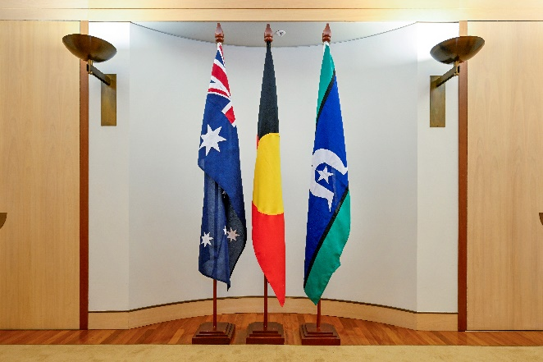
In a line of flagpoles of equal height, the order of the flags should follow the order of precedence. The Australian National Flag should always be flown on the far left (the position of honour) of a person facing the stage or press conference.
The Australian Aboriginal Flag and the Torres Strait Islander Flag may follow the Australian National Flag in either order as they are of equal precedence.
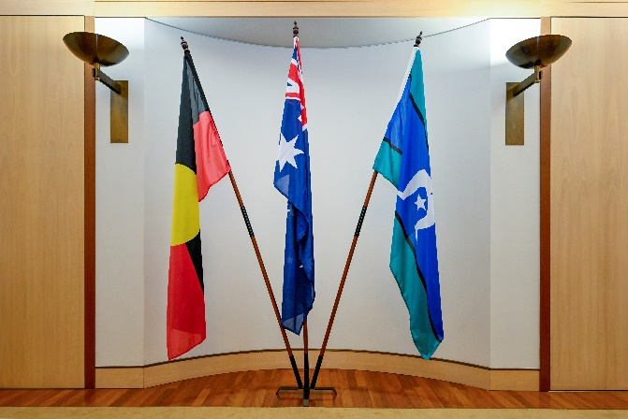
When displaying the Australian National Flag, the Australian Aboriginal Flag and the Torres Strait Islander Flag on a flag stand where the centre flagpole is highest, the Australian National Flag is placed in the centre. This applies if the centre flagpole is longer or if the flagpoles on either side are lower because they are tilted at an angle.
The Australian Aboriginal Flag and the Torres Strait Islander Flag may follow the Australian National Flag in either order as they are of equal precedence.

National flags and bilateral meetings
There are occasions, including bilateral meetings, where it is appropriate to display only the Australian National Flag with the national flag of a visiting country.
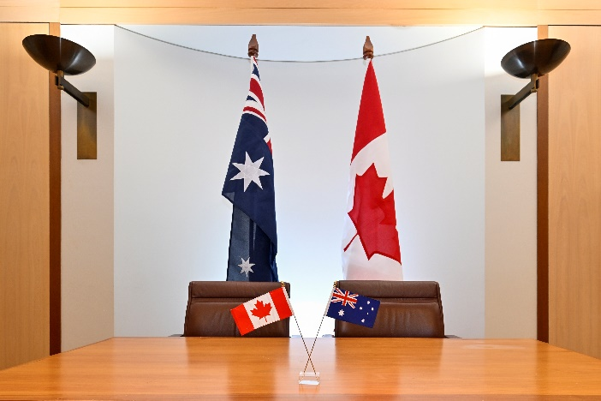
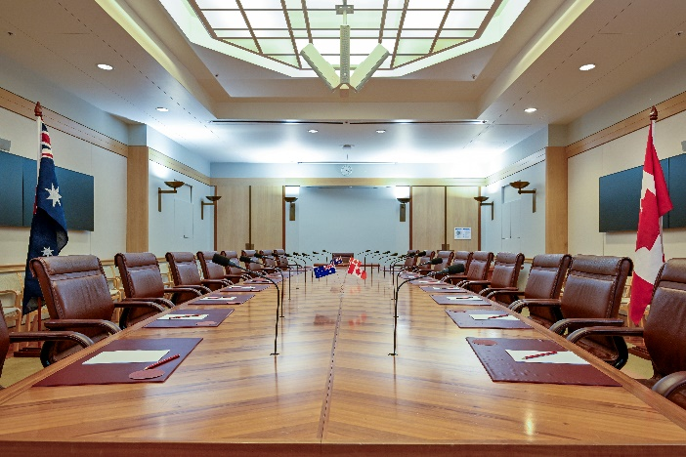
When the Australian National Flag is displayed with the national flag of another country, all the flags should, if possible, be the same size and flown on flagpoles of the same height. The Australian National Flag must take the position of honour on the left of a person facing the delegation leaders.
Should it be decided to place the flags of nations on a conference table, each flag should be placed in front of the leader of that country's delegation. The leader of the guest country’s delegation is seated on the left of a person facing the stage (Australian representative’s right side).
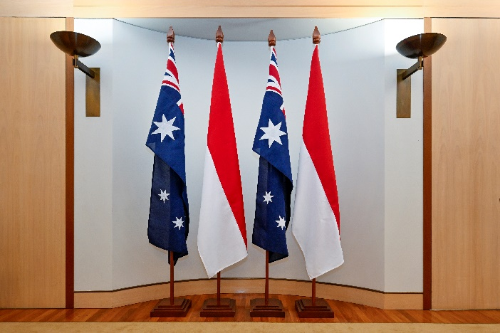
When displaying additional flags, multiple alternating national flags may be displayed in a single row.
There should be an even number of flags and the row should start with the Australian National Flag on the left.
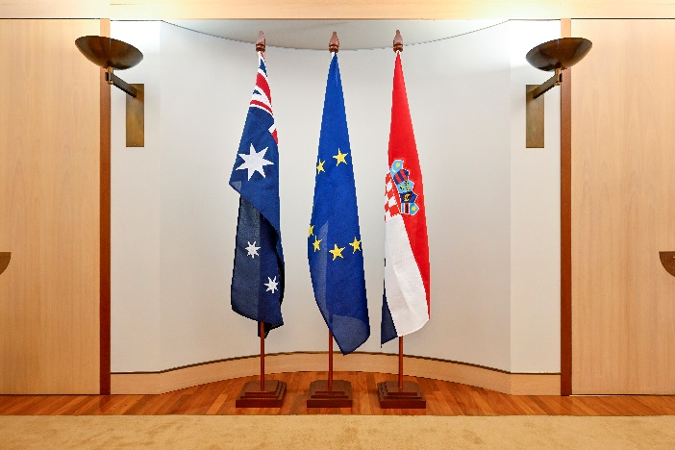
When hosting a meeting with a member state of the European Union (EU) there may be a requirement to display an EU Flag.
EU Flag requirements should be discussed with the appropriate representative of the visiting country.

Further questions
Queries about flag protocol can be directed to the Honours and Symbols Section, Department of the Prime Minister and Cabinet via email nationalsymbols@pmc.gov.au or phone 02 6271 5601.

