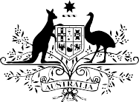
Gender Balance on Australian Government
Boards Report
2016-17
A report on the gender composition of Australian Government boards
© Commonwealth of Australia 2017

Gender Balance on Australian Government Boards Report 2016-17

978-1-925362-91-6 | Gender Balance on Australian Government Boards Report 2016-17 (Hardcopy)
978-1-925362-92-3 | Gender Balance on Australian Government Boards Report 2016-17 (PDF)
978-1-925362-93-0 | Gender Balance on Australian Government Boards Report 2016-17 (DOCX)

Copyright Notice
With the exception of the Commonwealth Coat of Arms, this work is licensed under a Creative Commons Attribution 4.0 International license (CC BY 4.0) (http://creativecommons.org/licenses/by/4.0/deed.en).
Third party copyright
Wherever a third party holds copyright in this material, the copyright remains with that party. Their permission may be required to use the material. Please contact them directly.

Attribution
This publication should be attributed as follows: Commonwealth of Australia, Department of the Prime Minister and Cabinet, Gender Balance on Australian Government Boards Report 2016-17.

Use of the Coat of Arms
The terms under which the Coat of Arms can be used are detailed on the following website: https://www.pmc.gov.au/government/its-honour.

Table of Contents
EXECUTIVE SUMMARY 4
GENDER BALANCE ON AUSTRALIAN GOVERNMENT BOARDS DATA 5
Overall Government Results 5
Portfolio Results 5
New Appointments 7
Chair and Deputy Chair Roles 8
External Nominations 9
APPENDIX 11
Gender Balance on Australian Government Boards Report 2016-17 – Guidelines 11

Executive Summary
The Gender Balance on Australian Government Boards Report is prepared annually by the Australian Government Office for Women, and reports on the Government’s performance against its gender diversity target.
On 1 July 2016, the Government’s new target of women holding 50 per cent of Government board positions overall, and men and women each holding at least 40 per cent of positions on individual boards, came into effect. This new target replaced the previous gender diversity target of women holding 40 per cent of Australian Government board positions overall.
This Report includes details of both whole-of-Government and individual portfolio performance against the Government’s gender diversity target in 2016-17. As at 30 June 2017, women held
42.7 per cent of Australian Government board positions. This is the highest outcome since public reporting on the gender balance of Government boards began in 2010-11.
Statistics on new appointments made in 2016-17 show how individual portfolios have progressed towards meeting the target. Of the 729 new appointments across Government made in 2016-17, 46.2 per cent of appointees were women. As at 30 June 2017, women comprised over 50 per cent of new appointments made by seven of the 18 portfolios.
In addition, the number of women across portfolios that hold Chair and Deputy Chair roles are reported. Specifically reporting on the number of women who hold these senior positions is important in understanding women’s representation at higher levels of leadership.
The scope of reporting on gender balance on Government boards is determined by the Gender Balance on Australian Government Boards Report 2016-17 – Guidelines (see Appendix).

Overall Government Results
As at 30 June 2017, there were 337 boards with a total of 2,508 members. Of these, 1,072 board members (42.7 per cent) were women. This compares to 30 June 2016, when there were 332 boards with a total of 2,351 members, 953 (40.5 per cent) of whom were women.
Table 1 details the number of boards, and the number and percentage of occupied positions, by gender, as at 30 June for the past four years.

Table 1 Gender balance on Australian Government boards
Year | Number of boards | Number of positions | Number of women | Number of men | % women
2017 | 337 | 2,508 | 1,072 | 1,436 | 42.7
2016 | 332 | 2,351 | 953 | 1,395 | 40.5
2015 | 361 | 2,570 | 1,005 | 1,565 | 39.1
2014 | 387 | 3,206 | 1,272 | 1,934 | 39.7

Portfolio Results
As at 30 June 2017, two portfolios out of 18 met or exceeded the new 50 per cent gender diversity target. A further 12 portfolios had between 40 and 50 per cent of their board positions held by women (see Figure 1 – page 6 and Table 2 – page 7).

Figure 1 Portfolio performance against the gender diversity target as at 30 June 2017
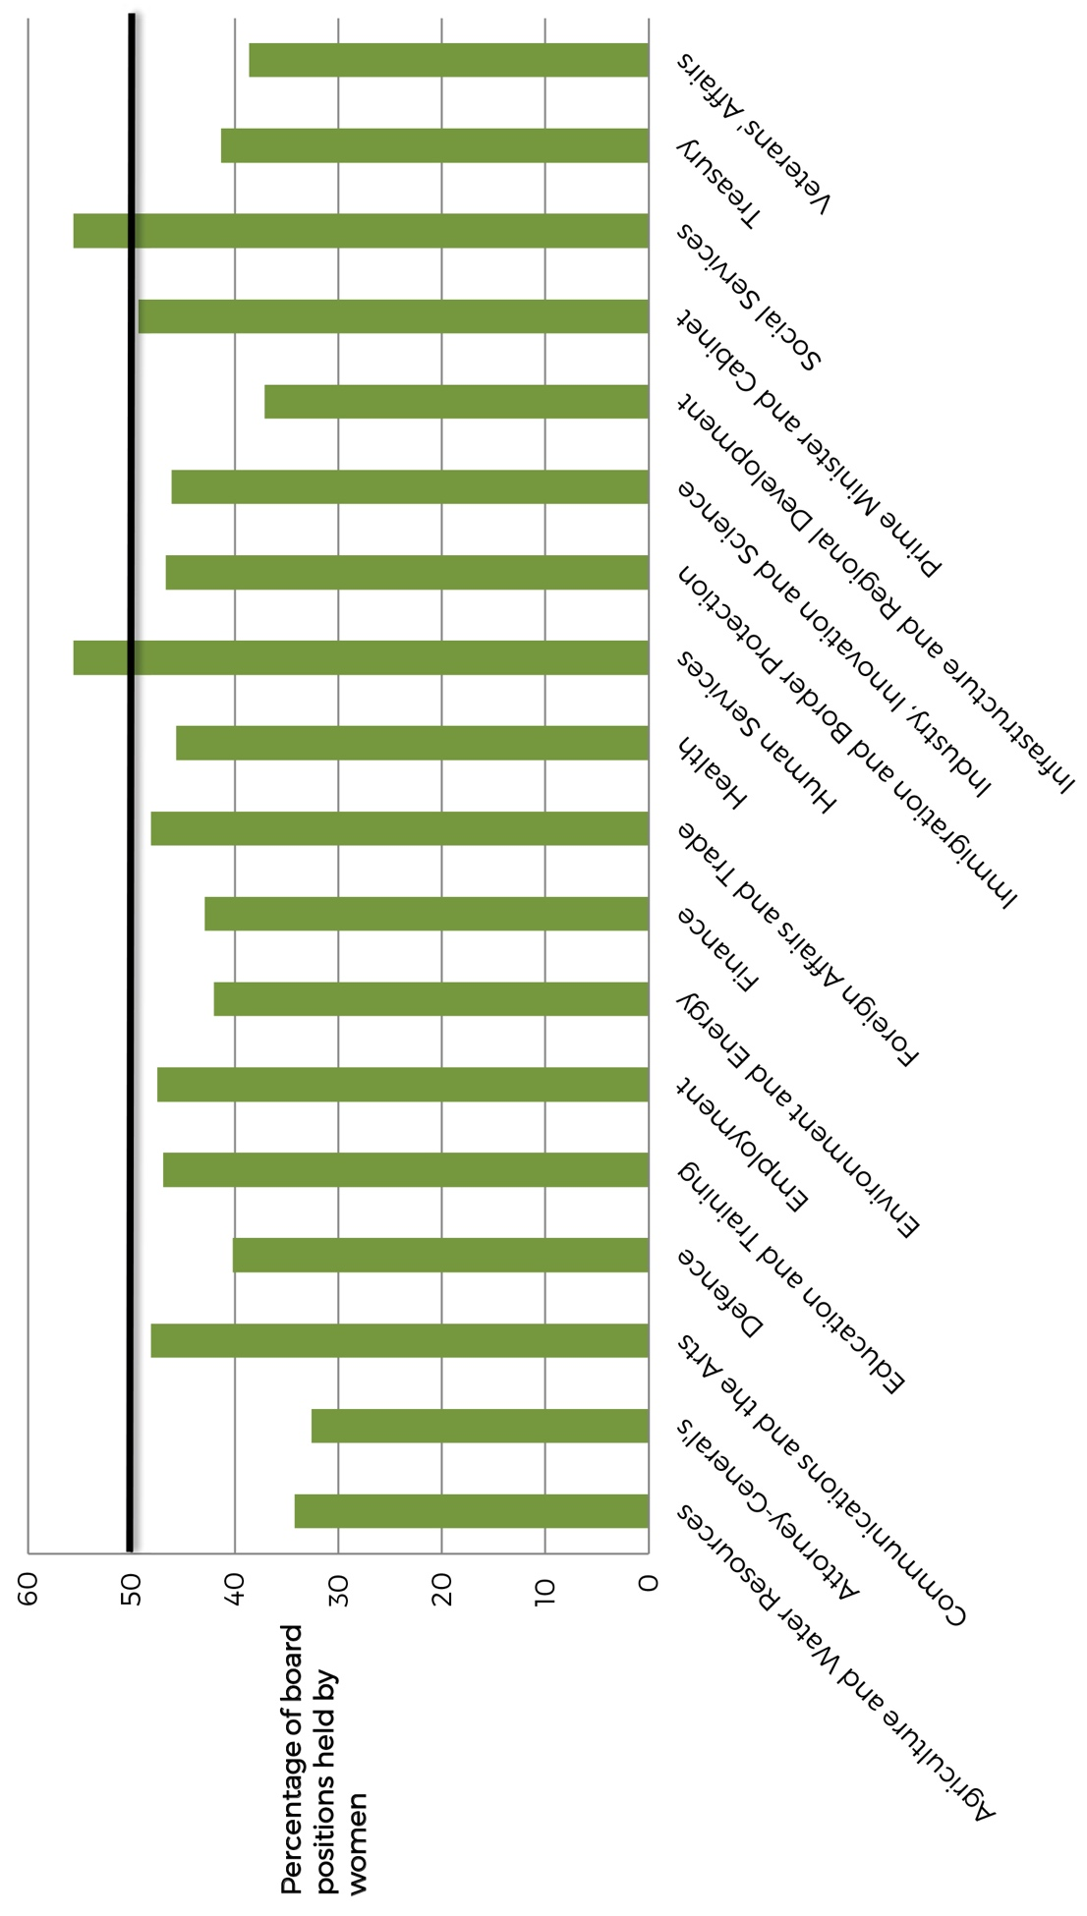

Table 2 Portfolio results as at 30 June 2017
Portfolio | Number of boards | Number of positions | Number of women | % women
Agriculture and Water Resources | 18 | 114 | 39 | 34.2
Attorney-General’s | 8 | 43 | 14 | 32.6
Communications and the Arts | 24 | 162 | 78 | 48.1
Defence | 18 | 102 | 41 | 40.2
Education and Training | 14 | 81 | 38 | 46.9
Employment | 7 | 61 | 29 | 47.5
Environment and Energy | 17 | 119 | 50 | 42.0
Finance | 6 | 21 | 9 | 42.9
Foreign Affairs and Trade | 20 | 162 | 78 | 48.1
Health | 49 | 444 | 203 | 45.7
Human Services | 2 | 9 | 5 | 55.6
Immigration and Border Protection | 2 | 15 | 7 | 46.7
Industry, Innovation and Science | 22 | 167 | 77 | 46.1
Infrastructure and Regional Development | 78 | 669 | 248 | 37.1
Prime Minister and Cabinet | 9 | 71 | 35 | 49.3
Social Services | 11 | 81 | 45 | 55.6
Treasury | 25 | 143 | 59 | 41.3
Veterans’ Affairs | 7 | 44 | 17 | 38.6
TOTAL | 337 | 2,508 | 1,072 | 42.7

New Appointments
New appointments are those appointments made over the 2016-17 financial year that were not reappointments of the same person to the same position.
Of the 729 new appointments made in 2016-17, 46.2 per cent of appointees were women.
This is slightly lower than the 2015-16 figure of 46.5 per cent. The individual portfolio results (see Table 3 – page 8) show that in 12 out of 18 portfolios there was an increase in the percentage of new appointees who were women. As at 30 June 2017, women comprised over 50 per cent of new appointments made by seven of the 18 portfolios.

Table 3 Gender balance of 2016-17 new appointments
Portfolio | Number of new appointments | Number of women | % women (2016-17) | % women (2015-16)
Agriculture and Water Resources | 19 | 9 | 47.4 | 38.9
Attorney-General’s | 8 | 3 | 37.5 | 42.9
Communications and the Arts | 10 | 6 | 60.0 | 54.5
Defence | 39 | 17 | 43.6 | 47.1
Education and Training | 33 | 14 | 42.4 | 14.3
Employment | 26 | 18 | 69.2 | 30.0
Environment and Energy | 15 | 10 | 66.7 | 42.1
Finance | 5 | 2 | 40.0 | 40.0
Foreign Affairs and Trade | 62 | 28 | 45.2 | 61.4
Health | 166 | 77 | 46.4 | 45.2
Human Services | 4 | 3 | 75.0 | 40.0
Immigration and Border Protection | 7 | 3 | 42.9 | 0.0
Industry, Innovation and Science | 63 | 29 | 46.0 | 40.8
Infrastructure and Regional Development | 186 | 72 | 38.7 | 45.2
Prime Minister and Cabinet | 25 | 13 | 52.0 | 51.2
Social Services | 25 | 16 | 64.0 | 66.7
Treasury | 32 | 13 | 40.6 | 53.3
Veterans’ Affairs | 4 | 4 | 100.0 | 53.9
TOTAL | 729 | 337 | 46.2 | 46.5

Chair and Deputy Chair Roles
As the most senior board members, the Chair and Deputy Chair are crucial to the functioning of every board. As at 30 June 2017, women held 31.8 per cent of Chair and Deputy Chair positions across all Government boards. This is a decrease of 0.2 percentage points since
2015-16.
Table 4 details the number of Chair and Deputy Chair positions, and the percentage of these positions held by women as at 30 June for the past four years. This data excludes Chief Executive Officer, Executive Director and Managing Director positions.
Table 4 Gender balance of Chair and Deputy Chair roles
Year | Total Chair/Deputy Chair positions | Number of women | Number of men | % women
2017 | 403 | 128 | 275 | 31.8
2016 | 425 | 136 | 289 | 32.0
2015 | 409 | 123 | 286 | 30.1
2014 | 455 | 140 | 315 | 30.8

External Nominations
The 2016-17 year is the first year that the Office for Women has collected and reported on external nominations (see Figure 2 – page 10).
An externally nominated appointment is an appointment made on the nomination of a State or Territory Government, a non-Government body, another Commonwealth Minister, or another portfolio. This includes appointments processes where it is either legislated or accepted practice for nominations to be provided to the Minister. While all nominations are reported, not all nominations made by external bodies resulted in the appointment of the nominee i.e. multiple nominations may be received for the same vacancy.
Of the 729 new appointments made in 2016-17, 115 were appointed following a nomination from an external body. Women accounted for 53 per cent of these nominations.

Figure 2 Percentage of women nominated by external bodies 2016-17
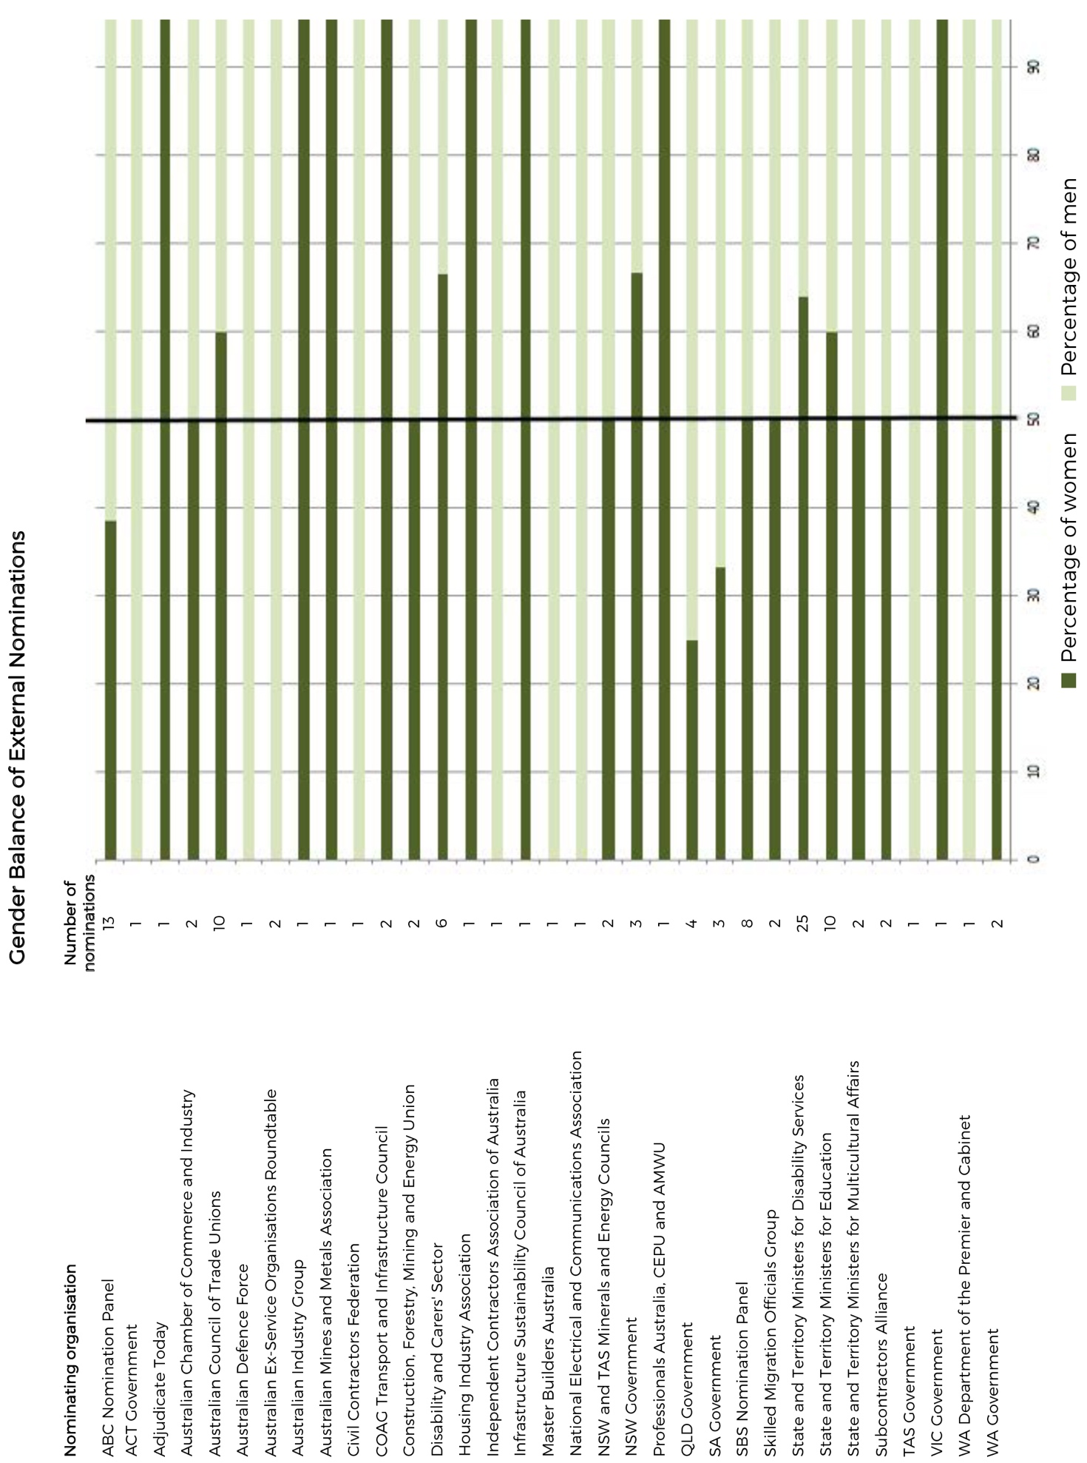

Appendix

Gender Balance on Australian Government Boards Report 2016-17 Guidelines
Not all appointments to all Government boards are reportable. Boards that are within the scope of the 2016-17 Gender Balance Report are as follows:
  - bodies covered by the Public Governance, Performance and Accountability Act 2013 (PGPA Act);
  - ministerial advisory committees;
  - review committees where the appointments are made by a minister or Cabinet; and
  - Commonwealth statutory authorities.
A list of the relevant entities that are subject to the PGPA Act can be found at: www.finance.gov.au/publications/flipchart/index.html.
Within this subset of boards, only appointments that have some level of input or sign-off from particular representatives of the Government are included, that is:
  - the Prime Minister alone;
  - one or more Commonwealth Government Ministers;
  - the Governor-General in Council; and
  - Cabinet.
The Report excludes appointments that are:
  - to a Commonwealth Court or Tribunal;
  - formally elected with no formal Government approval;
  - nominated by a third party with no formal Government approval;
  - of a particular office-holder to a particular board or committee required by legislation
(ex officio appointments);
  - appointed by an organisation without Government involvement;
  - nominated by a State or Territory Government without Commonwealth Government approval;
  - nominated by a government of another country without Commonwealth Government approval; or
  - acting appointments (appointments of six months or less).
Reportable appointments must have had a person filling the position as at 30 June 2017 to be included.
Employees engaged under the Public Service Act 1999 or other enabling legislation are not included unless the engagement is for the specific purpose of serving on a Commonwealth decision-making or advisory board, committee, council or similar.
Boards that comprise only one person are not included; however, boards that have several members and only one member is reportable are included.

New Appointments
New appointments are appointments made over the 2016-17 financial year, which fulfil all of the criteria above but do not require the successful candidate to have been formally working in the role at 30 June 2017. These do not include reappointments.

External Nominations
These are nominations for appointments that fulfil the criteria above and are received from a State or Territory Government, a non-Government body, another Commonwealth Minister, or another portfolio. They do not include appointments recommended by a Department, the Chair/CEO/Board of the body itself, or by two or more Ministers where one was the portfolio Minister. The nomination process could be either legislated or accepted practice.

