Gender Balance
on Australian Government Boards
Report 2017–18
A report on the gender
composition of Australian
Government boards
© Commonwealth of Australia 2018

Gender Balance on Australian Government Boards Report 2017–18
978-1-925363-61-6 Gender Balance on Australian Government Boards Report 2017–18 (Hardcopy)
978-1-925363-62-3 Gender Balance on Australian Government Boards Report 2017–18 (PDF)
978-1-925363-63-0 Gender Balance on Australian Government Boards Report 2017–18 (HTML)

Copyright Notice
With the exception of the Commonwealth Coat of Arms, this work is licensed under a Creative Commons Attribution 4.0 International licence (CC BY 4.0) (https://creativecommons.org/licenses/by/4.0/).

Third party copyright
Wherever a third party holds copyright in this material, the copyright remains with that party. Their permission may be required to use the material. Please contact them directly.

Attribution
This publication should be attributed as follows:
© Commonwealth of Australia, Department of the Prime Minister and Cabinet, Gender Balance on Australian Government Boards Report 2017–18.

Use of the Coat of Arms
The terms under which the Coat of Arms can be used are detailed on the following website: http://www.pmc.gov.au/government/its-honour.

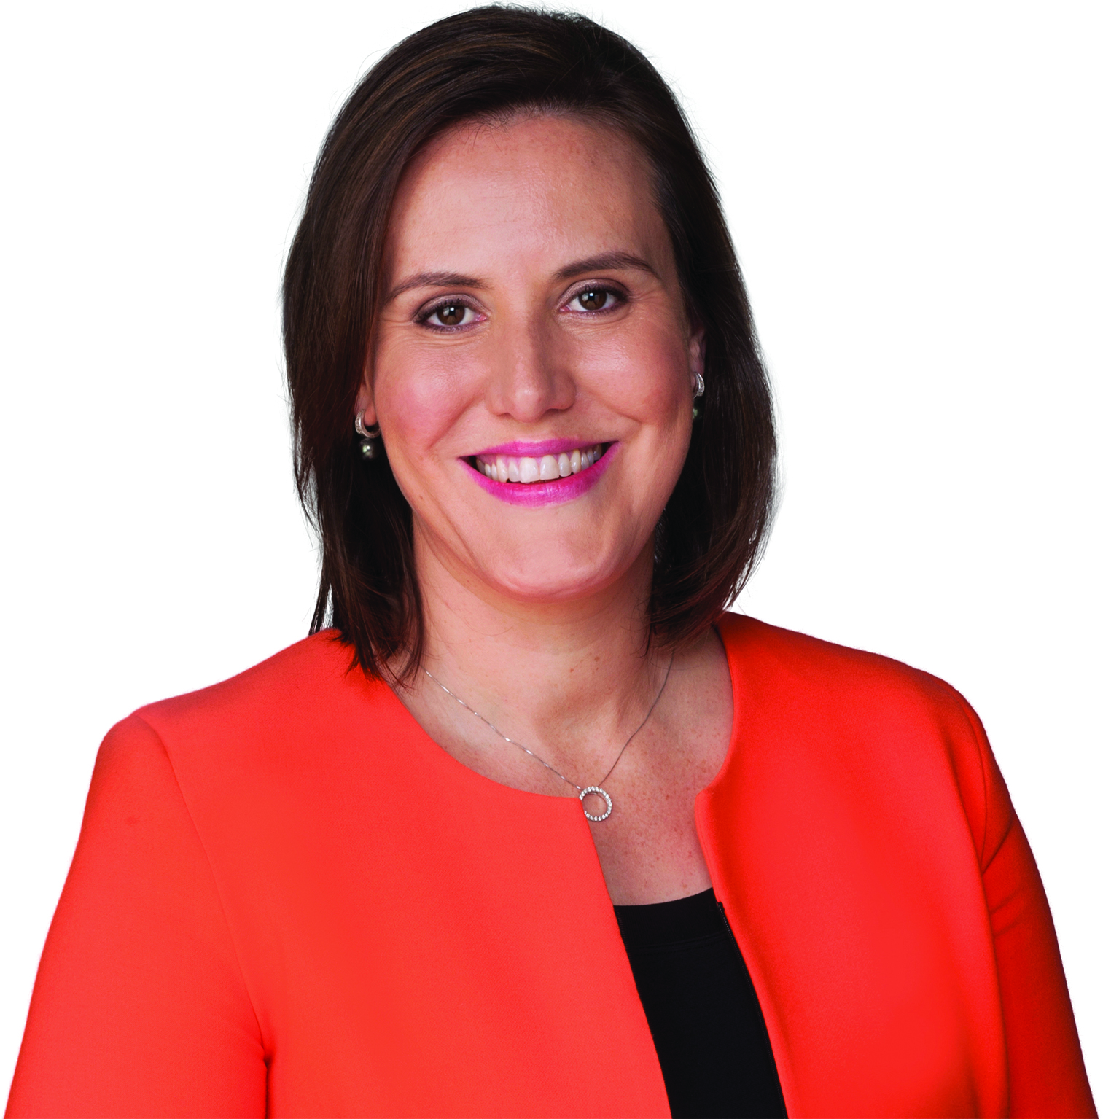
Foreword
As Minister for Women, one of my key priorities is to increase the number of women in leadership and decision-making positions in Australia.
A considerable body of evidence tells us that diversity on boards makes for stronger advice and solutions, more rapid innovation, and more productive stakeholder relationships, driving better overall performance.
For this reason, I am strongly committed to the Australian Government achieving its target of women holding 50 per cent of Government board positions overall, and men and women each holding at least 40 per cent of positions on individual boards.
I am delighted to report that the Australian Government is on track to achieve this gender diversity target. The statistics at 30 June 2018 show that women now hold 45.8 per cent of positions, an increase of 3.1 percentage points since 30 June 2017. This is the highest result since public reporting began in 2010–11.
My Ministerial colleagues are behind this important initiative and driving real progress. Six government portfolios have now reached or exceeded the 50 per cent target. A further four portfolios are within 5.0 percentage points of meeting the target.
This demonstrates the Government’s efforts to improve women’s representation on Government boards is having a real impact.
This builds on the strong female representation in the Commonwealth Public Service with women now comprising half of all Departmental Secretaries.
I will continue to work with my Ministerial colleagues and State and Territory Governments to improve the gender diversity of their nominations to Australian Government board positions.
Kind regards,
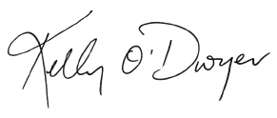
Kelly O’Dwyer
Minister for Jobs and Industrial Relations
Minister for Women

EXECUTIVE SUMMARY
The Gender Balance on Australian Government Boards Report is prepared annually by the Australian Government Office for Women, and reports on the Government’s performance against its gender diversity target.
On 1 July 2016, the Government’s target of women holding 50 per cent of Government board positions overall, and men and women each holding at least 40 per cent of positions on individual boards, came into effect. This target replaced the previous gender diversity target of women holding 40 per cent of Australian Government board positions overall.
This Report includes details of both whole-of-Government and individual portfolio performance against the Government’s gender diversity target in 2017–18. As at 30 June 2018, women held 45.8 per cent of Australian Government board positions. This is the highest outcome since public reporting on the gender balance of Government boards began.
Statistics on new appointments made in 2017–18 show how individual portfolios have progressed towards meeting the target. Of the 542 new appointments made in 2017–18, 53.1 per cent of appointees were women. This is higher than the 2016–17 figure of 46.2 per cent. The individual portfolio results as at 30 June 2018, women comprised 50 per cent and over of new appointments made by 11 of the 16 portfolios.
In addition, the number of women across portfolios that hold Chair and Deputy Chair roles are reported. Specifically reporting on the number of women who hold these senior positions is important in understanding women’s representation at higher levels of leadership.
Due to Ministerial and portfolio changes made in December 2017 some individual portfolio data in this report may not comparable with the 2016–17 individual portfolio data.
The portfolios that are not comparable are as follows:
- The Defence portfolio combined the Department of Defence and the Department of Veteran Affairs to be reported together in the 2017–18 Report.
- The Home Affairs portfolio replaced Immigration and Border Protection.
- The Jobs and Innovation portfolio replaced Employment and combined the Department of Jobs and Small Business and the Department of Industry, Innovation and Science to be reported together in the 2017–18 Report.
The scope of reporting on gender balance on Government boards is determined by the Gender Balance on Australian Government Boards Report 2017–18 — Guidelines (see Appendix).

GENDER BALANCE ON AUSTRALIAN GOVERNMENT BOARDS DATA

Overall Government Results
As at 30 June 2018, there were 339 boards with a total of 2,530 members. Of these, 1,158 board members (45.8 per cent) were women. This compares to 30 June 2017, when there were 337 boards with a total of 2,508 members, 1,072 (42.7 per cent) of whom were women.
Table 1 details the number of boards, and the number and percentage of occupied positions, by gender, as at 30 June for the past four years.
Table 1: Gender balance on Australian Government boards
Year | Number  of boards | Number of positions | Number of women | Number of men | % women
2018 | 339 | 2,530 | 1,158 | 1,372 | 45.8
2017 | 337 | 2,508 | 1,072 | 1,436 | 42.7
2016 | 332 | 2,351 | 953 | 1,395 | 40.5
2015 | 361 | 2,570 | 1,005 | 1,565 | 39.1
2014 | 387 | 3,206 | 1,272 | 1,934 | 39.7

Portfolio Results
As at 30 June 2018, six portfolios out of 16 met or exceeded the 50 per cent gender diversity target. A further nine portfolios had between 40 and 50 per cent of their board positions held by women (see Figure 1 – page 4 and Table 2 – page 5).
Figure 1: Portfolio performance against the gender diversity target as at 30 June 2018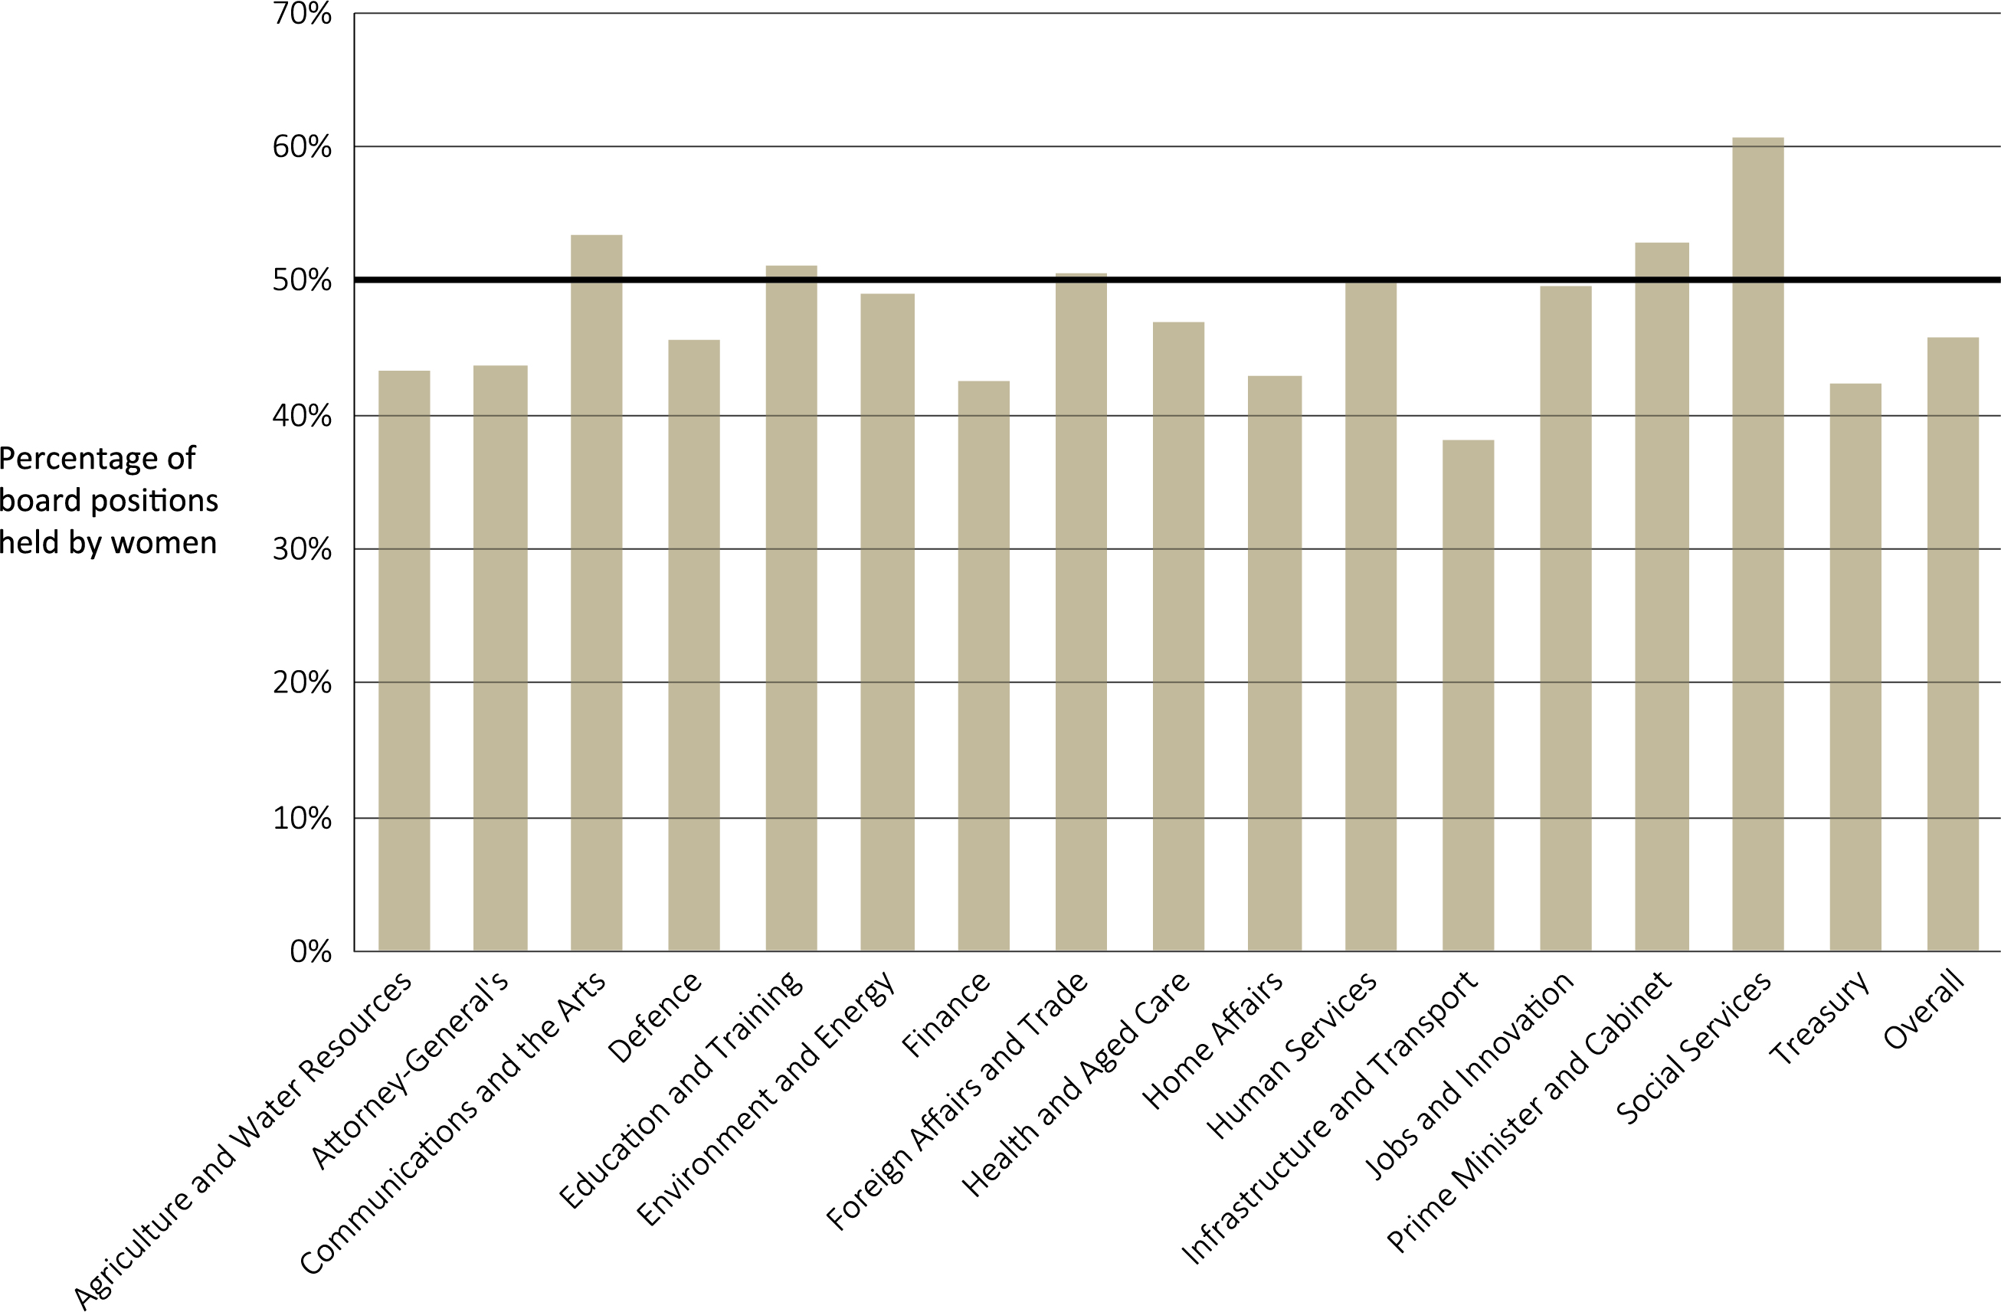
Table 2: Portfolio results as at 30 June 2018
Portfolio | Number of boards | Number of positions | Number of women | % women
Agriculture and Water Resources | 19 | 97 | 42 | 43.3
Attorney-General’s | 6 | 39 | 17 | 43.6
Communications and the Arts | 26 | 167 | 89 | 53.3
Defence | 25 | 147 | 67 | 45.6
Education and Training | 15 | 94 | 48 | 51.1
Environment and Energy | 15 | 102 | 50 | 49.0
Finance | 7 | 40 | 17 | 42.5
Foreign Affairs and Trade | 21 | 164 | 83 | 50.6
Health | 49 | 539 | 252 | 46.8
Home Affairs | 2 | 21 | 9 | 42.9
Human Services | 2 | 10 | 5 | 50.0
Infrastructure, Regional Development & Cities | 80 | 610 | 232 | 38.0
Jobs and Innovation | 31 | 234 | 116 | 49.6
Prime Minister and Cabinet | 8 | 51 | 27 | 52.9
Social Services | 9 | 71 | 43 | 60.6
Treasury | 24 | 144 | 61 | 42.3
TOTAL | 339 | 2,530 | 1,158 | 45.8

New Appointments
New appointments are those appointments made over the 2017–18 financial year that were not reappointments of the same person to the same position.
Of the 542 new appointments made in 2017–18, 53.1 per cent of appointees were women. This is higher than the 2016–17 figure of 46.2 per cent. The individual portfolio results (see Table 3 – page 6), as at 30 June 2018, women comprised 50 per cent and over of new appointments made by 11 of the 16 portfolios.

Table 3: Gender balance of 2017–18 new appointments
Portfolio | Number of new appointments | Number of women | % women (2017–18)
Agriculture and Water Resources | 41 | 20 | 48.8
Attorney-General's | 13 | 7 | 53.8
Communications and the Arts | 47 | 30 | 63.8
Defence | 24 | 12 | 50.0
Education and Training | 61 | 34 | 55.7
Environment and Energy | 23 | 14 | 60.9
Finance | 12 | 5 | 41.7
Foreign Affairs and Trade | 41 | 24 | 58.5
Health | 101 | 52 | 51.5
Home Affairs | 15 | 7 | 46.7
Human Services | 4 | 2 | 50.0
Infrastructure, Regional Development & Cities | 79 | 37 | 46.8
Jobs and Innovation | 41 | 23 | 56.1
Prime Minister and Cabinet | 4 | 3 | 75.0
Social Services | 17 | 9 | 52.9
Treasury | 19 | 9 | 47.4
TOTAL | 542 | 288 | 53.1

Chair and Deputy Chair Roles
As the most senior board members, the Chair and Deputy Chair are crucial to the functioning of every board. As at 30 June 2018, women held 35.0 per cent of Chair and Deputy Chair positions across all Government boards. This is an increase of 3.2 percentage points since 2016–17.
Table 4 details the number of Chair and Deputy Chair positions, and the percentage of these positions held by women as at 30 June for the past four years. This data excludes Chief Executive Officer, Executive Director and Managing Director positions.

Table 4: Gender balance of Chair and Deputy Chair roles
Year | Total Chair/  Deputy Chair positions | Number  of women | Number  of men | % women
2018 | 389 | 136 | 253 | 35.0
2017 | 403 | 128 | 275 | 31.8
2016 | 425 | 136 | 289 | 32.0
2015 | 409 | 123 | 286 | 30.1
2014 | 455 | 140 | 315 | 30.8

External Nominations
An externally nominated appointment is an appointment made on the nomination of a State or Territory Government, a non-Government body, another Commonwealth Minister, or another portfolio. This includes appointments processes where it is either legislated or accepted practice for nominations to be provided to the Minister. While all nominations are reported, not all nominations made by external bodies resulted in the appointment of the nominee i.e. multiple nominations may be received for the same vacancy.
Of the 542 new appointments made in 2017–18, 95 were appointed following a nomination from an external body. Women accounted for 44 per cent of these nominations (see Figure 2 – page 8). This is a decrease of 9 percentage points since 2016–17.
Figure 2: Percentage of women nominated by external bodies 2017–18
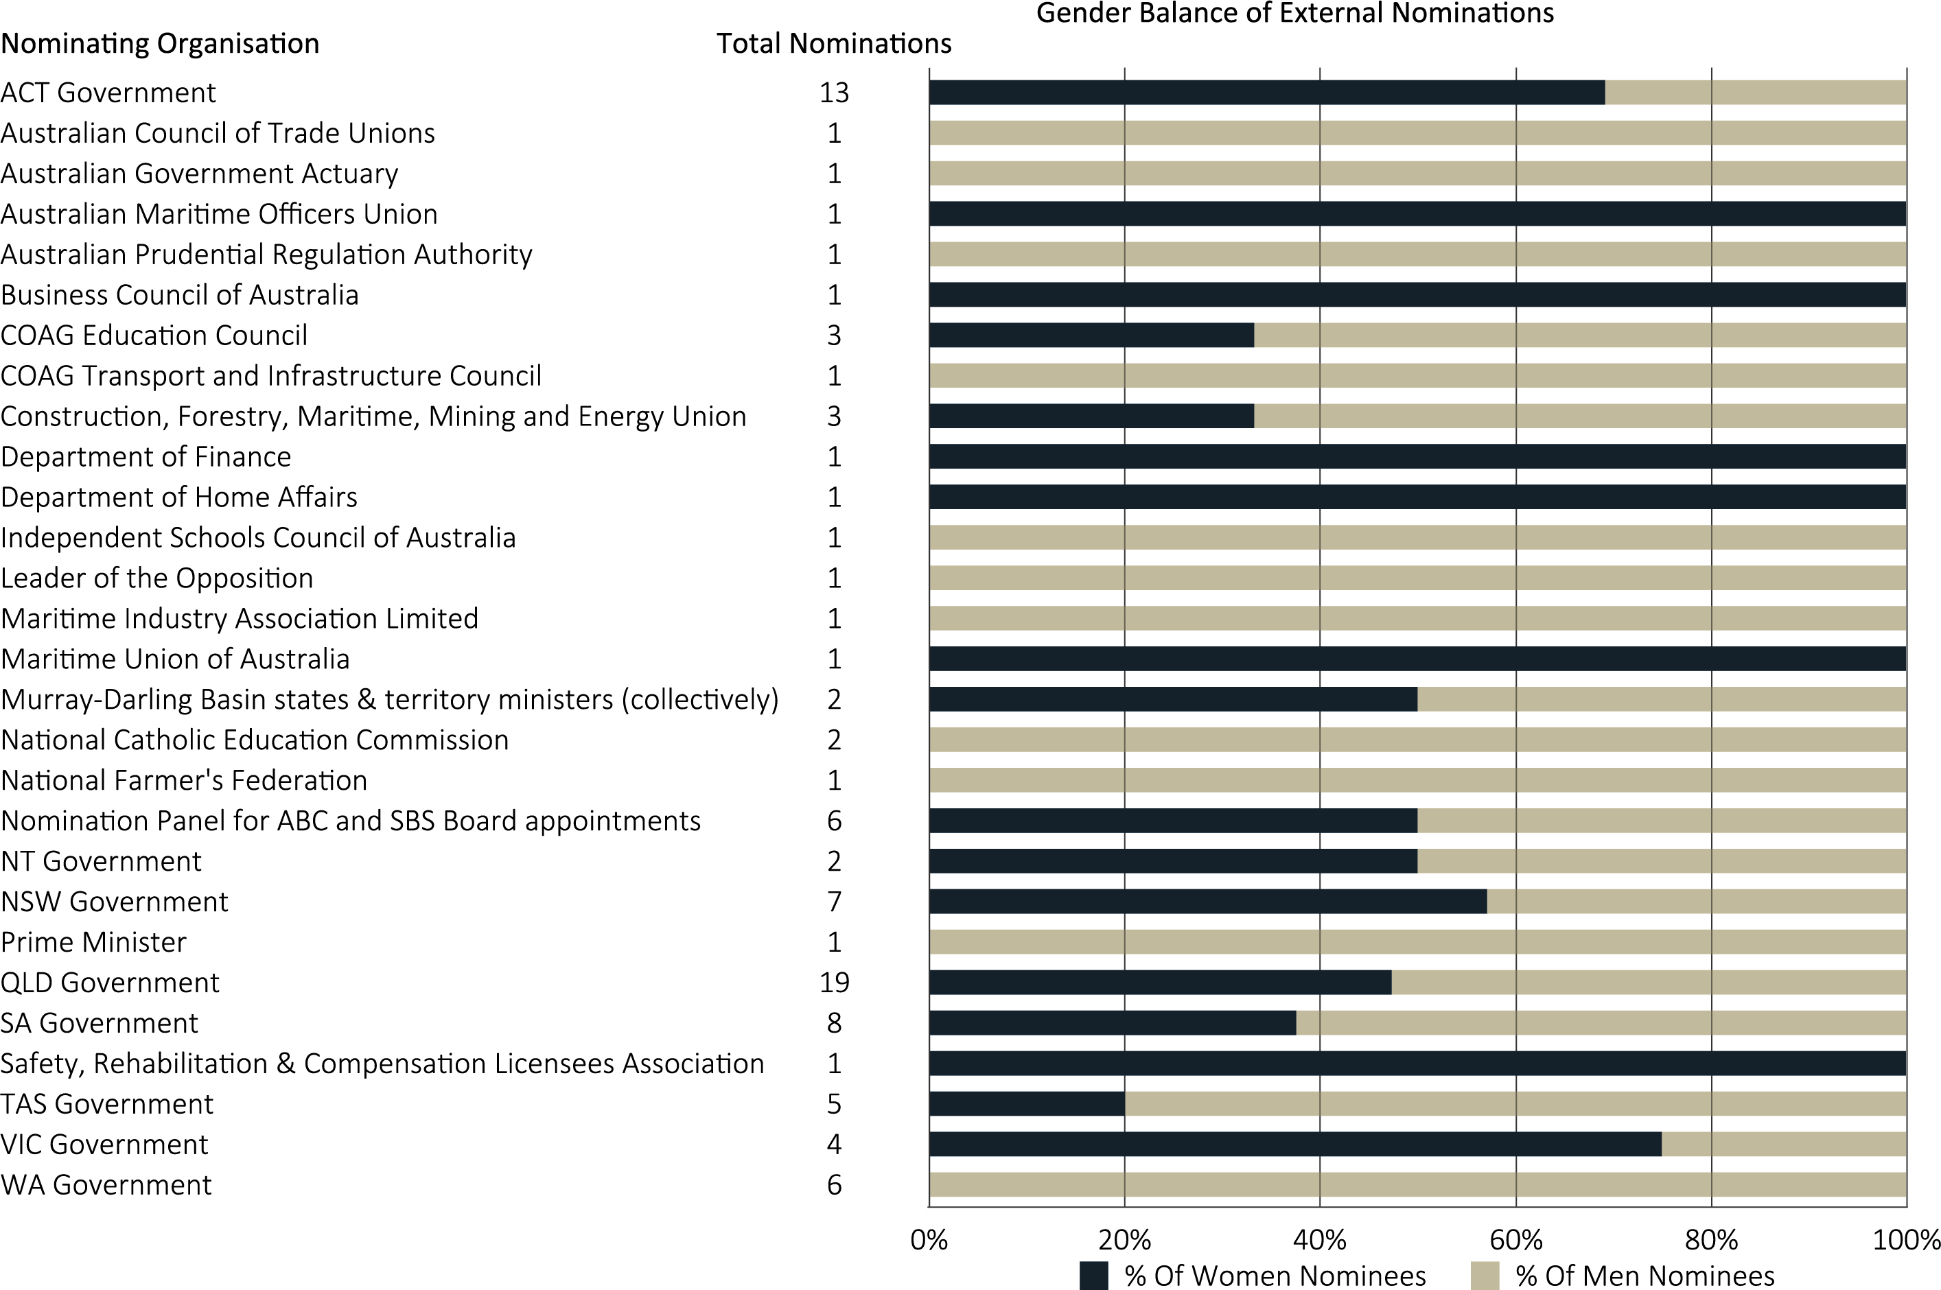

APPENDIX

Gender Balance on Australian Government Boards Report 2017–18 — Guidelines
Not all appointments to all Government boards are reportable. Boards that are within the scope of the 2017–18 Gender Balance Report are as follows:
- bodies covered by the Public Governance, Performance and Accountability Act 2013 (PGPA Act);
- ministerial advisory committees;
- review committees where the appointments are made by a minister or Cabinet; and
- Commonwealth statutory authorities.
A list of the relevant entities that are subject to the PGPA Act can be found at: www.finance.gov.au/publications/flipchart/index.html.
Within this subset of boards, only appointments that have some level of input or sign-off from particular representatives of the Government are included, that is:
- the Prime Minister alone;
- one or more Commonwealth Government Ministers;
- the Governor-General in Council; and
- Cabinet.
The Report excludes appointments that are:
- to a Commonwealth Court or Tribunal;
- formally elected with no formal Government approval;
- nominated by a third party with no formal Government approval;
- of a particular office-holder to a particular board or committee required by legislation (ex officio appointments);
- appointed by an organisation without Government involvement;
- nominated by a State or Territory Government without Commonwealth Government approval;
- nominated by a government of another country without Commonwealth Government approval; or
- acting appointments (appointments of six months or less).
Reportable appointments must have had a person filling the position as at 30 June 2017 to be included.
Employees engaged under the Public Service Act 1999 or other enabling legislation are not included unless the engagement is for the specific purpose of serving on a Commonwealth decision-making or advisory board, committee, council or similar.
Boards that comprise only one person are not included; however, boards that have several members and only one member is reportable are included.

New Appointments
New appointments are appointments made over the 2017–18 financial year, which fulfil all of the criteria above but do not require the successful candidate to have been formally working in the role at 30 June 2018. These do not include reappointments.

External Nominations
These are nominations for appointments that fulfil the criteria above and are received from a State or Territory Government, a non-Government body, another Commonwealth Minister, or another portfolio. They do not include appointments recommended by a Department, the Chair/CEO/Board of the body itself, or by two or more Ministers where one was the portfolio Minister. The nomination process could be either legislated or accepted practice.

