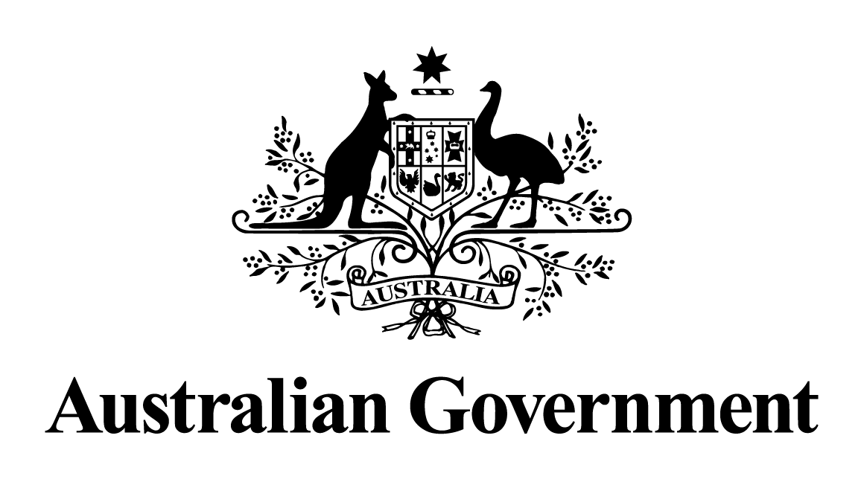
Australian Government Response to the
Parliamentary Joint Committee on Intelligence and Security Report:

Review of Administration and Expenditure: No. 20 (2020-2021) – Australian Intelligence Agencies

Australian Government response to the Parliamentary Joint Committee on Intelligence and Security report

Review of Administration and Expenditure: No. 20 (2020-2021) – Australian Intelligence Agencies

Recommendations

Recommendation 1

The Committee recommends the Australian Government amend the Auditor General Act 1997 and the Intelligence Services Act 2001, as necessary, to enable the Auditor-General to:
• undertake audits on matters related to National Intelligence Community agencies where the Auditor-General regards this as appropriate; providing that classified reports of such audits are to be presented to Parliament via submission to the Parliamentary Joint Committee on Intelligence and Security, and are exempt from presentation to the House of Representatives and Senate (to the extent they contain classified material); and
• provide the Parliamentary Joint Committee on Intelligence and Security with copies of classified ANAO reports provided to relevant ministers relating to the agencies under the Committee’s oversight, where the Auditor-General regards this as appropriate, and subject to the relevant provisions of the Intelligence Services Act 2001 governing the provision of information to the Committee.

The Government notes the Committee’s recommendation.

It is critical in a democracy that intelligence agencies are subject to strong and effective oversight and accountability mechanisms. The 2017 Independent Intelligence Review acknowledged the broad architecture of the current intelligence oversight system “remains appropriate”, balancing the need for secrecy and the requirement for robust accountability. Nevertheless, the 2017 Independent Intelligence Review did recommend changes to components of that system. The Government subseqeuntly introduced the Intelligence Services Legislation Amendment Bill 2023 on 22 June 2023, which will continue to enhance oversight by expanding the jurisdictions of the Inspector-General of Intelligence and Security (IGIS) and the Parliamentary Joint Committee on Intelligence and Security (PJCIS).

The Government notes the terms of reference for the 2024 Independent Intelligence Review includes that it will consider “whether current oversight and evaluation mechanisms are effective and consistent across the National Intelligence Community (NIC)”. Government will await any recommendations from the 2024 Independent Intelligence Review before considering any further alterations to oversight mechanisms.

Recommendation 2

The Committee recommends the Australian Government amend legislation to enable classified annual reports of intelligence agencies subject to review of Administration and Expenditure under the Intelligence Services Act 2001 to be provided to the Parliamentary Joint Committee on Intelligence and Security.

The Government notes the Committee’s recommendation.

There is no Intelligence Services Act 2001 legislated requirement for agencies to produce classified annual reports. Were an agency to produce a classified report, section 29 (1)(b) of the Intelligence Services Act 2001 stipulates that the Parliamentary Joint Committee on Intelligence and Security can review any matter in relation to intelligence agencies referred to the Committee by the responsible Minister or the Attorney-General or a resolution of either House of the Parliament.

Recommendation 3

The Committee recommends that the Office of National Intelligence work with the National Intelligence Community (NIC) to develop consistent data collection on staff movement and staff retention, and work to develop a whole-of-NIC strategy to improve attraction and retention. The Committee recommends that the Office of National Intelligence update the Committee in 12 months on its progress in this area.

The Government accepts in principle the Committee’s recommendation.

The Government notes the terms of reference for the 2024 Independent Intelligence Review include to consider “whether workforce decisions by the NIC at both the agency and community levels reflect a sufficiently strategic response to current and future workforce challenges, anticipate future capabilities of other states so we are best positioned to counter threats, are in line with the Australian Public Service commitments to diversity and inclusion and offer options if recruitment targets cannot be met”.
Government will await any recommendations from the 2024 Independent Intelligence Review before providing an update to the Committee on workforce considerations and strategy.

Recommendation 4

The Committee recommends that the Director-General of Security consider reporting publicly, when appropriate opportunities arise, on the prevalence of disinformation, misinformation and harmful propaganda that threaten Australia’s national security, their sources, and strategies undertaken by intelligence agencies to reduce their impact.

The Government accepts the Committee’s recommendation.

The Director-General of Security will consider reporting publicly about disinformation, misinformation and harmful propaganda that threaten Australia’s national security where relevant to ASIO’s heads of security as defined in the Australian Security Intelligence Organisation Act 1979, and when in line with Australia’s national interest.

