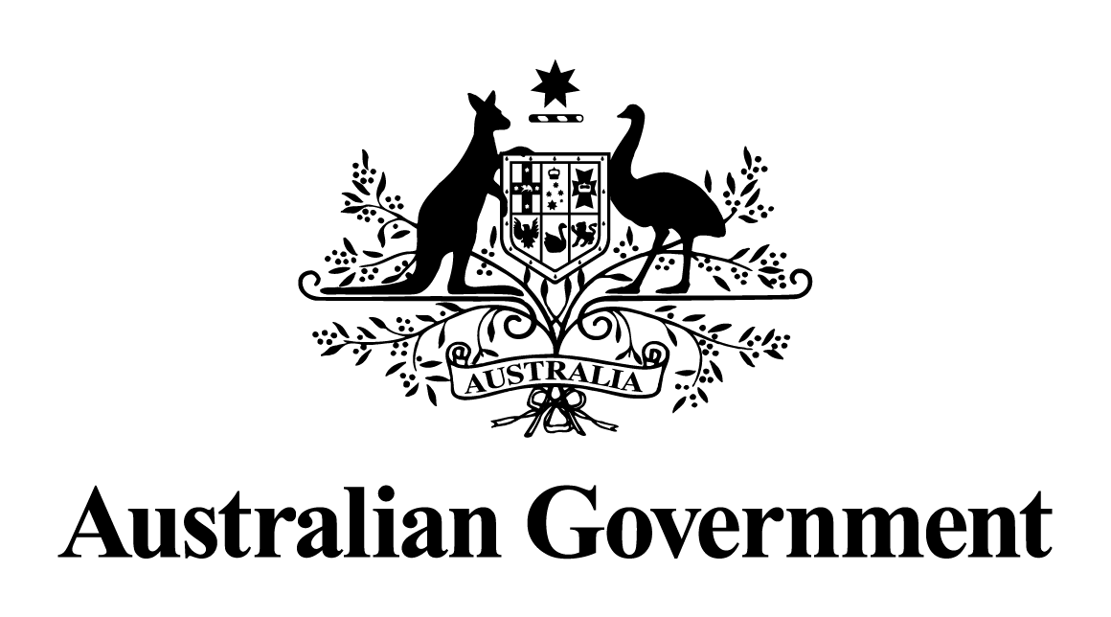

# Australian Government response to the Parliamentary Joint Committee on Intelligence and Security report:

# Reviews of Administration and Expenditure: No. 18 (2018-2019) and No. 19 (2019-2020) – Australian Intelligence Agencies.

February 2022

## Recommendations

### Recommendation 1

* The Committee recommends that the Australian Government resource the Office of National Intelligence to consider the potential scope of a shared psychological support service for all National Intelligence Community agencies to access for mental health support of staff.
* This shared service could be scoped in line with potential study support for psychology post-graduate students to become clinical practitioners within the support service upon completion of the supported study.

#### The Government agrees to this recommendation in principle.

Due to the nature of the work undertaken by its employees, the NIC is acutely aware of the need to be proactive in supporting employees’ wellbeing. Taking into account the findings of the Productivity Commission Inquiry Report into Mental Health and the National Suicide Prevention Adviser’s recommendations, together with the existing mechanisms within agencies to support staff well-being and security requirements, including mental health and psychological support services, the Office of National Intelligence (ONI) agrees to investigate the establishment of a shared NIC employee assistance program (EAP) Standing Offer Panel.

As part of its leadership and coordination role, ONI will continue to broaden its endeavours to promote careers in psychology in the NIC, such as by supporting psychology students through the provision of clinical placements (as required for postgraduate studies towards the award of Master of Clinical Psychology) across the NIC, and offering study support.

### Recommendation 2

* The Committee recommends that the Australian Government investigate the establishment of a staff support advice Ombudsman service for access by employees of all National Intelligence Community agencies.

#### The Government agrees to this recommendation.

The Office of National Intelligence will investigate the merits of and requirements for a staff support advice Ombudsman service taking into account the role of the Inspector-General of Intelligence and Security (IGIS) and the varying employment law frameworks and staff grievance processes across the intelligence community.

### Recommendation 3

* The Committee recommends that the Australian Government investigate the creation of a mechanism to enable National Intelligence Community agencies to apply to have an individual who lodges persistent and repeated applications and appeals for access to historical ‘open access’ material under the Archives Act 1983 to be declared vexatious. This mechanism could be created in similar terms to those provided under Part VIII, Division 1 of the Freedom of Information Act 1982.
* Alternately, if the above is not supported, then the Committee recommends that additional resourcing be provided to National Intelligence Community xiv agencies that identify these issues in Budget bids, to address ongoing and persistent applications and appeals.

#### The Government notes this recommendation.

The Government acknowledges the resourcing implications for NIC agencies of high-volume applicants under the *Archives Act 1983*. As part of implementing the Government’s response to the Tune Review, the Attorney-General’s Department is considering potential *Archives Act* reform and will consider the issue identified in Recommendation 3 as part of this process.

### Recommendation 4

* The Committee recommends that the Australian Government resource the Office of National Intelligence to conduct an enterprise-wide review of lessons learned from the initial and ongoing response to the COVID-19 pandemic in the next 18 months. This review should then be provided to all National Intelligence Community agencies for consideration, development and implementation.
* A copy of the full classified review report should be provided to the Committee for information and consideration during the relevant Administration and Expenditure Review in which its conclusion falls.

#### The Government notes this recommendation.

The Office of National Intelligence (ONI) undertook a lessons-learned exercise in conjunction with the National Intelligence Community (NIC) on the impact of COVID-19, noting that each agency’s response has been tailored to its specific geographic footprint and operational model. ONI continues to engage with NIC agencies to refine and adjust processes as required through existing governance mechanisms.