2014 Progress Report

Australian National Action Plan on Women,
Peace and Security 2012-2018

© Commonwealth of Australia 2014
ISBN 978-1-922098-64-1 2014 Progress Report Australian National Action Plan on Women,
Peace and Security 2012–2014 (Hardcopy)

ISBN 978-1-922098-65-8 2014 Progress Report Australian National Action Plan on Women,
Peace and Security 2012–2014 (PDF)

ISBN 978-1-922098-66-5 2014 Progress Report Australian National Action Plan on Women,
Peace and Security 2012–2014 (RTF)
Ownership of intellectual property rights in this publication
Unless otherwise noted, copyright (and any other intellectual property rights, if any) in this publication is owned by the Commonwealth of Australia (referred to below as the Commonwealth).
Creative Commons licence
With the exception of the Coat of Arms, this publication is licensed under a Creative Commons Attribution 3.0 Australia Licence.
Creative Commons Attribution 3.0 Australia Licence is a standard form license agreement that allows you to copy, distribute, transmit and adapt this publication provided that you attribute the work. A summary of the licence terms is available from http://creativecommons.org/licenses/by/3.0/au/deed.en.
The full licence terms are available from http://creativecommons.org/licenses/by/3.0/au/legalcode.
The Commonwealth’s preference is that you attribute this publication (and any material sourced from it) using the following wording:
Source: Licensed from the Commonwealth of Australia under a Creative Commons Attribution 3.0 Australia Licence.
The Commonwealth of Australia does not necessarily endorse the content of this publication.
Use of the Coat of Arms
The terms under which the Coat of Arms can be used are set out on the Department of the Prime Minister and Cabinet website (see http://www.dpmc.gov.au/guidelines/).
2014 Progress Report
Australian National Action Plan
on Women, Peace and Security 2012-2018

Minister’s Foreword
The Australian Government recognises that armed conflict has devastating repercussions for societies. Women and girls are disproportionately affected in conflict and post-conflict settings and – tragically – are often subjected to gross human rights violations, including sexual and gender-based violence being used as a weapon of war. As the Minister Assisting the Prime Minister for Women, I want to see effective justice for all people affected by sexual violence.
I also want to see women take their rightful place at the peace negotiation table as we know that women’s exclusion from the peace process leads to exclusion from the all-important reconstruction efforts. We know that women’s participation in institutional reform facilitates greater access to justice for women who have been subjected to human rights violations and thus their inclusion in this process is vital.
United Nations Security Council Resolution 1325 on Women, Peace and Security (UNSCR1325) was adopted almost 14 years ago. It set an historic precedent in recognising the central role of women to the development and maintenance of international peace and security, and calling for an end to the impunity of sexual-based violence in conflict situations.
The Australian Government’s strong commitment to UNSCR 1325 and the Women, Peace and Security agenda is affirmed through the Australian National Action Plan on Women, Peace and Security 2012-2018 (the National Action Plan). The National Action Plan establishes a clear framework for a coordinated, whole of government approach to implementing the Women, Peace and Security agenda, and commits Australia to specific actions to ensure a gender perspective is considered in peace and security processes both domestically and overseas.
This is the first Progress Report of the National Action Plan. Importantly, this report provides the first comprehensive picture of the actions undertaken across the whole of government to implement the Women, Peace and Security agenda from the commencement of the National Action Plan in March 2012 until 31 December 2014. It also establishes baseline data from which to measure future progress against our responsibilities under the National Action Plan.
I am pleased to see the breadth of work being implemented across government under the National Action Plan and I look forward to continuing to work with both civil society and across government with my Ministerial colleagues to build on the progress we have made thus far.
I am also proud that Australia is an active agent in providing better outcomes for women and girls in conflict and post-conflict settings, and of our place as one of the global leaders in relation to the Women, Peace and Security agenda.
Senator the Hon Michaelia Cash
Minister Assisting the Prime Minister for Women
Assistant Minister for Immigration and Border Protection

Regularly used Acronyms
ACC | Australian Civilian Corps
ACMC | Australian Civil-Military Centre
ADF | Australian Defence Force
AFP | Australian Federal Police
AGD | Attorney-General’s Department
APS | Australian Public Service
AusAID | Former Australian Agency for International Development
CEDAW | Convention on the Elimination of All Forms of Discrimination against Women
CSW | United Nations Commission on the Status of Women
DFAT | Department of Foreign Affairs and Trade
GenCap | Gender Standby Capacity Project
IDG | International Deployment Group (Australian Federal Police)
NATO | North Atlantic Treaty Organisation
PMC | Department of the Prime Minister and Cabinet
PPDPR | Pacific Police Development Programme (Regional)
RAMSI | Regional Assistance Mission to Solomon Islands
UN | United Nations
UNHCR | United Nations High Commissioner for Refugees
UNSCR | United Nations Security Council Resolution

Contents
Minister’s Foreword | 3
Regularly used Acronyms | 4
Contents | 5
Overview | 6
Background | 7
Women, Peace and Security | 7
UN Security Council Resolutions on Women, Peace and Security | 7
Australia’s National Action Plan | 8
Inter-departmental Working Group | 8
Reporting and Reviews | 8
Accountability | 9
Civil Society Engagement | 10
Progress Report | 11
Strategy 1 | 12
Strategy 2 | 14
Strategy 3 | 20
Strategy 4 | 29
Strategy 5 | 47
Additional Case Studies | 49
Next Steps | 51
Further information | 54
Annex A | 55
Annex B | 58
Annex C | 69

Overview
The Australian National Action Plan Women on Peace and Security 2012–2018 (National Action Plan) is a Whole-of-Government policy to implement the United Nations Security Council Resolution 1325 (UNSCR 1325) and other United Nations (UN) Security Council resolutions related to Women, Peace and Security. It was officially launched on International Women’s Day, 8 March 2012.
The National Action Plan consolidates and builds on efforts to integrate a gender perspective into peace and security efforts, protect women’s and girls’ human rights, especially in relation to gender-based violence, and promote their participation in conflict prevention, management and resolution.
The Australian Government committed to report on progress made under the National Action Plan every two years. This is the first Progress Report and demonstrates the Government is tracking well against its responsibilities under the National Action Plan. For example, a gender perspective has been integrated into 29 official Government policy and guidance documents related to peace and security, and the Women, Peace and Security agenda is being embedded into the Government’s approach to human resource management, with over half (54.3 per cent) of the 1141 Australian military, police and Australian Public Service (APS) personnel deployed in operations receiving training on Women, Peace and Security.
The Government is also using its term on the UN Security Council to work with fellow members to ensure all relevant peacekeeping and peace-building operations address the impact of conflict on women and girls; prevent impunity for sexual violence; pursue more comprehensive consideration and integration of these issues across the UN Security Council’s entire agenda; and advocate for peacekeeping mandates developed by the UN Security Council to include specific gender equality language and considerations (including the appointment of women protection advisors or gender advisers). Australia’s strong focus on Women, Peace and Security has seen results, with increased attention being paid to Women, Peace and Security across the breadth of the UN Security Council’s work.
The Government also works with civil society organisations to deliver services in conflict and post-conflict settings, promote the role of women in peace-building and reconstruction efforts, and raise awareness and provide education on Women, Peace and Security. This ranges from providing funding for a civil society report card on Australia’s implementation of the National Action Plan, to international aid on programmes such as women’s empowerment training in Burma, to participating in a panel discussion on conflict-related violence against women and girls in the Democratic Republic of the Congo.

Background

Women, Peace and Security
Conflict causes great human suffering. It takes people’s lives and destroys families, communities and entire nations. Women and girls experience conflict very differently to men and boys, and are disproportionately affected by war. Despite not often engaging in combat, up to 90 per cent of casualties in recent conflicts have been civilians and most of them have been women and children.
The challenges faced by women in conflict and post-conflict situations are wide ranging and complex, and are deeply connected to ongoing issues such as physical and mental health and economic security. Tragically, targeted gender-based violence is often used as a weapon of war.
The UN Security Council works to address the disproportionate and unique impact of armed conflict on women, recognising the under-valued and under-utilised contributions women make to conflict prevention, peacekeeping, conflict resolution and peace-building, and stressing the importance of their equal and full participation as active agents in peace and security.
The UN Security Council’s agenda comprises both geographic situations and thematic issues. Women, Peace and Security is one of these larger thematic agenda items on which the UN Security Council holds annual Open Debates, ad-hoc briefings, and adopts resolutions and presidential statements.

UN Security Council Resolutions on Women, Peace and Security
On 31 October 2000, the UN Security Council unanimously adopted UNSCR 1325 on Women, Peace and Security. Under UNSCR 1325, the UN Security Council expressly recognised for the first time, the disproportionate impact conflict and post-conflict situations can have upon women and girls. UNSCR 1325 called on the UN system and Member States to integrate a gender perspective into all peacekeeping operations, peace processes, and return, resettlement, and reintegration programmes in post-conflict settings. This call was repeated in the UN Secretary-General’s 2004 report on Women, Peace and Security, in which he called upon Member States to develop national action plans to effectively implement UNSCR 1325.
There are six other UN Security Council Resolutions that complement UNSCR 1325:
- UNSCR 1820 (2008) identified sexual violence as a tactic of war that requires specialised military and police responses;
- UNSCR 1888 (2009) established a Special Representative of the Secretary-General on Sexual Violence in Conflict to provide high level leadership on this issue;
- UNSCR 1889 (2009) calls for action to accelerate implementation of Resolution 1325, including a strategy to increase the number of women participating in peace talks;
- UNSCR 1960 (2010) calls for an end to sexual violence in armed conflict and ending impunity for perpetrators of sexual violence;
- UNSCR 2106 (2013) adds greater operational detail to previous resolutions on Women, Peace and Security and conflict-related sexual violence, and reiterates that all actors, including the UN Security Council, parties to armed conflict, and all Member States and United Nations entities, must do more to implement previous mandates and combat impunity for conflict-related sexual violence; and
- UNSCR 2122 (2013) places stronger measures and responsibility on the UN Security Council, UN Member States, and regional organisations to dismantle barriers to enable women to participate in conflict resolution and recovery.

Australia’s National Action Plan
The National Action Plan was the result of extensive national consultations between government departments and agencies and the Australian public, including representatives from civil society and non-government organisations.
The National Action Plan sets out Australia’s actions in the domestic and international arenas to integrate a gender perspective into peace and security efforts; to protect women’s and girls’ human rights; and to promote their participation in conflict prevention, management and resolution.
The National Action Plan has five strategies for embedding women’s participation in peace and security. These are:
Integrating a gender perspective into Australia’s policies on peace and security;
Embedding the Women, Peace and Security agenda into the Australian Government’s approach to human resources management for Defence and the Australian Federal Police and deployed personnel;
Supporting civil society organisations to promote equality and increase women’s participation in conflict prevention, peace-building, conflict resolution and relief and recovery;
Promoting Women, Peace and Security implementation internationally; and
Taking a coordinated and holistic approach domestically and internationally to Women, Peace and Security.
The National Action Plan is available online on the Department of the Prime Minister and Cabinet’s (PMC) website at: www.dpmc.gov.au/women/publications-articles/government-international/nap-peace-and-security-2012-18.cfm
The Office for Women, in PMC, the Department of Foreign Affairs and Trade (DFAT), Department of Defence (Defence), the Australian Federal Police (AFP), and Attorney-General’s Department (AGD) have specific actions and responsibilities under the National Action Plan. Within Defence, the Australian Civil-Military Centre (ACMC) is responsible for a number of specific actions.

Inter-departmental Working Group
The Women, Peace and Security Inter-departmental Working Group (Working Group) operates as the primary governance mechanism responsible for Australia’s implementation of UNSCR 1325. The Working Group consists of senior executive service level representatives from agencies with responsibility for implementing actions under the National Action Plan. The Office for Women chairs the Working Group.
Reporting and Reviews
The Government is committed to release a Progress Report against the Monitoring and Evaluation Framework every two years over the six year lifespan of the National Action Plan. There will therefore be three Progress Reports on the National Action Plan, of which this is the first. The second Progress Report will be released in 2016, and the third in 2018.
To ensure that Government is accountable for its responsibilities under the National Action Plan, there will also be two independent reviews during its lifespan. The first review will be an interim review in 2015, which will focus on assessing whether the actions under the National Action Plan are still relevant. The interim review will also provide guidance for the remainder of the National Action Plan’s implementation, including advice on emerging issues in relation to Women, Peace and Security.
The final review will take place as the National Action Plan approaches its expiry in 2018. It will assess the overall success of the National Action Plan and provide advice on how Australia can continue to implement UNSCR 1325 and related resolutions.
The Office for Women is responsible for the development of the Progress Reports for the National Action Plan and coordinating the independent reviews.

Accountability
To strengthen the accountability of Government to its commitments under the National Action Plan, Progress Reports will be tabled in the Australian Federal Parliament.
In addition to the Government monitoring its progress on the implementation of the National Action Plan, civil society organisations also play an important role in keeping the Government to account. The first Annual Civil Society Report Card on Australia’s National Action Plan (Civil Society Report Card) was officially launched on 16 October, 2013 by the Minister Assisting the Prime Minister for Women. The Civil Society Report Card is available on the Australian Council for International Development’s website at: www.acfd.asn.au/resources-publications/fles/civil-society-report-card-2013.
The Government looks forward to annual Civil Society Report Cards as an important way for the civil society sector to hold the Government accountable to its responsibilities.

Civil Society Engagement
The Government recognises the wealth of knowledge and expertise on Women, Peace and Security within civil society, and understands that proactive engagement with civil society is an important outcome of the National Action Plan.
Civil society organisations have been strong and vocal advocates for the development of an Australian National Action Plan and play a vital role in:
- helping to promote equality and increase women’s engagement with the Women, Peace and Security agenda at the grassroots, national and international levels; and
- holding the Government to account on its obligations under UNSCR 1325 and the implementation of the National Action Plan.
The National Action Plan tasks the Office for Women to support civil society organisations to promote equality and increase women’s participation in conflict prevention, peace-building, conflict resolution, and relief and recovery.

Progress Report
The measures outlined in the National Action Plan Monitoring and Evaluation Framework have been developed to track the effectiveness of the National Action Plan and its implementation over time, and hold the Government to account on its obligations under UNSCR 1325 and the Women, Peace and Security agenda more broadly.
The Progress Report is structured to provide both quantitative and qualitative data on the measures outlined in the Monitoring and Evaluation Framework.
Data for the Progress Report is primarily point-in-time as at 31 December 2013. This will provide baseline data for subsequent reports.
Case studies and any data that is not point-in-time will focus on the period from March 2012 (when the National Action Plan was launched) to 31 December 2013.

Strategy 1

Integrate a gender perspective into Australia’s policies on peace and security.
Ia. Number, title and description of relevant official policy and guidance documents that contain reference to the Women, Peace and Security agenda or resolutions 1325,1820,1888,1889, i960,2106 and 2122.
The Government is making progress on ensuring gender perspectives are integrated into Government policies relating to peace and security, both domestically and internationally. There are currently 29 relevant official Government policy and guidance documents that relate to the Women, Peace and Security agenda. These documents range from agency National Action Plan implementation plans, to the Partnership Framework between Australia’s aid programme and the United Nations High Commissioner for Refugees (UNHCR), which specifically identifies that Australia will encourage full implementation of UNSCR 1325.
An example of a relevant document relating to Women, Peace and Security is the Defence National Action Plan Implementation Plan. To progress the Women, Peace and Security agenda in Defence, the position of Director National Action Plan for Women, Peace and Security (the Director) was established in August 2013. The Director currently reports to the Vice Chief of the Defence Force and is responsible for coordinating the implementation of Defence’s initiatives in support of the National Action Plan. From July 2014, the Director will report directly to the Chief of the Defence Force, highlighting the importance of National Action Plan implementation in Defence. In addition, progress on the Defence National Action Plan Implementation Plan is facilitated by a Defence Working Group chaired by the Director and comprising representatives from the Australian Defence Force (ADF) and Defence Groups.
As a priority, Defence is ensuring the inclusion of Women, Peace and Security and its obligations to Government in implementing the National Action Plan in key strategic guidance documents, including the 2014 refresh of the Defence Corporate Plan, the 2014 Defence Annual Plan, the Defence International Engagement Strategy and the Defence Regional Engagement Strategy. Operational guidance on Women, Peace and Security will be included in the Chief of the Defence Force Planning Directives which inform strategic direction and planning for operations. Defence will also record its progress on the implementation of the National Action Plan in Defence Annual Reports. In addition, as recommended to agencies in the 2013 Civil Society Report Card on Australia’s National Action plan on Women, Peace and Security, ACMC has undertaken a gender audit of its policy and programme activities to ensure best practice standards and effective integration of gender perspectives across programme activities, and to develop the ACMC National Action Plan Implementation Plan.
In addition, the 2012 Review into the Treatment of Women in the Australian Defence Force specifically describes how the National Action Plan intersects with the work and recommendations of the Review, which is designed to enhance military capability and contributions to peace and security efforts through increased participation of women in the ADF, on deployments, and in senior decision-making roles. Implementation of the Review’s recommendations will strengthen the ADF’s and Australia’s role in implementing UNSCR 1325.
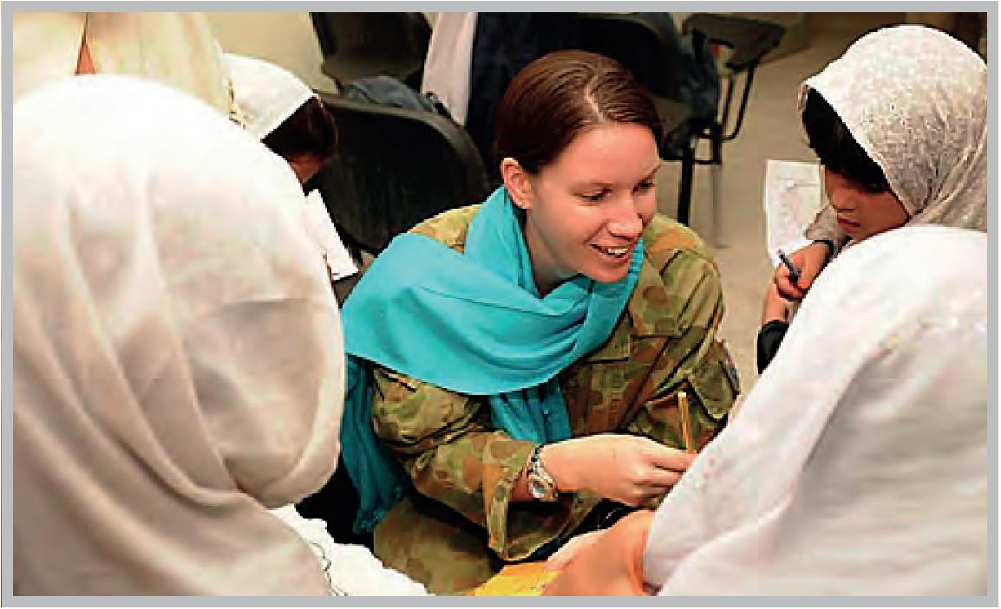
Corporal Ali Lenicka visits Malalai Girls School during a female engagement patrol throught Tarin Kot, Afghanistan.
Photo: Department of Defence.
For the AFP, implementation of the National Action Plan is guided by the International Deployment Group (IDG) Gender Strategy with a Gender Guidance Note, further outlining the ways in which the National Action Plan will inform the design of new and continuing stability missions and capacity building programmes, including for the protection of women and girls. In addition to documents that explicitly reference the Women, Peace and Security agenda and associated UN Security Council resoluitions, all AFP IDG programme design documents for capacity development missions outline the ways in which the AFP will support partner country policing organisations to progress gender equality, with guidance being obtained from the IDG’s Strategic Framework for Police Development.
The full list of relevant official policy and guidance documents relating to the Women, Peace and Security agenda, including titles and descriptions, is at Annex A.

Strategy 2

Embed the Women, Peace and Security agenda in the Australian Government’s approach to human resource management of Defence, Australian Federal Police and deployed personnel.
2a. Number and percentage of Australian Government employees (military, police and Australian Public Service personnel) deployed in operations that have received training on Women, Peace and Security (including their responsibilities under UNSCR 1325,1820,1888,1889 and i960), and a description of that training.
Enhancing the understanding and competence of government staff regarding the Women, Peace and Security agenda is an important element of the National Action Plan. The Government has been developing and implementing training programmes for Defence, police and civilian personnel, and will continue to increase the number of training courses and the number of deployed personnel trained. For example, whilst training on Women, Peace and Security is only currently delivered to ADF personnel undertaking the UN Military Observers Course, the Defence National Action Plan Implementation Plan includes tasking to develop and implement Women, Peace and Security and UNSCR 1325 modules in pre-deployment training for North Atlantic Treaty Organisation (NATO) operations, and subsequently, across the Defence training continuum, including staff courses and leadership development. It is anticipated the pre-deployment training will be implemented by 31 December 2014.
Due to the varying nature of deployments across agencies and forces, for the purposes of this report, each agency uses its own definition of ‘personnel deployed in operations’. As an example, the AFP includes personnel deployed to peacekeeping and peace-building operations in conflict and post-conflict settings such as UN, multilateral and bilateral operations, and does not include personnel working on capacity development programmes in fragile settings or personnel deployed through the AFP’s International Network for the purposes of international law enforcement cooperation. DFAT personnel deployed in operations refers to deployments to Solomon Islands and Afghanistan.
As at 31 December 2013, a total of 1,441 Australian military, police and APS personnel were deployed in operations. The vast majority of these (83.2 per cent) were from Defence. Deployed men outnumbered deployed women, with women representing only 18.2 per cent of total deployed personnel.
Of the 1,441 personnel deployed in operations, 783 (54.3 per cent) had received training on Women, Peace and Security. The AFP had the highest percentage of personnel who received training (68.8 per cent), followed Defence at 53.1 per cent, with DFAT having the lowest at 37.9 per cent. The cumulative average across agencies show that deployed women were more likely than deployed men to receive training on Women, Peace and Security, with 70.6 per cent of deployed women receiving training compared to 50.7 per cent of deployed men.
Further information on the number and percentage of personnel deployed in operations by agency, and the number and percentage that received training on Women, Peace and Security as at 31 December 2013 is at Annex B, Table 1.

Description of Women, Peace and Security Training
The range of training received by deployed personnel on Women, Peace and Security (including their responsibilities under UNSCR 1325, 1820, 1888, 1889 and 1960) is described and listed in alphabetical order below.
Australian Civilian Corps (ACC) pre-deployment training – Gender Equality Training for ACC registered members focuses on integrating gender equality into humanitarian emergencies caused by either conflict or natural disasters. Trainees receive a general introduction to the issues of protection and equal involvement of women and men in post-crisis reconstruction. They develop an understanding of the gendered impacts of emergencies and the differential impact and needs of women, men, boys and girls, which can facilitate improved, sustainable and equitable outcomes. All ACC deployees are also trained on how to report on the way their work contributes to gender equality (including prevention of sexual and gender-based violence). Gender results reporting is critical to delivering on existing policy commitments and achieving deployment outcomes. ACC training is for ACC members only.
Between March 2012 and 31 December 2013, 287 potential ACC members have received gender training as part of the ACC Foundation Training. Additionally, 25 ACC Post-Disaster Response Team members plus 30 other members have received gender training, taking the total number of members trained since March 2012 to 342. It is also worth noting that the ACC has now recruited 38 gender equality specialists, of which 17 have specific expertise in sexual and gender-based violence.
Civil-Military Leaders’ Workshops and Civil-Military Interactive Workshops – ACMC developed a comprehensive training package on the implementation of the principles of Women, Peace and Security in civil-military contexts which have been incorporated into the annual Civil-Military Workshops. This package is supported by the training documentary, Side by Side: Women, Peace and Security. ACMC also funded a partnership activity with the Australian National Committee for UN Women to produce a Women, Peace and Security Training and Facilitator Manual. This manual is shared with civil-military actors in current training and was launched within Defence by the Executive Director of the Australian National Committee for UN Women, and the Chief of the Defence Force at the 2014 Defence Women in Peace and Security conference on 16–17 June 2014.
Gender E-learning training module – DFAT is developing a new e-learning training module. Currently in its testing phase, the module is due to come online during 2014. The module includes a section on UNSCR 1325 and Women, Peace and Security. The introductory online gender training will be available to all DFAT staff.
Gender Field Advisor Course – during 2013, one senior ADF woman completed the Gender Field Advisor Course and one senior ADF woman completed the Gender Field Advisor Train-the-Trainer Course at the Nordic Centre for Gender in Military Operations (NCGM), Sweden. A further two women from the ADF attended the NCGM in January 2014, one of whom is now deployed to the International Security Assistance Force in Afghanistan. It is anticipated that another ADF woman will attend the NCGM in August 2014 in anticipation of a possible deployment to the International Security Assistance Force in January 2015.
Graduate Training Programme – Women, Peace and Security has been identified as a priority theme in the human rights training provided to all DFAT graduate trainees and international participants in the graduate training programme. The session includes experts from academia and DFAT, providing information on the frameworks for the Women, Peace and Security agenda, as well as case studies.
International Deployment Group Capacity Development Training session on the Role of Women in Capacity Development – AFP personnel complete a one hour classroom-based session on the role of women in capacity development, which forms part of a broader package of capacity development training. ACMC facilitated this process by providing an expert presenter. By the end of the session it is expected that participants will be able to:
- discuss the issues faced by women in failed states/conflict environments that led to the introduction of UNSCR 1325 and 1820;
- show an understanding of UNSCR 1325 and 1820; and
- discuss the importance of the role of women in the process of capacity development.
A detailed post-course assessment is currently being developed to ensure that participants take their learning in this area seriously and to contribute to ongoing training improvements.
United Nations Core Pre-deployment Training Modules – this online training course for AFP personnel comprises four modules, two of which relate directly to UNSCR 1325 and associated resolutions, namely: “Effective Mandate Implementation” and “Standards, Values and Safety of UN Peacekeeping Personnel”. Part 1c of the Effective Mandate Implementation module is dedicated to Women, Peace and Security. It outlines the UN position (contained in Security Council resolutions and UN policy) that conflict can only be addressed effectively when peacekeeping operations ensure respect for international humanitarian law, human rights and the rights of women and children in conflict. It then provides practical tools for peacekeeping personnel to utilise in the field. Part 1b of the Standards, Values and Safety of UN Peacekeeping Personnel focuses on sexual exploitation and abuse, with the aim to familiarise UN peacekeeping personnel with UN rules, core values, standards of conduct and discipline, and the consequences of misconduct.
Defence conducted the United Nations Military Observers Course in 2012 and 2013 for ADF and international military staff, which included UN-developed content on Women, Peace and Security. This is a four week course to prepare officers as UN Military Observers in peacekeeping operations. A total of 62 ADF personnel and international military staff (14 women and 48 men) attended this training.
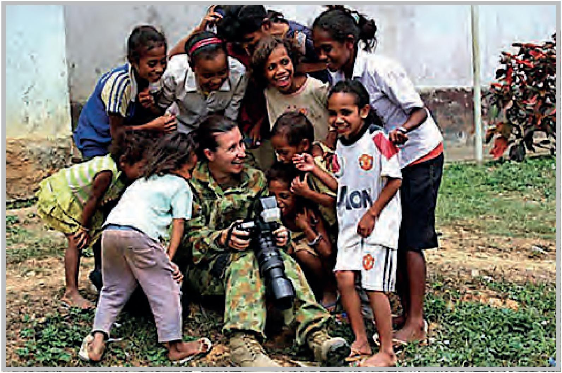
Able Seaman Imagery Specialist Lee-Anne Mack during a visit to Madabeno district for Operation Tower, Timor-Leste 2012.
Photo: Department of Defence.
Women, Peace and Security briefing is mandatory for DFAT officers posted to Afghanistan and Solomon Islands and recommended to all other posted officers. The briefing covers the genesis of UNSCR 1325 and subsequent resolutions and outlines Australia’s position and role in progressing the aims of this agenda. It provides information to increase participants’ ability to analyse the links between gender and conflict and gender and peace; to understand the importance of ensuring women’s participation in peace and conflict resolution; to understand the challenges faced by women in conflict situations and the strategies needed for appropriate protection, and to promote gender-sensitive approaches across a range of activities. The documentary Side by Side: Women, Peace and Security is made available to participants. Over the course of the National Action Plan, DFAT will consolidate and expand this pre-posting training to include a wider range of resident missions and additional training elements.
Working in Fragile and Conflict-Affected States Course – This DFAT training is available to all staff in the Department, whole of government and implementing partners. The course aims to increase participants’ ability to recognise and address the causes of instability and conflict, and promote conflict-sensitive development across a range of activities. Some of the practical tools introduced in the training include: conflict analysis; political settlement analysis; Do No Harm; and programming for peace. It includes a dedicated module on Women, Peace and Security. The learning objectives for the Women, Peace and Security module are:
- to analyse the links between gender and conflict and gender and peace;
- to understand the importance of ensuring women’s and men’s participation in peace and conflict resolution; and
- to undertake a series of exercises on gender-sensitive conflict analysis and related issues.
The documentary Side By Side: Women, Peace and Security is shown to participants during the gender module.
During the 2012–2013 financial year, eight training sessions were held, five for staff in Canberra, including one for the graduate intake, and three sessions for staff in Suva, Yangon and Nairobi. In total, 174 people attended the training, of which 133 were aid personnel. In addition, five staff from across government and 36 staff from implementing partners attended the training.
2b. Number of women and men employed by the Australian Federal Police, Australian Defence Force and Department of Defence, disaggregated by department and level.
Ensuring women have opportunities to participate in AFP and Defence deployments overseas, including in decision-making positions, is an important component of ensuring women play a significant role in issues of peace and security. Collecting sex-disaggregated data on the number of women and men that could potentially be deployed is the first step to understanding the situation including the untapped potential for women’s representation on deployments.
Across the AFP and Defence, men outnumber and outrank their female colleagues. The total number of employees in the AFP as at 31 December 2013 was 6,923, of which just over a third (34.3 per cent) are women. The total number of ADF Permanent Forces, ADF Reserve Forces and APS employees of the Department of Defence as at 31 December 2013 was 126,332. This was made up of 102,081 men (80.8 per cent) and 24,251 women (19.2 per cent). When it comes to seniority, the top ADF Officer rankings of General and Lieutenant General for example, are all held by men, and of the 43 Major General’s, only two are women. In the AFP, of the 83 Senior Executives, 67 are men (80.7 per cent) and 16 are women (19.3 per cent). For full information on the number and levels of women and men employed by the AFP and Defence, refer to Annex B, Tables 1 to 7.
Defence continues to progress the Implementation Plan for the Removal of Gender Restrictions for ADF Combat Roles. The potential outcome of lifting these restrictions is the ability to recruit more women, thereby potentially increasing the number of women available for deployment. Implementation is well underway with all ADF roles open to in-Service transfers from January 2013. As an example, the Navy now has two female trainees undertaking the Clearance Diving Course. In-Service transferees were permitted to participate in Special Forces selection from January 2014. Direct entry from the public into these combat roles is expected to commence by January 2016.
Defence is also actively implementing the recommendations of the Report on the Review into the Treatment of Women in the Australian Defence Force (Broderick Review Phase 2) and the Review of Employment Pathways for APS Women in the Department of Defence (McGregor Review). The Broderick Review specifically describes how the National Action Plan intersects with the work and recommendations of the Review, and how it is designed to enhance military capability and contributions to Women, Peace and Security efforts through increased participation of women in the ADF, on deployments, and in senior decision-making roles. Of the 21 recommendations for the Broderick Review, 16 have been completed and the remainder are progressing in accordance with the approved timeframes. Implementation of the Broderick and McGregor Reviews will strengthen the ADF’s and Australia’s role in implementing UNSCR 1325.
In addition, the ADF is developing diversity plans that aim to increase the proportional representation of women through changes to recruitment and training pipelines, re-engaging women who have left the Services, and providing conditions of service more conducive to supporting women and men to balance career and family.
2C. Number of Australian Government employees (military, police and APS personnel) deployed and posted to conflict and post-conflict settings (as defined by individual agencies) disaggregated by sex and department.
The data on deployments and postings demonstrate considerable inequity between the number of women and men deployed and posted to conflict and post-conflict settings, and the seniority of the positions they hold. Of the 1455 women and men deployed and posted to conflict and post-conflict settings, only 264 (18.1 per cent) of these were women. Whilst this is relatively low, policies currently being implemented have the potential to increase the number of women being deployed. For example, the removal of gender restrictions for ADF combat roles has the potential to increase the number of women deployed in conflict and post-conflict settings in the future.

Australian Federal Police
Conflict and post-conflict settings to which AFP members were employed in peacekeeping and peace-building operations as at 31 December 2013 included Afghanistan, Cyprus, Solomon Islands, South Sudan, and Timor-Leste. Conflict and post-conflict states are also amongst the many countries to which the AFP International Network members are deployed for the purposes of international law enforcement cooperation.
One hundred and ninety AFP personnel were deployed to conflict and post-conflict settings as at 31 December 2013. The highest level deployment was at Senior Executive Service level which was held by a man. There were 20 deployees at the Executive level, three of whom were women. One of these women held the highest position in the Mission to which she was deployed (Cyprus).
A female member of the AFP currently occupies the role of Police Advisor United Nations New York, which provides advice to the Australian Permanent Mission to the UN, providing the AFP with opportunities to participate in high-level dialogue about Women, Peace and Security themes. For further information on the numbers and levels of AFP deployed personnel refer to Annex B, Table 10.
The AFP also deploys personnel to fragile states, most notably in the Pacific. As at 31 December 2013, an additional 88 personnel (73 men and 15 women) were deployed to these settings (namely Fiji, Mauritius, Nauru, Papua New Guinea, Samoa, Tonga and Vanuatu), where they provided support to local policing organisations, with the objective of strengthening the rule of law and international law enforcement cooperation.

Defence
ADF and Defence personnel were deployed to seven specific UN, NATO, regional security and maritime surveillance operations in Afghanistan, Israel, Jordan, Lebanon, Pacific Region, Sinai Peninsula, South East Asia, South Sudan and Syria. The 1,199 personnel deployed to these operations as at 31 December 2013 covered the full spectrum of rank from Private (junior non-commissioned officer) to Major General (two star senior officer). The highest rank level of a woman deployed by the ADF was Lieutenant Colonel and by the Department of Defence the highest level was Executive Level 2. For further information on the numbers and levels of ADF and Defence deployed personnel refer to Annex B, Table 9.
It is worth noting that deployment numbers for Defence include employment groups that have been restricted to men (particularly for Army), which reflect the combat related tasks for the operations. The numbers are therefore skewed towards higher representation of men. The removal of gender restrictions from ADF combat roles across the ADF may improve this differential but it is anticipated that numbers of men will remain much higher than women.
Defence women were deployed to conflict and post-conflict settings during the reporting period in senior leadership positions such as Assistant Commanders, Commanding Officers, Senior Policy Advisors, Gender Advisors, Regimental Sergeant Majors, senior embeds in NATO Headquarters, and Chiefs of Staff. Examples include:
- Army Brigadier as the first female Assistant Commander (Australian) Joint Task Force 633 Afghanistan, 2011–2012. This officer was the first woman commanding 1500 Australian personnel serving with ADF units and embedded international forces in a combat zone.
- Army Colonel as a senior embed with International Security Assistance Force – Chief of Sustainment and Stability Operations, 2013.
- Navy Commander as a Gender Advisor in International Stabilisation Assistance Force Joint Command, Kabul, 2013. This officer was the first ADF officer selected for this role.
- Army Lieutenant Colonel as Chief of Staff Joint Task Force 633 Kabul, 2012.
- Two Air Force Wing Commanders as Commanding Officers, Multinational Base Tarin Kowt, 2012 and 2013.
- APS Executive Level 1 as a Political Advisor for Joint Task Force 633, Afghanistan, 2013.

Department of Foreign Affairs and Trade
DFAT staff members are often posted to countries that are experiencing or have experienced armed conflict or armed violence. Postings include long term postings (over 12 months), Australian Civilian Corps deployments (generally for up to 12 months) and whole-of-government deployments (generally for one to three years).
Of the 66 women and men deployed by DFAT to Afghanistan and the Solomon Islands as at 31 December 2013, there were 40 men and 26 women. Men were more strongly represented at higher level postings, for example, they represented 80.0 per cent of postings at the Senior Executive Service Band 1 level. At the lower levels, such as APS level 6 however, there was more even representation (55.6 per cent men and 44.4 per cent women). For further information on the number and levels of DFAT postings, refer to Annex B, Table 11.
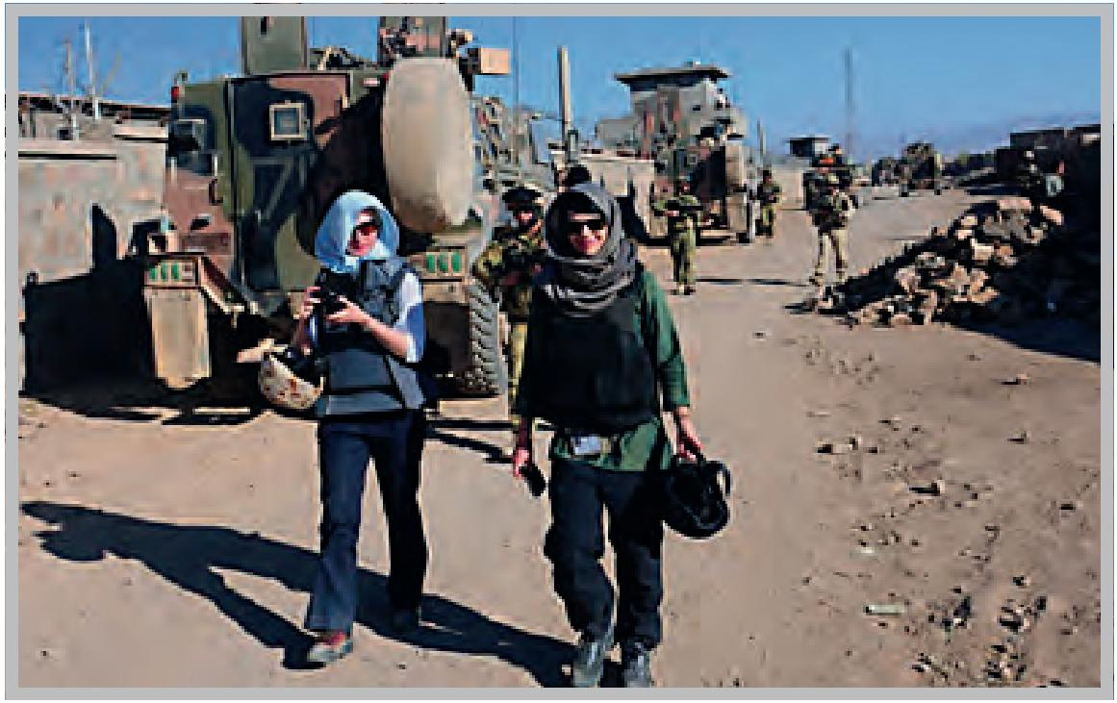
Development Adviser Maryam Bell (L) and Third Secretary Australian Embassy Kabul Lauren Patmore (R) during a visit to the construction of the Australian funded Malalai Girls School, Tarin Kot, Uruzgan. 4 November 2010.
Photo Credit - Uruzugan PRT -US military PAO via DFAT.

2d. The number of reported cases of sexual exploitation and abuse allegedly perpetrated by Australian Government employees (military, police and civilian personnel) deployed to conflict and/or post-conflict settings reported to Australian and host government agencies.
There are currently no reported cases of sexual exploitation or sexual abuse allegedly perpetrated by Australian Government employees deployed to conflict or post-conflict settings reported to Australian or host government agencies.
Defence has an extensive system for reporting, managing and investigating complaints against personnel generally, and on operations overseas. Defence policy provides a mechanism for the reporting of any incident, which raises a reasonable suspicion that a criminal or Service offence has been committed (as a notifiable incident), to military command and a Defence Investigative Agency. In theatre, an investigation service element is maintained for this purpose, with a ready capability to be deployed to an operations area to investigate reports. In addition, complaints or allegations made to UN assistance missions or other human rights agencies by local nationals, and subsequently reported to military command in theatre, are managed by the ADF under this Defence policy.
The AFP has a robust Professional Standards regime based on the AFP’s Core Values and Code of Conduct, with all complaints subject to the external oversight of the Commonwealth Law Enforcement Ombudsman. The AFP’s integrity regime applies to members operating both domestically and offshore, with members deployed to offshore missions being subject to Commander’s Orders that prohibit sexual fraternisation with members of host nation communities (on account of the inherent potential for abuses of power inequality). Members who fail to comply with the AFP’s integrity framework are removed from mission, providing both direct personal consequences for those who fail to comply and a strong disincentive for inappropriate behaviour by members offshore.

Strategy 3

Support civil society organisations to promote equality and increase women’s participation in conflict prevention, peace-building, conflict resolution and relief and recovery.
3a. Description of civil society activities funded by the Australian Government that pertain to Women, Peace and Security.
Civil society organisations have a wealth of expertise to offer the Government in its efforts to implement the National Action Plan and support the Women, Peace and Security agenda.
Civil society organisations play a vital role in peace-building, mediation and humanitarian action on the ground in conflict and post-conflict settings. They provide support to women and girls that experience gender-based violence and advocate for the rights of women and girls to governments. They also engage in dialogue with policy-makers on issues relating to Women, Peace and Security at the domestic, regional and global levels, and play an important role in raising the profile and educating the general public about issues relating to Women, Peace and Security.
The Government will continue to support domestic and international organisations to promote the roles and address the needs of women in the prevention, management and resolution of conflict, engage in peace and security initiatives, and raise awareness of UNSCR 1325 and the Women, Peace and Security agenda.
Government supported civil society activities pertaining to Women, Peace and Security are described below in alphabetical order, under sub-headings of domestic, country-based, regional and global initiatives.

Support for domestic initiatives
Annual Civil Society Organisation Dialogue on the National Action Plan – ACMC and the Office for Women provided funding for the 2013 Annual Civil Society Organisation Dialogue. This forum, co-hosted by the Women’s International League for Peace and Freedom Australia, the Australian National Committee for UN Women, the Australian Council for International Development and the Australian National University Gender Institute, allowed civil society organisations to showcase their contributions to Women, Peace and Security efforts, and facilitated dialogue between civil society and the Government on the Women, Peace and Security agenda and discuss agency progress against the National Action Plan.
The Deputy Chief Police Officer, Australian Capital Territory Policing, delivered a presentation on the protection of human rights, with a particular focus on women and girls. The Royal Australian Air Force Air Marshal, the Vice Chief of Defence Force, and the then Deputy Secretary Defence People, addressed the role of ADF women in peace and security operations, Defence’s implementation of the National Action Plan and UNSCR 1325, and the key strategic reform reviews on women in the ADF and their contribution to military capability.
The output from this dialogue informed the Civil Society Report Card on the National Action Plan.
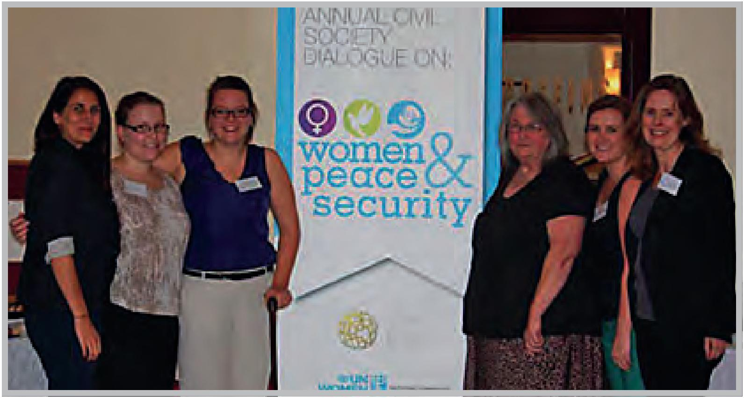
Organisers of the Annual Civil Society Dialogue on Women, Peace and Security. From left to right – Katherine Sciglitano (Australian Council for International Development), Alex Kershaw (Australian National Committee for UN Women), Susan Hutchinson (Australian Council for International Development), Barbara O’Dwyer (Women’s International League for Peace and Freedom Australia), Rebecca Bromhead (Australian National Committee for UN Women), Fiona Jenkins (Australian National University Gender Institute).
Annual Civil Society Report Card on Australia’s National Action Plan (Civil Society Report Card) – In recognition of the technical expertise of civil society organisations in the implementation of UNSCR 1325, the Office for Women and ACMC provided funding for the 2013 Civil Society Report Card. The Civil Society Report Card provided key recommendations and comments on progress against the National Action Plan. The Minister Assisting the Prime Minister for Women formally launched the Civil Society Report Card in October 2013. Members of Defence and ACMC participated on a discussion panel at the launch.
Engagement with the Australian National Committee for UN Women – Defence has been actively engaged with the Executive Director of the Australian National Committee for UN Women since 2012, to provide advice and guidance on issues affecting Defence’s cultural reform and gender equality reform priorities. This engagement has raised awareness of Women, Peace and Security issues affecting the ADF. The Executive Director of the Australian
National Committee for UN Women has also served as a member of the HMAS Success Commission of Inquiry Implementation Advisory Group, the Secretary of the Department of Defence / Chief of Defence Force Gender Equality Advisory Group, and the Defence National Action Plan Implementation Working Group. More recently, the Executive Director of the Australian National Committee for UN Women was appointed as the Chief of Defence Force’s inaugural Gender Advisor (a part-time position) to advise on internal Defence gender issues and progress.
ACMC and the Office for Women developed a documentary in partnership with UN Women titled Side by Side: Women, Peace and Security. The documentary is designed to support implementation of UNSCR 1325 and includes statements by senior UN leaders including Secretary-General Ban Ki-Moon, peacekeepers, humanitarians, and women who have experienced and survived conflict. The DVD is accompanied by an educational toolkit, with exercises, lesson plans and facilitators notes for trainers and educators of pre-deployment peacekeepers. The documentary was launched in August 2012 by the then Parliamentary Secretary for Defence, the then Global Ambassador for Women and Girls, and the Executive Director of the Australian National Committee for UN Women, and is a publicly available educational resource for Government agencies and civil society.

Support for international and country-based programmes
The Government supports the Women, Peace and Security programmes of civil society organisation in a number of countries, including but not limited to Burma, Papua New Guinea, and the Philippines. For example:
Family, Sexual Violence Community Engagement in Papua New Guinea (International Women’s Development Agency, 2012–2013) – With funding from the Australian Non-Government Organisation Cooperation programme, the project aimed to promote recognition of and policy and programme outcomes to address the prevalence of violence against women, the differential impacts of conflict on women and men, and women’s rights to contribute to building and sustaining lasting and inclusive peace in communities. The non-government organisation, Eastern Highlands Family Voice, expanded implementation to the district level and completed a needs assessment in Unngai district to identify issues affecting women and develop strategies to address them.
Supporting Peace in Mindanao (Philippines) (Multiple partners, $11.9 million, 2005–2015) – This Australian aid programme provides grants to civil society organisations and academic institutions to help build the conditions for improved security and development in conflict-affected Mindanao. It supports the conduct of research, provision of technical assistance to key institutional partners, expertise for policy advice, capacity development of civil society organisations, and direct peace-building activities with affected communities. Grants are provided to support four areas of work: building more capable and legitimate institutions in conflict-affected areas; expanding economic opportunities for conflict affected populations; strengthening the foundations for a negotiated peace; and building the resilience of conflict-affected populations. It also enables Australia to develop relationships with key actors in the peace process and engage in policy dialogue about efforts to secure a lasting end to conflict in Mindanao, including the important role of women in this endeavour. It involves multiple partners, including Balay Mindanaw Foundation, Consortium of Bangsamoro Civil Society and the Mindanao Commission on Women (MCW). The MCW is the single largest grant recipient under the programme ($1.4 million 2008–2014) and has become a significant voice in articulating a Mindanao peace and development agenda from a woman’s perspective. Australia has also supported the work of Women Engaged in Action on 1325, a national network of women in peace, human rights and women’s organisations, to ensure women’s perspectives are considered in efforts to establish the new autonomous Bangsamoro government in Mindanao heralded in the recent peace agreement between the Government of the Philippines and the Moro Islamic Liberation Front.
Women’s Advanced Empowerment Training in Burma (Palaung Women’s Organisation, 2012–13) – This Australian Non-Government Cooperation programme activity supported Palaung Women’s Organisation and their partners, the Human Rights Education Institute of Burma and Ta’ang Students and Youth Organisation. There has been ongoing armed conflict in the Palaung area between the National Burma Army and armed resistance groups. The Paulaung Women’s Organisation implemented a peer education discussion and training series on issues such as violence against women, trafficking, women and children’s rights, the UN Convention on the Elimination of All Forms of Discrimination against Women (CEDAW), women’s leadership and community organisations. By May 2013, 12 workshops had been completed in seven different townships in Burma.

Support for regional programmes
Beyond country specific activities, the Government supports a number of regional programmes that assist civil society to engage in Women, Peace and Security issues including but not limited to activities in Pakistan, Nepal, Sri Lanka, Fiji, Indonesia, Bougainville, Solomon Island and Tonga. Examples include:
Joining the Dots: Exploring the Economic Empowerment of Women in Conflict Affected Areas – This regional research inquiry was conducted collaboratively between Justice Equality Rights Alliance International (an Australian based women’s non-government organisation), Asia Pacific Women’s Watch (a regional network of women’s organisations and groups in Asia Pacific), and Women and Media Collective (a Sri Lankan based non-government organisation). The research study was carried out in six countries from the Asia Pacific: Aceh in Indonesia (East Asia), Fiji (the Pacific), Kyrgyzstan (Central Asia), and Pakistan, Nepal and Sri Lanka (South Asia). The research highlights displacement, insecurity and violence, economic insecurity, and a lack of representation of women in decision-making structures, as key barriers to women’s economic development and empowerment in conflict-affected societies. It found that each barrier intersects and compounds the issues for women within conflict and conflict-affected areas.
Pacific Regional Women, Peace and Security Media and Policy Network – This involved media initiatives to advance implementation of UNSCR 1325 by media policy makers and women’s non-government organisations and the general public in Bougainville (Leitana Nehan Women’s Development Agency), Fiji (Fiji Women’s Crisis Centre), Solomon Islands (Vois Blong Mere) and Tonga (Ma’a Fafne moe Famili Inc).

Support for global efforts
The Government contributes to global efforts to support the work of civil society on Women, Peace and Security. For example, From Communities to Global Security Institutions (UN Women, 2010–2014) is a UN Women programme that works with a range of partners including women’s civil society organisations to support women’s engagement in decision-making on peace-building, gender-responsive security sector reform, and accountability for UNSCR 1325 and 1820 in Haiti, Liberia, Rwanda, South Sudan, Timor-Leste and Uganda. It is strengthening women’s security and voice in peace-building at community, national, international levels; institutionalising protection of women in national security services and in peacekeeping forces; and building accountability for UNSCR 1325 through improved production and population of indicators on UNCSR 1325 and UNSCR 1820. In Timor-Leste, this has included establishing men’s networks in 13 districts as part of the Men’s Association Against Violence Network to advocate for gender equality and ending violence against women and children.
Case study
Liberian Peace Huts
From Communities to Global Security Institutions is a UN Women programme that implements a number of country level initiatives to enhance local peace-building initiatives and build security sector reform. One of the most successful initiatives is based on an indigenous model of community peace-building in Liberia using peace huts, which are modelled after the traditional “palava” hut system where local leaders and elders mediate and resolve cases between individuals within a community.
Liberian women working through the Women’s Non-Government Organisation Secretariat of Liberia (WONGOSOL) have directed support from Australia to establish 22 peace huts in several districts in Liberia. WONGOSOL is a coalition of at least 51 women and civil society organisations based in Liberia that provides women and civil society organisations with the platform to identify, articulate and present their views and priorities on socio-economic and political issues, particularly matters relating to rebuilding peace and reconstruction as they affect women and girls.
Through this initiative direct support is provided to civil society organisations that facilitate women’s participation in conflict mediation and resolution through local institutions. The peace huts provide safe spaces for women and women’s organisations to discuss and review issues that impact on their daily lives and resolve disputes, particularly disputes relating to sexual and gender-based violence. The peace hut civil society organisations and women also engage in community sensitisation of local leaders and decision-makers such as the police, particularly on issues of sexual and gender-based violence.
Prior to the lobbying and advocacy efforts of women and civil society organisations under WONGOSOL, women and civil society groups were rarely consulted in matters of security and protection. This project is therefore supporting local capacities and mechanisms by involving women and civil society organisations and integrating their priorities and contributions in peace-building processes. As a result, women’s security and protection is seen and treated as part of women’s human rights, and as integral to achieving peace in Liberia.
Women’s contributions are encouraged and integrated into peace-building processes and more women and civil society organisations are working with law enforcement agents. Consequently, there is increased and more rapid reporting of cases of violence or impending violence and greater awareness of the negative impact of violence against women by men and boys. The involvement of women’s and civil society organisations and their contributions, has resulted in improved security for women and improved mechanisms for addressing violence against women in Liberia, including through increased reporting.
Innovation through phone hotlines is aiding rapid response to reported cases through mediation and punishment, where applicable. The success of the Liberian peace hut model has had a catalytic effect, with both Kenya and Mali adopting the model. In 2013, the International Peace Initiatives (a non-governmental organisation based in Kenya), created a global peace hut using the Liberian model.
3b. Description of approaches taken by the Australian Government to share information with civil society on the Women, Peace and Security agenda.
The Government undertakes a range of engagement activities intended to facilitate information sharing between the Government and domestic and international civil society sectors that relate to the Women, Peace and Security agenda. Activities range from participating in panel discussions at public events, giving formal presentations, inviting civil society representatives to the Women, Peace and Security Inter-departmental Meetings, and collaboratively working with civil society to develop the Women, Peace and Security Civil Society Engagement Strategy.
The Office for Women is currently investigating options for a stronger internet presence for the National Action Plan to facilitate greater sharing of information on Government activities and progress with civil society and the general public.
Activities undertaken by the Government from March 2012 (when the National Action Plan was launched), until 31 December 2013 are listed in alphabetical order.
Annual Civil Society Dialogue on Women, Peace and Security, 15 April 2013 (Canberra).
Arria-formula meeting – On 17 May 2013, Australia and Guatemala co-hosted a UN Security Council Arria-formula meeting on the implementation of the UN Security Council’s Women, Peace and Security agenda. The then Minister for Defence delivered opening remarks and Australia’s then Global Ambassador for Women and Girls facilitated discussion. This meeting included senior UN officials and Gender and Women Protection Advisers serving in UN peacekeeping missions, non-Security Council UN members, UN agencies and civil society. The event attracted over 250 participants.
Australian Red Cross ‘Women and War’ Event – DFAT provided support for this event that provided different perspectives of the impact of conflict on women. The Defence Director, National Action Plan on Women, Peace and Security, was a member of the panel at this event, and highlighted the practical implementation of UNSCR 1325 in NATO operations in Afghanistan. A DFAT representative who had worked on Women, Peace and Security in both a government and non-government capacity also participated on the panel, held at DFAT offces in Canberra in 2013.
2013 Chief of Defence Force Gender Conference – In April 2013, Defence hosted its inaugural national conference Gender in Defence and Security Leadership. The conference facilitated meaningful discussion on women’s roles and representation in security and Defence, with an agenda targeting issues directly relevant to the National Action Plan, with speakers from a range of agencies across Australia, including the AFP, the Australian National Committee for U N Women and other civil society organisations.
Defence National Action Plan Implementation Plan Working Group – The Defence National Action Plan Implementation Working Group comprises representatives from the Services and Groups within Defence to facilitate progress of the National Action Plan. Civil society is represented on the Working Group by the inclusion of the Executive Director of the Australian National Committee for UN Women.
Human Rights, Security and Development: a Changing Environment, Human Rights and Policing Conference 2013, 16–18 April 2013 (Canberra) – The AFP Commander, National Women’s Advisory Network Chair, delivered a presentation in Canberra on human rights and policing.
Individual meetings with Civil Society Organisations – Individual agencies regularly meet with civil society organisations including the Women’s International League for Peace and Freedom Australia, the Australian Council for International Development and the Humanitarian Crisis Hub to name a few, to discuss upcoming Women, Peace and Security related events and developments.
Launch of the 2013 Annual Civil Society Report Card on Australia’s National Action Plan – Representatives from Defence and ACMC participated in a panel discussion at this launch, which focussed on Australia’s implementation of the Women, Peace and Security agenda.
National Women’s Alliances – Event details and information on Women, Peace and Security has been shared with the National Women’s Alliances. The National Women’s Alliances represent over 180 women’s organisations and bring forward the views, voices and issues of Australian women and, in particular, women from marginalised and disadvantaged groups. The National Women’s Alliances are made up of a mix of sector-based and issues-based women’s groups each with a distinct focus, including women’s equality and economic security, violence against women, indigenous women and rural women.
Non-Government Organisation Roundtable on Human Rights – DFAT hosts an annual roundtable on human rights with civil society in Australia. The most recent roundtable was held on 20 June 2013. This provides a platform for open and constructive dialogue on human rights issues of concern. In 2013, the roundtable included a session on the UN Security Council and the Women, Peace and Security agenda.
Non-Government Organisation Working Group on the UN Security Council – The Australian Permanent Mission to the UN, New York has engaged regularly and broadly with non-government organisation representatives based in New York. The Head of Mission, Australia’s Ambassador and Permanent Representative to the UN hosted a series of discussions with the Non-Government Organisation Working Group on the UN Security Council, to hear perspectives about evolving challenges and discuss recommendations for further UN Security Council action. Sessions were held in January, May and August 2013.
Non-Government Organisation Working Group on Women, Peace and Security – The Australian Permanent Mission to the UN, New York engages closely with the Non-Government Organisation Working Group on Women, Peace and Security which coordinates Women, Peace and Security civil society organisations in New York on key gender issues. This includes a regular exchange of information.
Panel Discussion in the Democratic Republic of the Congo – On 23 July 2013, DFAT partnered with Uruguay, Amnesty International and the Global Network of Women Peace-builders to host a panel discussion on conflict-related violence on women and girls in the Democratic Republic of the Congo. The impact of unregulated arms flow on the proliferation of conflict and instability was also discussed. On behalf of the UN Security Council, Australia and the United States of America accepted 1500 postcards from Amnesty International as part of its campaign highlighting the impact of small arms proliferation on sexual violence perpetrated against women and girls in the Democratic Republic of the Congo.
Royal Papua New Guinea Constabulary (RPNGC) discussion about women in leadership, 4 November 2013 (Port Moresby, Papua New Guinea) – During a visit to Papua New Guinea to mark the arrival of newly deployed AFP members, at the request of RPNGC, the Acting Assistant Commissioner Reform and the Assistant Commissioner, AFP National Manager of the IDG, delivered a leadership address to a group of women from the RPNGC. The women discussed the challenges they faced working in a male dominated environment and the Assistant Commissioner, National Manager of the IDG, provided her personal views on women leaders and their responsibility to engage with other women, including senior women across the law and justice sector. Discussions during the 45 minute meeting broached a range of issues including the need to better investigate domestic violence, sexual assault and crimes against children.
UN Panel Discussion, Participation of Women in Peace-building, 6 September 2013, (New York, United States of America) – During Australia’s UN Security Council Presidency, Australia co-hosted an interactive panel on Women’s Participation in Peace-building with Conciliation Resources and the Non-Government Organisation Working Group on Women Peace and Security in New York. It brought together peace-building practitioners from conflict-affected countries, civil society, peacekeeping missions and UN agencies with UN Security Council members, donor countries and UN Member States. It developed a set of recommendations on expanding women’s participation in peace-building which was circulated to UN members in the lead up to the UN Security Council Open Debate on Women, Peace and Security. The event was moderated by Australia’s then Global Ambassador for Women and Girls and included a presentation by the AFP Assistant Commissioner, National Manager of the IDG. More than 130 people attended the discussion.
UN Security Council Civil Society Consultations – DFAT hosted roundtables (12 December 2013 and 15 May 2013) with civil society during Australia’s UN Security Council term to discuss issues and themes of interest in the UN Security Council. These included a specific session on Women, Peace and Security that discussed the work Australia has progressed in the UN Security Council and an exchange of views on future opportunities. The 15 May 2013 session included a reception hosted by the then Foreign Minister. Both sessions involved approximately 50 Australian civil society organisation representatives. Offcials from relevant government agencies attended including Defence, Office for Women and DFAT.
UN Women Global Technical Review Meeting, 5–7 November 2013, (New York, United States of America) – An ACMC representative was endorsed by DFAT, Defence and the Office for Women to attend the Technical Review Meeting on building accountability for implementation on UN Security Council Resolutions on Women, Peace and Security. The ACMC representative presented on accountability processes of the Australian Government, including the National Action Plan, the Women, Peace and Security Inter-departmental Working Group, government agency implementation plans and civil society engagement and reporting. Participants included global experts on Women, Peace and Security. Recommendations developed from the Technical Review Meeting focussed on development of National Action Plans, engagement of civil society organisations, resourcing and finance for Women, Peace and Security, and innovation in implementation. Key recommendations were submitted to UN Women.
Women, Law Enforcement, Change and Opportunity development seminar, 26 October 2012 (Canberra) – AFP Assistant Commissioner, National Manager of the IDG, facilitated a workshop which considered the relationship between responsibility to protect and Women, Peace and Security in an international policing context.
Women, Peace and Security Civil Society Engagement Strategy – This strategy outlines how the Government will engage with Australian civil society organisations to implement the National Action Plan. This document was developed by the Office for Women in consultation with government and civil society. The strategy will be available on the PMC website in the near future.
Women, Peace and Security Interdepartmental Working Group – Representatives from the Civil Society Coalition on Women, Peace and Security are invited to attend meetings of the Working Group on an annual basis to facilitate greater sharing of information and knowledge. At the 24 April 2013 meeting, the Working Group welcomed the Australian Council for International Development and the Australian National Committee for UN Women to the meeting to provide an overview of the Annual Civil Society Dialogue on Women, Peace and Security.
3C. Description of domestic educational activities that relate to the promotion of the Women, Peace and Security Agenda.
An example of a recent education event is the 2014 Chief of Defence Force’s Defence Women in Peace and Security Conference which was held in Canberra on 16–17 June 2014. The focus of the conference was Women, Peace and Security and the implementation of the National Action Plan, and experiences of women in peace operations. The Minister Assisting the Prime Minister for Women spoke at the conference about Australia’s commitment to the Women, Peace and Security agenda and the importance of women’s engagement in peace and security processes.
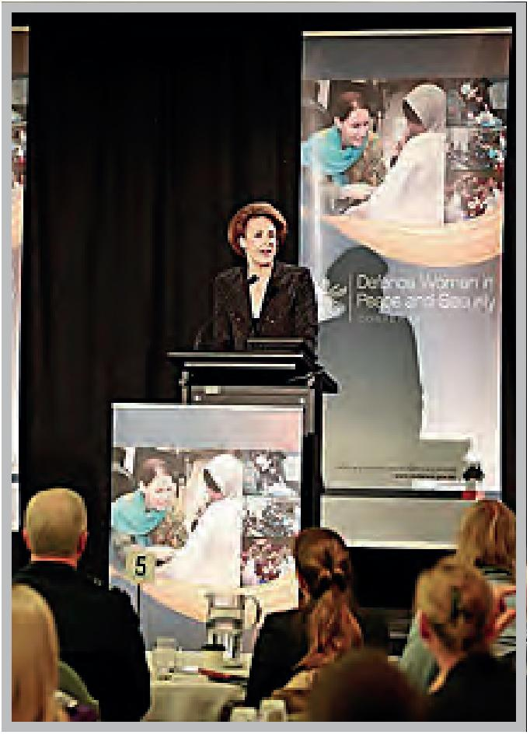
Minister Assisting the Prime Minister for Women, Senator the Hon Michelia Cash, speaking at the 2014 Chief of Defence Force’s Defence Women in Peace and Security Conference, 16–17 June 2014.
Photo: Department of Defence.
Education activities relating to Women, Peace and Security undertaken during the reporting period of this Progress Report (March 2012 to 31 December 2013) are listed in alphabetical order below. Note there is considerable cross-over with this section and Section 3b and many of the activities listed in 3b could also be considered education activities.
Centre for Defence and Strategic Studies – The ACMC and the Defence Director, National Action Plan, provided a training session on application of Women, Peace and Security and National Action Plan accountabilities at the Centre for Defence and Strategic Studies to Defence, AFP, DFAT and other senior government and foreign representatives. Participants engaged in a syndicate exercise where they applied the operational principles of Women, Peace and Security to the Defence National Action Plan Implementation Plan.
2013 Chief of Defence Force Gender Conference – In April 2013, Defence hosted its inaugural national conference ‘Gender in Defence and Security Leadership’. The conference facilitated meaningful discussion on women’s roles and representation in security and Defence, with an agenda targeting issues directly relevant to the National Action Plan. There were speakers from a range of agencies across Australia, including the AFP and civil society organisations. The Australian National Committee for UN Women gave a presentation on the National Action Plan.
Civil-Military Interaction Workshop (CMIW): Australia – ACMC developed and delivered UNSCR 1325 training to ADF, AFP, APS and civil society representatives at the Civil-Military Interaction Workshop in Australia during 2013. This is standardised training that has been integrated into the schedule of normal civil-military considerations. Presentations on civil-military interaction (e.g. Afghanistan) and scenario-based activities that consider and apply Women, Peace and Security principles at a strategic and operational level are included.
Civil-Military Interaction Workshop (CMIW): New Zealand – ACMC partnered with the New Zealand Government to develop and deliver a workshop to participants from South Pacific and Caribbean civil-military-police organisations during 2013. Participants were introduced to the paper Gendered Crises: Gendered Response and documentary Side by Side: Women Peace and Security. Women, Peace and Security issues were discussed in several presentations.
Civil-Military Relations Module, National Security College – ACMC supported delivery of the National Security College module by providing several lectures, including on Protection of Civilians, which included Women, Peace and Security considerations.
Defence website on National Action Plan implementation – Defence has developed a website available to the general public detailing the National Action Plan and Defence’s obligations in the implementation of UNSCR 1325 through the Defence National Action Plan Implementation Plan. It includes details on UNSCR 1325 and related resolutions, gender perspective in operations, and progress against the National Action Plan. The website can be accessed at: www.defence.gov.au/vcdf/initiatives/nationalactionplan.htm
Documentary: Side by Side; Women, Peace and Security.
International Day of Peace celebrations, 28 October 2013 (Canberra) – AFP facilitated a presentation on the Women, Peace and Security agenda as part of International Day of Peace celebrations during which the Executive Director of the Australian National Committee for UN Women delivered an interactive presentation at AFP Headquarters.
International Women’s Day 2013 – A number of senior ADF women attended national and international events as guest speakers on UNSCR 1325, the Women Peace and Security agenda, gender perspective in military operations, women in operational command, and women in conflict settings. This included a video teleconference event between Afghanistan, Al-Minhad (United Arab Emirates) and Canberra. An education and information session was held at Williamtown Air Force Base to highlight Women Peace and Security programmes in Bougainville and the Democratic Republic of Congo, and was open to ADF, Defence and members of the public.
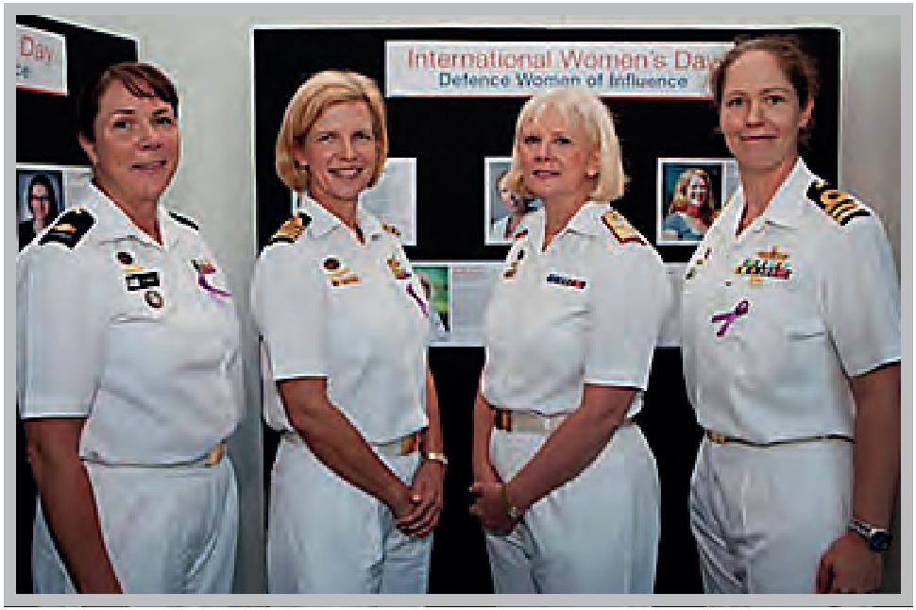
International Women’s Day, Defence Women of Infuence (from left to right), Warrant Officer Jo Jordan, Captain Jenni Wittwer, Rear Admiral Robyn Walker, and Commander Belinda Wood.
Photographer - ABIS Lee-Ann Mack.
Case Study
Interview with AFP Assistant Commissioner Mandy Newton
On Sunday 24 November, 2013, an interview with Assistant Commissioner Newton was broadcast on ABC radio where she discussed the AFP’s deployment to Papua New Guinea and elsewhere in the Pacific. Assistant Commissioner Newton noted that she hoped the presence of female AFP officers in Papua New Guinea would encourage young girls to become police officers so that the organisation would become more responsive to the issues confronting women and girls. She also said that the AFP is committed to developing a genuine understanding of the situation of women and girls in Papua New Guinea so that it is able to maximise the impact of its support on all members of society.

Case study
Video message to the Australian Army
In June 2013, the Chief of Army, Lieutenant General David Morrison, AO, published a video message to the Australian Army following the announcement on 13 June 2013 of civilian police and Defence investigations into allegations of unacceptable behaviour by Army members. This included an alleged ring of soldiers calling themselves the Jedi Council who were reported as producing highly inappropriate and offensive material demeaning women and distributing it across the internet and Defence email network. The purpose of his message was to articulate the standards of behaviour and adherence to Army values that he expected from every Army member, and to clearly state that there was no place in the Army for members who exploited and demeaned their colleagues. General Morrison’s video was viewed widely across the internet in Australia and around the world, with over 1,433,171 hits.

Case study
Women, Peace and Security Training Manual and Facilitator Guide
ACMC and the Australian National Committee for UN Women have worked together to develop and publish a Women, Peace and Security training manual and facilitator guide, and hold a series of eight workshops across Australia delivered by the Australian National Committee for UN Women. These workshops aimed to increase understanding in the Australian community of Australia’s commitment to and engagement with UNSCR 1325 (including through the National Action Plan) and the broader Women, Peace and Security agenda. The eight two hour training sessions were held with civil society organisations in Melbourne, Canberra, Perth, Sydney, Brisbane and Adelaide in 2013. The Women, Peace and Security Training Manual was utilised as a guide for the training sessions.

Strategy 4

Promote Women, Peace and Security implementation internationally.
4a. Description of international assistance provided for activities pertaining to Women, Peace and Security.
Definition(s)
International assistance refers to any type of assistance provided by the Australian Government to advance activities under the Women, Peace and Security agenda internationally. This includes, but is not limited to, activities of international aid organisations, civil society organisations, governments and the UN.

Australia’s general approach
Australia’s overarching approach to advancing UNSCR 1325 internationally is to support efforts that address the impact of conflict on women and the vital contribution women make in preventing and managing conflict and promoting sustainable peace.
Our international development assistance to the Women, Peace and Security agenda spans the four key thematic areas in which Australia aims to improve outcomes for women and girls through the National Action Plan on Women, Peace and Security:
- Prevention – incorporating a gender perspective in conflict prevention and recognising role of women in preventing conflict;
- Participation – recognising and enhancing the important role women play in all aspects of peace and security;
- Protection – protecting human rights of women and girls with special consideration for gender-based violence; and
- Relief and Recovery – ensuring a gender perspective is incorporated in all relief and recovery efforts to support specific needs and recognise the capacity of women and girls.
Australia provides practical support through a range of development partners working on Women, Peace and Security including multilateral organisations, partner governments, and non-government, research and women’s organisations. Support is provided in individual countries, regionally and globally through mechanisms that deliver assistance in fragile, conflict and post-conflict countries and in humanitarian emergencies.

Support for Global Efforts
The Government supports a number of global programmes and activities that support Women, Peace and Security internationally.
For example, Defence is represented annually at the International Association Peacekeeping Training Centre and the Asia Association Peacekeeping Training Centre which allows for the exchange of knowledge and curriculum development on gender modules for international peace operations courses.
The Women, Peace and Security agenda is promoted through international reporting mechanisms such as the CEDAW and the Beijing plus 20 Review, and events such as the UN Commission on the Status of Women (CSW). For example, Australia, the United Kingdom and the Women’s International League for Peace and Freedom hosted a side event in 2014 at the 58th session of CSW, titled Women’s participation in peace processes: How can the international community support women’s leadership in conflict resolution? This event specifically considered the evolving peace processes in Colombia, South Sudan and Syria. The panel discussion provided the opportunity for participants to consider the successes and the challenges in women’s participation and leadership in peace-building and peace negotiations. It provided an opportunity for states, UN agencies and civil society to discuss the ongoing barriers to women’s full and effective participation and how the international community can work together to advance the UN Security Council’s Women, Peace and Security agenda, particularly UNSCR 1325 and UNSCR 2122. Participants included representatives from international civil society organisations and ministers responsible for women’s affairs. Australia’s Minister Assisting the Prime Minister for Women spoke at the event and Australia’s Ambassador for Women and Girls chaired the event.
A senior female ADF officer was selected as part of a UN Department of Peacekeeping Operations team to develop the UN Child Protection Course and related training materials. In 2013 that member conducted the validation workshop in Kenya, and two pilot courses in Malaysia and Uruguay. She has been asked to conduct a Train-the-Trainers course in 2014 for troop-contributing nations deployed to conflict areas where Women, Peace and Security and Child Protection are key concerns. The Child Protection Course includes a significant component on gender, in particular women and girls.
UN Development Programme Gender Perspective Conference, Asia – A keynote speech was delivered by a senior woman from the ADF at the UN Development Programme Gender Perspective Conference in Asia. The speech emphasised the importance of gender programmes and women’s representation at key leader meetings in conflict areas including Bougainville and Timor-Leste. Conference participants were from the civil, military and police sectors.
UN Military Observers Course Kenya – Two ADF members (one man and one woman) conducted training at the Humanitarian Peace Support School in Kenya in late 2013 for 27 students from African Union states including Ethiopia, Kenya, Rwanda, South Sudan, Tanzania and Uganda, and one Australian member (female Navy Lieutenant). Five of the 27 students were women. The training included a UN module on Women, Peace and Security, covering UNSCR 1325, vulnerable children, what women bring to the peacekeeping effort, and the impact of conflict on women. Australia had funded the training as part of an Australian/UN Memorandum of Understanding for enhanced cooperation in trade/investment, development, governance, capacity building, food security, peace and security and humanitarian assistance.
UN Military Observers Course Rwanda – Defence staff conducted preparation training in Rwanda in 2013 for participants from Africa and Australia to deploy as UN Military Observers in peacekeeping operations. Of the 34 students, 28 were men and six were women.
Australia also contributes to the UN Peace-building Fund (UN Peace-building Support Office, 2006–2015), which aims to contribute to gender equality by increasing the participation of women in political processes, strengthen their voices in post-conflict planning processes and address their specific post-conflict needs. In doing so, the UN Peace Building Fund supports the Women, Peace and Security agenda, reflected in UNSCR 1325, 1820, 1888, 1889 and 1960. For example, in Nepal, the UN Peace-Building Fund has supported the provision of reproductive healthcare services to female ex-combatants from the Maoist army during the discharge and reintegration process, thereby ensuring a gender-sensitive disarmament, demobilisation and reintegration process.
The UN Peace-building Fund seeks to meet the UN Secretary-General’s target of allocating at least 15 per cent of UN Peace-building Funds to projects that have gender equality as the main objective. In 2013, however, only 7.4 per cent of funding provided through the UN Peace-building Fund met this target, reduced from 10.8 per cent in 2012. In an effort to stimulate greater demand for funding for projects with gender equality as the main objectives, in 2013 the Peace-building Support Office improved the technical guidance to partners through the new Peace-building Fund Guidelines and the launch of a new programme in partnership with UN Women, piloted in June 2013 with 30 practitioners from 18 countries. Additionally in 2013, the Peace-building Support Office organised a thematic review on gender and peace-building.

Support for Humanitarian Efforts
DFAT supports a number of humanitarian programmes that support Women, Peace and Security internationally. This includes support to the Inter-Agency Standing Committee Gender Standby Capacity Project (GenCap, 2012–13) which targets gender experts deployed in humanitarian situations. It builds the capacity of humanitarian actors in critical humanitarian emergencies to mainstream gender in all sectors of the response. It strengthens the integration of gender within humanitarian response, as well as the Humanitarian Coordinator role and advances humanitarian reform as a whole. It also addresses substantive issues related to deployment of GenCap Advisers and mainstreams gender-based violence into the training modules of standby partners.
In March 2013, Defence funded three ADF women from the Australian Navy to participate in an Australian sponsored Habitat for Humanity ‘Hand in Hand’ project which build homes using local building materials and techniques for female headed households living in poverty in Nepal. The initiative, while not directly related to a conflict or post-conflict setting, provided an opportunity for the participants to gain valuable insights to the role of women in rebuilding communities.

Support for Regional Efforts
Exercise PIRAP JABIRU is a bilateral exercise, held biennially, between the ADF Peace Operations Training Centre and the Royal Thai Armed Forces Peacekeeping Centre. This exercise was conducted in the vicinity of Bangkok during the period 16–26 July 2012. The exercise targeted a multinational training audience of 76 participants (62 men and 14 women) from 17 countries in the region, with representatives from armed services and regional police services. The key theme for the 2012 exercise was the protection of civilians.
Pacific Islands countries – AGD is working with the AFP to assist police organisations and law and justice agencies in Kiribati and Tuvalu to implement reforms to policing legislation, including police powers to protect victims of gender-based violence and administrative provisions to enhance opportunities for women in policing, including requirements for merit based recruitment. AGD has assisted with similar reform efforts in other Pacific Islands countries including Tonga and the Solomon Islands.
AGD continues to represent Australia on the Pacific Islands Law Officers’ Network Sexual and Gender-based Violence Working Group. The working group is considering challenges to effective implementation of sexual and gender-based violence laws in the Pacific, and identifying initiatives undertaken to address them. A summary of the current sexual and gender-based violence laws in Pacific countries, prepared by the working group, is available on the Sexual and Gender-Based Violence page of the Pacific Islands Law Officers’ Network website: http://www.pilonsec.org/.
Revise criminal laws in Pacific Islands countries to improve prosecution outcomes in cases involving gender-based violence – AGD is assisting the Cook Islands to review and modernise its Crimes Act, including drafting new provisions to address domestic violence as a criminal offence. AGD has provided advice to other Pacific jurisdictions on law reform options to address gender-based violence, including Nauru and Solomon Islands.
The N Peace Network, Phase II (UNDP, 2011–12) – This network strengthens the role of women in building and restoring peace in Indonesia, Nepal, Sri Lanka and Timor-Leste. The training and dialogues it delivers on UNSCR 1325 and Women, Peace and Security issues have enabled women from the region to increase their participation in peace processes in their countries and improved advocacy and mediation skills for women and women’s groups. These skills and the sharing of best practices have assisted women to influence policies and improve practical intervention in their countries as well as expand their outreach.

Support for country-based programmes
Australia supports a range of country-based programmes that promote and support the Women Peace and Security agenda. For example:
Capacity Building of Karen Women’s Organisation in Burma (Australian People for Health, Education and Development Abroad, 2012–13) – With funding from the Australian Non-Government Organisation Cooperation programme, the Karen Women’s Organisation has empowered women through promoting their participation in all aspects of the political sphere including freedom, democracy, equality and sustainable peace. It developed women’s organisational and political knowledge to provide women in communities and camps with the skills to enable them to participate in leadership roles.
Elimination of Violence Against Women: Access to Justice for Women Affected by Violence in Afghanistan (Asia Foundation, 2013–16) – This programme supports national efforts in Afghanistan to improve the provision of services for women affected by violence, to increase access to justice for survivors of violence and to improve the prevention of violence against women. Specifically, the programme is strengthening access to justice for women through the training of formal and community-based justice sector actors such as police and khateebs on Afghanistan’s Elimination of Violence Against Women Law, women’s rights within Islam and actions to prevent violence against women. It also builds the capacity of key formal and community justice mechanisms, including Elimination of Violence Against Women Committees, Family Resolution Centres and Police Family Response Units to improve their management and responses to violence against women cases. Through education and awareness activities targeting men (traditional and religious leaders), educators and women, the programme also aims to help change community attitudes toward violence and advocate for the protection of women’s rights.
Exercise GARUDA KOOKABURRA – This is a bilateral exercise, held biennially between the ADF Peace Operations Training Centre and the Pusat Misi Pemaliharaan Perdamaian (Peacekeeping Mission Centre), was conducted in Sentul, Indonesia in 2013. The aim of the exercise is to conduct a joint/combined exercise, through seminar and syndicate work, in order to improve understanding of the strategic and operational planning considerations for participating in complex and multi-dimensional peace operations, including Women, Peace and Security. Of the 59 participants (51 men and nine women), 12 were members of the ADF.
Indonesian staff development workshop – Defence and the Indonesian Peacekeeping Training Centre will deliver an Indonesian staff development workshop on Women, Peace and Security themes, including gender, protection of civilians and child protection in 2014.
Military planning and operations courses with Indonesian and Thailand Defence partners in 2013 – The ADF Peace Operations Training Centre conducts biennial exercises with nations in the region to improve understanding of the strategic and operational planning considerations for participating in complex and multi-dimensional peace operations. Themes include Women, Peace and Security considerations and protection of civilians.
Strengthening Conflict-sensitive Programming to address Violence Against Women in Kenya (ActionAid, 2012–13) – With funding from the Australian Non-Government Organisation Cooperation programme (a DFAT funded programme supporting 45 accredited Australian non-government organisation to deliver cost effective, practical and direct poverty reduction programmes), ActionAid is building the capacity of communities and partners in conflict-sensitive approaches so that these can be mainstreamed in humanitarian programmes to strengthen the capacity of institutions and communities to promote a violence-free election. From July 2012–July 2013, 261 women were given increased knowledge and skills to conduct conflict-sensitive planning. Fifty-four leaders of women’s forums were trained on strategies to protect women and girls against violence and action plans have been designed by women to help ensure the respect and protection of women during times of crisis.
Government Offcials from DFAT, Office for Women and Defence, met with a Thai Delegation, including the Thai Minister for Gender Equality, in 2013 to discuss Women, Peace and Security and the development of Australia’s National Action Plan, and how lessons learnt by Australia could influence the development of Thailand’s National Action Plan.
Violence Against Women in Nepal (Human Rights Grants Scheme to the Women’s Rehabilitation Centre, 2012–2013) – This Australian aid programme grant funded an assessment of victims and survivors of domestic violence in Nepal using DOVA (the Human Rights Assessment Instrument on Domestic Violence). It strengthened implementation of existing policies and laws to enhance action research and policy analysis skills to strengthen evidenceled and rights-based advocacy about the implementation gaps in existing policies and laws. It also strengthened cooperation between activists, experts and government; strengthened international network of activists and experts in the field of domestic violence; and trained participating organisations to train new organisations in use of the DOVA methodology.
Case study
Scenario-Based Pre-Deployment Training for Military Peacekeepers
A persistent challenge of post-conflict and peacekeeping mission environments is the widespread sexual and gender-based violence against women and girls. To address these challenges, and working on behalf of the UN interagency group, UN Women and the United Nations Department of Peacekeeping Operations with support from the Australian aid programme and other partners developed scenario-based modules for pre-deployment training of military peacekeepers on preventing and responding to conflict-related sexual violence. This training, based on real life cases from conflict and post-conflict countries, affords decision makers the opportunity to implement tactical protection measures including best practices aimed at preventing or responding to sexual and gender-based violence. In addition, the training facilitates the military commanders’ understanding of the roles that various mission components should and must play in addressing human rights violations, including crimes of sexual violence.
This training has been piloted in several major troop-contributing countries including Argentina, Bangladesh, Brazil and Uruguay. During the International UN Military Contingent Officers Course held in October 2012 at the Centre for UN Peace Keeping, New Delhi, over thirty military officers from Bangladesh, Bhutan, Botswana, Brazil, Ethiopia, Fiji, India, Iran, Kenya, Lesotho, Mongolia, Nigeria, Slovakia, Sri Lanka, Sudan, Sweden, Tanzania, United Kingdom, and United States of America were trained. To ensure women’s direct engagement, 15 per cent of military officers trained were women. In December 2012, nearly 100 Nepalese military officers (including 12 women and commandants) received pre-deployment training in preparation for deployment to assignment in missions in Cote d’Ivoire (UNOCI), the Democratic Republic of Congo (MONUSCO), Lebanon (UNIFIL), and South Sudan (UNMISS). The training provided best practices, effective rules of engagement, and effective measures to prevent and respond to cases of sexual and gender-based violence.
4b. Description of strategies employed by the ADF and AFP to facilitate the engagement and protection of local women in peace and security efforts.
Australia’s deployed military and police personnel play a vital role in the protection of communities, including women and girls. Australia strongly advocates for the inclusion of protection tasks in peacekeeping mandates.
For example, in a first for Australia, a senior ADF woman was deployed as a Gender Advisor embed in the International Security Assistance Force Joint Command in Afghanistan in 2013, facilitating opportunities to meet with Afghan women to inform and shape direction to the International Security Assistance Force Joint Command on gender perspective considerations. This included attendance at the Independent Department of Local Governance launch of their Anti-Harassment Policy for Women in March, which was also attended by key female Government officials (including the Governor of Bamyan and Mayor of Nili), and a meeting with approximately 20 women police officers of varying ranks at Kabul City Police Station in June 2013. An ADF woman is currently deployed as a Gender Advisor embed in the International Security Assistance Force, and it is anticipated that a third member will deploy to the same position in July 2014. Developing this Gender Advisor capability for the ADF is being further cemented with a potential Gender Advisor Network currently under consideration by Defence and DFAT.
In the ADF’s work in Afghanistan, the protection and longer-term security of the civilian population was central to the mission of the Mentoring Task Force. To facilitate this, Female Engagement Teams, for the engagement with, and protection of, local women, were deployed in Afghanistan with the Combined Team – Uruzgan, as an initiative of International Security Assistance Force to meet with local Afghan women and discuss their security needs. Ongoing Female Engagement Team activity includes supporting International Women’s Day events, and meeting with women community leaders to discuss gender issues. The Female Engagement Teams also support education programmes, economic development, and the provision of health services, medicine and school supplies to the local population.
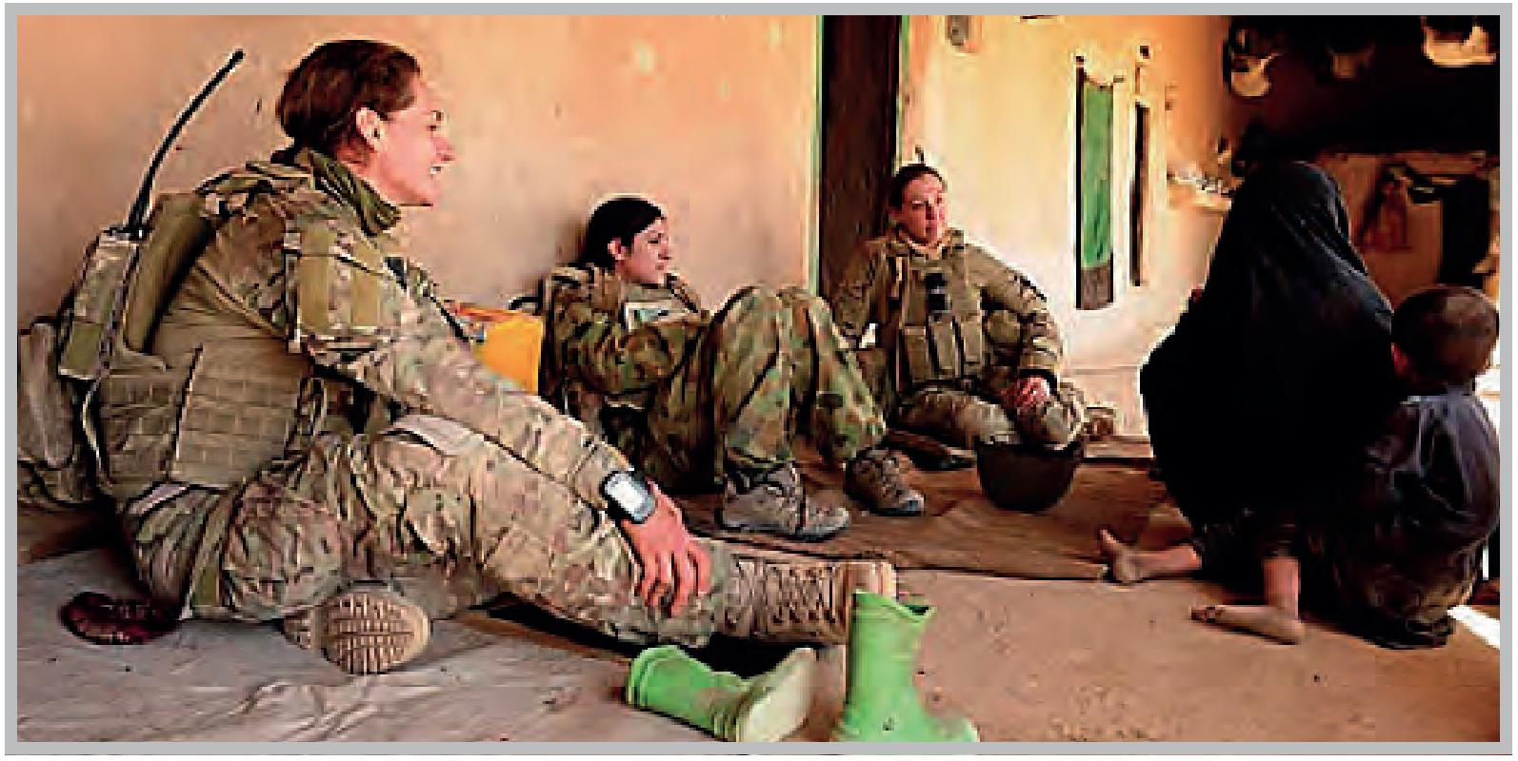
A Female Engagement Team from Mentoring Task Force-Three speak with women in the Karmisan Valley, Afghanistan.
Photo: Department of Defence.
Operation Illuminate, Afghanistan – AFP members actively engaged and encouraged the Afghanistan National Police Executive to provide female officers with a greater level of access to formal training and opportunities within the organisation. The AFP withdrew from Afghanistan in January 2014.
Papua New Guinea-Australia Policing Partnership (PNG-APP) – The AFP encourages and supports the Royal Papua New Guinea Constabulary (RPNGC) to identify female officers for personal and professional development programmes and to recruit females into the organisation. With AFP support, the RPNGC continues to aim for approximately 40 per cent of all course participants to be female, including those from provincial locations. The AFP is supporting the RPNGC to construct new female barracks at the training college to ensure that the maximum number of suitable female applicants can be recruited and accommodated in an appropriate facility.
In 2013, with the support of the AFP, the most senior female officer in the RPNGC was placed into the acting role of Assistant Commissioner Reform. Six women recently graduated from the RPNGC’s officer training course, earning them the rank of Inspector.
Regional Assistance Mission to Solomon Islands (RAMSI) – In their role as influencers, Participating Police Force executive members continue to promote gender equality and women’s participation in discussions with their Royal Solomon Islands Police Force (RSIPF) counterparts. The AFP, in collaboration with the Christian Care Centre, supports women’s safehouses in Solomon Islands and has supported the RSIPF to provide training to male officers on the need to take police action against domestic violence.
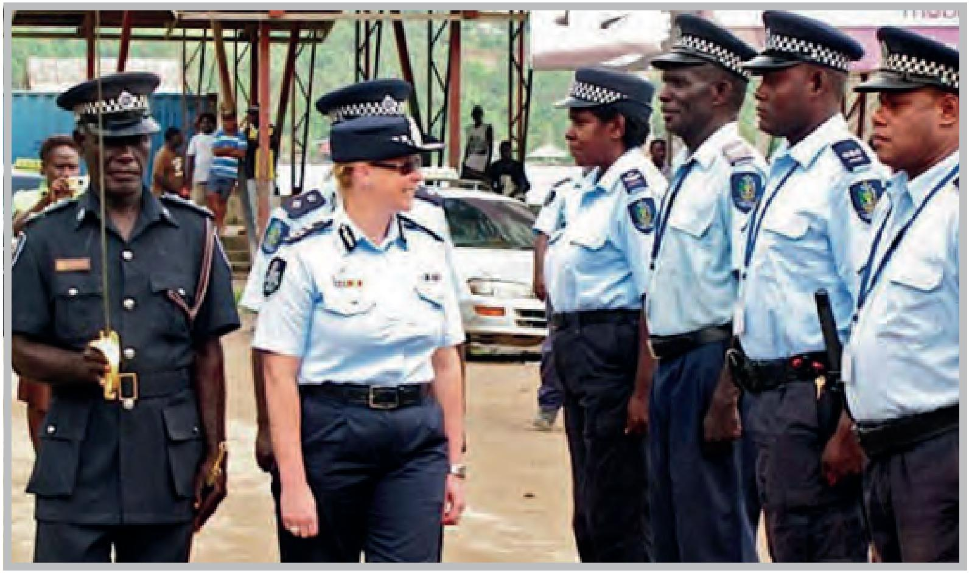
AFP Assistant Commissioner Mandy Newton meets with the RSIPF.
Photo: AFP.
Timor-Leste Police Development Programme (TLPDP) – The AFP works closely with Timor-Leste’s national police force (PNTL) to encourage the involvement of female officers in policing and to support their career progression. This includes influencing the PNTL to select female training participants and working closely with the Chief of the PNTL Gender Section to improve management and leaderships skills. For example:
- The AFP supported a senior female PNTL officer in her role as District Commander of Liquicia. The AFP supported and encouraged the development of a gender equality support network within the PNTL to engage women in regional forums.
- Between 25 and 29 August 2013, the AFP supported five PNTL female officers to attend the Australasian Council of Women and Policing Conference. The officers were exposed to keynote speakers who discussed a range of gender-based issues.
- The AFP supports up to five safe houses in Timor-Leste for victims of domestic violence through FOKUPERS (a civil society organisation). Funding, equipment and training support is provided to civil society organisations which support victims of gender-based violence such as: PRADET for physical and psychological treatment; CASA VIDA for educative and remedial support for child victims; and ALFELA for legal assistance to victims of gender based violence. The AFP supports the strengthening of processes between these organisations and police.
- The AFP supported the development of special accommodation for women at the PTNL training college.
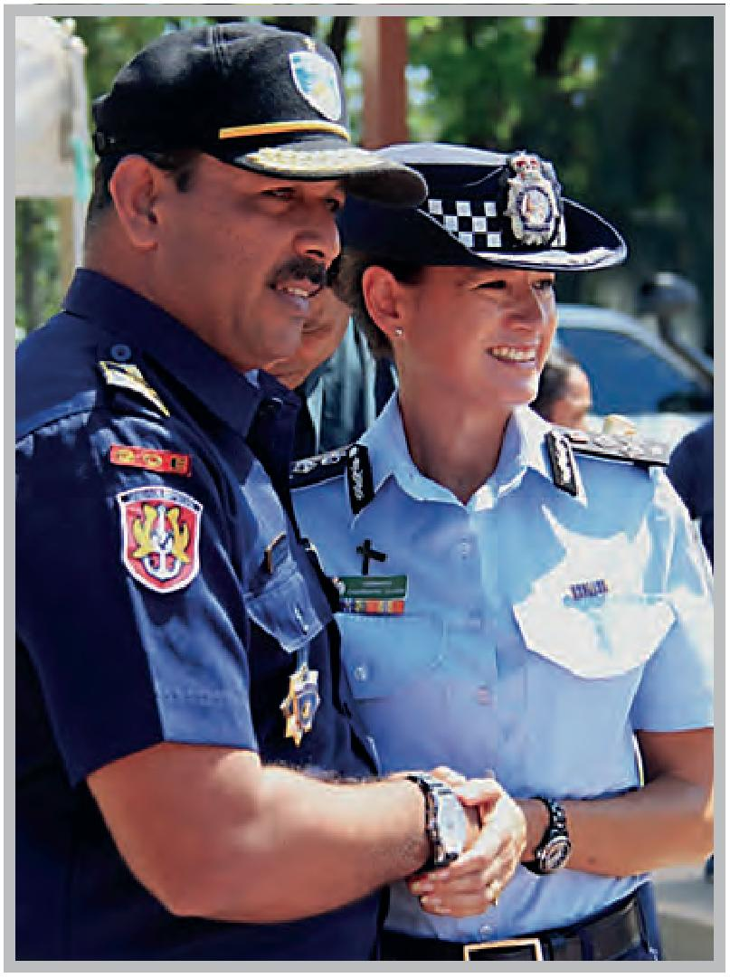
AFP Commander, Charmaine Quade, with Commander General Monteiro of the PNTL
Photo: AFP.
Tonga Police Development Programme (TPDP) (Trilateral programme between the Tonga Police Service, AFP and New Zealand Police) – The AFP supports the Tonga Police Service to conduct merit based recruitment, promotion and training selection processes. As a result, women now occupy five of the nine senior executive roles in the organisation. In 2013, the AFP actively campaigned for a 50/50 split of male and female recruits in the next police recruit class. Ten women and 10 men were selected to commence training in the next intake.
United Nations Mission in the Republic of South Sudan (UNMISS) – A female AFP member was appointed as the Deputy State Adviser to Kwajok, South Sudan (this is the highest police post at the state level), providing a strong female role model for local police.
AFP members supported the establishment of the UNMISS Women’s Advisory Network which advocates on behalf of women police officers and raises awareness about Women, Peace and Security themes, including gender equality, in South Sudan. The AFP withdrew in January 2014.
Vanuatu-Australia Police Partnership (VAPP) – The AFP and Vanuatu Police Force have agreed to promote gender equality within the Vanuatu Police Force. With AFP support, the Commissioner remains supportive of improving the conditions and development of women in the Vanuatu Police Force. This was discussed and agreed by all members at a meeting held in September 2013.
4c. Description of peace processes in which Australia has played a prominent role.
DFAT has a longstanding record of supporting peace processes in our region. During the reporting period no formal peace processes took place which necessitated DFAT assistance.
The following highlights how Australia is supporting implementation of UNSCR 1325 in Mindanao in the Philippines.
Case study
Women at the Peace Table Phase II: Enhancing Participation of Women from Asia Pacific in Peace Processes
Women at the Peace Table is bringing together women active in peace-making in the Asia Pacific region to identify and employ strategies for increasing and ensuring visibility to women’s participation and contributions to peace processes. This project focuses on conflict early warning and conflict prevention.
In Mindanao, through support from Australia, women from the frontlines of conflict have joined their colleagues from across the globe to operationalise UNSCR 1325 and subsequent UN Security Council resolutions such as 1820, focused on curbing sexual violence in war.
On 27 March 2014, the Government of the Philippines and the Moro Islamic Liberation Front signed the Comprehensive Agreement on the Bangsamoro, bringing to a close 17 years of peace negotiations. The agreement marks an historic accomplishment on the path to achieving long term security, stability and prosperity for the people of the southern Philippines.
Continued efforts by all parties will be needed to convert the promise of this agreement into reality. There are a number of internationally supported mechanisms to support this goal, including the International Monitoring Team, which is tasked with monitoring and reporting on the enforcement of the ceasefre between the two parties. It includes a Civilian Protection Component involving civil society organisations, to enhance community involvement in efforts to ensure compliance with the ceasefre agreement. Australia assisted one of the member organisations, the Mindanao Peoples Caucus, to deploy an all-women contingent to the Civilian Protection Component. The choice for an all-women contingent meant that women’s contributions were not left out. Furthermore, the all-women group were provided with the opportunity and platform to play a catalytic and advocacy role using UNSCR 1325 and subsequent resolutions such as UNSCR 1820 as their main tools.
The Civilian Protection Component of the International Monitoring team ensures women not only champion early warning signals and conflict prevention at the grassroots level, but also form part of the formal structures of the Government of the Philippines and the Moro Islamic Liberation Front agreement.
4d. Description of institution-building strategies Australia has been involved in that promote Women, Peace and Security.
Definition(s)
Formal and informal institutions will be included within the scope of this measure. A formal institution may include organisations that are specifically defined by a code of ethics and have set objectives, values and behaviours to achieve particular ends. This would encompass UN institutions, civil society organisations, universities and government agencies.
Informal institutions include bodies with “behavioural regularity based on socially shared rules, usually unwritten, that are created, communicated, and enforced outside of officially-sanctioned channels.” This would include institutions such as the Civil Society Coalition on Women, Peace and Security.
The Government understands the importance of strengthening domestic and international institutions that promote Women, Peace and Security to advance the Women, Peace and Security agenda internationally. The Government engages in a range of institution building strategies that strengthen consideration of the needs of women and girls in peace and security issues, as well as women’s involvement in peace and security resolution. These range from promoting the rule of law through police capacity development in the Pacific, to promoting stability through the Australian aid programme.
Listed below in alphabetical order are global, regional, country-based and domestic institution-building strategies Australia has been involved in, that promote the Women, Peace and Security agenda.

Global Strategies
The Australian Civilian Corps (ACC) – DFAT supports the deployment of civilian specialists as a part of its efforts to support Women Peace and Security. The ACC is a group of specialised civilian specialists who provide stabilisation and recovery assistance to fragile states and countries experiencing or emerging from conflict or natural disaster. They provide a flexible and timely Australian response designed to bridge the gap between humanitarian and emergency relief and long term development programmes. The ACC has a strong cadre of technical experts in gender equality and gender-based violence. The availability of sexual and gender-based violence expertise was strengthened through targeted recruitment action in 2013.
DFAT supports global institution-building efforts that support Women Peace and Security such as providing support to the Crisis Prevention and Recovery Thematic Trust Fund, (UN Development Programme (UNDP), 2011–2013) – The Bureau for Crisis Prevention and Recovery (BCPR) is the agency within UNDP with specialist expertise on conflict and peace-building and leads on issues of crisis prevention and recovery in UNDP. The Fund’s Eight-Point Agenda includes supporting full implementation of UNSCR 1325 and incorporating gender equality priorities into advocacy and strategic planning in the development, humanitarian, peace, and security spheres. BCPR also supported better access to justice for abused women through, for example, new family protection units established in Iraq, which by the end of 2013 had heard thousands of cases related to sexual and gender-based violence. BCPR also supported better access to justice for abused women in the Democratic Republic of the Congo, Sierra Leone and Somalia, through new initiatives that strengthen the courts, police and other legal systems.
NATO Committee on Gender Perspective (NCGP) – This is an annual conference and meeting in which the ADF (a senior ADF female) has participated in since 2011. The NCGP provides advice to the NATO Military Committee on gender issues, including the implementation of UNSCR 1325 and related resolutions, and supports the mainstreaming and integration of a gender perspective into NATO’s military operations. Each conference results in specific recommendations to the Military Committee on outcomes and products for use by NATO armed forces and partner nations to enhance operational effectiveness.
Prevention and Response to Sexual and Gender-Based Violence in Humanitarian Emergencies, (UN Children’s Fund (UNICEF) and UN Population Fund (UNFPA), 2012–14) – Gender-Based Violence Area of Responsibility (GBV AoR) is the global forum for coordinating prevention and response to gender-based violence in humanitarian settings. The group brings together non-government organisations, UN agencies, academics and others under the shared objectives of ensuring more predictable, accountable, and effective approaches to gender-based violence prevention and response. The GBV AoR addresses gender-based violence in humanitarian settings, which includes programming to address gender-based violence that involves coordination, prevention and response with a multi-sectoral approach (e.g. health and community services, shelter and site planning). Amongst other initiatives, funding from Australia enabled UNFPA to hire a full-time consultant to support implementation of the Gender-Based Violence Information Management System and a dedicated full-time coordinator for the GBV AoR Working Group.
Sexual and Gender-based Violence Protection Initiatives, (UNHCR, 2012–2016) – A key commitment for DFAT under the Australia–UN High Commission for Refugees (UNHCR) Partnership Framework (2013–2016) is to support implementation of UNHCR’s strategy to prevent and respond to sexual and gender-based violence in refugee and internally displaced populations. UNHCR’s sexual and gender-based violence protection initiatives include practical activities such as providing safe spaces for children in camps and enhancing the security of refugee women out collecting firewood.
Australia supports UN Women as a key UN institution responsible for promoting the Women, Peace and Security agenda. UN Women’s programmes on Women, Peace and Security are guided by a series of commitments to women’s rights. These include UNSCR 1325, and six supporting UN Security Council Resolutions – 1820, 1888, 1889, 1960, 2106 and 2122. Other key reference points are the Beijing Platform for Action and CEDAW. Around the world, UN Women acts to build women’s participation and influence in decision-making to prevent and resolve conflicts. It supports women’s engagement in all aspects of peace-building, towards more inclusive, egalitarian societies that can end gender discrimination and resolve conflicts without violence. Its programmes foster women’s peace coalitions and prepare them to engage in peace processes. It reaches out to peacekeepers to detect and stop conflict-related sexual violence. Other initiatives back justice and security institutions that protect women and girls from violence and discrimination, public services fully responsive to women’s needs, women’s greater access to economic opportunities, and women’s engagement in all forms of national and local public decision-making.
UN Women Global Review on National Action Plans Technical Expert Meeting – Defence (ACMC) was selected as a representative and technical expert to present and participate in the UN Women Global Review on National Action Plans. This conference provided the opportunity for the Australian Government to present its best practice examples and lessons learnt on implementation of the Australian National Action Plan, in particular on the selected topic of ‘Accountability: monitoring, reviewing and reporting’. Key findings of this Global Review have been consolidated into a report that is to be tabled at the UN Security Council to highlight the impact and effectiveness of National Action Plans.
Wilton Park Women in Peace-building Event – Defence (ACMC) presented at, and co-funded, the Women in Peace-building Conference with the Norwegian and British Governments, held at Wilton Park, United Kingdom, from 18–20 March 2013. This conference focused on ways to implement the UN Secretary General’s Seven Point Action plan on women’s participation in peace-building and conflict resolution. Key recommendations from technical experts were collated in a report that was utilised to drive policy, and government and international advocacy. ACMC provided senior representation and advised the Australian High Commissioner in London who attended and delivered a speech.

Regional Strategies
Pacific Police Development Programme – Regional (PPDPR) – The AFP works with the Pacific Islands Chiefs of Police, New Zealand Aid Programme and New Zealand Police to cooperatively address domestic violence in the Pacific region. An AFP advisor has worked with police in the Federated States of Micronesia, Guam, Palau, and the Republic of the Marshall Islands to establish specialised domestic violence units, train police staff and build partnerships with non-government organisations that support victims of domestic violence. Similar work is planned throughout the region, as is support for gender-based violence training (to be delivered by the Fiji Women’s Crisis Centre) and the promotion of White Ribbon Day in 2014. In addition, the AFP is providing advisory support to help strengthen local Women’s Advisory Networks.
PPDPR funded Pacific Islands police to attend the Australasian Council of Women and Policing Conference in Adelaide in August 2013.
The AFP is also co-funding a Pacific Islands Forum Secretariat study on the economic impacts of violence against women.
Under the Pacific Police Development Program, AGD provides legislation, policy and implementation training and assistance to support Pacific law and justice agencies build their capabilities to implement reforms to improve police powers to protect victims of gender-based violence. This includes through the AGD Pacific Legal Policy Twinning Program, direct policy and legislation training and drafting assistance and participation in the Pacific Islands Law Officers’ Network Sexual and Gender-based Violence Working Group.

Country-based Strategies
Operation Illuminate – Afghanistan – AFP members provided advice and guidance to the Afghanistan National Police on gender equity issues including compliance with operational orders on same sex searching. The AFP-initiated Violence against Women Programme is designed to teach participants the skills required for dealing with victims of gender-based violence. The course continues to be run under the European Union Police Mission programme at the Central Training Centre. The AFP withdrew from Afghanistan in January 2014.
Papua New Guinea - Australia Policing Partnership (PNG-APP) and the Stongim Gavman Programme – Under Phase IV of the partnership (2013–2017), the AFP is providing support to Royal Papua New Guinea Constabulary (National Police Force) Sexual Offences Squads and Family and Sexual Violence Units (in partnership with other Government of Australia programmes) in order to improve the quality of investigations and support and referral services available to victims of gender-based or family and sexual violence.
The PNG-APP is working with Royal Papua New Guinea Constabulary training staff at Bomana Police College to include sessions on gender (identified by the Papua New Guinea Government as a cross-cutting issue) in the curriculum of all courses delivered, or sponsored by, Bomana Police College. Training staff will seek input in to curriculum development from groups that address the causes and effects of personal and institutional violence.
Under the Strongim Gavman Program, AGD places experienced lawyers in Papua New Guinea Government law and justice agencies for two to three years to provide policy and strategic legal advice and capacity development, including administrative, leadership and management support. Through this programme AGD deployees in Papua New Guinea have supported the introduction and operation of a Family and Sexual Offences Violence Unit (FSV Unit) in the Papua New Guinea Office of the Public Prosecutor. The objective of the FSV Unit is to undertake specialist, quality family and sexual violence prosecutions, engage with family and sexual violence stakeholders, including by providing training and awareness activities, and participate in family and sexual violence law reform activities. The FSV Unit is seeing continued positive progress towards this objective, including increased capacity to successfully prosecute family and sexual violence matters, and the introduction of a dedicated Victim Liaison Officer. This complements the work of the AFP and other Australian development assistance.
Regional Assistance Mission to Solomon Islands (RAMSI) – The AFP supports a range of institution-building initiatives through RAMSI such as:
- The RAMSI Participating Police Force (PPF) has supported the Royal Solomon Islands Police Force (RSIPF) Family Violence Unit and the Community Policing Unit to undertake a number of community awareness programmes on gender specific legislation and policies. These have been conducted in a number of regions and communities across Solomon Islands.
- The PPF has supported the RSIPF to amend business plans to include organisational commitments under the Solomon Islands Gender Action Plan.
- The PPF has supported the RSIPF to increase reporting and investigation rates regarding family violence.
- The PPF continues to support the Family Violence Conference (held for the previous three years) which brings together relevant stakeholders in the community, including churches, to discuss progress on various approaches and initiatives.
- Christian Care Centre – the PPF continues to assist the centre to provide support services for victims of crime. Initiatives have previously included infrastructure projects, fund raising and the development of a Memorandum of Understanding.
- Continued support for the Save the Children – Crime Prevention Councils ‘Children and Youth in Conflict with the Law’ project.
- Supporting the RSIPF to participate in the World Vision Channels of Hope Project. The project uses community and faith leaders to interpret biblical passages to discredit some of the origins of beliefs surrounding domestic violence. The Channels of Hope Project recently delivered training to RSIPF officers so they can undertake workshops aimed at reducing gender-based violence within communities.
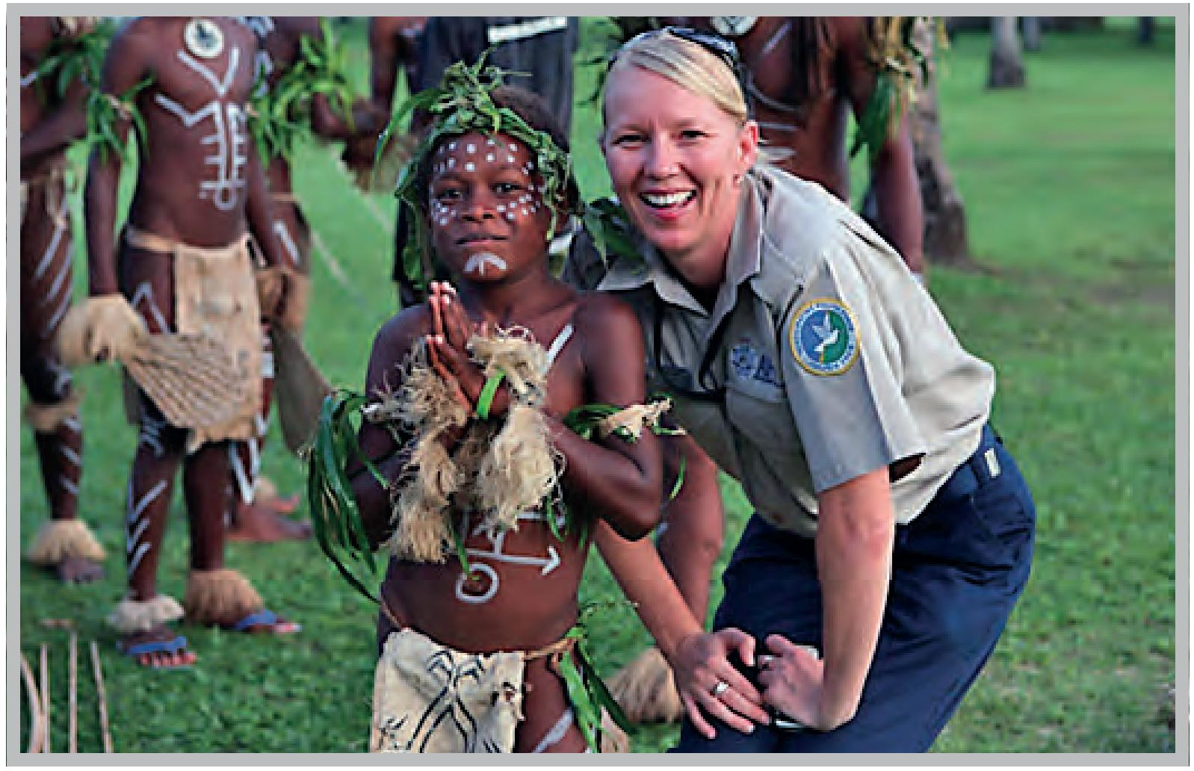
AFP Member of the Pacific Participating Police Force, RAMSI.
Photo: AFP.
Samoa - Australia Police Partnership (SAPP) – The AFP has assisted the Samoa Police Service to draft a gender and equity policy and will provide ongoing support and guidance to implement the policy. The AFP also continues to support the Samoa Police Service Women’s Advisory Network.
Timor-Leste Police Development Programme (TLPDP) – The AFP provides a range of assistance through the TLPDP. Examples include:
- The AFP has dedicated Gender Equality Officers who liaise with community stakeholders, the National Police of Timor-Leste (PNTL) and the Secretary of State for Security on issues relating to Women, Peace and Security and gender. The Gender Equality Officers ensure that gender equality themes are inculcated in AFP support to the PNTL – this ranges from work with executive administration and governance areas to operational teams.
- The AFP supported the PNTL to incorporate gender neutral language and gender appropriate examples in all investigation training curricula. The prevention and investigation of gender-based violence has also been written into the curriculum to ensure recognition of the issue at the national level.
- The AFP assisted the PNTL in incident response management – the PNTL system is now able to disaggregate crime data and provide more accurate and timely information on gender-based violence trends across the country.
- The AFP works with a number of stakeholders to coordinate their efforts to promote gender equality. Programme staff participate in the Gender Equality Coordination Group (GECG) which consists of representatives from civil society organisations including UN Women, UNFPA, UNICEF, USAID, EU Delegation, Asia Foundation, PAZ Y Desarrollo, Plan International, and the Justice Sector Support Facility.
- The AFP-TLPDP was consulted during the design of the Government’s $21 million Ending Violence Against Women programme, which commenced in early 2014. It will continue to be a significant partner in the implementation of the programme in Timor-Leste over four years.
- FOKUPERS – AFP-TLPDP assists this civil society organisation to support victims of domestic and sexual violence through counselling and assistance through the court process and provision of safe houses. This assistance includes grant based funding, equipment and training.
- ALFeLa – Timorese Women and Children’s Legal Aid Service. AFP-TLPDP assists this civil society organisation to support women and children to access a fair formal justice system through legal aid, community legal education and advocacy.
- PRADET – grant based funding and support. The AFP-TLPDP has supported this civil society organisation to construct a Psychosocial Rehabilitation Centre in order to establish a safe, secure and confdential place for victims of gender-based violence. AFP-TLPDP also assisted PRADET to develop the organisation’s enabling services via strategic planning workshops, the purchase of new equipment and legal training for staff. This enables the organisation to better respond to and assist victims of gender-based violence.
- CASA VIDA – grant based funding and support. The AFP-TLPDP assisted the civil society organisation CASA VIDA to repair/upgrade infrastructure and gifted essential equipment. CASA VIDA provides educative and remedial support for child victims of gender-based violence and prepares them for future independence and reintegration with families and community.
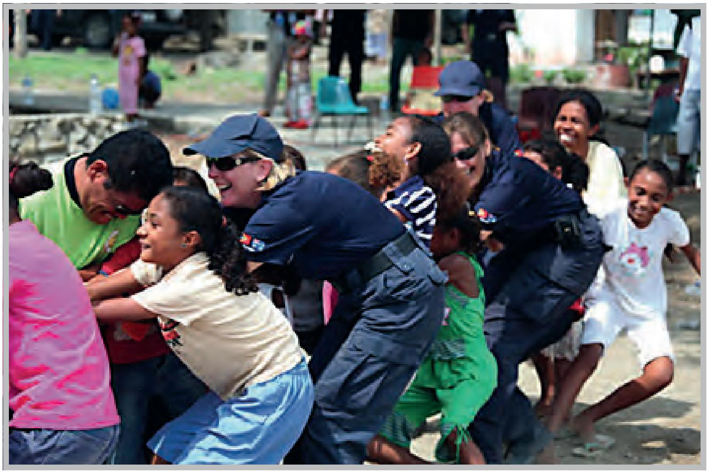
AFP and community members participate in a tug of war in Timor-Leste.
Photo: AFP
Tonga Police Development Programme (TPDP) (Trilateral programme between the Tonga Police Service, AFP and New Zealand Police) – Under the TPDP, the AFP supports the Tonga Police Women’s Advisory Network by facilitating attendance at regional meetings. The AFP assisted the Domestic Violence Crisis Centres to host a conference, which brought together stakeholders from the community, church groups, non-government organisations, government agencies and police to discuss approaches to and initiatives for combating violence against women and children. As a result of that conference a police woman has been seconded to each of the two crisis centres to facilitate the reporting of domestic violence incidents. The TPDP continues to support and fund an annual women’s conference.
UN Mission in the Republic of South Sudan (UNMISS) – The AFP provided a range of assistance through UNMISS (until they withdrew in January 2014) including:
- AFP members supported the establishment of a Gender Unit within the South Sudan National Police Service.
- UNMISS established policy frameworks to lay the foundation for gender mainstreaming and protection of individual rights in security sector reform. This includes training on gender-related topics including sexual and gender-based violence and the rights of women and girls.
- An AFP member was attached to the Gender, Child and Vulnerable Persons Protection team in Bentiu. The role required the member to work with the South Sudan National Police Service to protect women and children’s rights and was an integral part of both the UNMISS and South Sudan strategy to promote human rights.
- An AFP officer organised a mediation session between four chiefs of the traditional court in Bentiu with a UN Legal Advisor to discuss the detention of women and children and ways in which the traditional court could work with the higher court system.
Vanuatu - Australia Police Partnership (VAPP) – The AFP supports the Vanuatu Police Force to engage and discuss issues affecting women and children. VAPP initiatives include:
- A recruit course with 33 participants will be supported by the VAPP in 2014. Of the attendees, 20 per cent will be women. The selection process has identified 158 suitable candidates for the 2014 recruit course, 68 of whom are women. The Police College Commander expects a larger number of women than men to be selected for the 2014 recruit course.
- Female officers in Vanuatu are not able to drive police vehicles due to cultural sensitivities. VAPP has reached agreement with the Vanuatu Police Force Commissioner to support provision of driver training for all officers on the next recruit course. This training will be funded by VAPP. Final approval from the Commissioner will be sought for females to drive police vehicles following the completion of this course. As the ability to drive is a pre-requisite for deployment to UN missions, undertaking driver training will enable Vanuatu women to deploy alongside their male colleagues.
- VAPP funded the building of police stations and posts in Aneityum, Craig Cove, Loh, Pentecost, Santo, Saratamata, Silaewia, Sola and Tanna. This makes improved policing services available to women, children and vulnerable persons around the country. VAPP continues to support and influence the deployment of female officers to these and other locations.
- VAPP funded the refurbishment of a new Family Protection Unit (FPU) building in Luganville, Santo. The building will provide vulnerable women and children with a safe and comfortable location to meet with Vanuatu Police Force who are trained to provide support and respond to their protection needs.
- VAPP is supporting the development of a Professional Standards Unit to improve integrity, discipline and professionalism within the Vanuatu Police Force. The investigation team has never had a female officer. However, as part of the new structure, a woman will be allocated to the Professional Standards Unit so that women and children can make complaints about police behaviour without fear of retribution or intimidation. The Professional Standards Unit will also provide support to female officers in the Vanuatu Police Force, who will have an avenue to address victimisation, bullying and unlawful assaults committed by officers within the organisation.
- VAPP supported Vanuatu to host the Pacific Islands Chiefs of Police Women’s Advisory Network (WAN) conference in Port Vila in June 2013. The AFP also provided funding for a local WAN conference for Vanuatu Police Force female officers in September 2013.
- VAPP supports the Vanuatu Women’s Centre and other civil society organisations that assist and support women and children around the country. VAPP provides operational funding support to the Family Protection Unit and the Crime Prevention Unit so that they can visit remote island communities and respond to the needs of vulnerable people.
- VAPP commissioned a community perceptions survey in 2011 to better understand the views of communities in local and remote locations about police behaviour and services provided. This data is being used to better align the support provided by the VAPP to the Vanuatu Police Force and ensure improvements to police interaction with vulnerable persons in communities around the country.
Women at the Indonesian Peace Table – (Centre for Humanitarian Dialogue, with the Indonesia Institute of Sciences, and with cooperation of the State Ministry for Women Empowerment and Child, 2012). The project aims to document and disseminate the experiences of women from various spheres who are directly involved in Indonesian conflict resolution; identify women for facilitation or mediation roles in the future both in Indonesia and beyond; and facilitate nuanced gender awareness and engagement with regards to peacemaking and conflict resolution amongst Indonesian policy makers and practitioners. Training provided increases the understanding of UNSCR 1325 and other international norms on Women, Peace and Security related advocacy and messaging as well as preparing those trained to address related issues.
Case study
Supporting Police Women Regionally
The AFP has long supported regional institutions which aim to foster the role of women in policing, namely the Pacific Islands Chiefs of Police Women’s Advisory Network (PICP WAN) and the Australasian Council of Women in Policing (ACWAP). In addition to providing direct financial support to enable women from the Pacific Islands to attend regional meetings and conferences, the AFP provides support through mentoring, coaching and technical support. For example, the AFP has assisted the PICP WAN and local networks to develop terms of reference and strategic plans, and has helped women to improve their presentation skills so they can deliver compelling messages at regional fora. Both the PICP WAN and ACWAP provide women (and to a lesser extent men) with a platform to discuss gender issues, to share experiences and learn from others, to develop and sustain professional networks and to collectively determine the future of women police throughout the region.

Case study
Empowering women through secure environments in Timor-Leste
Empirical evidence has shown that challenging the pre-existing status quo through reform of policies, improving protection, security and access to justice for survivors of human rights violations including violence, as well as providing essential recovery services and promoting gender equality are essential prerequisites to achieving sustainable peace. To effectively promote and achieve the varying components outlined above requires a multi-sectoral and holistic approach. This is particularly necessary as there is a direct causal link between insecurity, violence (including post-conflict violence), inequality, poverty, and the continued violation of women’s rights. To address these challenges, UN Women, supported by the Australian Government, is providing support through various programmes for women, girls, and communities including in Timor-Leste.
In Timor-Leste, as part of efforts to address the persistent challenge of sexual and gender-based violence, inputs were integrated into the 2012–2014 National Action Plan on Gender-Based Violence, which was approved by the Council of Ministers with resource allocation for survivors of violence as well as training for law enforcement agents (Policia Nacional de Timor-Leste – PNTL) to enable them to tackle incidences of violence. Taking into consideration the critical role that men do, ought, and should play in relation to addressing violence, a network of men to advocate for gender equality, prevention and ending of violence against women and children (the Men’s Association Against Violence – AMKV) has been established in at least thirteen districts in Timor-Leste. Advocacy and training workshops are organised for and by the group to understand challenges of women’s security, protection and advocate anti-violence through football activities especially for young boys. So far, a total of 1,323 people have participated in the discussion and workshop activities relating to violence against women. Consequently, greater awareness of the impact and challenge of violence against women has led to a reduction in incidences of violence against women and sexual and gender-based violence, as well as increased reporting of such incidences to law enforcement agents. Some of the participants interviewed admitted that the discussions and training have imparted greater sensitivity and helped them to change their attitudes in dealing with women daily or providing support to survivors of violence.
4e. Number and description of interventions and support of resolutions and policy in the UN Security Council, General Assembly, UN Human Rights Council and other relevant fora addressing Women, Peace and Security issues.
Australia is a strong advocate of the Women, Peace and Security agenda. This can be seen during our term on the UN Security Council 2013-2014 and our many interventions and support of resolutions and policies that address Women, Peace and Security issues. A full list and description of interventions and support of resolutions is at Annex B.
Our commitment to the Women, Peace and Security agenda can also be seen through our strong presence at fora such as the Commission on the Status of Women (CSW). Women, Peace and Security was a priority for the Australian Government during the negotiations at the 57th session of CSW in 2013 where the priority theme was “Elimination and prevention of all forms of violence against women and girls”. A number of conclusions on sexual violence in conflict and arms trade were included in the CSW57 Agreed Conclusions. At the 58th session of CSW in 2014, attended by the Minister Assisting the Prime Minister for Women, Australia successfully lobbied to ensure Women, Peace and Security once again featured strongly in the Agreed Conclusions, including agreeing to adopt measures to implement and monitor the Millennium Development Goals for women and girls in armed conflict and post-conflict situations, women and girls affected by violent extremism, and ensuring women’s effective participation at all levels and at all stages and in peace processes and mediation efforts, conflict prevention and resolution, peacekeeping, peace-building and recovery.
Case study
Australia UN Security Council term 2013-2014
As a member of the UN Security Council, Australia has been working with fellow members and the UN System to ensure all relevant peacekeeping and peace-building operations address the impacts of conflict on women and girls; prevent impunity for sexual violence; pursue more comprehensive consideration and integration of these issues across the UN Security Council’s entire agenda; and advocate for peacekeeping mandates developed by the UN Security Council to include specific gender equality language and considerations (including the appointment of women protection advisors or gender advisers, where appropriate). Australia recognises that for the UN Security Council to remain responsive, it is critical that timely and relevant information and analysis is provided systematically by all UN actors deployed on conflict resolution and peace-building efforts. We have engaged in efforts to increase the information and briefings on Women, Peace and Security issues to the UN Security Council.
Our strong focus on Women, Peace and Security has seen results. There is increased attention being paid to Women, Peace and Security across the breadth of the UN Security Council’s work. This is evident largely in the wording of Presidential Statements and resolutions, particularly those that renew UN Security Council mandates, as well as increasing attention to the agenda in thematic debates. We must continue, across the whole breadth of the UN Security Council’s work, to rigorously strengthen its consideration of the gender dimensions of conflict.
For example, as pen holder on Afghanistan, Australia strongly advocated for targeted references to Women, Peace and Security in resolution 2145 on UN Assistance Mission in Afghanistan. This resolution recalls all relevant Women, Peace and Security resolutions and contains concrete direction for addressing the issues faced by women within its mandate.
The passing of UNSCR 2122 in October 2013 was a significant achievement toward the implementation of the Women, Peace and Security agenda. UN Resolution 2122 effectively puts in place a roadmap for a more systematic approach to the implementation of commitments on Women, Peace and Security. Concretely, these measures include: the development and deployment of technical expertise for peacekeeping missions and UN mediation teams supporting peace talks; improved access to timely information and analysis on the impact of conflict on women and women’s participation in conflict resolution in reports and briefings to the UN Security Council; and strengthened commitments to consult as well as include women directly in peace talks. The resolution also recognises that the impact of conflict on women is exacerbated as a result of inequalities. The resolution makes some unprecedented advances. It addresses the rights of women who are pregnant as a result of rape during conflict and recognises the need to ensure that humanitarian aid includes support for access to the full range of sexual and reproductive health services.
Alongside the passing of UN Resolution 2122, Australia participated in the annual debate on Women, Peace and Security, focused on “Women, Rule of Law and Transitional Justice in Conflict-Affected Situations”. Australia’s statement focused on the need for women’s participation in peace processes, the importance of considering gender-based crimes in transitional justice systems and the importance of women’s leadership within justice systems.
The other key advancement was the passing of resolution 2106 on sexual violence in conflict. This resolution provides greater operational detail to the four previous resolutions on this topic, and reiterates that all actors must do more to implement previous mandates and combat impunity for these crimes.
In addition, in April and June we participated in Open Debates on Sexual Violence in Conflict. Australia’s statements highlighted the need to end impunity, make best use of existing sanctions mechanisms, ensure women’s participation in conflict resolution and peace-building and to systematically deploy gender experts to mandated missions.
Australia has also led or participated in several other debates, side events and Arria-formula meetings on Women, Peace and Security, which provide in-depth consideration of aspects of the Women, Peace and Security framework and its effective implementation.
On 17 January 2014, we participated in an Arria-formula meeting on women’s participation in resolving the Syrian conflict which was important for Geneva II.
On 10 December 2013, we participated in a panel discussion, hosted by Liechtenstein, Switzerland, and the Non-Government Organisation Working Group on Women, Peace and Security, on ‘Strengthening Women, Peace and Security in the UN Security Council: Better Policy, Better Practice’. Discussion focused on how advocates could work to strengthen the Council’s consideration of Women, Peace and Security issues, particularly through more consistent consideration of the gender impacts of conflict, across its agenda. We highlighted the potential of UNSCR 2122 to improve the provision of timely and relevant Women Peace and Security information to the UN Security Council.
During our UN Security Council Presidency, on 6 September 2013, Australia co-hosted an interactive panel on Women’s Participation in Peace-building with Conciliation Resources and the Non Government Organisation Working Group on Women Peace and Security, in New York. It brought together peace-building practitioners from conflict-affected countries, civil society, peacekeeping missions and UN agencies, with Security Council members, donor countries and UN Member States and developed a set of recommendations on expanding women’s participation in peace-building which was circulated to UN members in the lead up to the UN Security Council Open Debate on Women, Peace and Security.
On 17 May 2013, Australia and Guatemala co-hosted a UN Security Council Arria-formula meeting on the implementation of the UN Security Council’s Women, Peace and Security agenda. The then Minister for Defence delivered opening remarks and then Global Ambassador for Women and Girls facilitated discussion. It included senior UN officials and Gender and Women Protection Advisers serving in UN peacekeeping missions, non-Council UN members, UN agencies and civil society representatives.
We also support the United Kingdom’s Preventing Sexual Violence Initiative that seeks to end impunity for perpetrators of such crimes. Australia shares the United Kingdom’s view that there is a need to take concrete steps to address sexual and gender-based violence and in particular to ensure that the perpetrators of serious sexual violence crimes are held to account. The Australian Minister for Foreign Affairs is a champion of the initiative and in September during U N General Assembly Leaders’ Week, Australia joined 138 countries in signing the Declaration of Commitment to End Sexual Violence in Conflict. Australia participated in the June 2014 Preventing Sexual Violence In Conflict Global Summit in London and looks forward to the finalisation of the International Protocol on the Investigation and Documentation of Sexual Violence in Conflict.
Australia also participated in the Open Debate on the UN Secretary-General’s annual report on sexual violence in conflict in April 2014.
4f. Description of initiatives that contribute to the development of best practice guidance on issues relating to Women, Peace and Security.
Recognition and response to the different experiences, needs and roles of women and girls in conflict and post-conflict situations is essential to lay a strong foundation for sustainable peace and security. To achieve this, existing political, social and cultural structures and attitudes that perpetuate gender inequality and overlook the needs of women and girls, and the value that women’s perspectives bring to peace and security issues, need to be challenged and replaced with best practice.
Australia has undertaken a range of initiatives that contribute to best practice guidance on Women, Peace and Security. For example, within Defence, the 2012 Review into the Treatment of Women in the Australian Defence Force provided an opportunity for significant cultural reform to examine and overcome the underlying culture and structures that may have contributed to the marginalisation of women in the ADF. Best practice and internally recognised and successful themes and principles relating to organisational reform provide the framework for the Review’s recommendations. Implementation of the Review’s recommendations will strengthen the ADF’s and Australia’s role in implementing UNSCR 1325.
Listed below in alphabetical order are initiatives undertaken by Australia that contributed to best practice on Women, Peace and Security.
ACMC Gender Audit – The ACMC implemented best practice standards by undertaking a gender audit in 2013 on ACMC policy and programme activities to enable effective integration of gender perspectives across programme activities and develop the ACMC National Action Plan Implementation Plan. Activity progress is monitored and reviewed by the ACMC Women, Peace and Security Working Group that meets quarterly.
Development of education and training material for regional peace operations and UN military observers training – ADF Peace Operations Training Centre has developed education and training material with specific reference to Women, Peace and Security, gender mainstreaming and child protection. Best practice delivery including scenario based training using real life examples integrated into both theory and practice. This is used in the conduct of UN military observer training in Australia and internationally.
Guidance for Mediators – Addressing Conflict-Related Sexual Violence in Ceasefires and Peace Agreements (United Nation’s Department of Political Affairs (UNDPA), 2011–13)
This UNDPA Guidance document was developed with support from the Australian aid programme. One of the UNDPA Guidelines’ key aspects is the inclusion of sexual violence in the definition and the monitoring of cease-fires. Among its key principles, the UNDPA Guidance obliges mediators to engage parties in discussing the issue and to work towards frm commitments to cease all acts of conflict-related sexual violence. The UNDPA Guidance is designed for mediator (particularly UN mediators) and mission chiefs, and is incorporated in training and briefing materials for envoys and their teams.
Guidelines on the Protection of Civilians for Defence and Australian Federal Police – ACMC is facilitating the development of Protection of Civilians Guidelines, including the protection of women and girls, for Defence and the AFP. On 20 November 2013, ACMC hosted the first Protection of Civilians Guidelines Workshop with representatives from ACMC, Defence, AFP and the Office for Women (with off-line contributions from the AGD and DFAT). The objective of the Workshop was to bring stakeholders together to discuss their preliminary views on the scope of the proposed Guidelines and to develop a clear idea of how the Guidelines would be utilised.

Mentors in Violence Prevention training to Army personnel – In late 2013, the Chief of Army engaged world experts, Dr Jackson Katz and Dr Shannon Spriggs, to provide training in support of the Army Cultural Framework. The aim of this training is to discuss the role of strong male leaders in fighting violence against women and minority groups. The training consisted of a half-day session for all Brigadiers and Major Generals, and three full-day sessions for Commanding Officers and Regimental Sergeant Majors. In addition, Mentors in Violence Prevention training was delivered to influential personnel in Army units.
ACMC publication of two operational research papers on the implementation of Women, Peace and Security – There is a recognised need for operational information on the ‘how to do’ aspect of Women Peace and Security. ACMC, in response to its responsibilities under the National Action Plan, its mandate on the provision of best practice in civil-military contexts and partner agency requirements, has developed and published two operation papers to fill a unique research gap. These are supported by Australian Government partners (AFP and DFAT) and international agencies (UN Department of Peacekeeping Operations/UN Women).
- Gendered Crises, Gendered Responses: The Necessity and Utility of a Gender perspective in Armed Conflicts and Natural Disasters: An Introductory Overview – This paper is intended to be an educational and awareness raising resource for those personnel (civilian, police or military) who are engaging with gender issues in a crisis environment. It is designed to support the development of national civil-military capabilities to prevent, prepare for and respond more effectively to conflicts and disasters overseas.
- Conflict-related Sexual and Gender-based Violence: An Introductory Overview to Support Prevention and Response Efforts – This paper provides an introductory overview on the subject of sexual abuse in conflict and post-conflict environments, and how to improve understanding of conflict-related sexual violence.
A third research paper, The experiences and reflections of Australian female personnel in peace and stabilisation operations, is currently being developed. It is anticipated this will be completed mid-2014.
Review of Practical Implementations of UNSCR 1325 for the Conduct of NATO-led Operations and Missions (NATO, 2013) – Produced with support from the Australian aid programme, this Review was commissioned by Allied leaders at the 2012 Chicago Summit. The aim was to assess efforts by NATO to integrate a gender perspective in the planning, conduct and assessment of operations, and to develop recommendations for strengthening future work in this area. The purpose of the Review was to provide an overview, assessment and recommendations relative to the practical implications of UNSCR 1325 and related resolutions for NATO-led operations to assist in the further development of NATO policies, action plans, and military guidelines. The Review Team made field trips to both Afghanistan and Kosovo, where NATO-led troops are deployed. The senior ADF female Gender Advisor in International Stabilisation Assistance Force contributed significantly to the conduct of the review, utilising her NATO experience and expertise in gender issues.
The Report of this Review, released in October 2013, recommended targeted training, planning, assessment and gender advisory activities to improve gender mainstreaming in NATO-led operations and UNSCR 1325. NATO has taken steps to address the shortcomings identified in the Review. The NATO Military Authorities have developed a robust implementation plan, which identifies the specific ways in which the military intends to take forward the Review’s recommendations. This plan was endorsed by defence ministers, including the Australian Minister for Defence, on 23 October 2013. The outcomes of this review have informed, in part, the development of the Defence National Action Plan Implementation Plan.
4g. List of Australian women and men in senior UN decision-making positions relating to peace and security.
Definition(s)
Senior UN decision-making positions refer to D2 level positions and above.
As at 31 December 2013, there were no Australians serving in senior UN decision-making positions relating to peace and security.

Strategy 5

Take a coordinated and holistic approach domestically and internationally to Women, Peace and Security.
5a. Number and key outcomes of Australian Government inter-departmental meetings that address the Women, Peace and Security agenda.
The Government understands the importance of fostering cooperation and information sharing across government to ensure the best possible outcomes for Australia’s efforts on issues relating to Women, Peace and Security. Below is a list of Government inter-departmental meetings held between March 2012 (when the National Action Plan was launched) and 31 December 2013.
Women, Peace and Security Inter-departmental Working Group (WPS Working Group) – The WPS Working Group met four times between March 2012 and December 2013. Each agency provided an update on their activities and any other relevant information, including upcoming events.
Meeting dates and key outcomes are as follows:
30 May 2012:
- role and scope of the WPS Working Group and Terms of Reference were developed;
- agreed on the need for a communication strategy on how to engage effectively with civil society.
7 December 2012:
- agreed to complete the Reporting Framework every six months to share information across agencies;
- Terms of Reference for the WPS Working Group were amended to include clauses on decision-making and engagement with civil society organisations;
- agencies agreed to develop a sub-committee of the WPS Working Group to plan and prepare for National Action Plan reporting requirements;
- agreed to consult the Australian Council for International Development on their possible involvement in leading and coordinating non-government organisation engagement with the WPS Working Group; and
- ACMC agreed to circulate the draft concept note on the Protection of Civilians Guidelines to the WPS Working Group for comment.
24 April 2013:
- Terms of Reference for the WPS Working Group endorsed;
- the Australian Council for International Development and the Australian National Committee for UN Women attended the meeting to provide an overview of the Civil Society Dialogue on Women, Peace and Security and the Civil Society Report Card; and
- agencies noted the lack of baseline data from which National Action Plan progress can be measured and agreed to prepare a paper outlining the types of data and data capturing mechanisms required for the Progress Report and a proposed template for the Progress Report for consideration by the WPS Sub-Committee.
27 November 2013:
- agreed to develop an Administrative Note for the National Action Plan outlining relevant Machinery of Government changes and their implications for the National Action Plan for endorsement out of session;
- agencies agreed that the Progress Report data will cover the period from March 2012 to 31 December 2013, and that point-in-time data will be as at 31 December 2013;
- agencies agreed to continue to report progress on activities on a six-monthly basis, and there would no longer be a requirement to use the Reporting Framework;
- draft Civil Society Engagement Strategy will be circulated to the Women, Peace and Security Civil Society Coalition for comment; and
- agreed to make the final Civil Society Engagement Strategy publicly available and placed on PMC website.
Women, Peace and Security Inter-departmental Working Group Sub-Committee (WPS Sub-Committee) – The WPS Sub-Committee met three times between its establishment in June 2013 and December 2013. Its primary aim is to support the Working Group to meet its reporting obligations under the National Action Plan. In its first three meetings, the WPS Sub-Committee settled the structure of the report and finalised data collection processes, including agreeing definitions for reporting purposes.
Secretary of the Department of Defence / Chief of Defence Force Gender Equality Advisory Board (GEAB) – The GEAB is a direction-setting advisory body that drives and shapes the direction of the Secretary’s and Chief of Defence Force’s gender equality priorities within the broader Defence cultural reform agenda. The GEAB focuses on strategies to improve gender equality, diversity and talent management, and also considers the progress of the Implementation Plan for the Removal of Gender Restrictions in ADF Combat Roles. Its members comprise senior Defence officials, ADF women’s advisors, senior private sector and civil society representatives, and a Special Advisor (Sex Discrimination Commissioner, Australian Human Rights Commission). The GEAB meets quarterly, and since December 2013, includes Women, Peace and Security and National Action Plan implementation as a standing agenda item.
Key outcomes from the 13 December 2013 meeting, relating to Women, Peace and Security were:
- Women, Peace and Security issues and National Action Plan implementation will be included in the Defence International Engagement Plan, the Defence Annual Plan and the 2014 refresh of the Defence Corporate Plan; and
- the 2014 Chief of Defence Force Conference will be focussed on the National Action Plan and Women Peace and Security.
Defence National Action Plan Implementation Plan Working Group – The Defence National Action Plan Implementation Working Group comprises representatives from the Services and Groups within Defence to facilitate progress of the National Action Plan. Civil society is represented on the Working Group by the Executive Director of the Australian National Committee for UN Women.
The first Working Group meeting was held on 29 November 2013 and was focussed primarily on agreeing to the proposed initiatives against the National Action Plan actions, and to discuss the requirements for the 2014 Progress Report. A key outcome from the 29 November 2013 meeting was agreeing specific tasks to implement the National Action Plan.
ACMC National Action Plan Implementation Plan Working Group – The Working Group was established in November 2011 with the objective to effectively coordinate and monitor ACMC National Action Plan activities. The Working Group is composed of all ACMC programme managers with actions under the National Action Plan. One ACMC Executive representative also attends each quarterly forum. The Defence Director National Action Plan for Women, Peace and Security also attends. Key outcomes to date include:
- the conduct of a gender audit and review on UNSCR 1325 to establish and plan the ACMC National Action Plan Implementation Plan;
- the development of the ACMC National Action Plan Implementation Plan 2012–2014;
- the completion of a number of tasks for National Action Plan actions outlined in this Progress Report; and
- quarterly monitoring, review and collation of reporting on progress of ACMC actions under the National Action Plan.
ADG’s Women’s Network event on the relevance of Women, Peace and Security – Representatives from the Office for Women and ACMC spoke at the network event to raise awareness and assist in finding linkages between agency work and the Women, Peace and Security agenda.

Additional Case Studies
Case studies that highlight the Government’s efforts to promote the Women, Peace and Security agenda.
Australia promotes Women, Peace and Security internationally by specifically supporting initiatives related to the implementation of UNSCR 1325 and the Women, Peace and Security agenda more broadly. The Government’s efforts include supporting women’s participation in formal peace negotiations, working to prevent and respond to sexual violence in conflict, and supporting women’s roles in conflict prevention and peace-building.
The case studies presented below are from the period between March 2012 and 31 December 2013.
Case Study
N-Peace – Promoting Women’s’ Leadership in Peace Building Processes in Asia
A necessary safeguard to achieving lasting peace in war-torn societies is the participation and engagement of women and women’s groups as part of the leadership and decision-making process. When women are engaged, they are able to influence decisions and actions that impact on their lives and livelihoods. To ensure women’s participation and representation in post-conflict and peace-building processes, N-Peace was established in 2010 to promote women’s leadership for conflict prevention, conflict resolution and peace-building.
Since its creation, N-Peace with support from Australia and other partners has built a network of over one thousand members in at least six countries, namely Afghanistan, Indonesia, Nepal, Philippines, Sri Lanka and Timor-Leste. The network has successfully brought increased visibility of Women, Peace and Security issues and is gradually expanding to countries in the Pacific including Papua New Guinea.
Through its engagement strategy, N-Peace supports and strengthens women’s role in leading community recovery and peace-building. It provides organisations and women leaders with support through training and by giving them a space to network and voice their priorities and contributions, both in their own country as well as across the Asia region. The engagement strategy affords women the opportunity to employ their knowledge of the environment to highlight and document challenges and priorities relating to Women, Peace and Security issues, discuss effective strategies to address these challenges, and share and disseminate information including best practices. Through regional and national forums organised by N-Peace and supported by Australia, spaces have been provided to women’s groups for dialogues, which have resulted in increased knowledge and visibility of Women, Peace and Security issues in the countries and the Asia region. Women participants have also acknowledged stronger network and partnerships for advocacy resulting in effective implementation of UNSCR 1325.
To deepen the knowledge and catalytic role of women and women’s groups, N-Peace adopts a step-by-step and community approach in delivering both national and regional ‘Training of Trainers’ (ToT) programmes across Asia and beyond. Following the success of the first regional forum in 2011, a second N-Peace regional ToT involving at least 28 women (based on the Centre for Inclusive Security’s curriculum for Women Waging Peace) learning and exchanging essential skills on problem solving and inclusive security took place from 20–27 November 2012. The ToT adopted an integrated methodology, combing peace, conflict theories, and practical skills to promote effective strategies to peace-building.
As reported by most participants trained, the ToT has been very effective in increasing their understanding of UNSCR 1325, sharpening their mediation skills as well as assisted in exchange of ideas and best practices critical for peace-building. The knowledge received by the trainers on the Women, Peace and Security framework, UNSCR 1325, transitional justice and good governance coupled with skills on negotiations, strategic planning, advocacy and coalition building is helping them to expand and sustain their work on Women, Peace and Security. In fact, from November 2012 to early 2013, the 28 Peace Trainers who participated in the second regional ToT successfully cascaded the training to 123 other women across various countries. Sessions conducted in Indonesia, Nepal, Papua New Guinea and Timor-Leste, included 28 women peace builders who were trained via the Second N-Peace Regional ToT, joining a pool of 50 women trainers in total. A total of 23 women were trained in Papua New Guinea on peace negotiations, mediation and the Women, Peace and Security agenda and 20 women were trained in Banda Aceh building knowledge on the Conflict Prevention Framework and effective implementation of Women, Peace and Security. In Timor-Leste, 20 women received training on effective implementation of UNSCR 1325 and in Nepal, 30 women were trained on advocacy skills for effective implementation of Nepal’s National Action Plan on UNSCR 1325 and 1820. Through this surge of training and sharing of experiences, the N-Peace ToT continues to be effective in increasing understanding of UNSCR 1325, as well as harnessing individual and collective capacities required for peace-building at grassroots level across Asia.

Case Study
Creation of Pacific Police Development Programme (Regional) (PPDPR) Gender Advisor Role
In recognition of the magnitude of challenges faced by women in the Pacific, in 2013 the AFP created a dedicated gender advisor role to ensure the mainstreaming of gender in PPDPR programming. The PPDPR Gender Advisor provides support to seven Pacific Islands countries (Cook Islands, Federated States of Micronesia , Kiribati, Niue, Palau Republic of Marshall Islands, and Tuvalu), with an emphasis on raising police agency awareness of diversity and gender issues. The PPDPR Gender Advisor provides both technical advice and general mentoring to police women in all seven countries, with a particular emphasis upon leadership and career development.
Specific initiatives to date have included: the development and delivery of a diversity training session, which is now incorporated in to all PPDPR training programmes; financial support for Pacific police women to attend the Australasian Council of Women in Policing conference in Australia (2013), as well as coaching and mentoring to assist women with the development of conference presentations; the design and development of a career development programme (held in Tahiti in March 2014), which was delivered to 15 women identified by Commissioners throughout the region as emerging leaders; and, engaging with leading non-government organisations throughout the region to provide culturally relevant gender sensitisation training for Pacific Islands police.
The PPDPR Gender Advisor complements the work of the AFP gender advisors in Timor-Leste.

Next Steps
The Australian Government is deeply committed to ensuring the implementation of all actions under the National Action Plan. We are two years into the six year plan, and whilst the Government has made sound progress against many of the strategies and actions under the National Action Plan, there is still work to do.
The first step of implementation was for agencies to gain a full understanding of what work relating to Women, Peace and Security was already being undertaken within each agency and then to identify the gaps and find ways to address them. Agencies have come a long way in this, which can be seen by the number of training courses being delivered on Women, Peace and Security, and the number of policy and guidance documents that integrate gender into peace and security considerations.
The Government recognises the wealth of knowledge and expertise within civil society relating to Women, Peace and Security, and acknowledges that greater efforts to draw on this expertise will benefit the Government’s implementation of the National Action Plan. This Progress Report identifies what has been done, what’s currently being done and therefore what still needs to be done, leaving a clearer pathway for government agencies and civil society to engage more proactively to implement actions under the National Action Plan.
Below is a list of actions agencies will undertake as the next steps to implementing the National Action Plan.
- Agencies plan to work with civil society to develop the scope of the Interim Review to ensure it provides insight into Australia’s progress against the National Action Plan by evaluating the effectiveness of the activities that have been undertaken.
- Engage with civil society at the next Civil Society Dialogue on Women, Peace and Security and for the Civil Society Report Card, and working more closely on various activities under the National Action Plan such as raising awareness and promoting women’s roles in Women, Peace and Security.
- Defence are continuing to work at accelerating the incorporation of Women, Peace and Security gender mainstreaming provisions into military doctrine, operational planning directives and corporate guidance. In this regard a new goal has been included in the 2014 refresh of the Defence Corporate Plan and will reflect strategic targets, major outputs, benefits and challenges in relation to UNSCR 1325 and implementing the National Action Plan. Defence will also continue to raise awareness of Defence’s commitment to the Women, Peace and Security agenda in fora such as the recently held Chief of Defence Force Conference on ‘Defence Women in Peace and Security’, and other Government and non-government events.
- On the ground, Defence will ensure a Women, Peace and Security perspective is integrated in the planning and conduct of all joint exercises. Currently Defence is investigating the Women, Peace and Security considerations for Talisman Sabre in 2015. Defence will also develop and implement a joint and Single-service pre-deployment training package on Women, Peace and Security for personnel deploying to NATO operations. This is expected to be in place by 31 December 2014. Training will also be rolled out on Women, Peace and Security across the Professional Military Education and Training continuum, including staff courses and leadership development courses from 2015–2017.
- The AFP is currently scoping the development of agency level operational Guidelines on the Protection of Civilians and considering the utility and scope of the proposed joint Protection of Civilians doctrine and guidelines for the ADF and AFP which the ACMC is in the process of developing as per Action Item 1.2 of the National Action Plan. The Protection of Civilians Guidelines will be developed with a component on the protection of women and girls.
- The ACMC is also undertaking a research project titled: ‘Deployed Women: Australian uniformed and civilian female personnel in multilateral peace and stabilisation operations’. This project will document the experiences and contributions of Australian uniformed and civilian female personnel in multilateral peace and stabilisation operations, examine how Australian women themselves assess what they bring to these operations as women, and, in so doing, contribute to the evidence base regarding the impact of female personnel in these environments.
- DFAT is continuing to strengthen implementation of UNSCR 1325 through a range of mechanisms. For example, Australia has been a strong and consistent advocate for strengthening the Women, Peace and Security agenda in the UN Security Council (2013–2014). Australia will continue to collaborate with like-minded States to include strong, operative provisions in peacekeeping and peace-building mandates and other UN Security Council products to further embed Women, Peace and Security language and considerations in UN Security Council practice. This includes addressing the impacts of conflict on women and girls; calling for the accountability of perpetrators of sexual violence; advocating for the appointment of gender advisors or women protection advisors; and encouraging women’s participation in all levels of decision-making, conflict resolution and peace-building. In the remainder of our term, Australia will pursue more comprehensive consideration of Women, Peace and Security issues across the UN Security Council’s agenda, and will continue to be a strong advocate for Women, Peace and Security and gender equality more broadly across the UN system.
- Australia will continue to encourage States to ensure that rape, sexual slavery, enforced prostitution, forced pregnancy, enforced sterilisation and other forms of sexual violence of comparable gravity are criminalised along with other serious international crimes as part of our campaign to achieve the universalisation of the Rome Statute of the International Criminal Court.
- Australia will continue to advocate for ending impunity for crimes of sexual violence in debates in all relevant fora, including the UN, and in particular the Security Council, and the International Criminal Court’s Assembly of States Parties, in order to help build the necessary political will.
- Australia will contribute $700,000 for a range of criminal justice projects aimed at enhancing accountability for serious international crimes, including crimes of sexual violence.
- On 2 June 2014, the Minister for Foreign Affairs jointly hosted the Australian Dialogue on Preventing Sexual Violence in Conflict (Dialogue) with the British High Commission. The Dialogue harnessed the combined expertise of diplomatic, aid, military, policing, civil society and academia to develop recommendations and shape Australia’s work to eliminate sexual violence in situations of armed violence in advance of the Global Summit to End Sexual Violence in Conflict in London. Participants at the Dialogue identified four main areas for Australia’s future effort: being prepared; supporting women and investing in women’s organisations; providing sophisticated responses to complex situations; and improving gender equality to prevent sexual violence. Whole of government commitments to actions to prevent sexual violence in conflict were identified against each focus area and are outlined in the Dialogue Outcomes Statement.
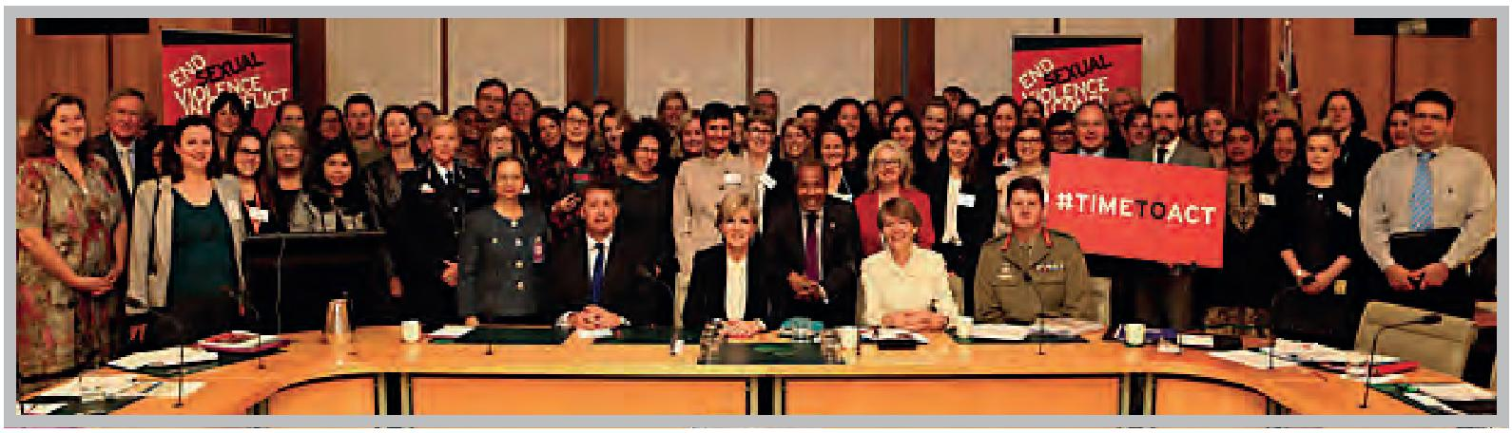
Seated from left to right: British High Commissioner, Paul Madden; Minister for Foreign Affairs, the Hon Julie Bishop MP: Hilary Charlesworth, Australian National University: Major General Gus McLachlan, ADF and participants at the Australian Dialogue on Preventing Sexual Violence in Conflict held in Canberra 2 June 2014.
Photo: DFAT.
- From 10 – 13 June 2014, government representatives from over 120 countries, and over 1,000 experts, faith leaders, youth organisations and representatives of civil society and international organisations, came together in London at the Global Summit to End Sexual Violence in Conflict (Global Summit). The Global Summit agreed practical steps to tackle impunity for the use of rape as a weapon of war, and to begin to change global attitudes to these crimes, as summarised in the Chair’s Summary and the Statement of Action. Australia’s Ambassador for Women and Girls attended the Global Summit and signed the Statement of Action.
At the Global Summit, the group committed to break the taboo around wartime rape and take action to put an end to its use. Participants were also united in their determination to tackle sexual violence in conflict and shatter the culture of impunity. Those involved pledged their support for engendering a global shift in attitudes towards sexual violence as not a lesser crime, but an atrocity of the first order. Participants were also unified in calling for concrete, practical and forward looking outcomes, and to sending a message that the era of impunity for wartime sexual violence was over. The crucial role of governments in ending sexual violence was acknowledged, as was work with regional and international organisations. Furthermore, the International Protocol on the Documentation and Investigation of Sexual Violence in Conflict, supported by Australia, was launched setting out international standards on how to collect the strongest possible information and evidence, whilst protecting witnesses, in order to increase convictions and deter future perpetrators. Where appropriate, Australia will advocate for use of the International Protocol on the Documentation and Investigation of Sexual Violence in Conflict.
- In 2014, Australia has provided $1.65 million to support humanitarian and protection activities, focused on preventing and responding to sexual and gender-based violence and enhancing capacity to strengthen protection and gender responses in emergency settings. Support has been provided through ProCap and Gencap, the Women’s Refugee Commission (WRC) and UNICEF/UNFPA for the work of the Gender-Based Violence Area of Responsibility (GBV AoR). Australia has supported these three organisations for several years, with previous projects delivering important results including innovation work in protection in humanitarian emergencies—a sector in which Australia has taken the lead amongst donors. 2014 funding will assist in strengthening the capacity of disabled people’s organisations to advocate on the inclusion of women and girls with disabilities in humanitarian action (WRC), responding to priority gaps and needs in emergency protection and gender responses (GenCap and ProCap) and advancing a comprehensive and coordinated approach to gender-based violence at the feld level, including prevention, care, support, recovery and work to hold perpetrators accountable (GBV AoR).
- Australia is providing $1 million in support to the Global UN Women programme From Communities to Global Security Institutions, to support women’s engagement in decision-making on peace-building and gender-responsive security sector reform including in Timor-Leste, Liberia and Uganda.
- As part of Australia’s $17.7 million programme to help end violence against women in Afghanistan, Australia will provide $3.3 million over three years from June 2014 to support Afghan women’s organisations to strengthen their advocacy and leadership efforts on issues that impact Afghan women most: combating violence against women, ensuring that important gains made over the last ten years in women’s rights and protection are maintained, and having a voice in peace and security discussions; pilot a Young Women’s Leadership Programme to help build a new generation of women leaders in Afghanistan; and expand and strengthen women’s networks across the country so Afghan women in rural and urban areas have a voice in their future.
- Australia will provide $2.5 million to support the Inclusive Development in Post-Conflict Bougainville programme to provide village level economic infrastructure and social support for women, men, girls and boys. Decisions over the activities to be funded are made by all-women committees. The programme aims to help rebuild communities to reduce poverty and alleviate conditions that lead to conflict and associated violence against women.
- In the Papua New Guinea Highlands, Australia will support Women’s Human Rights Defenders’ Network and Repatriation research focussing on prevention work that challenges traditional community attitudes to sorcery, investments in organisational development for partners, and men and boys behavioural change activities. Research on informal and formal repatriation will explore whether repatriation for women is a viable pathway out of violence.

Further information
If you have further questions regarding the 2014 Progress Report please contact the Office for Women by email at unscr1325@pmc.gov.au.

Annex A
List (alphabetical) and description of relevant official policy and guidance documents that contain reference to the Women, Peace and Security agenda or resolutions 1325, 1820, 1888, 1889, 1960, 2106 and 2122 (refers to Strategy 1a).
1. AFP International Deployment Group (IDG) Gender Strategy – In keeping with the National Action Plan, this document outlines the ways in which gender will be addressed in all IDG work, including daily operations, police development programmes and stability operations. The strategy articulates specific objectives and target outcomes, which are aligned with the National Action Plan.
2. An Effective Aid Programme for Australia: Making a real difference – Delivering real results (2012) – This document from the former agency AusAID, outlines the (previous Government’s) overall aid strategy through to 2016–17 which specifies promoting gender equality and empowering women as overarching goals of the aid programme. It states that efforts to meet gender equality goals and targets will be increased, including by encouraging the participation of women in peace-building. It also specifies Australia’s support for UNSCR 1325 and the intention to continue to work to enhance the safety and security of women and girls in disaster and conflict situations.
3. Australia – UN High Commissioner for Refugees (UNHCR) Partnership Framework (2013–2016) – This former agency AusAID document provides the details of the Partnership Framework between Australia’s aid programme and the UNHCR. It outlines overarching global objectives including agreement to advance gender equality and the empowerment of women within all UNHCR programmes and policies, including UNHCR staffng, in line with the UN system-wide policy on gender equality. It also identifies that Australia will encourage full implementation of UNSCR 1325.
4. Australian Civil Military Activity Report and Forward Plan 2013/14 – This report highlights the key activities of the ACMC, with Women, Peace and Security identified as a key thematic priority.
5. Australian Civil Military Centre National Action Plan Implementation Plan – This document outlines the specific actions and processes to implement ACMC’s responsibilities under the National Action Plan. It specifies the areas that will undertake the work, identifies areas and individuals responsible and timeframes for delivery and integrates into the broader Defence Implementation Plan.
6. Australian Defence Doctrine Publication 3.11 – Civil Military Cooperation – an Annex to Chapter 5, covering Gender Awareness, is in draft and expected to be released in 2014.
7. Australian Defence Doctrine Publication 3.20 – The Military Contribution to Humanitarian Operations – covers operational environment, culture, gender, religion and disabilities. This was published in December 2013.
8. Australian Defence Doctrine Publication 3.8 – Peace Operations – Two chapters relating to Planning and Training are in draft and expected to be released in 2014.
9. Australian Defence Doctrine Publication 5.0 – Joint Planning – This is being updated to reflect Women, Peace and Security and gender issues prior to publishing.
10. Australian Defence Force Publication 5.0.1 – Joint Military Appreciation Process – This is the broad framework for military planning and is due for release in 2014.
11. Consular operations handbook – This handbook used by DFAT contains specific instruction on responding to harmful traditional practices.
12. Defence National Action Plan Implementation Plan – This document outlines the specific tasks and activities to implement Defence’s responsibilities under the National Action Plan. It specifies the responsible Defence Task Leads that will undertake the work and timeframes for delivery.
13. Defence Strategic Communication Plan 2014 for the Defence Implementation Strategy for the Australian National Action Plan for Women, Peace and Security – This plan provides a schedule of communication initiatives for 2014 in support of National Action Plan implementation, primarily to reinforce Defence’s commitment to the Women, Peace and Security agenda in the broader Australian community, and to ensure that internally, Defence personnel gain an understanding of, and commitment to, the role of women in Australia’s peace and security efforts.
14. Department of Foreign Affairs and Trade Code of Conduct for Overseas service – Employees of DFAT travelling overseas on official business, including those on long-term postings, are required to provide an undertaking that they will comply with the Code of Conduct for Overseas Service, which is underpinned by the Australian Public Service Code of Conduct. This contains provisions on appropriate personal behaviours, which includes sexual behaviour.
15. Department of Prime Minister and Cabinet’s Strategic Framework for Women’s Policy – This document outlines the Government’s four priority areas for assisting women to further their economic independence and participation in their communities, and be safe from violence. International Engagement and Reporting is one of the priority areas with the implementation of the National Action Plan a key outcome.
16. Framework for Working in Fragile and Conflict-Affected States (2011) – This former AusAID agency reference document outlines Australia’s approach to working in fragile and conflict-affected states including Australia’s work to strengthen the role of women in the prevention and resolution of conflicts and in rebuilding their societies after conflict. It states that our approach to situations of fragility and conflict is informed by Australia being a signatory to a number of international conventions and frameworks, including UNSCR 1325 and UNSCR 1820 that focus on women’s equal participation in decisions concerning peace and war and on the prevention of the systematic use of sexual violence in conflicts as a tactic of warfare. It also highlights the importance of engaging women and youth in the negotiation of peace settlements and post‑conflict priority setting processes to accelerate recovery and to the medium to long‑term sustainability of peace-building and state-building efforts.
17. Guidelines on the Protection of Civilians for Defence and Australian Federal Police – The ACMC is facilitating the development of Protection of Civilians Guidelines, including the protection of women and girls, for Defence and the AFP. On 20 November 2013, ACMC hosted the first Protection of Civilians Guidelines Workshop with representatives from ACMC, Defence, and PMC - Office for Women (with off-line contributions from the Attorney-General’s Department and Department of Foreign Affairs and Trade). The objective of the Workshop was to bring stakeholders together to discuss their preliminary views on the utility scope of the proposed joint Guidelines. A second Protection of Civilians Workshop is planned for mid 2014.
18. Humanitarian Action Policy (2011) – This strategic-level framework from the former agency AusAID, guides Australia’s commitments to deliver effective and appropriate humanitarian action. It references Australia’s long term support of UN Security Council resolutions on Women, Peace and Security (1325, 1889, 1820 and 1888) and Australia’s intention to expand international work to end violence against women. It also builds on the strategic partnerships formed with government, UN agencies and civil society to prevent and respond to sexual violence in conflict, post-conflict and other humanitarian settings.
19. Humanitarian Action Policy Implementation Plan (2012) – This former agency AusAID plan sets out how Australia will meet its commitments under the Humanitarian Action Policy to deliver effective and appropriate humanitarian action through Australian aid. It includes that Australia will support protection activities that align with internationally accepted guidelines, and address gender-based violence and sexual and reproductive health to prioritise the safety and dignity of affected populations. It outlines that Australia is committed to gender equality in humanitarian action; will promote humanitarian action that equally meets the needs of women, girls, boys and men and includes their active participation in its planning and implementation; will increase disaggregation of data by sex so to better plan for and understand the impacts of humanitarian action; and collect data from implementing partners that articulates how assistance is provided by sex and age.
20. AFP International Deployment Group (IDG) Gender Guidance Note – This guidance note outlines the ways in which the IDG Gender Strategy, the National Action Plan and UNSCR 1325, 1820, 1888, 1889 and 1860 on Women, Peace and Security can inform the design of new and continuing stability missions and capacity building programmes.
21. 2012 Matthew Davey Award Report by Lieutenant Commander Jennifer Macklin, Royal Australian Navy – This report describes best practice in diversity management and inclusive practices. Refers to enhancing existing cross-cultural competence training through ADF Peace Operations Centre to provide a cohort of deployment-ready diversity specialists and gender advisors for a range of operations.
22. Navy Diversity Strategy 2014–2019 – This document contains strategic objectives that are underpinned by initiatives to support the implementation of UNSCR 1325 and incorporation of a gender perspective into operational planning, deployment training and operations.
23. Promoting Opportunities for All: Gender Equality and Women’s Empowerment (2011) – This strategic document from the former agency AusAID, outlines the overall approach to gender equality and women’s empowerment in the delivery of Australian aid, which is organised around four thematic pillars: (i) advancing equal access to gender-responsive health and education services, including through targeted support in fragile states and conflict-affected countries; (ii) increasing women’s voice in peace-building, including supporting the participation of women in peace-building processes by promoting the implementation of UNSCR 1325; (iii) empowering women economically, and (iv) ending violence against women and girls, including in disaster and conflict situations. It identifies the importance of working with partners in security sector and emergency response teams to address the specific vulnerabilities experienced by women and girls living in conflict and fragile states and regions experiencing a humanitarian disaster. It also identifies the importance of contributing to international debate on ending violence against women through support for UN agencies with a global mandate supporting implementation of UNSCR 1325, 1820, 1888, 1889 and 1960.
24. Protection in Humanitarian Action Framework (2013) – This framework from the former agency AusAID, guides Australia’s commitment to improving the safety of people affected by natural and human-induced crises through humanitarian action. The approach includes mainstreaming protection and basing assistance on a context analysis that identifies the threats women, girls, boys and men are exposed to, their vulnerabilities and ability to protect themselves. It refers to Australia’s commitment to support global capacity for preventing and responding to gender-based violence and addressing gender-based violence in the National Action Plan and the 2011 Humanitarian Action Policy. It highlights that in times of crisis the risks of gender-based violence, such as domestic violence, rape, sexual assault and trafficking, increase.
25. Review into the Treatment of Women in the Australian Defence Force (ADF) Phase 2 Report – This document outlines how increasing the representation of women in the ADF will contribute to the implementation of the National Action Plan, and recognises the vital contribution that women make to Australia’s military capability and implementation of UNSCR 1325.
26. Vice Chief of Defence Force Directive 5/2013 – This Directive of 26 August 2013 to the Director, National Action Plan for Women, Peace and Security outlines the Director’s responsibilities to internal and external stakeholders and the monitoring, coordinating and reporting requirements for the progress of Defence National Action Plan actions.
27. Women, Peace and Security – AusAID’s implementation of United Nations Security Council Resolution 1325 (2010) – This booklet from the former agency AusAID, sets out the support provided by Australia to implement UNSCR 1325 by recognising and supporting the role women play in preventing conflict and building-peace; supporting women’s participation in formal peace negotiations and as part of reconstruction efforts; ensuring that men’s and women’s needs are addressed in support provided during and after conflict; and working to prevent and respond to sexual violence in conflict.
28. Women, Peace and Security Australian Civil Society Engagement Strategy – This document outlines how the Government will engage with Australian civil society organisations to implement the National Action Plan.
29. Women, Peace and Security: An Introductory Manual and Facilitator Guide – This document was developed and published by the Australian National Committee for UN Women in collaboration with ACMC in 2013. This programme was launched within Defence by the Executive Director, the Australian National Committee for UN Women, and the Chief of Defence Force at the 2014 Defence Women in Peace and Security conference on 16–17 June 2014.

Annex B
Table 1: Number and percentage of Australian Government employees deployed in operations that have received training on Women, Peace and Security as at 31 December 2013 (refers to Strategy 2a).
Agency | Total number of personnel deployed | Number of women deployed | Number of men deployed | Total number and % of deployed personnel trained | Number of deployed women trained | Number of deployed men trained | % of deployed women trained | % of deployed men trained
 |  |  |  | 637
Defence | 1,199 | 195 | 1,004 | (53.1%) | 148 | 489 | 75.9% | 48.7%
 |  |  |  | 121
AFP | 176 | 41 | 135 | (68.8%) | 28 | 93 | 68.3% | 68.9%
 |  |  |  | 25
DFAT | 66 | 26 | 40 | (37.9%) | 9 | 16 | 34.6% | 40.0%
 |  |  |  | 783
TOTAL | 1,441 | 262 | 1,179 | (54.3%) | 185 | 598 | 70.6% | 50.7%
Table 2: Number of women and men employed by Defence and the Australian Federal Police as at 31 December 2013 (refers to Strategy 2b).
Agency | Total number of employees | Number of women employees | Number of men employees | % of women employees | % of men employees
Defence - ADF Permanent Forces | 56,524 | 8,302 | 48,222 | 14.7% | 85.3%
Defence - APS Civilians | 21,650 | 8,812 | 12,838 | 40.7% | 59.3%
Defence - ADF Reserves | 48,158 | 7,137 | 41,021 | 14.8% | 85.2%
AFP | 6,923 | 2,374 | 4,549 | 34.3% | 65.7%
Total | 133,255 | 26,625 | 106,630 | 20.0% | 80.0%
Table 3: ADF Permanent Members by Rank Level as at 31 December 2013 (refers to Strategy 2b).
ADF Members (Full-Time) |  | Women | Men | Total
Officer | General (O10) | 0 | 1 | 1
 | Lieutenant General (O09) | 0 | 7 | 7
 | Major General (O08) | 2 | 41 | 43
 | Brigadier (O07) | 10 | 137 | 147
 | Colonel (O06) | 50 | 404 | 454
 | Lieutenant Colonel (O05) | 193 | 1,420 | 1,613
 | Major (O04) | 611 | 3,058 | 3,669
 | Captain (O03) | 943 | 3,892 | 4,835
 | Lieutenant (O02) | 477 | 1,657 | 2,134
 | Second Lieutenant (O01) | 57 | 225 | 282
 | Officer Cadet (O00) | 262 | 1,069 | 1,331
 | Officer Total | 2,605 | 11,911 | 14,516
Other Ranks | Regimental Sergeant Major-Army (E10) | 0 | 3 | 3
 | Warrant Officer Class 1 (E09) | 126 | 1,319 | 1,445
 | Warrant Officer Class 2 (E08) | 388 | 3,295 | 3,683
 | Staff Sergeant (E07) | 2 | 25 | 27
 | Sergeant (E06) | 737 | 4,921 | 5,658
 | Corporal (E05) | 1,388 | 7,335 | 8,723
 | Lance Corporal (E04) | 147 | 1,329 | 1,476
 | Private Profcient (E03) | 1,971 | 12,993 | 14,964
 | Private (E02) | 457 | 2,512 | 2,969
 | Private Trainee (E01) | 338 | 2,069 | 2,407
 | Recruit (E00) | 143 | 510 | 653
 | Other Ranks Total | 5,697 | 36,311 | 42,008
 | Grand Total | 8,302 | 48,222 | 56,524
Table 4: Defence APS Employees by Rank Level as at 31 December 2013 (refers to Strategy 2b).
Defence APS employees | Women | Men | Total
Secretary of Department | 0 | 1 | 1
Senior Executive (Band 3) | 2 | 14 | 16
Senior Executive (Band 1) | 39 | 86 | 125
Senior executive (Band 2) | 11 | 44 | 55
Defence Families of Australia | 1 | 0 | 1
Inspector General - ADF | 0 | 1 | 1
Religious Advisory Services | 0 | 5 | 5
Executive Level 2 | 522 | 1,686 | 2,208
Executive Level 1 | 1,521 | 3,091 | 4,612
Graduate | 29 | 51 | 80
APS Level 6 | 2,114 | 3,601 | 5,715
APS Level 5 | 1,386 | 1,853 | 3,239
APS Level 4 | 1,313 | 1,129 | 2,442
APS Level 3 | 1,246 | 791 | 2,037
APS Level 2 | 567 | 399 | 966
APS Level 1 | 57 | 76 | 133
Trainee | 4 | 10 | 14
TOTAL | 8,812 | 12,838 | 21,650
Table 5: ADF Reserve Members by Rank Level as at 31 December 2013 (refers to Strategy 2b).
ADF Reserve member | Women | Men | Total
General (O10) | 0 | 0 | 0
Lieutenant General (O09) | 0 | 10 | 10
Major General (O08) | 3 | 58 | 61
Brigadier (O07) | 6 | 223 | 229
Colonel (O06) | 41 | 543 | 584
Lieutenant Colonel (O05) | 149 | 1,786 | 1,935
Major (O04) | 557 | 3,368 | 3,925
Captain (O03) | 1,031 | 3,846 | 4,877
Lieutenant (O02) | 325 | 1,030 | 1,355
Second Lieutenant (O01) | 11 | 45 | 56
Officer Cadet (O00) | 59 | 448 | 507
Officer Total | 2,182 | 11,357 | 13,539
Regimental Sergeant Major-Army (E10) | 0 | 0 | 0
Warrant Officer Class 1 (E09) | 117 | 1,469 | 1,586
Warrant Officer Class 2 (E08) | 254 | 2,635 | 2,889
Staff Sergeant (E07) | 9 | 67 | 76
Sergeant (E06) | 635 | 3,064 | 3,699
Corporal (E05) | 1,225 | 5,502 | 6,727
Lance Corporal (E04) | 184 | 1,828 | 2,012
Private Profcient (E03) | 1,574 | 8,737 | 10,311
Private (E02) | 695 | 4,586 | 5,281
Private Trainee (E01) | 109 | 886 | 995
Recruit (E00) | 153 | 890 | 1,043
Other Ranks Total | 4,955 | 29,664 | 34,619
GRAND TOTAL | 7,137 | 41,021 | 48,158
Table 6: Breakdown of Reserve Member elements as at 31 December 2013 (refers to Strategy 2b).
 | Reserve Member Elements | Women | Men | Total
Navy | Navy Active Reserve (RES-A) | 958 | 3,735 | 4,693
 | Navy Standby Reserve (RES-I) | 561 | 2,812 | 3,373
 | Total Navy | 1,519 | 6,547 | 8,066
Army | Army Active Reserve (RES-A) | 1,902 | 12,423 | 14,325
 | Army High Readiness Reserve (RES-HRR) | 15 | 255 | 270
 | Army Standby Reserve (RES-I) | 1,983 | 14,979 | 16,962
 | Local Observer Element (RES-LOE) | 30 | 53 | 83
 | Regional Forces Surveillance L (RES-FSL) | 43 | 374 | 417
 | Reserve Response Forces (RES-RRF) | 16 | 85 | 101
 | Total Army | 3,989 | 28,169 | 32,158
Air Force | RAAF Active Reserve (RES-A) | 684 | 2,748 | 3,432
 | High Readiness Reserve (RES-HRR) | 30 | 177 | 207
 | High Readiness Specialist Res (RES-HSR) | 15 | 20 | 35
 | RAAF Specialist Reserve (RES-ES) | 137 | 368 | 505
 | RAAF Standby Reserve (RES-I) | 763 | 2,993 | 3,756
 | Total Air Force | 1,629 | 6,306 | 7,935
Service Details |  | 7,137 | 41,022 | 48,159
Table 7: Australian Federal Police employees by Rank Level as at 31 December 2013 (refers to Strategy 2b).
Band | Total number of employees | Total number of female employees | Total number of male employees
Casual | 24 | 9 | 15
Band 1 | 2 | 0 | 2
Band 2 | 559 | 136 | 423
Band 3 | 1,627 | 508 | 1,119
Band 4 | 1,547 | 652 | 895
Band 5 | 1,115 | 339 | 776
Band 6 | 521 | 254 | 267
Band 7 | 929 | 305 | 624
Band 8 | 249 | 86 | 163
Executive Level | 267 | 69 | 198
SES | 83 | 16 | 67
Grand Total | 6,923 | 2,374 | 4,549
Table 8: Number of women and men deployed and posted to conflict and post-conflict settings by agency as at 31 December 2013 (refers to Strategy 2c).
Agency | Total number of deployed | Number of women deployed | Number of men deployed | % of women deployed | % of men deployed
Defence | 1,199 | 195 | 1,004 | 16.3% | 83.7%
AFP | 190 | 43 | 147 | 22.6% | 77.4%
DFAT | 66 | 26 | 40 | 39.4% | 60.6%
Total | 1,455 | 264 | 1,191 | 18.1% | 81.9%
Table 9: The levels of deployed ADF and Department of Defence APS women and men as at 31 December 2013 (refers to Strategy 2c).
ADF | Level | Total | Women | Men | % women | % men
Major General (E) | O08 | 2 | 0 | 2 | 0.0% | 100.0%
Brigadier (E) | O07 | 9 | 0 | 9 | 0.0% | 100.0%
Colonel (E) | O06 | 13 | 0 | 13 | 0.0% | 100.0%
Lieutenant Colonel (E) | O05 | 49 | 5 | 44 | 10.2% | 89.8%
Major (E) | O04 | 88 | 10 | 78 | 11.4% | 88.6%
Captain (E) | O03 | 149 | 31 | 118 | 20.8% | 79.2%
Lieutenant (E) | O02 | 27 | 8 | 19 | 29.6% | 70.4%
2nd Lieutenant (E) | O01 | 0 | 0 | 0 | 0.0% | 0.0%
Warrant Officer 1 (E) | E09 | 37 | 4 | 33 | 10.8% | 89.2%
Warrant Officer 2 (E) | E08 | 61 | 6 | 55 | 9.8% | 90.2%
Staff Sergeant (E) | E07 | 13 | 1 | 12 | 7.7% | 92.3%
Sergeant (E) | E06 | 127 | 17 | 110 | 13.4% | 86.6%
Corporal (E) | E05 | 205 | 40 | 165 | 19.5% | 80.5%
Lance Corporal (E) | E04 | 231 | 49 | 182 | 21.2% | 78.8%
Private (E) | E03 | 10 | 3 | 7 | 30.0% | 70.0%
Private (P) (E) | E02 | 166 | 16 | 150 | 9.6% | 90.4%
ADF Total |  | 1,187 | 190 | 997 | 16.0% | 84.0%
Civilian | S&T 4-6 | 2 | 0 | 2 | 0.0% | 100.0%
 | EL2 | 2 | 1 | 1 | 50.0% | 50.0%
 | EL1 | 3 | 2 | 1 | 66.6% | 33.3%
 | APS 4-6 | 5 | 2 | 3 | 40.0% | 60.0%
Civilian Total |  | 12 | 5 | 7 | 41.7% | 58.3%
Grand Total |  | 1,199 | 195 | 1,004 | 16.3% | 83.7%
Table 10: AFP personnel deployed to conflict and post-conflict settings as at 31 December 2013 (refers to Strategy 2c)
Level | Total number deployed | Number of women deployed | Number of men deployed | % of women deployed | % of men deployed
Band 3 | 5 | 2 | 3 | 40.0% | 60.0%
Band 4 | 35 | 12 | 23 | 34.3% | 65.7%
Band 5 | 67 | 15 | 52 | 22.4% | 77.6%
Band 6 | 9 | 3 | 6 | 33.3% | 66.6%
Band 7 | 47 | 6 | 41 | 12.8% | 87.2%
Band 8 | 6 | 2 | 4 | 33.3% | 66.6%
Executive | 20 | 3 | 17 | 15.0% | 85.0%
SES | 1 | 0 | 1 | 0.0% | 100.0%
Grand Total | 190 | 43 | 147 | 22.6% | 77.4%

Table 11: The levels of deployed DFAT women and men as at 31 December 2013 (refers to Strategy 2c).
Classification Level | Total number of deployed | Number of women deployed | Number of men deployed | % of women deployed | % of men deployed
SESi | 5 | 1 | 4 | 20.0% | 80.0%
EL2 | 15 | 6 | 9 | 40.0% | 60.0%
ELi | 30 | 13 | 17 | 43.3% | 56.7%
APS6 | 9 | 4 | 5 | 44.4% | 55.6%
BB2 | 7 | 2 | 5 | 28.6% | 71.4%
Grand Total | 66 | 26 | 40 | 39.4% | 60.6%

Annex C

Number and description of interventions and support of resolutions and policy in the UN Security Council, General Assembly, UN Human Rights Council and other relevant fora addressing Women, Peace and Security issues (refers to Strategy 4e).
Number | Resolution / policy title | Description (of policy and support)
March 2014 | Australian statement to the UN Security Council on post-conflict peace-building. | Australia’s statement highlighted the importance of the participation of women and the role of police in peace-building.
March 2014 | Australian statement to Australia-United Kingdom side event at CSW on Women, Peace and Security. | Australian event focused on the successes and challenges in women’s participation in peace processes and identifying opportunities for the international community to support women’s leadership in conflict resolution.
March 2014 | Australian statement to Thailand side-event on Women, Peace and Security. | Australia’s statement focused on implementing the frameworks of UNSCR 2106 and UNSCR 2122.
January 2014 | Australian statement to the International Conference on Syria (“Geneva II”). | Australia stated that the priority which the Secretary-General has placed on the participation of women at this conference is to be commended. Women have suffered disproportionately as a result of the conflict and must be a central part of its resolution, including at each stage of the transition process.
October 2013 | S/RES/2122. | This resolution addressed the persistent gaps in the implementation of the Women, Peace and Security agenda, as highlighted in the most recent Secretary-General’s report.
October 2013 | Australian statement to UN Security Council on Women, Peace and Security. | Australia’s statement focused on the need for women’s participation in peace processes, the importance of considering gender-based crimes in transitional justice systems and the importance of women’s leadership within justice systems.
October 2013 | Australian statement on Women’s Empowerment to the UN General Assembly (UNGA) Third Committee. | The statement noted the UN Security Council’s Women, Peace and Security agenda remains highly relevant, and concerted efforts must be made to implement it effectively. The treatment of women in conflict settings is an international peace and security issue. And women’s contribution to conflict prevention, resolution, and peace-building is fundamental to achieving lasting peace. Further efforts must also be made to ensure women’s vital contributions as agents of peace and security, are harnessed.
September 2013 | Declaration of Commitment to End Sexual Violence in Conflict. | Australia joined 111 other nations (now over 140) in signing the Declaration of Commitment to End Sexual Violence in Conflict.
September 2013 | Australian statement at a Prevention of Sexual Violence in Conflict side event at UNGA68 by the Minister for Foreign Affairs. | The statement noted that the Initiative is an essential step in raising awareness and developing responsive capacity to address sexual violence.
September 2013 | Australian statement to UN Security Council high level meeting on small arms. | Australia noted that for states emerging from conflict, disarmament, demobilisation and reintegration programmes for former combatants must be carefully designed and implemented, and weapons accounted for. Security sector reform must include effective weapons management. Such transition processes must be inclusive, with women’s participation crucial.
August 2013 | S/PRST/2013/12 Cooperation between the UN and regional and subregional organisations in maintaining international peace and security. | The UN Security Council reaffirms the vital role of women in the prevention and resolution of conflicts, peace negotiations, peace-building, peacekeeping, humanitarian response and post-conflict reconstruction, further reaffirms the importance of the prevention of and protection from sexual violence in armed conflicts and post-conflict situations, and stresses the need for the UN and regional and subregional organisations to work to ensure that women and gender perspectives are fully integrated into all peace and security efforts undertaken by the United Nations and regional and subregional organisations, including by building the necessary capacity.
July 2013 | S/PRST/2013/11 The situation in the Great Lakes region: Supporting the Great Lakes Framework. | The UN Security Council further commends efforts to include women and civil society in the implementation of the Peace and Security Cooperation Framework and to promote the full and effective participation of women in conflict resolution and peace-building, including through the implementation of a Sub-regional Action Plan for the implementation of resolution 1325 (2000). It welcomes in this regard the Regional Conference on Women, Peace, Security and Development held in Bujumbura on 9–11 July 2013.
June 2013 | S/RES/2106. | This was a resolution focusing on accountability for perpetrators of sexual violence in conflict and stressing women’s political and economic empowerment.
June 2013 | Australian statement to the UN Security Council. | Australia’s statement highlighted the need to ensure regular briefings to the UN Security Council on the use of sexual violence, ending impunity, ensuring women’s participation in conflict resolution and peace-building and systematically deploying gender experts to mandated missions.
June 2013 | UNHRC resolution 23/25 Accelerating efforts to eliminate all forms of violence against women: preventing and responding to rape and other forms of sexual violence. | Recalling UN Security Council resolutions 1325 (2000) of 31 October 2000, 1820 (2008) of 19 June 2008, 1888 (2009) of 30 September 2009, 1889 (2009) of 5 October 2009 and 1960 (2010) of 16 December 2010, on Women, Peace and Security, 1674 (2006) of 28 April 2006, and all relevant UN Security Council resolutions on children and armed conflict, including UNSCRs 1882 (2009) of 4 August 2009 and 1998 (2011) of 12 July 2011.
June 2013 | HRC resolution 23/26 The deterioration of the situation of human rights in the Syrian Arab Republic, and the need to grant immediate access to the commission of Inquiry. | Recalling UN Security Council resolutions 1325 (2000) of 31 October 2000, 1820 (2008) of 19 June 2008, 1888 (2009) of 30 September 2009, 1889 (2009) of 5 October 2009 12. Calls upon all parties to fully respect international law applicable to the rights and protection of women and girls, and to take special measures to protect women and girls from gender-based violence, particularly rape and other forms of sexual abuse, and also calls for the involvement of women at decision-making levels in conflict resolution and peace processes.
June 2013 | Australia’s Ambassador for Women and Girls is expert speaker on integration of a gender perspective in the work of the Human Rights Council and its mechanisms. | The presentation provided best practice examples of mainstreaming gender (including the Women, Peace and Security agenda) across the work of UN entities.
June 2013 | Australia’s statement in the Human Rights Council for the Annual Discussion on Women’s Human Rights. | Australia’s statement focused on ending violence against women.
June 2013 | Australian statement to the Human Rights Council for the interactive dialogue with the Working Group on the issue of discrimination against women in law and in practice. | Australia’s statement focused on women’s participation.
May 2013 | Arria-Formula Meeting on Implementing the UN Security Council’s Women, Peace and Security Agenda statement by the then Minister for Defence. | Australia’s statement noted that furthering the effective implementation of the UN Security Council’s Women, Peace and Security agenda is a priority for Australia, urged other members to ensure Women, Peace and Security was considered across the breadth of the UN Security Council’s work and discussed Australia’s regional experiences in Bougainville, Solomon Islands and Timor-Leste.
April 2013 | Australian statement to the UN Security Council on sexual violence in conflict. | Australia’s statement highlighted the need to end impunity, ensure women’s participation in conflict resolution and peace-building and to systematically deploy gender experts to mandated missions.
April 2013 | Australian statement to the UN Security Council on peace-building. | Australia’s statement highlighted the role of women in peace-building, noting the evidence is clear that engaging women in the negotiation of peace-building settlements and post-conflict decision-making is key to ensuring sustainable recovery and long term peace. More effort is needed to take forward the Secretary-General’s seven point action plan on gender-responsive peace-building, particularly in the areas of economic recovery and governance.
April 2013 | The Organisation for Security and Co-operation in Europe (OSCE) Asian Partners Conference on Improving the Security of Women and Girls. Opening Address by the then Australia Global Ambassador for Women. | Address – “We recognised that Australia’s strong commitment to gender equality domestically and internationally is well established. A key priority is our work on the Women, Peace and Security agenda. As a member of the UN Security Council, for the next two years Australia will have a direct hand in shaping solutions to the world’s most pressing security challenges. We will pursue a more comprehensive and inclusive approach to gender concerns across the UN Security Council’s agenda. We’ll be pressing for an end to impunity for perpetrators of sexual violence. We will also push for all relevant peacekeeping and peace-building operations to properly address the impact of conflict on women and girls and to encourage increased participation of women”.
March 2013 | Australian statement to the Commission on the Status of Women (CSW). | Australia specifically referenced Women, Peace and Security in its statement to the 57th session of CSW noting that: “Australia is deeply committed to promoting the Women, Peace and Security agenda across the breadth of our work on the UN Security Council. We are working actively to support efforts to prevent and address conflict-related sexual violence; to put an end to impunity for perpetrators of such crimes; and to promote the early involvement of women in conflict prevention, resolution and peace-building. Australia affirmed that the effective participation of women in post-conflict peace-building processes is critical to achieving lasting peace”. Australia noted that women’s civil society organisations played a critical part in shaping our National Action Plan, and their ongoing role in monitoring compliance is central to the National Action Plan’s success.
February 2013 | Australian statement to the UN Security Council on peacekeeping operations. | Australia’s statement highlighted the role of women: “Experience has shown us that for peacekeeping missions to be successful, peace-building and development objectives must be considered from the early planning stages. Recognition of this was a central element in Resolution 2086 (2013) adopted by the UN Security Council on 21 January 2014 – the first thematic resolution on peacekeeping adopted by the UN Security Council in over a decade. Consideration of the Women, Peace and Security agenda is a critical part of this process, as is child protection work. But our progress on implementing the Women, Peace and Security agenda in peacekeeping remains mixed and unsystematic. We urge the UN Department of Peacekeeping Operations to finalise its five year forward looking strategy on Women, Peace and Security. The dedicated resources that have been established to support these agendas, such as gender advisors, women protection advisors and child protection advisors, must be budgeted for and deployed. Access and reporting lines with senior mission leadership are essential to ensuring gender and protection concerns are being integrated into mission planning and operations.
 |  | We welcome the development of the gender training strategy, as well as the implementation of various scenario-based training modules on sexual violence, violence against women and girls, and child protection. But we still need to see mission-specific early warning indicators to assist in strengthening the early warning capacity of peacekeeping missions”.
January 2013 | Australian statement to UN Security Council on UN peacekeeping. | In its statement Australia highlighted two areas which we believe are central to peacekeeping and peace-building: the Protection of Civilians and Women, Peace and Security. The duty of peacekeepers to protect civilians – whether through direct activities, such as protecting against conflict-related sexual violence, or working to build local capacities such as through the training of the security sector – are central to the restoration of security and moving towards a healthy civil society. This is a central pillar of peace-building. We also know that peace-building processes involving the participation of women are more likely to succeed. Peacekeeping missions can play a strong role in fostering such participation, including through the work of gender advisors and role models.
December 2012 | Speech to Political - Military Seminar: UNSCR 1325 and Women, Peace and Security in NATO-led Operations and Missions by the Australian Ambassador to NATO. | Discussed how the implementation of the Women, Peace and Security agenda can make NATO-led operations and missions more efficient and effective.
November 2012 | Australian statement to the UN Security Council on Women, Peace and Security. | Australia highlighted that women’s organisations play an indispensable role in enabling women to prevent conflict, and promote and build peace. But women’s organisations can only operate effectively in safety, and with support. In this regard, Australia strongly supports the Secretary-General’s call for protection of women’s human rights defenders during conflict situations, given their specific vulnerability.
October 2012 | S/PRST/2012/23. | The UN Security Council highlighted the impact of women’s civil society organisations, recognised the need in the UN Security Council’s own work for more systemic attention to the Women, Peace and Security agenda and welcomed the Secretary-General’s call for enhanced women’s participation, at all levels, in conflict prevention, conflict resolution and peace-building.
September 2012 | HRC resolution 21/15 Human rights and transitional justice. | Recalling further UNSCR 1325 of 31 October 2000 and its subsequent resolutions 1820 of 19 June 2008, 1888 of 30 September 2009, 1889 of 5 October 2009 and 1960 of 16 December 2010 on Women, Peace and Security, and reaffirming the important role of women in the prevention and resolution of conflicts and in peace-building, and the need to increase their role in decision making with regard to conflict prevention and resolution.
July 2012 | Australian statement to the UN Economic and Social Council on the advancement of women. | Australia’s statement welcomed efforts to mainstream a gender perspective into the UN system policies and programmes.
June 2012 | Australia’s statement to the Human Rights Council for the clustered interactive dialogue with the Special Rapporteur on Violence Against Women. | Australia’s statement covered women’s rights to full participation in peace-building work.
June 2012 | Australia’s statement to the Human Rights Council for the annual day of discussion: Remedies and reparations for women who have been subjected to violence. | Australia’s statement noted its support which has helped increase the number of new women village court magistrates recruited and trained in Papua New Guinea, up from ten in 2004 to more than 600 at the end of 2011. This will lead to better access to justice for women at the village level and possibly help mitigate the causes of violence against women. Australia also funds projects that address gender-based and sexual violence for vulnerable Iraqi migrant women in Jordan and a Kenyan based project assisting refugee women and girl survivors of gender based violence.
June 2012 | Australian statement to the UN Security Council on Protection of Civilians in Armed Conflict. | Australia’s statement placed emphasis on the importance of the role of women, who bring distinct perspectives and skills to this work.
Through-out the reporting period | Country specific statements and mandates of the UN Security Council. | Australia has been instrumental in advocating for gender considerations across the UN Security Council’s work in country specific statements and peacekeeping mandates. For example:
 |  | On Afghanistan: UNSCR 2145 on UN Assistance Mission in Afghanistan (UNAMA) recalls all relevant Women, Peace and Security resolutions and contains multiple focused references to women’s protection, participation and prevention. Australia was penholder for this resolution.
 |  | In our statements: Australia welcomes the UN’s role in supporting the elections, and encourages the Afghan Government to work with the UN to strengthen the sustainability, integrity and inclusiveness of the electoral process. Australia encourages continued efforts to ensure women are able to safely exercise their rights to vote and participate in the process. Their participation will be a decisive measure of the elections’ representativeness and its success.
 |  | On human rights: Afghanistan needs to be vigilant in building on the gains of the last decade, particularly in relation to the rights of women and girls. Today’s resolution reaffirms that message. Australia continues to urge full implementation of the Elimination of Violence Against Women Law and encourage the Afghan government to finalise and implement a National Action Plan on Women, Peace and Security to support the active participation of women in the peace and reconciliation process.
 |  | On Mail: in the MINUSMA mandate (UNSCR 2100) language included:
 |  | OP16 (b) (iii) To assist the transitional authorities of Mali and communities in the north of Mali to facilitate progress towards an inclusive national dialogue and reconciliation process, notably the negotiation process referred to in paragraph 4 above, including by enhancing negotiation capacity.
 |  | OP16 (c) (ii) To provide specific protection for women and children affected by armed conflict, including through the deployment of Child Protection Advisors and Women Protection Advisors.
 |  | Other UN Security Council Resolutions which reference Women, Peace and Security include: 2086, 2090, 2091, 2093, 2095, 2096, , 2100, 2101, 2106, 2109, 2110, 2112, 2113, 2116, 2117, 2119, 2120, 2121, 2122, 2126, 2127, 2137, 2138, and 2140.
 |  | Presidential statements of the UN Security Council which include Women, Peace and Security include:
 |  | S/PRST/2013/2 (12 February 2013) Protection of civilians in armed conflict;
 |  | S/PRST/2013/4 (15 April 2013) Peace and security in Africa;
 |  | S/PRST/2013/11 (25 July 2013) The situation in the Great Lakes region: Supporting the Great Lakes Framework;
 |  | S/PRST/2013/12 (6 August 2013) Cooperation between the UN and regional and subregional organisations in maintaining international peace and security;
 |  | S/PRST/2013/17 (14 November 2013) The situation in the Democratic Republic of the Congo;
 |  | S/PRST/2014/3 (12 February 2014) Protection of civilians in armed conflict; and
 |  | S/PRST/2014/5 (21 February 2014) Promotion and strengthening of the rule of law in the maintenance of international peace and security.

www.un.org/en/globalissues/women/peace.shtml
This includes the Australian Defence Force (ADF).
Please note that the Gender Field Advisor Course participant and the Gender Field Advisor Train-the-Trainer Course participant are not counted in the data provided at 2a. as they were not deployed to a conflict or post-conflict setting.
Please note that the two women who undertook the NCGM training in January 2014 are not included in the data at 2a. as the training was undertaken after this reporting period (post-31 December 2013).
DFAT has reported on staff deployment to Afghanistan and the Solomon Islands only. Data does not include short term assignments or missions, consultant/contractor travel, or travel that did not originate in Australia.
A male person who delivers the sermon (khu bah) during the Friday prayer.
www.oecd.org/dac/governance-development/37790393.pdf
D2 is equivalent to ADF two-star/APS Band two Senior Executive Service Level.
Personnel deployed in support of seven specific operations and missions.
This includes AFP members deployed (including members on leave) to peacekeeping and peace-building operations in conflict and post-conflict settings, including UN, multilateral and bilateral operations in Afghanistan, Cyprus, Solomon Islands, South Sudan and Timor-Leste. It does not include personnel working on capacity development programmes in fragile settings or personnel deployed through the AFP’s International Network for the purposes of international law enforcement cooperation.
DFAT data includes diplomatic and aid deployees to Afghanistan and Solomon Islands only. Staff deployed to other locations can also undertake Working in Fragile and Conflict-Affected States training. Data for DFAT deployments does not include short term assignments or missions, consultant/contractor travel, or travel that did not originate in Australia. Data includes Whole-of-Government deployments funded by official Development Assistance where there is a Record of Understanding in place between relevant Government entities under the Regional Assistance Mission to the Solomon Islands (RAMSI). All Whole-of-Government deployees are managed by and remain employees of their home agency.
Data for Defence is broken into three categories to provide greater insight into women’s representation. These include ADF Permanent Forces, Defence civilians and ADF Reserve. Defence reserve force consists of a number of elements including Active Reserve and Standby Reserve. Active Reservists may be employed in a full-time or part-time capacity. Standby Reserve is not regularly employed. It is worth noting that there are an unknown number of APS employees who are also Reservists; the fgures represented in this report may ‘double up’ as they are considered to be fulflling two roles.
Comprises Active Reserve, Standby Reserve and Reserve members on Continuous Full Time Service.
Army ranks include Navy and Air Force equivalents.
This fgure includes AFP members in conflict and post-conflict settings (Afghanistan, Cyprus, Solomon Islands, South Sudan, and Timor-Leste) who were employed in peacekeeping and peace-building operations, and those deployed for the purposes of international law enforcement cooperation as at 31 December 2013.
Army ranks include Navy and Air Force equivalents.
AFP data does not include short term assignments or missions, consultant/contractor travel, or travel that did not originate in Australia. Whole-of-Government deployments include those funded by Offcial Development Assistance where there is a Record of Understanding in place between relevant Government entities. This covers the Regional Assistance Mission to Solomon Islands (RAMSI). All Whole-of-Government deployees are managed by and remain employees of their home agency.
DFAT has reported on diplomatic and aid deployments for Afghanistan and the Solomon Islands only. Data does not include short term assignments or missions, consultant/contractor travel, or travel that did not originate in Australia. Data includes Whole-of-Government deployments funded by official Development Assistance where there is a Record of Understanding in place between relevant Government entities under the Regional Assistance Mission to the Solomon Islands (RAMSI). All Whole-of-Government deployees are managed by and remain employees of their home agency.

