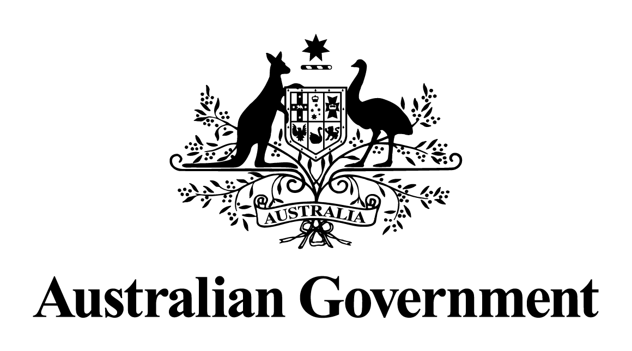

Response to the Senate Finance and Public Administration Legislation Committee Report on the Net Zero Economy Authority Bill 2024 [Provisions] and the Net Zero Economy Authority (Transitional Provisions) Bill 2024 [Provisions]

November 2024

Introduction

On 27 March 2024, the Senate referred the provisions of the Net Zero Economy Authority Bill 2024 (the Bill) and the Net Zero Economy Authority (Transitional Provisions) Bill 2024 (the Bills) to the Senate Standing Committee on Finance and Public Administration (the Committee).

The Committee tabled a progress report on 10 May 2024, and its final report on 13 May 2024, in which it made five recommendations about the design and operation of the Bills.

The Government accepts all of the recommendations made by the Committee, and responded to them by progressing the Bills through the House of Representatives on 5 June 2024 (Recommendation 1) with amendments that seek to give effect to the clarifications suggested by the Committee. Specifically, the Government moved amendments to address:

* Recommendation 2: The Committee recommended that the Australian Government consider the introduction of technical amendments to bring the operation of the Energy Industry Jobs Plan into greater alignment with existing dispute settlement and enforcement settings under the *Fair Work Act 2009.*
* Recommendation 3: The Committee recommended that the Australian Government consider the introduction of amendments to further clarify how existing obligations under enterprise agreements and other instruments will be considered at various stages of the Energy Industry Jobs Plan.
* Recommendation 4: The Committee recommended that the Australian Government consider the introduction of amendments to ensure that employers and their representatives are adequately consulted and have reasonable time to comply with their obligations under the Energy Industry Jobs Plan.
* Recommendation 5: The Committee recommended that the Australian Government consider the introduction of amendments that clarify how personal information collected by the Net Zero Economy Authority will interact with provisions of the *Privacy Act 1988.*

The table below provides more detail on the amendments made to address the Committee’s recommendations.

Government Response to Committee Recommendations

|  |  |  |
| --- | --- | --- |
| **No.** | **Recommendation** | **Government Response** |
|  | The committee recommends that the bills be passed as soon as practically possible. | **Accepted**  The Government has ensured prompt consideration of the Bills with the Net Zero Economy Authority Bill 2024 passed by both houses of Parliament on 9 September 2024 and the Net Zero Economy Authority (Transitional Provisions) Bill 2024 passed the Parliament on 22 August 2024, |
|  | The committee recommends that the Australian Government consider the introduction of technical amendments to bring the operation of the Energy Industry Jobs Plan into greater alignment with existing dispute settlement and enforcement settings under the Fair Work Act 2009. | **Accepted**  The Government moved technical amendments in the House of Representatives in support of this recommendation by:   * Enabling the Fair Work Commission (FWC) to arbitrate a dispute where the parties to a determination under clauses 60 or 61 have agreed that the Commission can arbitrate. It also permits the FWC to handle disputes through mediation or conciliation and allows disputes to be dealt with by persons other than the FWC, including by arbitration, if this is agreed by parties. * Providing that a person would generally need to bear their own costs in relation to any application through the courts and allowing:   + courts to order that a penalty, or part of a penalty, can be paid to an organisation or a person, not just the Commonwealth,   + courts to award compensation for loss that a person has suffered because of a contravention of a civil penalty provision   + the Authority’s CEO (CEO), or another authorised applicant, to apply for an injunction restraining a person from contravening a provision of, or requiring a person to comply with, a provision of Part 5 of the Bill * Allowing a state or territory court with appropriate jurisdiction to hear matters relating to the Plan. |
|  | The committee recommends that the Australian Government consider the introduction of amendments to further clarify how existing obligations under enterprise agreements and other instruments will be considered at various stages of the Energy Industry Jobs Plan. | **Accepted**  The Government moved amendments in the House of Representatives to support this recommendation by:   * Ensuring that supports provided under relevant enterprise agreements or other industrial instruments are taken into regard when the CEO considers making a Community of Interest application and when the FWC considers making a Community of Interest determination, or when the CEO or FWC consider whether to specify a particular employer in the application or determination. * Ensuring that supports offered under enterprise agreements or other industrial agreements will be taken into regard in considering whether it is unreasonable for an employer to undertake an action under clause 59. * Ensuring that the FWC must have regard to conduct to comply with obligations under relevant enterprise agreements or other industrial instruments when considering whether to make a determination or order under clauses 61 or 62. |
|  | The committee recommends that the Australian Government consider the introduction of amendments to ensure that employers and their representatives are adequately consulted and have reasonable time to comply with their obligations under the Energy Industry Jobs Plan. | **Accepted**  The Government moved amendments in the House of Representatives to support this recommendation by:   * Making it explicit that the CEO must consult with closing and dependent employers and each employer organisation entitled to represent the industrial interests of a closing or dependent employer as part of the community of interest process. * Clarifying that an employee would need to give reasonable notice to their employer when requesting time off work or flexible working arrangements to access provisions under clause 59, including receiving financial or career planning advice arranged by the employee, undertaking training or attending recruitment related activities, in order for that request to not be considered unreasonable. * Establishing that employees must provide evidence that would satisfy a reasonable person that time off work or flexible working arrangements and financial contributions were, or will be, used for the intended purpose. * Where the Authority’s CEO has provided a notice requiring a closing or dependent employer to give the CEO information or produce documents relevant to the operation of Part 5 of the Bill, enabling the CEO to agree to an employer taking a longer period than specified in the notice |
|  | The committee recommends that the Australian Government consider the introduction of amendments that clarify how personal information collected by the Net Zero Economy Authority will interact with provisions of the *Privacy Act 1988*. | **Accepted**  The Government moved amendments in the House of Representatives to support this recommendation by:   * Requiring closing and dependent employers to inform their employees that where the employee becomes a participating employee, personal information may be given to the CEO under clause 64 or disclosed by the CEO to a closing, dependent or receiving employer under clause 66. * Including a legislative note that highlights the operation of the *Privacy Act 1988* in relation to Part 5 of the Bill regarding the disclosure of personal information. |

Government Response to Australian Greens’ Additional Comments

|  |  |  |
| --- | --- | --- |
| **No.** | **Recommendation** | **Government Response** |
|  | That the Labor Government stop opening up new coal and gas projects and that the gas approval fast track provisions in Part 2 of Schedule 2 of the Offshore Petroleum and Greenhouse Gas Storage Legislation Amendment (Safety and Other Measures) Bill 2024 be removed from the Bill. | **Noted**  This Government notes that this recommendation does not relate to the Net Zero Economy Authority Bill 2024 or the Net Zero Economy Authority (Transitional Provisions) Bill 2024. |
|  | The Bill be amended to state that operational funding of the Authority be set at $52.035m in 2026-27 and indexed in line with CPI in each following year. Annual funding must be 'at least' at this level, but can go higher at the Government's discretion. | **Noted**  The Government notes that it is normal practice for government agencies to be funded through annual appropriation bills as this supports regular Parliamentary scrutiny of funding allocations, as do the regular Senate Estimates hearings. |
|  | The Bill should be expanded so the Fair Work provisions cover the 90% of the Australian workforce in the fossil fuel sector currently abandoned by the Government. This could be achieved either through regulation making power that can be used at a later date, or through the primary legislation. | **Noted**  Most of Australia’s coal-fired power stations and some gas-fired power stations have expected closure dates over the next 30 years. There is less certainty regarding the closure of other emissions intensive facilities and businesses in the mining, oil and gas sectors, and decisions to close may be due to a wide range of factors. The Energy Industry Jobs Plan (Plan) is focused on supporting workers impacted by closures that the Government knows will happen in the immediate future.  The Government notes that the Plan is complemented by a range of other programs that support different cohorts of workers. The Government allocated $134.2 million over the next four years, and $377.8 million over the medium term (and $40.1 million per year ongoing from 2035-36), through the 2024-25 Budget for the development and delivery of Regional Workforce Transition Plans (RWTPs) in key regions. The RWTPs will provide tailored supports to help workers, their families and the community in impacted regions to successfully navigate the net zero transformation. |
|  | If the Government fails to adopt recommendation 3, the Bill should be amended to empower the Board to independently cause a government review of coverage of "communities of interest" and Fair Work Coverage in Part 5 of the Bill to also include thermal coal mining, metallurgical coal mining or LNG —where they form the view that global demand for that sector's exports are reducing to a level that threatens an affected region and its economic stability. | **Noted**  The need for any amendments to the Plan will be considered in the review of Part 5 of the Bill which will be completed within 12 months of the Authority’s commencement. The timing of the review will provide an opportunity to assess the likely effectiveness of the Plan, determine whether it will operate as intended and contribute to the future direction of the Plan.  The Bill was amended in the Senate to include a new provision, which requires the Minister to cause independent reviews of the operation of the Act on a recommendation of the Board of the Authority. Before making its recommendation, the Board must consider the changing needs or circumstances of communities, regions, industries and workers that are, or will be, significantly affected by Australia’s transition to a net zero emissions economy.  The Board must cause a copy of the recommendation to be published on the Authority’s website. If the review sets out recommendations to the Commonwealth Government, the Minister must cause a response to each of the recommendations to be prepared and tabled in the Parliament. If the Commonwealth has not accepted a recommendation, the response must set out the reasons for not accepting the recommendation. |
|  | Amend the bill to include ‘adaptation’ as an additional function in section 16(1)(b) and include the National Emergency Management Agency and their Disaster Ready Fund Grants as another agency the NZEA can work with to facilitate targeted public investment in 16(3). | **Noted**  Adapting to the impacts of climate change, and building resilience to natural disasters is important but it is not a role for the Authority. It would dilute the Authority’s focus on managing economic transition, and duplicate the role of other bodies, such as the National Emergency Management Agency (NEMA).  NEMA is already working with communities to build resilience and preparedness for natural disasters, and by extension, the changing climate. This includes the $200 million per year Disaster Ready Fund and the National Disaster Risk Reduction Framework.  The Government is also investing $28 million to deliver the National Climate Adaptation and Risk Program, including Australia’s first National Climate Risk Assessment and National Adaptation Plan. This is being led by the National Adaptation Policy Office in the Department of Climate Change, Energy, the Environment and Water. |