Review of the Workplace Gender Equality Procurement Principles
  - Consultation paper, 2023
The Office for Women

1. Context
This paper has been developed to support consultation with employers and interested stakeholders to inform a review of the Workplace Gender Equality Procurement Principles (WGE Procurement Principles). It is targeted at employers with experience or interest in tendering for Australian Government contracts, and stakeholders with an interest in procurement as an avenue to advance gender equality in Australia.
In October 2021 the Australian Government commenced a targeted review of the Workplace Gender Equality Act 2012 (the WGE Act) (the Review). The Department of the Prime Minister and Cabinet (the Department) published the Review Report in March 2022. In August 2022, the Australian Government committed to implement all ten recommendations of the Review.
Recommendation 8 of the Review proposed the Office for Women, in consultation with the Workplace Gender Equality Agency (WGEA) and Department of Finance, review the WGE Procurement Principles.

2. Review of the Workplace Gender Equality Procurement Principles

2.1 Scope
The purpose of the review of the Procurement Principles (WGE Procurement Principles Review) is to consider:
- how the Australian Government applies the WGE Procurement Principles in practice;
- broader opportunities to strengthen the effectiveness of enforcing obligations under the WGE Act, and encourage employer compliance with WGEA reporting obligations for Commonwealth procurement participation; and
- how the Australian Government’s approach to procurement spending contributes to gender equality outcomes.
More details are defined in the Terms of Reference.

2.2 Consultation approach
The Office for Women welcomes submissions on the WGE Procurement Principles Review by 5pm AEST 19 September 2023. Organisations, groups or individuals wishing to contribute to the WGE Procurement Principles Review can do so using the online form.
The consultation questions at section 7 are a guide – please answer as many or as few as you wish. We welcome other comments you may have on the WGE Procurement Principles.

3. Current approach

3.1 Overview of the Workplace Gender Equality Act 2012
The WGE Act was established to promote and improve gender equality in the workplace and support employers in advancing workplace gender equality. The WGE Act requires relevant employers with 100 or more employees to report annually to WGEA against six gender equality indicators (GEIs):
- GEI 1 – gender composition of the workforce
- GEI 2 – gender composition of governing bodies of relevant employers
- GEI 3 – equal remuneration between women and men
- GEI 4 – availability and utility of employment terms, conditions and practices relating to flexible working arrangements for employees and to working arrangements supporting employees with family or caring responsibilities
- GEI 5 – consultation with employees on issues concerning gender equality in the workplace, and
- GEI 6 – sexual harassment, harassment on the ground of sex or discrimination.
Relevant employers with 500 or more employees are also required to have policies or strategies for all six gender equality indicators.

3.2 Compliance with the WGE Act
All relevant employers are required to be compliant with the WGE Act and expected to actively promote and improve gender equality in their workplaces. Compliance mechanisms and consequences for non-compliance can be a useful tool for the Australian Government to reinforce employer obligations, and set expectations that employers contribute to advancing gender equality in Australia.
A key consequence for non-compliance with the WGE Act is that non-compliant employers “may not be eligible to compete for contracts under the Commonwealth Procurement Framework and may not be eligible for Commonwealth grants or other financial assistance”. In addition, WGEA may publicly name employers as non-compliant (section 19D of the WGE Act).

3.3 Overview of the WGE Procurement Principles
The WGE Procurement Principles were introduced on 1 August 2013 to ensure the Government only deals with organisations who comply with the WGE Act.
The WGE Procurement Principles outline the steps relevant employers (businesses) who wish to participate in the Government’s procurement processes must take to comply with the policy. These are designed to provide an incentive for employers to report data to WGEA, and meet their other obligations under the WGE Act by linking compliance to eligibility for public procurement opportunities.
The supporting User Guide (included as part of the WGE Procurement Principles) describes the roles and responsibilities of organisations that are required to apply the WGE Procurement Principles, and sets out the model clauses for use by Australian Government agencies.
To be considered for relevant Australian Government procurement, all tenderers who are relevant employers must demonstrate they are compliant with the requirements under the WGE Act by supplying a letter of compliance either with their tender submission, or before entering into a contract with a procuring Australian Government agency.
WGEA supplies letters of compliance confirming that an employer is compliant with its obligations under the WGE Act for the particular reporting year. This letter is supplied at the time of registering with WGEA, and then annually each time the relevant employer has submitted a compliant report to WGEA.
The WGE Procurement Principles apply to any approach to market issued by Australian Government agencies that are at, or above, the relevant procurement threshold on or after 1 August 2013.

3.4 The WGE Procurement Principles in context
The Australian Government procures a wide range of goods and services for delivery right across Australia. In 2021-22 there were 92,303 contracts published on AusTender, the Australian Government’s centralised procurement information system, with a combined value of $80.8 billion. The WGE Procurement Principles Review is an opportunity for the Australian Government to assess its current approach for aligning procurement spending with compliance under the WGE Act.

Figure 1: Workplace Gender Equality Procurement Principles in Context
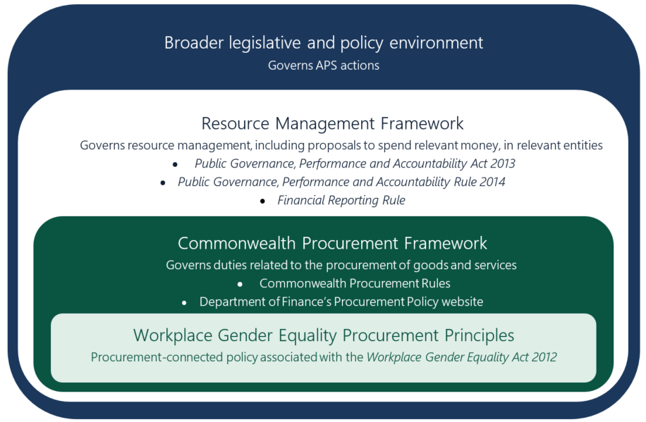

4. Summary of Review findings on procurement
The Review of the Act found stakeholders strongly supported making it clearer that relevant employers must comply with WGEA’s reporting obligations to receive Commonwealth procurement contracts. Relevant Australian Government departments agreed with stakeholder views that there is scope to strengthen the effectiveness of the WGE Procurement Principles. In response, the Review recommended making it clearer that relevant employers must comply with WGEA’s reporting obligations for Commonwealth procurement participation.
Through the Review, stakeholders raised concerns that it was not clear how the Commonwealth Government applied the WGE Procurement Principles in practice. In response, the Review recommended the WGE Procurement Principles be reviewed.
In considering strengthened compliance, the Review did not recommend financial penalties, or compliance and improvement notices, noting WGEA’s preference to provide support to comply, rather than apply penalties.

5. Questions

Tendering and compliance
- Has your organisation reported to the Workplace Gender Equality Agency in the last ten years?
- To what degree are you aware of and understand the WGE Procurement Principles and associated compliance requirements for tending and procurement?
- Has your organisation been awarded a contract (including a grant agreement) by the Australian Government in the last ten years?
- Has your organisation ever been denied a contract on the basis of Workplace Gender Equality Agency reporting non-compliance? If so, what was the impact on your organisation?
- How much effort is required to demonstrate compliance with Workplace Gender Equality Agency reporting for the purposes of procurement?
- To what degree does the requirement incentivise your organisation to begin or maintain compliance with the Workplace Gender Equality Act 2012 (WGE Act)?
- Are you aware of your obligations if your organisation becomes non-compliant with the WGE Act during the term of a contract?
- Are there any other matters you want to comment on in relation to the WGE Procurement Principles and compliance with Workplace Gender Equality Agency reporting requirements?

Gender equality outcomes
- Is the current approach of requiring compliance with WGE Act in order to apply for Australian Government procurements effective in promoting and improving gender equality within your organisation? If not, how could this be improved?
- Are there additional mechanisms that the Australian Government could consider in its procurement approaches that would advance gender equality in Australia?
- Are there any other matters you want to comment on in relation to the Australian Government’s approach to procurement and its impact on gender equality outcomes?

s18, Workplace Gender Equality Act 2012
The Procurement Principles defines the procurement threshold as “A procurement, other than one that is specifically exempt, where the value of the goods and services being procured exceeds the relevant procurement threshold outlined in paragraph 3.3 of the CPRs. The thresholds beyond which a procurement will be at or above the relevant procurement threshold as specified by the CPRs may be subject to change, however, as at November 2012 the relevant thresholds (including GST) are as follows: a. for FMA agencies, other than for procurements of construction services, the procurement threshold is $80,000; b. for relevant CAC Act bodies, other than for procurements of construction services, the procurement threshold is $400,000; or c. for procurements of construction services by FMA agencies or CAC Act bodies, the procurement threshold is $9 million.
Department of Finance, Procurement, Department of Finance website, 2023, accessed 18 July 2023.

